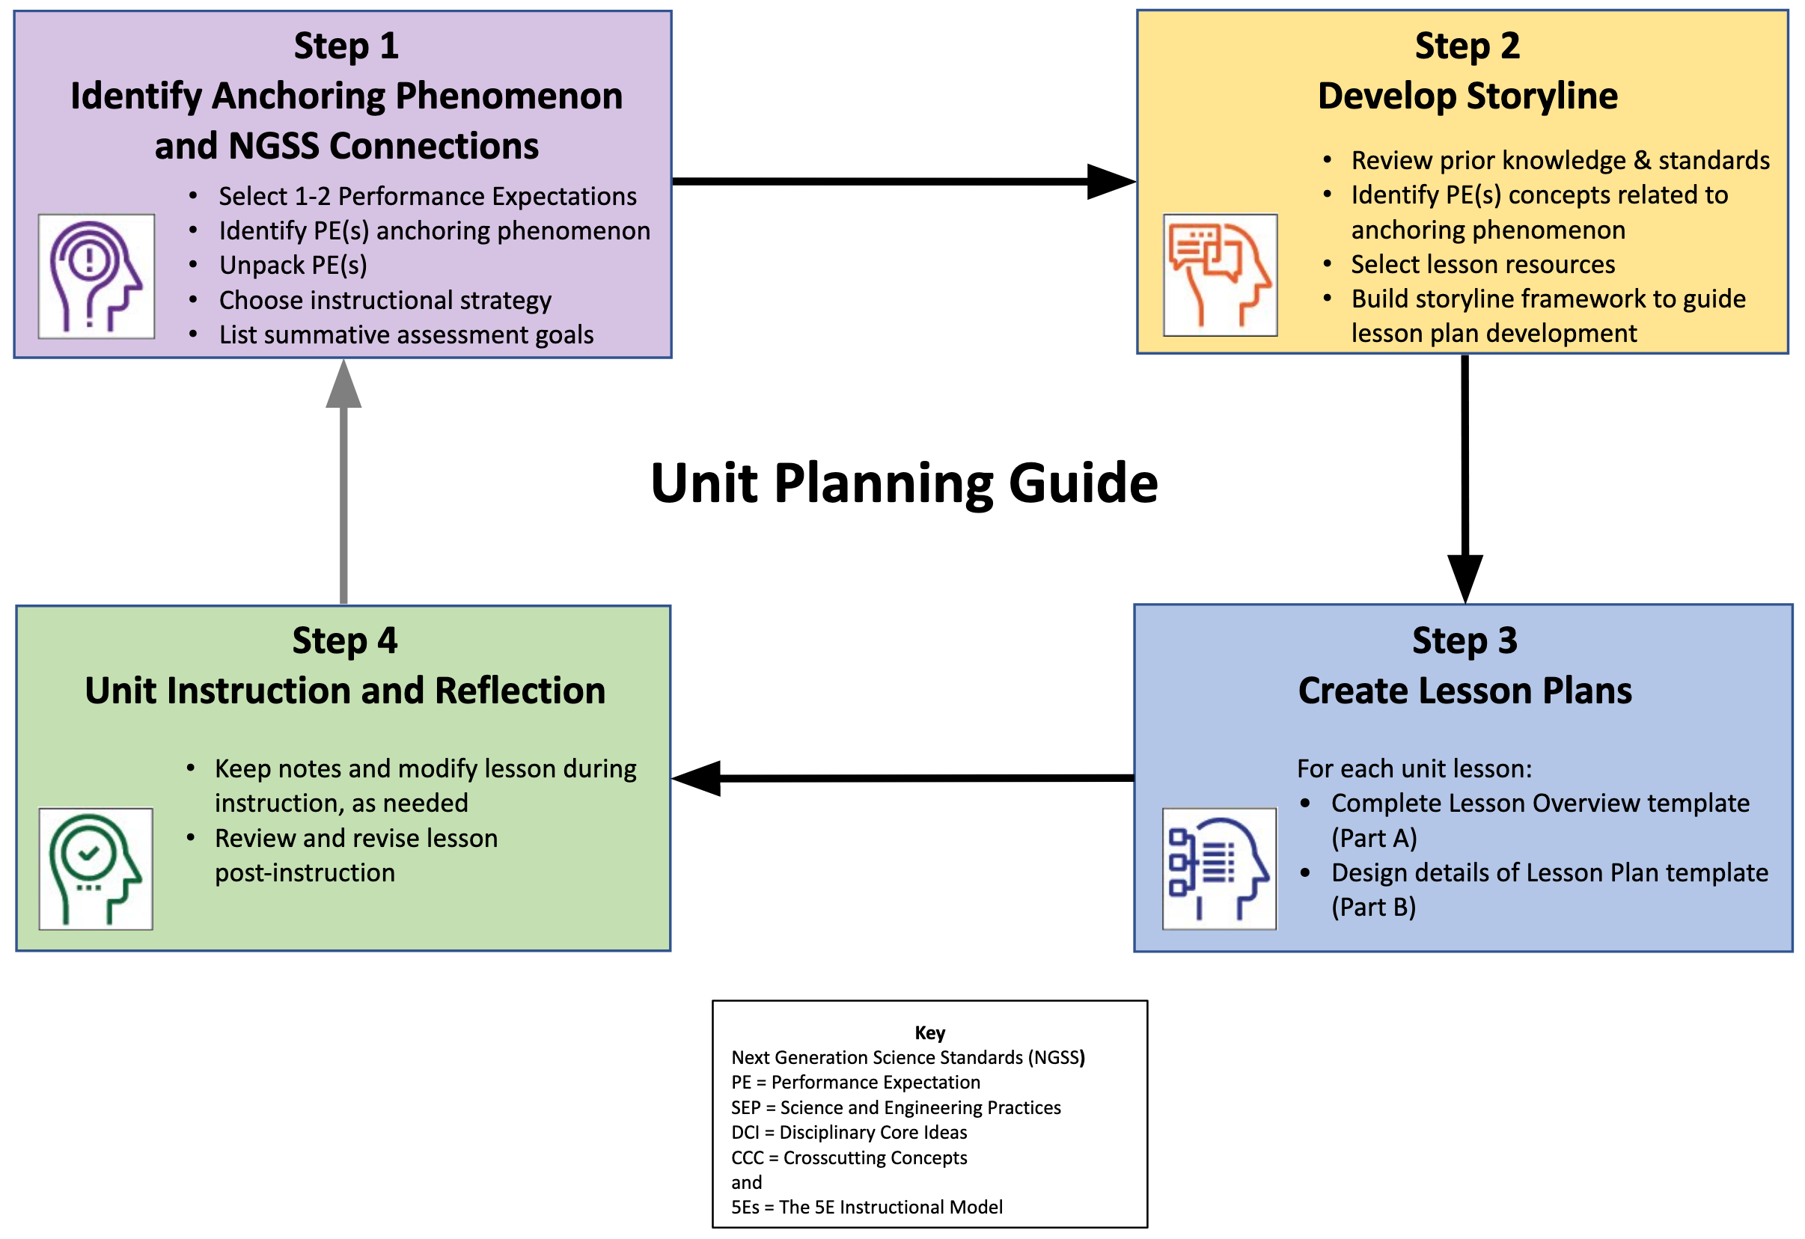
Topic:

 | Step 1: Identify Anchoring Phenomenon and NGSS Connections
Grade and Subject: |  |  | Instructional Time:
Unit Title:
Select the grade level NGSS Performance Expectation(s) (PEs) that build towards student learning goals.
The PE color coding reflects its 3-dimensional learning components. Search the Evidence Statements for details on what students should know and do.
Identify an anchoring phenomenon and related phenomena, problem, or project that corresponds to the PE(s), which is engaging and relevant to students. See more about phenomena and using phenomena with NGSS.
Describe an overview of how the anchoring and related phenomenon, problem, or project build toward understanding the PE(s) through student-led engagement opportunities to investigate the phenomena. Revise, as needed, during unit development.
Unpack the 3-D learning components of the Performance Expectation(s) in the following NGSS-aligned table below.
For guidance, see the NGSS Topic Arrangements and NGSS DCI Arrangements. Use tools to unpack each PE separately.
Science and Engineering Practices (SEP) |  | Disciplinary Core Ideas (DCI) |  | Crosscutting Concepts (CCC)
Choose an instructional strategy that best suits teaching and learning about the anchoring phenomena, problem, or project.
For ideas, see the Instructional Strategies matrix.
Generate goals for a summative assessment to measure student learning toward the identified PE(s) and its SEP(s), DCI(s), and CCC(s).

Step 2: Develop Storyline
Coherent Learning Progression
Develop a unit storyline that supports 3-dimensional learning and coherence for students.
- Review previous grade level Performance Expectations (PEs) and assess students’ prior knowledge to support storyline and lesson development.
- List key topics and main concepts, and select potential lesson activities about the anchoring phenomenon for the storyline framework.
- Use the storyline template (copy & paste) to create each sequence in a lesson or unit, which guides the development of lesson plans.

List previous grade level Performance Expectations that support the current grade level PE(s) in learning about the phenomenon:
Unpack the identified PEs related SEPs, DCIs, and CCCs:
Science and Engineering Practices Progression: | Disciplinary Core Ideas Progression: | Crosscutting Concepts Progression:

Prior Knowledge
Determine students’ prior knowledge (e.g., pre-test, class discussion, exit ticket, 1-minute report,KWL chart, survey, etc.) about the anchoring phenomenon:

Identify Key Topics
List the main concepts of the anchoring phenomenon that are the focus of the storyline and lesson plan learning goals, revise as needed:

Select Activity Resources
Identify lesson resources to investigate the anchoring phenomenon through a variety of activities, revise as needed (include title and):

Select the Storyline Unit Template (a, b, or c) that suits the detail and level of unit development:
Storyline Unit Template (a)
Unit Title (topic):
Anchoring Phenomenon
Previous Lesson…  Where we’ve been. | Fill in with previous lesson’s “what are we doing now”, if applicable.
This Lesson…  What we are doing now. | Teacher text about what happens in this lesson - to be completed after storyline
Driving Question…  What we’re investigating about the phenomenon. | Activities to Investigate the  Driving Question & PE alignment | Skills to Investigate the  Driving Question (SEPs) | What We Figure Out About the Driving Question (DCIs, CCCs) | New Questions &  Next Steps
(Lesson #: Student-driven lesson question)  (Lesson #: min.)  Building toward  ⬇  NGSS PE(s): | (Activities that build knowledge about anchoring phenomenon toward understanding lesson PE)
Next Lesson…  Where we’re going. | Teacher text about what happens in the next lesson based on this lesson’s outcomes.
Storyline adapted from nextgenstorylines.org under the Creative Commons License Attribution 4.0 License

Storyline Unit Template (b)
Lesson Title (topic):
Anchoring Phenomenon
Previous Lesson…
Where we’ve been.
This Lesson…
What we are doing now.
Driving Question…  What we’re investigating about the phenomenon. | Activities to Investigate the  Driving Question & PE alignment | Skills to Investigate the  Driving Question (SEPs) | What We Figure Out About the Driving Question (DCIs, CCCs) | New Questions &  Next Steps
(Lesson #: Student-driven lesson question)
(Lesson #: min.)

Building toward
⬇
NGSS PE(s):

 | .
Next Lesson…
Where we’re going.
Storyline adapted from nextgenstorylines.org under the Creative Commons License Attribution 4.0 License

Storyline Unit Template (c)
Lesson Title (topic):
Anchoring Phenomenon
Previous Lesson…
Where we’ve been.
This Lesson…
What we are doing now.
Driving Question…  What we’re investigating about the phenomenon. | Activities to Investigate the  Driving Question & PE alignment | Skills to Investigate the  Driving Question (SEPs) | What We Figure Out About the Driving Question (DCIs, CCCs) | New Questions &  Next Steps
(Lesson #: Student-driven lesson question)
(Lesson #: min.)

Building toward
⬇
NGSS PE(s):

Next Lesson…
Where we’re going.
Storyline adapted from nextgenstorylines.org under the Creative Commons License Attribution 4.0 License

Step 3: Create Lesson Plans
Lesson Overview Template (Part A)
Lesson Plan Sequence
Develop NGSS-aligned lessons that are guided by the 5Es instructional model to instruct the unit storyline.
Part A: Develop the learning plan overview to provide foundation for instruction.
Part B: Create detailed lessons for the learning plan using the 5Es instructional model to guide instruction.

Connect grade level Performance Expectation(s) to a lesson-based anchoring phenomenon topic.
See more about phenomena and using phenomena with NGSS.
PE(s):

Anchoring phenomenon topic:
Ask a Driving Question that connects to the identified grade level PE(s) and anchoring phenomenon topic, which is engaging and relevant to students.
See more about Driving Questions and using Driving Questions with NGSS.
Highlight specific SEPs, DCIs, and CCCs that support the PE(s) in learning about the phenomenon-based question.
Science and Engineering Practices Progression: | Disciplinary Core Ideas Progression: | Crosscutting Concepts Progression:

Prior Knowledge
Determine students’ prior knowledge (e.g., pre-test, class discussion, exit ticket, 1-minute report,KWL chart, survey, etc.) about the anchoring phenomenon:

Identify Key Topics
List the main concepts of the anchoring phenomenon that are the focus of the storyline and lesson plan learning goals, revise as needed:

Select Activity Resources
Identify lesson resources to investigate the anchoring phenomenon through a variety of activities, revise as needed (include title and):

 | Lesson Plan Template (Part B)
Grade and Subject: |  |  |  | Instructional Time:
 |  |  |  | min.
Lesson Title:
Anchoring Phenomenon:
Driving Question:
Lesson Introduction
Lesson Overview  (summary): |  |  | Learning Goals  (objectives):
Standards & Resource Alignment
Building Toward Target NGSS  PE with supporting SEP, DCI, CCC (links): |  |  | Lesson Resources  (sequence and links):
Teacher Preparation
Student Misconceptions  (potential student ideas that are problematic when engaging in the lesson): |  |  | Scientific Terminology  (vocabulary named once students “figure out” concepts of lesson):
Materials Preparation
Student Needs  (activity sheets, data packet, etc.): |  | Group Needs  (lab equipment, group data packets, etc.): |  | Safety & Technology Needs  (dangerous materials, websites cued, etc.):
Supporting Information
References  (links to cite sources of data, images, websites, etc.): |  |  | Background Reading  (for teachers and/or students):

For each lesson, select the relevant 5E instructional focus section(s) from the following:

Engage: Interest in a concept is generated and students’ current understanding is assessed.
ACTIVATE interest: Introduce anchoring phenomenon, driving question, and assess students’ prior knowledge
- Engages students in the concepts through a short activity or relevant discussion
- Connects students’ past and present experiences
- Creates interest and generates curiosity
- Uncovers students’ current knowledge and misconceptions
- Initiates student’s investigation into the anchoring phenomenon based on an observation, problem, or question
Student Anticipated Driving Question(s):
Lesson Activities (experiment, demonstration, video, visualization, reading, etc. coherently sequenced to help build understanding of PE):
(For each activity, provide details of the procedure including timing, teacher guidance, student prompts, strategies for discussions and differentiation, etc.)
Formative Assessment (activity sheet, Venn diagram, summary, exit ticket, think-pair-share, etc. to check for understanding of lesson concepts):
Consensus Discussion (claims, evidence, and reasoning on what students figured out in this lesson):
New Questions and Next Steps (student-driven questions, ideas on what to investigate in the next lesson and how to investigate it, etc.):

AND/OR

Explore: Students participate in activities to explore questions related to a concept.
BUILD Knowledge: Learn the science behind concepts
- Students explore the concepts with others to develop a common set of experiences
- Provides students with one or more actual experiences
- Offers opportunities for creative thinking and skills development
- Students make and record observations and ideas, make connections, and ask questions
- Students usually work in groups
- Teacher acts as coach or facilitator in student-led investigations
Student Anticipated Driving Question(s):
Lesson Activities (experiment, demonstration, video, visualization, reading, etc. coherently sequenced to help build understanding of PE):
(For each activity, provide details of the procedure including timing, teacher guidance, student prompts, strategies for discussions and differentiation, etc.)
Formative Assessment (activity sheet, Venn diagram, summary, exit ticket, think-pair-share, etc. to check for understanding of lesson concepts):
Consensus Discussion (claims, evidence, and reasoning on what students figured out in this lesson):
New Questions and Next Steps (student-driven questions, ideas on what to investigate in the next lesson and how to investigate it, etc.):

AND/OR

Explain: Students construct their understanding of a concept and develop evidence-based explanations.
DEVELOP Concepts: Research information using real-world data
- Develops students’ an explanation for the concepts they have been exploring with teacher providing supporting guidance
- Students describe their observations and come up with explanations
- Students listen critically to each other’s explanations
- Students learn to apply and interpret evidence
- Develops students’ academic vocabulary by applying scientific terms once students have figured out the lesson concepts
- Teacher guides students’ reasoning, asks appropriate questions, and directs students to additional supporting resources
Student Anticipated Driving Question(s):
Lesson Activities (experiment, demonstration, video, visualization, reading, etc. coherently sequenced to help build understanding of PE):
(For each activity, provide details of the procedure including timing, teacher guidance, student prompts, strategies for discussions and differentiation, etc.)
Formative Assessment (activity sheet, Venn diagram, summary, exit ticket, think-pair-share, etc. to check for understanding of lesson concepts):
Consensus Discussion (claims, evidence, and reasoning on what students figured out in this lesson):
New Questions and Next Steps (student-driven questions, ideas on what to investigate in the next lesson and how to investigate it, etc.):

AND/OR

Elaborate: Students deepen and expand their understanding by applying their understanding in new contexts.
APPLY Learning: Utilize information in new ways
- Extends students’ understanding or applies what they have learned in a new setting
- Students use the information they have gained to propose solutions and extend their learning to new situations
- Teacher supports students in broadening their understanding and extend ideas to other situations so they can draw broader conclusions beyond their experiment or investigation
Student Anticipated Driving Question(s) Extended/Applied in a New Context:
Lesson Activities (experiment, demonstration, video, visualization, reading, etc. coherently sequenced to help build understanding of PE):
(For each activity, provide details of the procedure including timing, teacher guidance, student prompts, strategies for discussions and differentiation, etc.)
Formative Assessment (activity sheet, Venn diagram, summary, exit ticket, think-pair-share, etc. to check for understanding of lesson concepts):
Consensus Discussion (claims, evidence, and reasoning on what students figured out in this lesson):
New Questions and Next Steps (student-driven questions, ideas on what to investigate in the next lesson and how to investigate it, etc.):

AND/OR

Evaluate: Students and teachers have opportunities to assess students’ understanding of a concept.
DEMONSTRATE Ability: Write, illustrate, create, etc. artifact(s) that accurately describe knowledge gained
- Students have the opportunity to demonstrate understanding of skills and concepts, and evaluate their own progress
- Teacher evaluates students’ understanding and progress, as well as their own instructional practice, and may implement alternative assessment strategies
- Enables adjustment of misconceptions, reinforces students’ understanding of the PE concepts in greater depth
Driving Question:
Skills Learning Performance (SEPs) Goals:
Formative Assessment (quiz, test, report, presentation, poster, video, model, etc. to demonstrate students’ understanding about the PEs.):
Content Learning Performance (DCIs, CCCs) Goals:
Summative Assessment (quiz, test, report, presentation, poster, video, model, etc. to demonstrate students’ understanding about the PEs.)

Step 4: Unit Instruction and Reflection
Lesson Notes During Instruction
- What modifications (instruction, timing, etc.) were made or are needed for specific lessons, activities, or resources?
- How effective (or ineffective) are specific lessons, activities, or resources for student learning?
- Which specific lessons, activities, or resources were or need to be changed?

Review and Revise Post-Instruction
- What parts of the lesson were a success?
- What were some challenges about the unit or lesson?
- How could the unit or lesson be changed or improved?

