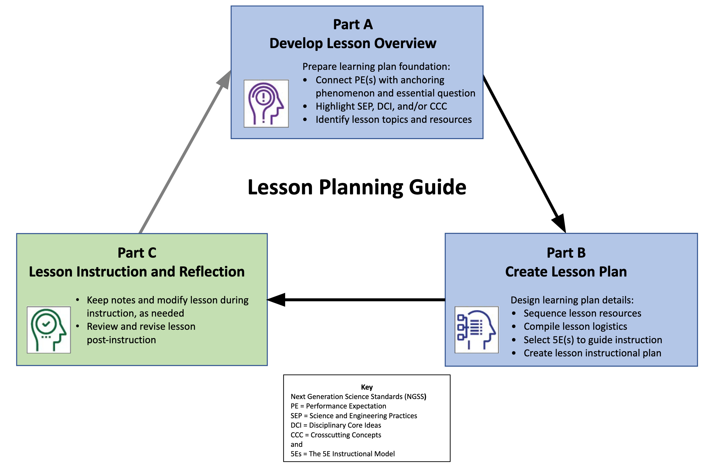

Lesson Overview Template (Part A)
Lesson Plan Sequence
Develop NGSS-aligned lesson(s) guided by the 5Es instructional model.
Part A: Develop the learning plan overview to provide foundation for instruction.
Part B: Create detailed lesson(s) for the learning plan using the 5Es instructional model to guide instruction.

Connect grade level Performance Expectation(s) to a lesson-based anchoring phenomenon topic.
See more about phenomena and using phenomena with NGSS.
PE(s):

Anchoring phenomenon topic:
Ask a Driving Question that connects to the identified grade level PE(s) and anchoring phenomenon topic, which is engaging and relevant to students.
See more about Driving Questions and using Driving Questions with NGSS.
Highlight specific SEPs, DCIs, and CCCs that support the PE(s) in learning about the phenomenon-based question.
Science and Engineering Practices Progression: | Disciplinary Core Ideas Progression: | Crosscutting Concepts Progression:

Prior Knowledge
Determine students’ prior knowledge (e.g., pre-test, class discussion, exit ticket, 1-minute report,KWL chart, survey, etc.) about the anchoring phenomenon:

Identify Key Topics
List the main concepts of the anchoring phenomenon that are the focus of the storyline and lesson plan learning goals, revise as needed:

Select Activity Resources
Identify lesson resources to investigate the anchoring phenomenon through a variety of activities, revise as needed (include title and):

 | Lesson Plan Template (Part B)
Grade and Subject: |  |  |  | Instructional Time:
 |  |  |  | min.
Lesson Title:
Anchoring Phenomenon:
Driving Question:
Lesson Introduction
Lesson Overview  (summary): |  |  | Learning Goals  (objectives):
Standards & Resource Alignment
Building Toward Target NGSS  PE with supporting SEP, DCI, CCC (links): |  |  | Lesson Resources  (sequence and links):
Teacher Preparation
Student Misconceptions  (potential student ideas that are problematic when engaging in the lesson): |  |  | Scientific Terminology  (vocabulary named once students “figure out” concepts of lesson):
Materials Preparation
Student Needs  (activity sheets, data packet, etc.): |  | Group Needs  (lab equipment, group data packets, etc.): |  | Safety & Technology Needs  (dangerous materials, websites cued, etc.):
Supporting Information
References  (links to cite sources of data, images, websites, etc.): |  |  | Background Reading  (for teachers and/or students):

For each lesson, select the relevant 5E instructional focus section(s) from the following:

Engage: Interest in a concept is generated and students’ current understanding is assessed.
ACTIVATE interest: Introduce anchoring phenomenon, driving question, and assess students’ prior knowledge
- Engages students in the concepts through a short activity or relevant discussion
- Connects students’ past and present experiences
- Creates interest and generates curiosity
- Uncovers students’ current knowledge and misconceptions
- Initiates student’s investigation into the anchoring phenomenon based on an observation, problem, or question
Student Anticipated Driving Question(s):
Lesson Activities (experiment, demonstration, video, visualization, reading, etc. coherently sequenced to help build understanding of PE):
(For each activity, provide details of the procedure including timing, teacher guidance, student prompts, strategies for discussions and differentiation, etc.)
Formative Assessment (activity sheet, Venn diagram, summary, exit ticket, think-pair-share, etc. to check for understanding of lesson concepts):
Consensus Discussion (claims, evidence, and reasoning on what students figured out in this lesson):
New Questions and Next Steps (student-driven questions, ideas on what to investigate in the next lesson and how to investigate it, etc.):

AND/OR

Explore: Students participate in activities to explore questions related to a concept.
BUILD Knowledge: Learn the science behind concepts
- Students explore the concepts with others to develop a common set of experiences
- Provides students with one or more actual experiences
- Offers opportunities for creative thinking and skills development
- Students make and record observations and ideas, make connections, and ask questions
- Students usually work in groups
- Teacher acts as coach or facilitator in student-led investigations
Student Anticipated Driving Question(s):
Lesson Activities (experiment, demonstration, video, visualization, reading, etc. coherently sequenced to help build understanding of PE):
(For each activity, provide details of the procedure including timing, teacher guidance, student prompts, strategies for discussions and differentiation, etc.)
Formative Assessment (activity sheet, Venn diagram, summary, exit ticket, think-pair-share, etc. to check for understanding of lesson concepts):
Consensus Discussion (claims, evidence, and reasoning on what students figured out in this lesson):
New Questions and Next Steps (student-driven questions, ideas on what to investigate in the next lesson and how to investigate it, etc.):

AND/OR

Explain: Students construct their understanding of a concept and develop evidence-based explanations.
DEVELOP Concepts: Research information using real-world data
- Develops students’ explanation for the concepts they have been exploring with teacher providing supporting guidance
- Students describe their observations and come up with explanations
- Students listen critically to each other’s explanations
- Students learn to apply and interpret evidence
- Develops students’ academic vocabulary by applying scientific terms once students have figured out the lesson concepts
- Teacher guides students’ reasoning, asks appropriate questions, and directs students to additional supporting resources
Student Anticipated Driving Question(s):
Lesson Activities (experiment, demonstration, video, visualization, reading, etc. coherently sequenced to help build understanding of PE):
(For each activity, provide details of the procedure including timing, teacher guidance, student prompts, strategies for discussions and differentiation, etc.)
Formative Assessment (activity sheet, Venn diagram, summary, exit ticket, think-pair-share, etc. to check for understanding of lesson concepts):
Consensus Discussion (claims, evidence, and reasoning on what students figured out in this lesson):
New Questions and Next Steps (student-driven questions, ideas on what to investigate in the next lesson and how to investigate it, etc.):

AND/OR

Elaborate: Students deepen and expand their understanding by applying their understanding in new contexts.
APPLY Learning: Utilize information in new ways
- Extends students’ understanding or applies what they have learned in a new setting
- Students use the information they have gained to propose solutions and extend their learning to new situations
- Teacher supports students in broadening their understanding and extend ideas to other situations so they can draw broader conclusions beyond their experiment or investigation
Student Anticipated Driving Question(s) Extended/Applied in a New Context:
Lesson Activities (experiment, demonstration, video, visualization, reading, etc. coherently sequenced to help build understanding of PE):
(For each activity, provide details of the procedure including timing, teacher guidance, student prompts, strategies for discussions and differentiation, etc.)
Formative Assessment (activity sheet, Venn diagram, summary, exit ticket, think-pair-share, etc. to check for understanding of lesson concepts):
Consensus Discussion (claims, evidence, and reasoning on what students figured out in this lesson):
New Questions and Next Steps (student-driven questions, ideas on what to investigate in the next lesson and how to investigate it, etc.):

AND/OR

Evaluate: Students and teachers have opportunities to assess students’ understanding of a concept.
DEMONSTRATE Ability: Write, illustrate, create, etc. artifact(s) that accurately describe knowledge gained
- Students have the opportunity to demonstrate understanding of skills and concepts, and evaluate their own progress
- Teacher evaluates students’ understanding and progress, as well as their own instructional practice, and may implement alternative assessment strategies
- Enables adjustment of misconceptions, reinforces students’ understanding of the PE concepts in greater depth
Driving Question:
Skills Learning Performance (SEPs) Goals:
Formative Assessment (quiz, test, report, presentation, poster, video, model, etc. to demonstrate students’ understanding about the PEs.):
Content Learning Performance (DCIs, CCCs) Goals:
Summative Assessment (quiz, test, report, presentation, poster, video, model, etc. to demonstrate students’ understanding about the PEs.)

Lesson Instruction and Reflection (Part C)
Lesson Notes During Instruction
- What modifications (instruction, timing, etc.) were made or are needed for specific lessons, activities, or resources?
- How effective (or ineffective) are specific lessons, activities, or resources for student learning?
- Which specific lessons, activities, or resources were or need to be changed?

Review and Revise Post-Instruction
- What parts of the lesson were a success?
- What were some challenges about the unit or lesson?
- How could the unit or lesson be changed or improved?

