Acidification of the Oceans

The pH scale is the measure of the acidity or alkalinity of an aqueous solution, especially water. It stands for “potential hydrogen,” and its values are derived from the negative exponent of the hydrogen ion concentration in the solution. In pure distilled water, a small number of water molecules (H₂O) dissociate into hydrogen ion (H⁺) and hydroxide ion (OH—), both with a concentration of 10^{—7} (one in every ten million water molecules is dissociated). Pure water is considered neutral, or pH of 7, based on the hydrogen ion concentration of 10^{—7}. If hydrogen ions are added from some other source (an acid), then their concentration increases, creating smaller negative exponents (10^{—6}, 10^{—5}, 10^{—4}, etc.). The smaller the pH, the more acidic the solution. If hydroxide ions are added from some source (a base), then some of them will bond with free hydrogen ions to form regular water molecules. This will decrease the hydrogen ion concentration (10^{—8}, 10^{—9}, 10^{—10}, etc.) and create a higher pH. The higher the pH, the more basic the solution. Consult http://en.wikipedia.org/wiki/PH for a full description of pH and for pH values of some common substances.
Seawater contains a great variety of dissolved ions and other compounds, only a few of which contribute hydrogen or hydroxide ions to the water. The pH of seawater is usually a little over 8, or slightly basic (it contains less than a tenth the free hydrogen ion concentration of pure water). It can vary locally based on the input of dissolved gases or solids, but in general ocean water is well mixed and maintains a uniform pH, especially far from shore.
Watch the videos at http://www.pmel.noaa.gov/co2/story/OA+Educational+Tools and http://www.pmel.noaa.gov/co2/story/Science+On+a+Sphere to see the best estimation of what ocean pH has been in the past and what it is projected to do in the future if current trends continue.
Now study this graph from http://hahana.soest.hawaii.edu/hot/trends/trends.html to see actual and calculated pH values for the ocean around Hawaii over a 20+ year period. Note that the range of pH values on the left scale is quite small (8.05 to 8.15) but that there seems to be a trend. The straight bold line is a best-fit line through all the data points. Use this graph, along with longer timeframe presented in the videos, to answer the questions below.
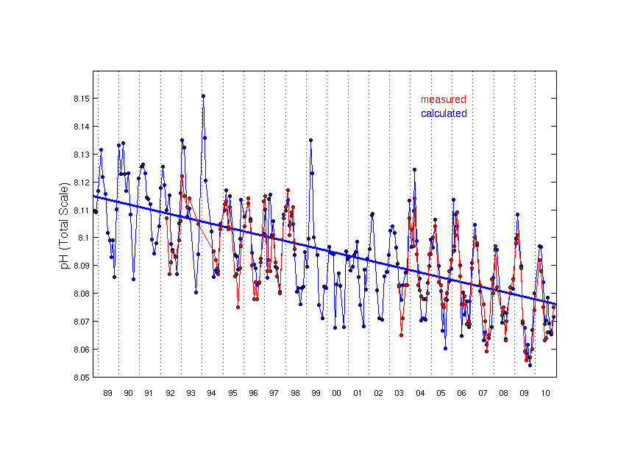
Questions
1. What is the typical pH of seawater, does that make it an acid or a base, and what does that say about the relative concentration of hydrogen and hydroxide ions in seawater?

2. What has been the trend in seawater pH over the 21 years for which precise data from the same location is available? How does this trend compare with the full range of values (noise in the data), and do the highest and lowest values over this timescale follow the same general trend as the average values.

3. What kinds of changes in ocean pH occurred prior to the 21-year period for which systematic data was collected, and how does it compare with the changes in that 21-year period?

4. What is predicted to happen to ocean pH over the coming decades if current trends continue in carbon emissions and other human modifications of the planet?

Answers:
1. Seawater has a pH of around 8.1, which makes it slightly basic. Hydroxide ions greatly outnumber hydrogen ions.

2. The average value of the pH of seawater around Hawaii dropped from 8.115 to 8.075 in the 21-year period from 1989 to 2010. Compared to this drop of 0.04, the range of values in a single year is as high as 0.07, but the high and low values (probably seasonal variations) follow the same basic trend as the average—dropping about 0.04 over the 21-year period.

3. While there were always some latitudinal and local variations in pH, in general the pH remained at around 8.15 during all the time prior to the 1980s, as far back as measurements were taken.

4. The drop in pH is expected no only to continue, but to accelerate for some decades before starting to level off at a lower value of around 7.5.

