What is the Earth’s Average Temperature?

Objectives
- Estimate the average temperature of the earth as a whole (atmosphere and surface combined), by applying several basic physical principles to satellite observations of solar energy.
- Compare this temperature to the global average temperature of the earth’s surface.

What You Should Already Know
- The principle of conservation of energy (expressed as a heat budget)
- A basic law of radiation: most substances emit radiative energy all the time
- Another basic law of radiation: the warmer an object is, the more radiation it emits

Introduction
What determines the average temperature of the planet as a whole (that is, the atmosphere and surface combined)? And what is that temperature? You can bet that the sun must have something to do with the answers. In this activity, we’ll figure out more precisely what.
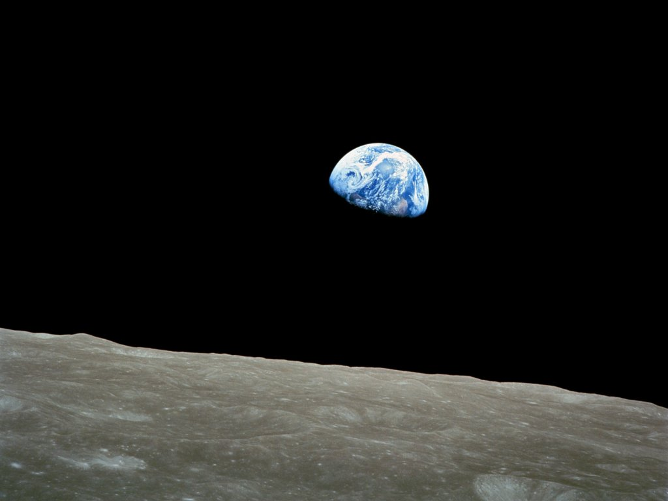
The earth, half lit by the sun. (Recorded by Apollo astronauts in 1969 from the surface of the moon.)
To set up a strategy for answering these questions, we first note that although the earth’s average temperature typically changes from year to year, it doesn’t change by very much. This means that the planet must lose about as much heat each year as it gains. That is, the planet’s heat budget must approximately balance.
Second, for the earth as a whole, absorption of solar radiation is far and away the largest source of heat.
Finally, the only significant way for the planet to lose heat is by emitting radiation to space. A basic law of radiation tells us that the amount of radiation that an object emits depends on its temperature: the hotter an object is, the more radiation it emits.

Hence, our strategy will be as follows:
- Determine how much solar radiation the earth absorbs, on the average.
- Figure out what the temperature of the earth as a whole must be, on the average, for the planet to lose as much heat by emitting radiation to space as it gains heat by absorbing radiation from the sun.
The first thing we need to know how is much solar radiation the earth receives from the sun. For several decades, satellites orbiting the earth above the atmosphere have measured the intensity of solar radiation reaching the earth. As shown in the photo above, at any given moment the sun lights half the planet, while the other half is dark. [However, because the earth rotates once per day, most places on the earth will spend part of the day exposed to the sun (daytime) and the rest of the day in the dark side (nighttime).] Averaged over a whole year and over the whole planet (including both the light and dark halves), satellites record about 342 Watts per square meter (W/m²) of solar radiation reaching the earth.
However, to determine the average temperature of the earth, the key is not how much solar radiation reaches the earth but rather how much the earth absorbs (and hence converts into heat). Some of the solar radiation reaching the earth reflects back to space rather than being absorbed. In the photo on the previous page, that’s why we can see the earth in the first place—the earth reflects some of the sunlight reaching it, which the camera on the moon then records.
Fortunately, satellites also record the amount of the solar radiation that the earth reflects. They observe that the earth reflects back to space an average of about 31% of the radiation arriving from the sun. The earth absorbs the rest (converting it into heat).

Questions
Question #1
If 342 W/m² of solar radiation arrive at the top of the earth’s atmosphere (averaged over the whole planet for a year), how much does the planet reflect back to space? [Optional: Insert multiple choices here.]
[Suggested strategy: to compute 31% of the arriving solar radiation, first divide the incoming solar radiation by 10 to get 10% of the total incoming, then multiply the result by 3 to get 30%, then add 1/10 of the 10% to get 31% of the total).]

Question #2:
How much solar radiation does the earth absorb (averaged over the whole planet for a year)? [Optional: Insert multiple choices here.]

As noted earlier, the planet’s heat budget for a typical year must nearly balance because the average temperature changes only a little from year to year. Most objects emit radiative energy continuously, and the earth, like the sun, is no exception. In fact, radiative emission to space is how the planet loses heat (see Figures 2(a)-(c) below).
The earth emits mostly longwave infrared (LWIR) radiation, which satellites orbiting the earth can measure. They typically record LWIR emission from the earth of around 235 W/m² averaged over the whole planet for a year.
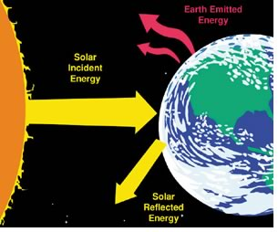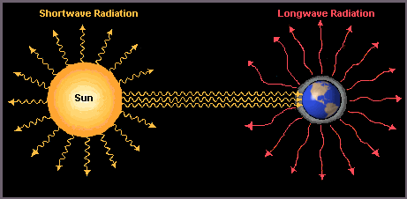
Figure 2(a) Figure 2(b) Figure 2(c)

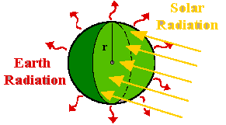
[Figures 2(a)-(c) all show solar radiation reaching the earth and the earth emitting longwave infrared radiation to space. Figure 2(a) shows (correctly) the earth reflecting some solar radiation back to space (and presumably absorbing the rest); Figure 2(b) (incorrectly) shows no reflection; and Figure 2(c) doesn’t show reflected light explicitly but does imply reflection because the sunlit half of the earth is lighter than the other half. Figures 2(b) and 2(c) show (correctly) all parts of the earth emitting longwave radiation, in all directions. Note that neither Figure 2(a) nor 2(b) shows the sizes of the earth and sun or the distance between them drawn correctly to scale.]
Question #3:
Does the yearly average energy budget for the earth as a whole approximately (if not exactly) balance, as we think it should based on observations of average temperature? (Explain your answer.)

Another basic law of radiation says that the amount of radiation that an object emits depends on its temperature. (In particular, the warmer an object is, the more radiation it emits.) Given the approximate balance between absorption of solar radiation and emission of LWIR to space, we conclude that the earth as a whole must be at about the right temperature to emit as much radiative energy as it absorbs from the sun.

Question #4:
Table 1 and Figure 1 show how much radiative energy an object emits at different temperatures. Using Table 1 or Figure 1, your answer to Question #2, and the fact that the energy budget for the planet as a whole averaged over a year approximately balances, what must the average temperature of the earth be?

We can also measure the temperature at the earth’s surface (using both satellites and thermometers) and estimate the long-term, global average temperature at the surface. The result: the global, long-term average surface temperature of the earth is around 15°C (60°F). (This varies a little bit from one year to the next, and has increased by about 1°C in the last century.)

Question #5:
How does the annual average temperature of the earth as a whole compare to the annual average temperature of the earth’s surface?

Based on the average temperature of the earth’s surface, we can calculate how much LWIR radiation the surface emits.

Question #6:
Using Table 1 or Figure 1 and the earth’s annual average surface temperature, how much LWIR radiation does the surface emit (on the average)?
How does the radiative emission from the surface compare to the radiative emission from the planet as a whole to space?

You should see some large differences! This raises the question: why is the earth’s surface is so much warmer (and emits much more radiative energy) than the planet as a whole?

Table 1:
Blackbody Emission of Radiative Energy
vs.
Temperature
Temperature (Kelvins) | Temperature (°C) | Temperature (°F) | Radiative Emission (W/m²)
313 | 40 | 104 | 545
308 | 35 | 95 | 511
303 | 30 | 86 | 479
298 | 25 | 77 | 448
293 | 20 | 68 | 419
288 | 15 | 59 | 391
283 | 10 | 50 | 364
278 | 5 | 41 | 339
273 | 0 | 32 | 316
268 | -5 | 23 | 293
263 | -10 | 14 | 272
258 | -15 | 5 | 252
253 | -20 | -4 | 233
248 | -25 | -13 | 215
243 | -30 | -22 | 198
238 | -35 | -31 | 182
233 | -40 | -40 | 168
228 | -45 | -49 | 154
223 | -50 | -58 | 141

Proximate references for borrowed figures:
- Figure 2(a): The Aluminum Association (http://www.aluminum.org/)
- Figure 2(b): Rita Haberlin, Geography, Peralta Community Colleges, California. (http://home.comcast.net/~rhaberlin/srtut/sr1q3n.htm)
- Figure 2(c): SOAR-High Earth System Science program, Gallaudet University, Washington, D.C. (http://csc.gallaudet.edu/soarhigh/modelt0.gif)

