CAM Animation Scenario: Causal Feedback Loop(s) in the 2011 Texas Drought

Read the following scenario and identify a causal feedback loop(s) to animate. Because multiple causal feedback loops exist in this complex story, you may want to take on the challenge of animating more than one causal loop, showing how one causal loop may be related to another.
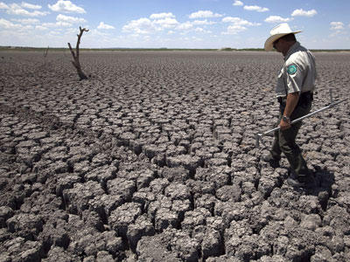
The year 2011 was a tough year for Texans. In 2011, Texas experienced the worst single-year drought in its recorded history. Additionally, the summer of 2011 was the hottest summer on record. Lakes and reservoirs dried up, crops and farm animals died in the field and more than five million trees died. Wildfires caused over 3 million Texas acres to burn, making 2011 the worst year for Texas wildfires in over a decade.

Figure 1: Texas State Park officer Thomas Bigham walks across the cracked lake bed of O.C. Fisher Lake Wednesday, Aug. 3, 2011, in San Angelo, Texas

What caused the drought?
The 2011 Texas drought is a multi-variable story of low rainfall, low evapotranspiration rates, tree and crop death, decomposition, wildfires and a Pacific Ocean phenomenon called La Niña.
“According to Richard Seager, a professor at the Lamont-Doherty Earth Observatory at Columbia University and a prominent drought researcher, this drought has one key thing in common with the Dust Bowl and the 1988 drought events: its origins can be traced to the tropical Pacific Ocean, where a periodic cooling of sea surface temperatures — a phenomenon known as La Niña — helped reconfigure global weather patterns during the past two years.” La Niña years are usually are accompanied by below average rainfall in the American Southwest. (ClimateCentral)
The year of the 2011 Texas drought was the hottest and driest in Texas history. Was this due only to La Niña or was a warming climate affecting the intensity and duration of droughts? The impact of a warming climate on drought is the focus of on-going research around the world. For example, research by Eleanor Burke, a specialist in climate extremes at the Hadley Center of the Met Office in Britain, projects that if global temperatures rise by 4 degrees Celsius (7.2 degrees Fahrenheit) — a fairly high amount — then southern Africa, Southeast Asia, the Amazon and the Mediterranean region would be considerably more prone to drought. http://www.metoffice.gov.uk/climate-change/guide/impacts/high-end/drought
Additionally, the National Oceanic and Atmospheric Administration has found that human-caused climate change is a major factor in the Mediterranean, where drought events are increasing in the winter when the region typically gets more rainfall. http://www.noaanews.noaa.gov/stories2011/20111027_drought.html
Can drought lead to more drought?
Hotter temperatures and drier air can worsen drought. By mid-summer, Texas had already experienced months of extremely dry weather, so there was very little moisture left in the ground. Moist soil has a cooling affect on the air above, so with low soil moisture, temperatures got hotter. Drought and hot temperatures can also affect evapotranspiration, a very important water cycle process that involves both plants and soil.

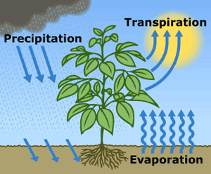
Under normal conditions, water evaporates from soil and transpires from plants(transpiration) into the surrounding air. As a matter of fact, during a non-drought season, an acre of corn gives off about 3,000-4,000 gallons (11,400-15,100 liters) of water each day, and a large oak tree can transpire 40,000 gallons (151,000 liters) per year. During a prolonged drought, soils dry out and evapotranspiration is greatly reduced. This in turn reduces rainfall and humidity, which can make droughts hotter and drier. In this way, a drought can “feed back into itself.
Figure 2 Evapotranspiration is the sum of evaporation from the land surface plus transpiration from plants. Precipitation is the source of all water. Credit: USGS
http://ga.water.usgs.gov/edu/watercycleevapotranspiration.html

Tree death in the 2011 Texas drought.
The Texas agricultural economy lost over 5 billion dollars worth of crops and livestock during the 2011 drought. Trees were also heavily impacted. The Texas A&M University Forest Service determined that the drought and the high temperatures were linked to the death of approximately 300 million rural trees and over five million urban trees. Some trees were directly killed by the drought whereas other trees died because the drought made them more susceptible to disease or insect. When trees and crops experience a sustained lack of water (severe water stress), rates of transpiration and plant tissues and processes are adversely affected. Severe water stress will injure trees and crops and will eventually kill them if water continues to be unavailable.
Tree death increases the amount of carbon dioxide (CO₂) in the atmosphere. Dead trees no longer remove CO₂ from the air during photosynthesis and as they slowly decompose, they release CO₂ to the air through the process of soil respiration. Regrowth of new trees will eventually rebalance this system.
Did the Texas 2011 drought lead to more wildfires?
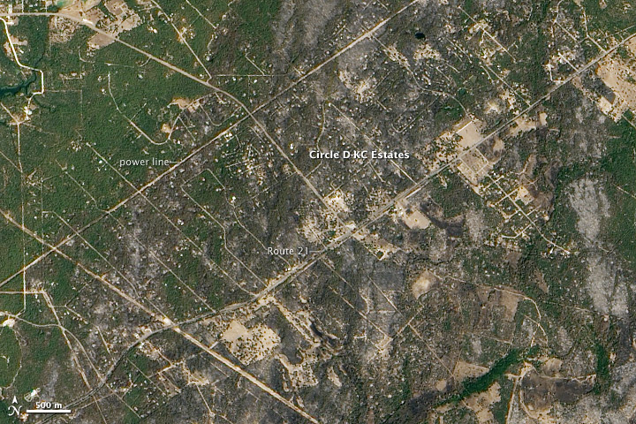
Figure 3. The Bastrop County Complex Fire in southern Texas started on September 4, 2011. By September 13, the fire was 70 percent contained, but had scorched 34,068 acres (13,787 hectares) leaving the burn scar above. The Advanced Land Imager (ALI) on NASA’s Earth Observing-1 (EO-1) satellite captured these images of the region on September 12, 2011 Source: NASA Earth Observatory

The hottest June-August weather on record, dry, parched lands from the on-going drought, and hot winds from Tropical Storm Lee created optimum conditions for wildfires in Texas, 2011. According to the Texas A&M Forest service, there were 31,453 small to large fires from Nov 15, 2010 to October 31, 201. Over 4 million acres burned, destroying close to 3000 homes making 2011 one of the worst recorded years for fires. The Bastrop County Complex Fire was the most destructive wildfire in Texas history, destroying over 1,1673 homes and causing over 300 million dollars in damage. Wildfires release CO2 to the atmosphere via the process of combustion.

To learn more about the Texas drought, explore the following resources:
Articles and websites:
Warming Amplifying Texas Drought, Wildfires Scientists Say
http://www.climatecentral.org/news/record-breaking-texas-drought-and-heat/

The Final Numbers Are In: Over 300 Million Trees Killed By the Texas Drought
http://stateimpact.npr.org/texas/2012/09/25/the-final-numbers-are-in-over-300-million-trees-killed-by-the-texas-drought/
Dried Out: Confronting the Texas Drought
http://stateimpact.npr.org/texas/drought/
Wildfires in Texas
http://earthobservatory.nasa.gov/Images/related_to.php?id=50342

La Niña years
http://www.amnh.org/explore/science-bulletins/(watch)/earth/visualizations/el-nino-to-la-nina
http://www.elnino.noaa.gov/lanina_new_faq.html

Evapotranspiration
http://ga.water.usgs.gov/edu/watercycleevapotranspiration.html

Tree/Crop Response to Water Stress

http://txforestservice.tamu.edu/main/popup.aspx?id=1283

Videos and Images:
Worst Drought in Texas History Ravages Crops, Livestock
http://www.pbs.org/newshour/bb/weather/july-dec11/texasdrought_08-31.html
Photographic Images of 2011 Texas Wildfires http://www.theatlantic.com/infocus/2011/04/texas-wildfires/100050/

