CAM Animation Scenario: Causal Feedback Loop in Thawing Permafrost
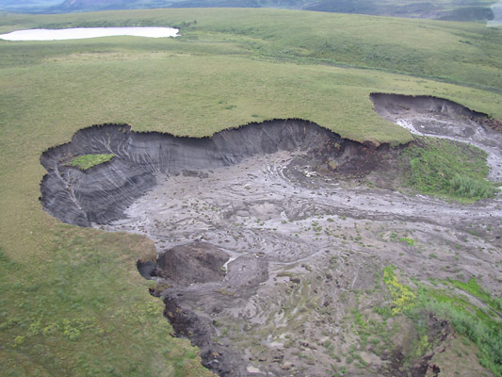
Figure 1. Thawing permafrost soil. Credit K. Kennedy
Permafrost refers to a layer of soil or rock that is frozen all year round. Found throughout much of Alaska, parts of Canada, and other countries in the far north, permafrost contains the un-decomposed remains of hundreds to thousands of years of dead plant and animal remains. As the Arctic warms, some of this permafrost soil is thawing. As the permafrost thaws, microbes are able to decompose the previously frozen plant and animal remains. The microbes respire as they decompose this thawing organic material, releasing carbon dioxide (CO₂) and methane (CH₄) into the air.

Carbon dioxide and methane are both greenhouse gases and contribute to keeping Earth’s atmosphere warm enough for the diversity of life to exist. Furthermore, methane is a powerful greenhouse gas – around 25 times more effective at trapping heat than carbon dioxide over a 100-year cycle. For this reason, scientists are concerned that increased amounts of carbon dioxide and methane released into the atmosphere from thawing permafrost will warm the atmosphere further. This additional warming can create a vicious cycle of thawing, decomposing and a warming atmosphere.

To learn more about permafrost, explore the following resources:

Articles and websites:

National Snow and Ice Data Center (NSIDC): Methane and frozen ground
http://nsidc.org/cryosphere/frozenground/methane.htmltp://www.teachersdomain.org/resource/ean08.sci.ess.earthsys.microbe/

New York Times: As permafrost thaws, scientists study the risks http://www.nytimes.com/2011/12/17/science/earth/warming-arctic-permafrost-fuels-climate-change-worries.html?ref=temperaturerising
Yukon Permafrost Network
http://permafrost.gov.yk.ca/permafrost101/

National Science Foundation: Arctic tundra may contribute to a warmer world
http://www.nsf.gov/news/news_images.jsp?cntn_id=114865&org=NSF

How rapidly is Permafrost changing and what are the impacts of these changes?
http://www.arctic.noaa.gov/essay_romanovsky.html

Climate Central: Permafrost will boost temps, but not quickly
http://www.climatecentral.org/blogs/melting-permafrost-will-boost-temps-but-not-much-this-century-15083

Videos:

NBC Learn: Thawing Permafrost from NBC Learn
http://www.nbclearn.com/changingplanet/cuecard/52627

Vimeo: Exploring our world In Thule, Greenland. Thawing permafrost may add greenhouse gases to the atmosphere
http://vimeo.com/55979928

Vimeo: Carbon comes out of the earth when permafrost thaws
http://vimeo.com/70971071

