Climate Change Mind Map
Goal: Learn climate change concepts and how the various they are interrelated.
Procedure: Working with your group, please define the following terms. Then write the terms on a large piece of butcher paper and draw lines show how these different concepts are interrelated. Use arrows to indicate cause and effect relationships between different concepts (solid arrows can indicate strong relationships, while dashed arrows can indicate weaker relationships.) Remember that it’s possible for some arrows to go both ways.
Here is an example:
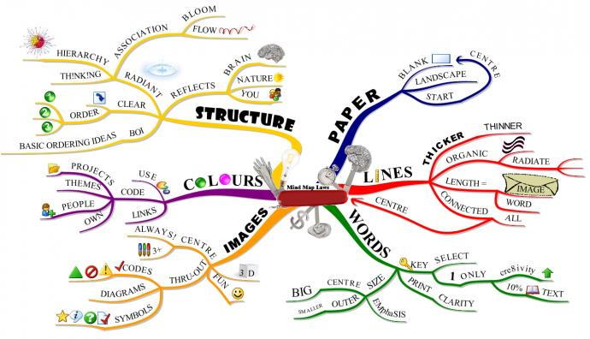
http://www.cityofderbyacademy.org/mind-maps/
Once everyone is finished, students compare the various maps and discuss the relationships among these concepts in order to better understand how they impact each other and their overall effect on the climate.
Basic Climate Change Mind Map
- Climate
- Weather
- Carbon Dioxide
- Carbon Cycle
- Terrestrial Heat
- Greenhouse Effect
- Global Warming
- Solar Energy
If you would like to expand the mind map to develop a broader understanding of the issue, you could add some or all of the following topics.
- Deforestation
- Ocean Acidification
- Sea Level Rise
- Loss of Snow Pack/Water Supply
- Arctic Sea Ice
  - Polar Bears
- Fossil Fuels
  - Coal
  - Oil
  - Natural Gas (Methane)
- Extreme Weather Events
  - Drought
  - Hurricanes
- Policy Solutions
  - Carbon Tax
  - Cap and Trade
- Transportation Solutions
  - Light Rail
  - Buses
  - Electric and Hybrid Cars
- Desertification
- Crop Loss/Failure and Loss of Food Security
- Population Growth
- Emergent Diseases

