English 101 Essay #3: Research paper: Food Item analysis
Byrd, Spring 2017

Consider This ……

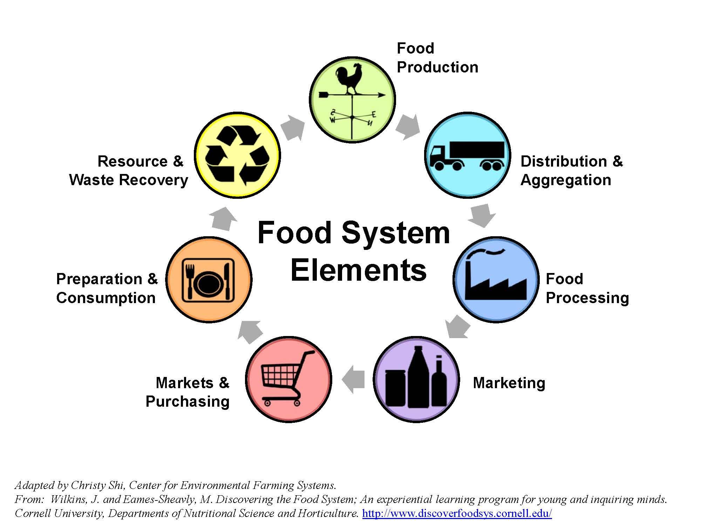

For this assignment, you will investigate a food item that you eat regularly, at least 3 times a week. The item you select can either be a whole food, like bananas or salt, or something that is processed. Keep in mind that a commodity analysis might be harder to do completely with an item that has many ingredients, and the focus might shift from origin to process, distribution, etc. The purpose of your investigation is to understand where your food comes from and the systems in which you participate as a food consumer. Don’t get distracted researching the history of a food item – though a little bit of this is okay. In your research, you will investigate where, how, and by whom your food product is grown, processed, and distributed and then draw conclusions about food justice and your food item. You will need to take careful notes when doing research and keep track of all sources of information to include in your works-cited page.

Requirements:
- You include a connection between your food consumption habits and the food commodity chain, and you identify and discuss one or more issues related to food justice that are inherent in the food system.
- You develop a claim connecting a food commodity to a food justice issue and support that claim with evidence from research. This development and organization of ideas as a claim + support is what distinguishes this assignment as an academic essay from a “report”.
- 5-page minimum of writing + works-cited page = 6 pages minimum.
- 3-5 outside reputable, relevant, and academically appropriate outside sources in support of your analysis and discussion;
- MLA format for page layout, in-text citations, and works-cited page;
- Essay has been proofread for errors to demonstrate your best work.

Options:
- Images: You might include images in your paper if these add to your rhetorical effectiveness and help add visual details to the process or justice issues.
- Voice: You can vary the degree to which you approach this from the first person, but you are expected to develop a tone and style appropriate to an academic audience.

Due Dates:
- Topic brainstorm and prewriting due in class, Thursday May 4th
- Source citations and research notes due typed on paper, May 9th – meet in Library.
- Draft of body or “middle” paragraphs (1 full page) due in class, Monday, May 22nd.
- Rough draft due Thursday, May 25th.
- Final draft due to Canvas on Tuesday, May 30th.

