The Wicked Problem of Water Quality in the Mississippi River Watershed
Externalities, Public Goods, and Common Resources – Navigating the market equilibrium

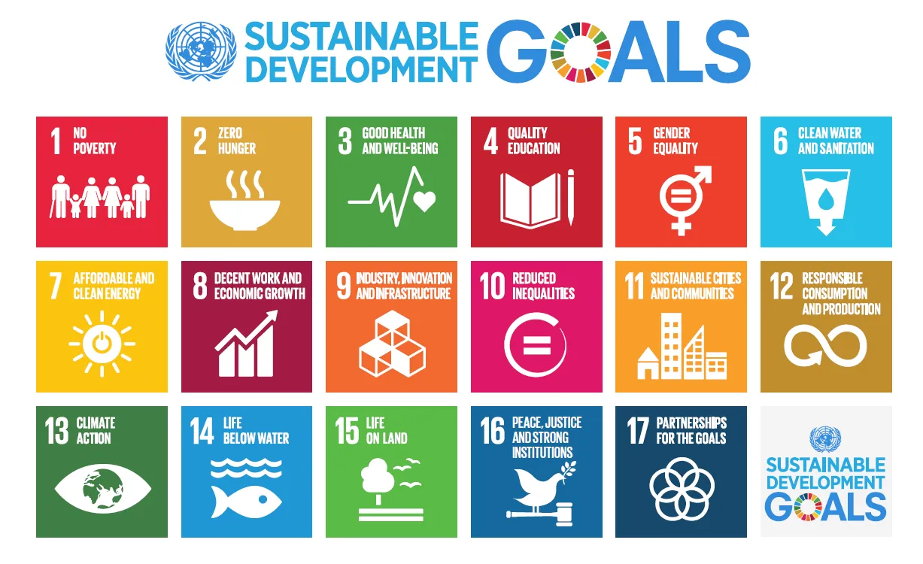

Consider our new understanding of what makes water quality a “wicked problem” using the example of the Mississippi River Watershed. In particular, focus on the SDGs related to clean water & sanitation and sustainable cities & communities.

By the end of the exercise, you will be able to:

- Design a policy for government intervention in the market for using water in a community.
- Predict and explain how stakeholders may change their behavior in response to the policy: firms, households, schools, etc.

Recall the following Stakeholder groups represented at the Town Meeting on Nitrogen in Mississippi River
- Family farms in the upper Midwest with large acreages of corn and soybean fields
- Fisheries industry that relies on fish harvest from the Gulf of Mexico
- Municipalities for which you must supply drinking water to the residents and treat all of the sewage
- Citizens of Misiziibi whom have seen rates for water and sewage increase over the last 10 years, hear a lot about nitrogen pollution in the Misiziibi water supply, and are worried about the health effects
- Small brewery that wants to expand its operations due to increasing beer consumption in the region
- Local non-governmental organization (NGO) that wants to protect a local endangered aquatic plants and habitat for riparian zone (riverside and floodplain) flora and fauna

Keep in mind the revised Stakeholder Map we created together as a class.

- Consider the following four markets:
  - Group 1: Agricultural: corn
  - Group 2: Fishing
  - Group 3: Breweries/beer
  - Group 4: Drinking water
- For your assigned industry, define the equilibrium in the private market outcome
  - Draw the supply and demand diagram for the good/service in question. Label the quantity axis as you see fit. Define the price-per-unit as appropriate.
  - Define who makes up the “supply” side and who makes up the “demand” side of the market.
  - Label the equilibrium price and quantity.
  - Label the consumer and producer surplus.
  - Assess the allocation of the total surplus amongst stakeholders in question.
- Consider the social costs and benefits of this industry
  - Brainstorm potential externalities that exist in the market.
  - How can you classify the good/service in question (i.e. common resource, public good, private good, etc.)?
  - Which side of the market likely experiences the externality and how is this internalized by the market?
  - How does the private outcome compare with the socially optimal outcome?
- Design an appropriate government intervention
  - How can the government use policies to achieve an improvement in overall social welfare?
  - How are surpluses affected and/or reallocated? Consider the elasticity of each side of the market.
  - Do you think these policies are feasible?

