The Demographics of Disability: Age and Sex

This assignment will familiarize you with data on disability from the US Census Bureau’s American Community Survey (ACS). The ACS is an ongoing statistical survey that is sent to about 2.6% of US residents each year. Individuals who receive the survey are required by law to complete it. The survey collects information on a variety of topics including disability, ancestry, educational attainment, income, language proficiency, migration, employment, and housing characteristics. (These questions were previously asked in the long form of the decennial US Census.) You can learn more about the ACS at https://www.census.gov/programs-surveys/acs/

You can also view a typical ACS survey questionnaire here:
http://www2.census.gov/programs-surveys/acs/methodology/questionnaires/2016/quest16.pdf
(The disability-related questions can be found on page 9 of the 2016 questionnaire.)

This assignment will strengthen your social science research skills. In particular, it will give you practice
- articulating research hypotheses and testing whether or not your hypotheses are supported by real data;
- creating and interpreting bivariate tables;
- explaining what is meant by confounding variables, and describing how a relationship between two variables can be altered or even reversed with the introduction of a third, confounding, variable.

Question #1. As shown in the questionnaire (link above), the ACS identifies several different categories of disability (e.g., cognitive disability, ambulatory disability, independent living disability, self-care disability, vision difficulty, and hearing difficulty). Based on these categories, what proportion of the population do you think has at least one disability? In addition, what do you think is the relationship between age and disability? What do you think is the relationship between sex and disability? Please support your hypotheses with at least one reference to the class readings.

Now let’s look at the data! Although the ACS has its own website, it’s often easier to find the data you need through American FactFinder, a site that provides access to data from many US Government sources.

First we’ll use American Factfinder to look at data on disability in the US.
Go to Factfinder: http://factfinder.census.gov/faces/nav/jsf/pages/index.xhtml

From there, click on and select “Show Me All.” In “topic or table name” type “disability” and select “Go.” A new screen will appear. Click on the table called disability characteristics.

Question #2. Drawing on data from the ACS, answer these questions: What percentage of the population has a disability? What sex has the highest percentage of individuals with disabilities? What age group has the highest concentration of individuals with disability? (Please support your answers with actual data from the disability characteristics table.) Do your findings confirm or challenge your hypotheses? (Please note that the data in the table are 2010-2014 American Community Survey 5-Year Estimates.)

It is important to realize that a third variable—a confounding variable (or control variable)—may influence the relationship between your two main variables. (A particular disability may be more prevalent among females than males, but more prevalent among male children than female children (and possibly other age groups, too)! In this example, age—the confounding variable—influences the relationship between sex and disability.) If you don’t include the relevant confounding variable(s) in your analysis, you may end up misinterpreting the relationship between your two main variables—but if you “control” for the confounding variable, you can more fully explain the relationship.
Question #3. As shown in the questionnaire (link above), the ACS identifies several different categories of disability (e.g., cognitive disability, ambulatory disability, independent living disability, self-care disability, vision difficulty, and hearing difficulty). Please select one of these categories and indicate what you think will be the relationship between sex and the disability you’ve selected. (Is the disability more common among males or females?) Also: Are there any confounding variables that might influence the relationship between sex and the disability you’ve selected? Please explain your answer.

Now let’s look at some data. We’ll use a different website, IPUMS USA, that allows us to see even more detail than American FactFinder. That is, we’ll construct a table using the detailed ACS data available through IPUMS.

First go to https://usa.ipums.org/usa/ From there, you’ll need to create an account and log in.
For this demonstration, however, you may use my account and password. Click on the “Login” link near the top of the page, then enter my account name ( Esther.Wilder@lehman.cuny.edu ) and password ( 99ida ).

Once you’ve logged in, go to https://usa.ipums.org/usa/sda/ From there, click on the “American Community Survey, 2001-2014” link about halfway down the page. A new screen will appear:

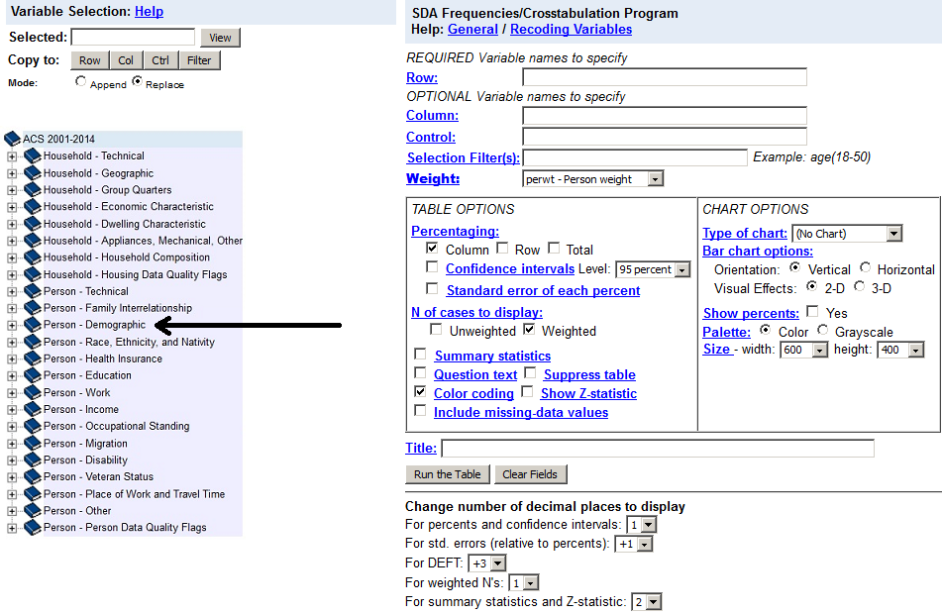

In the left-hand column double-click on “Person - Demographic” to see all the demographic variables. (Whenever you see a plus sign, it means you can expand and view all the variables in the category.) You should see “sex,” “age,” and many others. Now double-click on “Person - Disability” to see all the disability-related variables. You should see “disabwrk - Work disability,” “vetdisab - VA service-connected disability rating,” “diffrem - Cognitive difficulty,” and six others that correspond to the disability categories used in the ACS.

Double click on the disability variable that you would like to study. (That’s your dependent variable). Once you double-click, your variable will show up in the “Selected” box in the top left corner of the screen.

Below the “Selected” box is a “Copy to: Row” button. Click on that button to indicate that you want your disability variable to appear in the rows of the table you’re constructing.
Next, double-click on “sex” under “Person - Demographic.” Make sure that “sex” appears in the “Selected” box, then click the “Copy to: Col” button to indicate that you want “sex” to appear in the columns of your table.

Now that you have selected your row and column variables, you can go ahead and create a table showing the numbers of males and females who have (and who don’t have) the disability you have selected. Enter a title for your table, such as “Vision Disability by Sex in the US, 2010-2014.” Then select “Run the Table.” Your table will appear. Please copy the table and paste it into your assignment. Call it “Table 1.”

Remember that confounding variables can influence the relationship between sex and disability, however. Next we’ll explore whether age is a confounding variable for the disability you’ve chosen. Go back to the variable selection page, choose “age” from the “Person - Demographic” list, and click the “Copy to: Ctrl” button. That tells IPUMS that you want to use age as your control variable.

You don’t want a separate table for every single year of age, however. Instead, you’ll want age data for 5-year age groups. To indicate that you want to recode the age variable into 5-year age groups, copy or type this line into the “Control” box: age(r: 1-4; 5-19; 20-29; 30-39; 40-49; 50-59; 60-69; 70-79; 80-89; 90-120)
Note: If you have chosen a disability such as “self-care difficulty” or “ambulatory difficulty,” you will not have data for young children. (Toddlers may have self-care difficulties, but those aren’t disabilities in the usual sense.) If you look at the data for each year of age, you can see the age at which your disability question was first asked.

Now that you have controlled for age, give your new table a title such as “Vision Disability by Sex and Age in the US, 2010-2014.” Then select “Run the Table.” Your table will appear.
Please copy the table and paste it into your assignment. Call it “Table 2.”

Question #4. Please describe the relationship between sex and disability for the disability you have selected (Table 1). Then describe how controlling for age affects the relationship between sex and disability (Table 2). Does the consideration of age influence how we interpret the relationship between sex and disability? Please explain your answer and support it with data from your tables.

Question #5. What was the most important thing that you learned from this assignment? How do you think this exercise could be improved?

This assignment is due in class today. Please email it to me at Esther.Wilder@lehman.cuny.edu
Questions 1-4 are worth 20% each. Question 5, each Table, and the bibliography are worth 5% each.
Total = 100%. Please number your responses to each question.

Your assignment will be graded based on
- Accuracy and completeness of information and data presented. For example, are all the questions answered? Is the information and/or the correct data presented? Is the assignment free of quantitative errors in calculation and/or reporting?
- Organization and mechanics of writing, including grammar, punctuation and bibliographic formatting. For example, are the paragraphs well-organized with transitions between them? Are the responses free of awkward phrases/writing? Is the assignment free of spelling errors, typos, run-on sentences, grammatical mistakes, etc.? Are the sources correctly cited (please be sure to cite the IPUMS website).
- Argumentation, synthesis of information, interpretation and reasoning. For example, are the quantitative data correctly interpreted? Does the assignment make good use of the course materials (including course readings) to explain the results? Are the suggested sources used appropriately? Do the hypotheses and explanations make sense? Do the responses to the questions show evidence of a synthesis of course materials, including readings and discussions?

