Assessment Instrument Data
Graph 1
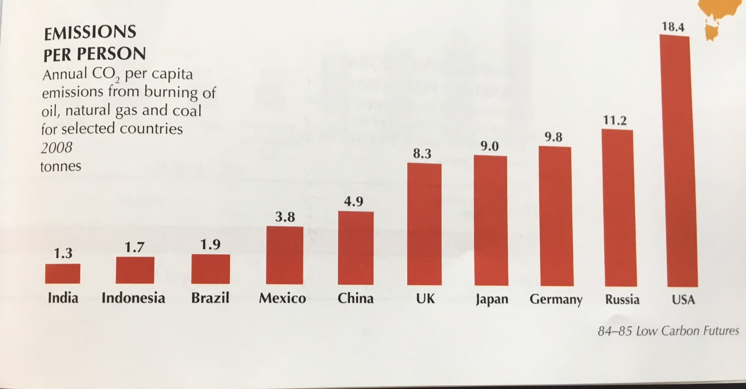
Source: Dow Kristin and Thomas E. Downing, The Atlas of Climate Change: Mapping the World’s Greatest Challenge (Berkeley: University of California Press, 2011) p.49

Graph 2
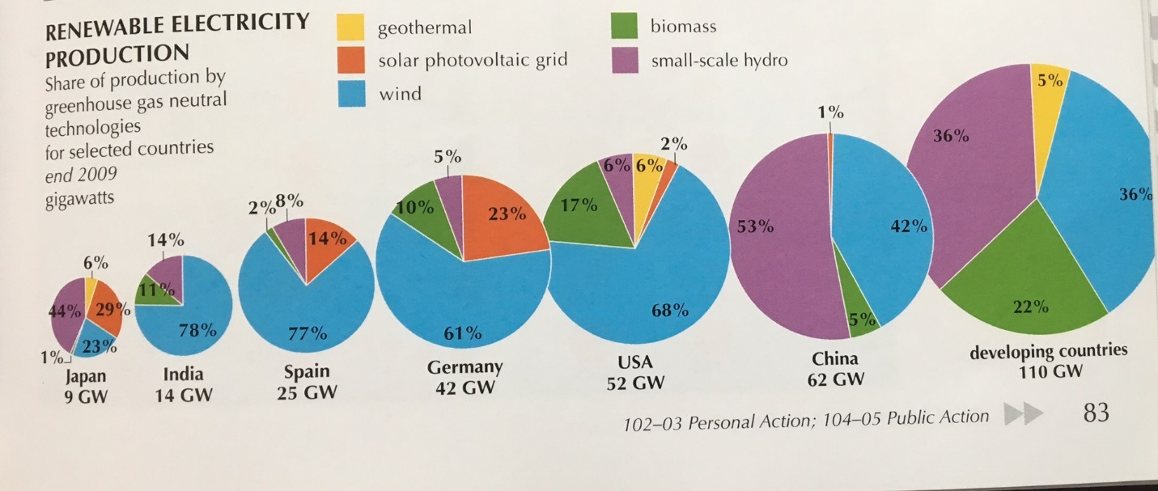
Source: Dow Kristin and Thomas E. Downing, The Atlas of Climate Change: Mapping the World’s Greatest Challenge (Berkeley: University of California Press, 2011) p.83

Table 1: Total Population for Selected Countries, 2008
Country | Total Population
Brazil | 193 million
China | 1.3 billion
Germany | 82.1million
India | 1.1 billion
Indonesia | 236.2 million
Japan | 128.1 million
Mexico | 113.7 million
Russia | 142.7 million
United Kingdom | 61.8 million
USA | 304.1 million
Source: Web

