QR Goals:
1. Students will be able to identify all aspects of a chart or table and interpret information and statistics presented on charts and in tables with particular emphasis on time-series data (knowledge and conceptual understanding)
2. Students will be able to compare and connect data and information across graphs. Students will consider possible historical contexts for change over time. Students will then create a new chart using various data from other charts (thinking and other skills)
3. Students will develop and support an argument for recent change in the chart and in the data. Considering historical context, data about the changes, and possible causation, students will make a prediction about the future course of the time-series data. (attitudes, values, dispositions and habits of mind)

This lesson will actually come later in the course when we get to the 20th century. Prior to this students will have read and learned a great deal about crime in US History and engaged in some QR work, but the heavier part of this comes with the numbers that are availble for the 20th century. We will already have looked at some graphs and charts prior to this point, so they will have had some assistance in class with how to read these.
These lessons will be completed in small groups (3 to 4 students) and the first two lessons will be conducted in class over two weeks, so that I can assist and adjust instructions as needed for classes. The third lesson will be completed by the groups outside of class with at least two weeks of time after the previous lessons to allow for enough time for completion.
Lesson 1: Graph Interpretation
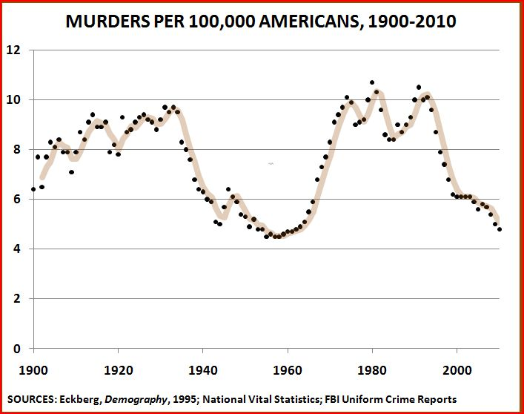
1. What does the X-axis show? The Y-axis?
2. Does this graph reflect actual numbers or a rate? What does that mean?
3. What do these numbers mean? What do they tell the reader? Try to verbalize the data and its meaning.
4. What changes and differences can you see over time?
5. What is the source of this information? How reliable is it? Why?

Lesson 2: Connecting Information Across Graphs
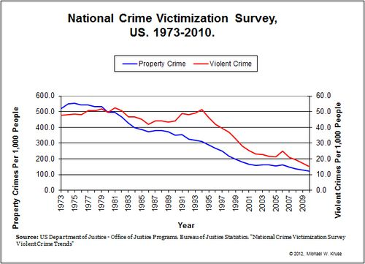
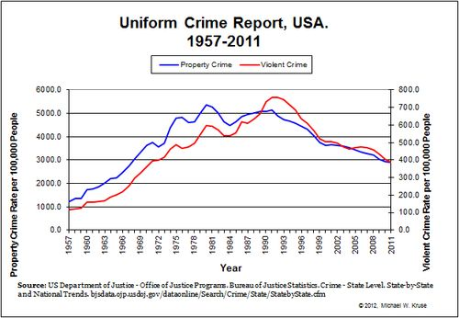
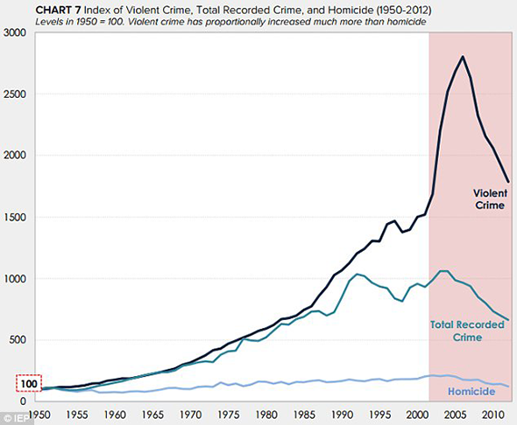
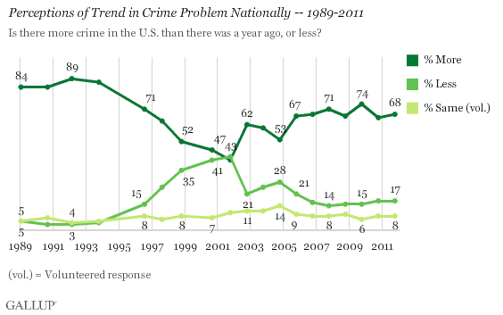
1. Review at least two of these graphs of information and use the questions from Lesson 1 to understand what information these graphs contain.
2. How do the graphs that you have chosen connect? Continue? Overlap? Conflict?
3. How would you explain the reason and/context for change that occurs within your graphs and also between them?
4. Create a new graph using data from at least two of these graphs that might support your thinking.

Lesson 3: Graphing the Future
1. Considering the work you completed in Lesson 2, what do you believe crime will look like in the next 3 decades?
2. Use recent crime data and trends from the FBI Uniform Crime report. If you want to draw data from another source, please check with me first.
3. Write a 200-word explanation/prediction of where you think the crime rate and trends will go over the next 30 years.
4. Create an additional chart that includes the work from Lesson 2 and adds in your predictions for the future.

