Overview of Assessment Plan
Joanne Miller
Students will have been introduced to types of measurement scales, normal and skewed distributions, and measures of central tendency and dispersion in readings and lecture followed by two computer lab sessions in which they learn to create frequency distributions, summary statistics, and graphs. The pretest follows this mode of traditional instruction. In addition, I will collect information during the first week of class on whether students have had classes in high school or college that introduced them to these concepts previously, whether they usually keep up with assignments each week, and their orientations toward numerical material.
The QR lesson plan is designed as a group exercise. It links the type of measurement scale to summary statistics and their interpretation in a comparative context. Students have the opportunity to learn from their peers (with instructor guidance), practice comparing summary statistics and graphs, and articulate what is learned and why this has substantive importance by investigating differences in attitudes and behavior in two countries. The post-test follows this experience.
Analysis
The questions asked in the pre and post-test overlap in the goals they assess.
- The knowledge goal is assessed in Questions #1 #2 and #3a.
- The thinking goal is assessed in Questions #3b #4 and #5 because they ask for a judgment based on data.
- The habit of the mind goal is assessed in Question #5c with asks students to apply knowledge about central tendency and dispersion to other issues or decisions.
Data on individual performance will be recorded for each part of each question so that areas of knowledge, thinking, and habit of the mind can be assessed more specifically. In addition, the data file will contain individual information collected during the first week of class on previous coursework, study habits, and fear of math
I am expecting that students who do well on the pretest will also do well on the post-test. I am most concerned if the opportunity to practice and to discuss concepts with data is effective for students who have difficulty with the pretest. The reason why they have difficulty on the pretest may be involve lack of previous coursework involving statistics, study habits, and/or fear of math.

Joanne Miller
Assessment Instruments for Introductory Statistics Course in Sociology

Background Information (1st week of class):
1. Have you previously had a statistics course in high school or college?
□ Yes
□ No

2. In the last semester you attended school, how often were you usually able to complete these types of assignments on time.
 | Never | Rarely | Sometimes | Usually | Always
Weekly readings | □ | □ | □ | □ | □
Weekly homework that is not graded | □ | □ | □ | □ | □
Review readings before lecture | □ | □ | □ | □ | □

3. How many hours per week do you usually study for a typical class, if there are no exams scheduled? _____
4. How many credits are you taking this semester? _____
5. Do you agree or disagree with the following statements.
 | Strongly  Agree | Agree | Disagree | Strongly Disagree
I find it hard to follow numerical evidence. | □ | □ | □ | □
I lose concentration when doing math problems | □ | □ | □ | □
I am good at math | □ | □ | □ | □

5. How many hours of week do you work for pay? _______

Pretest:
The following questions ask you about specific variables on which data were collected in a survey or reported to the federal government by states.
1. What specific type of measurement is each of the following variables and what is usually the best measure of central tendency:
Type of Best Measure of
Measurement Scale Central Tendency

Region of the U.S. _________________ ______________
Milligrams of salt in prepared foods _________________ ______________
Military rank ________________ _ ______________

2 What summary measure(s) of dispersion is/are possible to calculate for the number of days exercised in the past month among gym members. List any or all that are possible.

3. The following graph shows the number of physicians per 100,000 population in each state and Washington DC.

- How would you describe this distribution in terms of its overall shape? _________________________

- Do you expect the mean rate per 100,000 population to be higher, lower, or about the same as the median and why?

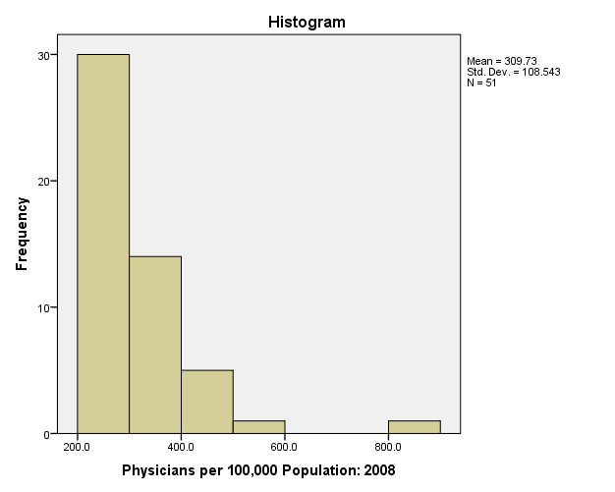

4. Describe how much dispersion is shown in people’s employment status in the graph following graph and why.
How much (low, moderate, or high) dispersion? __________________________
Why? ___________________________________________________________
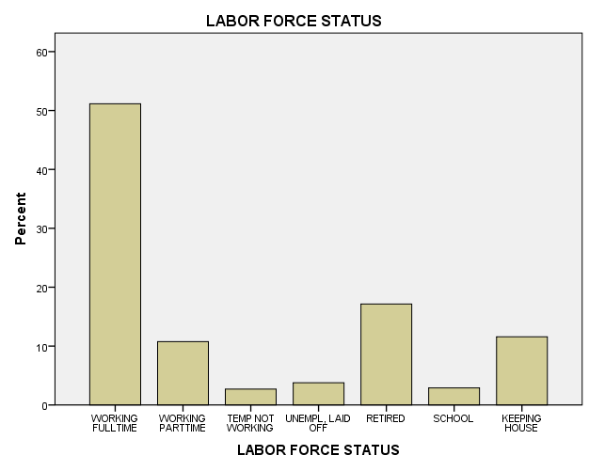

5. You are told that the mean poverty rate (percent of people in poverty) for states in the Midwest is 12.05 and the standard deviation is 1.27. The mean poverty rate for states in the West is 12.04 and the standard deviation is 2.56. These are actual data for states in 2008.

- In terms of the percent of people in poverty, what does the mean tell you about states in the two regions?

- In terms of the percent of people in poverty, what does the standard deviation tell you about states in the two regions?

- You are put in charge of federal anti-poverty programs for states in the Midwest and West. Based on this information, which region should you visit first to talk to state officials that may have experienced different levels of poverty. Why do you say this?

Post Test:
The following questions ask you about specific variables on which data were collected in a survey or reported to the federal government by states.
1. What specific type of measurement is each of the following variables and what is usually the best measure of central tendency:
Type of Measurement Scale Central Tendency
Divorce rate _________________ ______________
Dress size _________________ ______________
Brand of cell phone _________________ ______________

2. What summary measure(s) of dispersion is/are possible to calculate for the weight of adult men measured in pounds. List any or all that are possible.

3. The following graph shows the percent of households headed by married couples in each state and Washington DC.

- How would you describe this distribution in terms of its overall shape? _______________________________

- Do you expect the mean percent of households headed by married couples to be higher, lower, or about the same as the median and why?

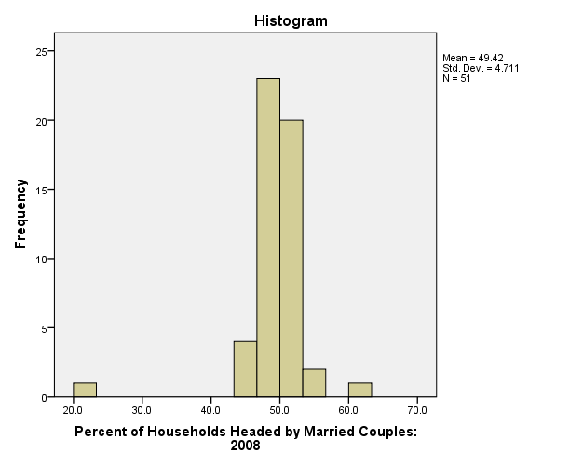

4. Describe how much dispersion is shown in people’s party affiliation in the following graph and why.
How much (low, moderate, or high) dispersion? __________________________
Why? ___________________________________________________________

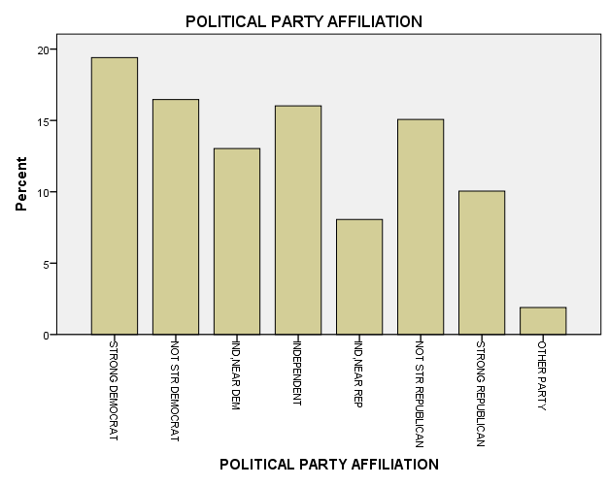

5. You are told that the mean imprisonment rate (people in prison per 100,000 population) for states in the South is 539 and the standard deviation is 137. The mean imprisonment rate for states in the rest of the United States is 351 and the standard deviation is 106. These are actual data for states in 2008.

- What does this mean tell you about imprisonment rates in the South compared to the rest of the rest of the states in the country?

- What does this standard deviation tell you about imprisonment rates in the South compared to the rest of the states in the country?

- What else would you like to know about the South to better understand these statistics on imprisonment compared to the rest of the country? Site at least 2 factors and explain their relevance.
Rubric for Both Pre and Post Test Instruments
Joanne Miller

1. What specific type of measurement is each of the following variables and what is usually the best measure of central tendency:
Type of Best Measure of
Measurement Scale Central Tendency

1st Variable _________________ ______________
2nd Variable _________________ ______________
3rd Varoab;e ________________ _ ______________

Correctly identifies each type of measurement scale (0-3 points) _____
Correctly identifies best measure of central tendency (0-3 points) _____
2 What summary measure(s) of dispersion is/are possible to calculate for (specific variable is interval or ratio scale). List all that are possible.
Does not answer (0 points)
Correctly identifies 1 dispersion measure when there are multiple (1 point)
Correctly identifies 2 dispersion measures when there are multiple (2 points)
Correctly identifies 3 dispersion measures when there are multiple
must include standard deviation among 3 measures (3 points) _____

3. The following graph shows (histogram for specific variable). How would you describe this distribution? Do you expect the mean to be higher, lower, or about the same as the median?

Does not answer (0 points)
Correctly identifies distribution as skewed (1 point) _____

Correctly identifies direction of skew: pretest is positive;
post-test is negative (1 point) _____

Correctly identifies effect of skew on mean and median:
pretest mean is higher; post-test mean lower than median (1 point) _____

4. Describe how much dispersion is shown in (specific variable) in the following graph and why.
Does not answer (0 points)
Correctly answers low in pretest, high in post-test (1 point) _____

Why?
In pretest, low spread of scores or majority in one category;
In post-test, scores spread out across categories (2 points) _____

5. You are told the means and standard deviations for two groups.
- In terms of (specific variable) what does the mean tell you about states in the two groups?

Does not answer (0 points)
Recognizes means as: pretest same; post-different different (1 point) _____

Clearly communicates meaning, not just numbers (1 point) _____

- In terms of (specific variable) what does the standard deviation tell you about states in the two regions?

Does not answer (0 points)
Recognizes standard deviation as: pretest different;
post-test different but not grossly different in terms scale values (1 point) _____

Clearly communicates meaning in terms of variation in variable,
not just numbers (1 point) _____

- Applied question

Pretest:

You are put in charge of federal anti-poverty programs for states in the Midwest and West. Based on this information, which region should you visit first to talk to state officials that may have experienced different levels of poverty. Why do you say this?

Does not answer (0 points)
Visit West first (1 point) _____
Officials in the West would differ more in the extent of poverty
experienced in their states (1 point) _____

Post-test

What else would you like to know about the South to better understand these statistics on imprisonment compared to the rest of the country? Site two factors and explain their relevance.

Does not answer (0 points)
Number of factor (1 point each up to 2) _____

Possible factors and explanation should be focused on large difference in means.
For example:
Is there more crime in the South than elsewhere in the country
Is there more poverty in the South than elsewhere in the country
Does the South follow different sentencing policies than the rest of the country.
Does the South follow different policing policies than the rest of the country.

