Nur 228 Revised QR Lesson/Assignment
Understanding Urinary Tract Infections and Antimicrobial Resistance
Fall 2017

Nur 228 is for second semester nursing students.

Learning Goals:

- Knowledge and Conceptual Understanding Learning Goal - Students will be able to identify appropriate analytical methods for assessing data from urine culture and sensitivity reports, and demonstrate the ability to interpret a bar chart.

- Thinking and Other Skills Learning Goal- Students will make appropriate quantitative calculations before they interpret and administer antibiotics for urinary tract infections based on the summary of the data in a bar chart.

- Attitudes, Values, Dispositions and Habits of Mind Learning Goal-Students will document communicating QR information with the goal of describing why they think a particular treatment is best in a discussion forum on blackboard.

Pre-Assessment:
To follow at a later date.

Part 2
Lecture:
We will cover urinary tract infection – an infection in any part of the urinary system, the kidneys, bladder or urethra. There are more than three million cases in the US per year. In this lesson we will explore the symptoms of urinary tract infections such as dysuria, urinary frequency, suprapubic pain, flank pain, and fever. The treatment consists of antibiotics. The type of medication and length of treatment will depend on the patient’s culture and sensitivity report.

Urinary Tract Infection Measurable Learning Objectives:
• identify what a urinary tract infection is
• list the symptoms of a urinary tract infection
• explain how the culture and sensitivity report works
Assessment: formative assessment as participation components of this unit and summative in the form of the final project for this unit in addition to final exam questions covering this key material.

In addition, you will develop skills to be able to:
Urinary Tract Infection Learning Goals:
• evaluate scientific resources for data acquisition
• demonstrate effective visual communication skills
• identify relevant numerical data sources and extract numerical data from data tables
• utilize these data to generate graphs that effectively visually represent the data (bar chart)
• gain comfort and confidence in mathematical skills utilizing quantitative data and QR to make informed decisions based on mindful risk/benefit assessments

Pre-class preparation (warm up): Due 2 hours prior to class on BB. Bring a copy to class.
Grading: Formative assessment. Graded on a scale of 0-3. (This grading system is used for each pre-class assignment and it primarily given for participation. A grade of 0 is given if nothing is submitted. A grade of 1 is given if students provide partial answers (either answering only some of the questions or part of each question). A grade of 2 is given if students provide complete but minimal answers for most of the questions while a grade of 3 is provided to students who present clear and well thought out answers.)

The bar chart can be created using Google docs. Information on how to do this can be found here.
Add a chart or graph
- On your computer, open a spreadsheet at sheets.google.com.
- Select the cells you want to include in your chart. To label your chart, add a header row or column.
- Click Insert Chart.

How to Create a Bar Graph in Google Docs - YouTube

Below is a Urine Culture and Sensitivity Report. Take this data and convert it into a bar chart including Interpretation of the data. A positive urine culture is based on the growth of bacteria at a high number of colony forming units (CFUs). Urine culture results should be interpreted in conjunction with clinical symptoms of urinary tract infection (UTI), such as dysuria, urinary frequency, suprapubic pain, flank pain, and fever. Please report your findings on our Blackboard discussion forum and respond to two classmates. Each group of four (4) students will be assigned a case scenario with a specific patient, symptoms and culture and sensitivity report.

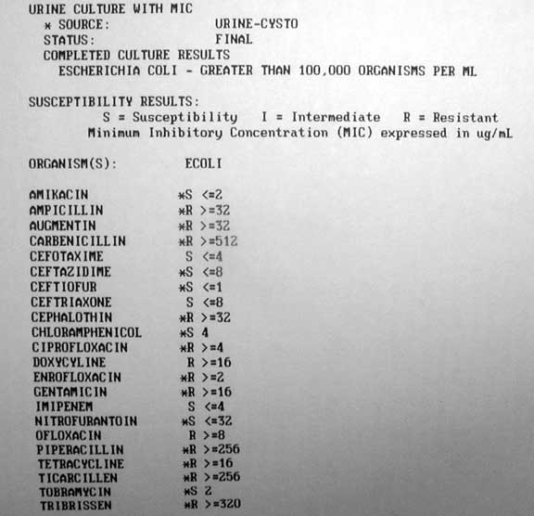

Group member assignments: identify a discussion facilitator to moderate the discussion, identify a secretary to take notes on the basic discussion and fill out the participation chart in the portfolio. In addition, please identify a presenter who will speak on behalf of the team to the class later during this project.
Within your group:
1. One student will share their thoughts from the pre-class work with the group.
2. If you (any other member of the group) has identified a similar issue and would like to extend on this idea/or topic, please contribute to the discussion before allowing the group to move on to the next students thoughts/ ideas.
3. The next student will share their thoughts until each student has presented.

Post-Assessment:
To follow at a later date.

Final project for this lesson:
Groups will document communicating QR information with the goal of describing why they think a particular treatment is best in a discussion forum on Blackboard.

