QR-Learning Goals
- Knowledge and understanding of tables & graphs: Students will be able to distinguish tables and graphs and will be able to interpret and summarize data presented in both formats. Two assignments have been completed during the semesters and were graded using rubrics.
- Thinking, analytical & writing skills: Students will be able to explain in writing descriptive statistical data (percentages & frequencies) presented in tables and basic graphs.
- Attitudes, values, dispositions and habits of mind: Students will learn basic analytical and quantitative skills and will be able to communicate in writing how percentages and frequencies are used in academic works. In addition, they will develop essential quantitative skills to understand what proportions are and what is percent analysis. Students will assess the importance of quantitative skills for sociological interpretations and explanation of social phenomena.
This is our final assessment regarding the NICE-project. During the semester, we focused on how to read statistical tables and how to read (and make sense) of simple graphs (pie, line & bar-graphs). In this final assessment, we will focus on data about labor unions and social and political issues related to unionization like the situation of unionized employees versus non-unionized employees in the economy.

You will have to interpret several graphs and some tables and answer the questions asked.

Figure 1: Union Density (% of union membership among wage earners in the United States, 1930-2014)

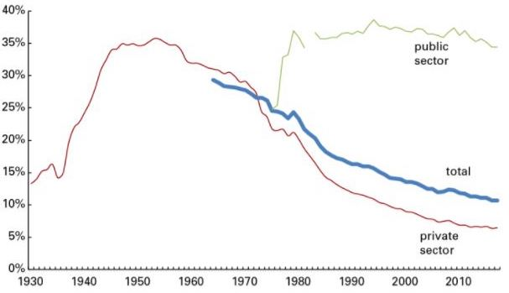

- Based on your reading of figure 1, which of the following statements is the most accurate summary and correct interpretation of the information presented on the above figure?

- Union density decreased during the 1930s but remained relatively low during the period 1940 to 1970.
- Union density in the public sector has fluctuated (up and down) during the period 1930 to 2014 while it has been always low in the private sector.
- Union density increased between 1930 and 1960, then it declined since the 1970s but remained relatively high in the public sector but very low in the private sector
- Union density has been historically very low in both the public and the private sectors of the US economy.
- All of the about statements are accurate.

Figure 2. Dental and Pension Benefits (Plans) for Unionized and Non-unionized Workers Employed in the Private Sector in the United States (US) and Canada.

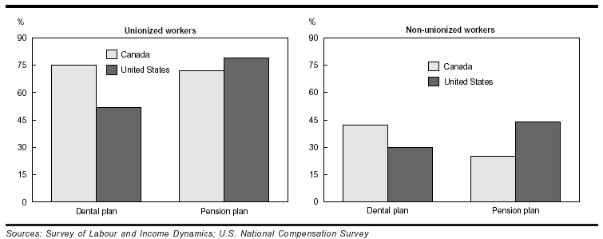

- Based on your interpretation of figure 2, which is the main difference regarding pension and dental benefits (plans) for unionized workers in the US and Canada?

- Pension plans are more important for non-unionized workers in Canada than for unionized employees in the US.
- Coverage in dental plans for unionized workers is higher in Canada than in the United States.
- Coverage in pensions plans for unionized workers is higher in Canada than in the United States
- Pension plans for both, unionized and non-unionized workers are higher in Canada than in the US.
- Both pension and dental plans have a higher coverage in the United States for non-unionized workers than for unionized workers in Canada.
- Based on your reading of figure 2, which of the following statements represents the most accurate summary and interpretation of the information presented on the above figure?
- The economic benefits provided by dental and pension plans in Canada for non-unionized workers are significantly better in comparison to the same group of workers in the United States.
- Overall, the coverage provided by pension and dental plans for unionized workers in Canada and the US is higher than for non-unionized workers in both countries.
- Pension plans have a better coverage for both type of workers (unionized and non-unionized) in Canada and in the United States.
- About 50% of unionized and non-unionized workers have pension and dental plans in both countries, Canada and the United States
- None of the above, all the previous statements are incorrect.

Table 1: Union Density 2000-2012: Selected States (US)
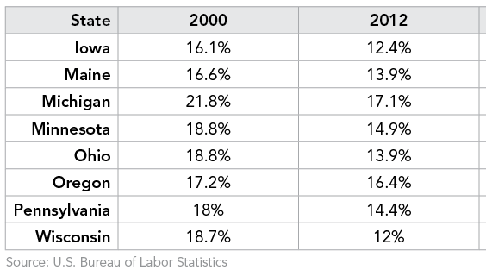

- Table 1, shows data about union density in several states in 2000 and in 2012. Based on your reading of this table, which state experienced the lower decline in union density between 2000 and 2012?

- Ohio
- Michigan
- Oregon
- Minnesota
- Wisconsin

- Table 1, shows data about union density in several states in 2000 and in 2012. Based on your reading of this table, which state experienced the higher decline in union density between 2000 and 2012?

- Ohio
- Michigan
- Oregon
- Minnesota
- Wisconsin

Figure 3. Median weekly earnings in 2014 of full-time salary employees by union, racial, gender and other characteristics.
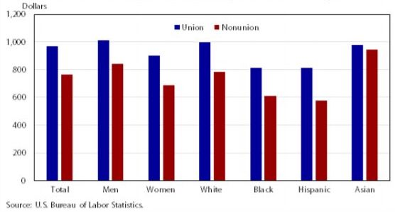

- Based on your reading of figure 3, which of the following statements is correct?

- In general, union members earn relatively higher salaries than non-union workers.
- Black and Hispanic unionized workers earn relatively lower salaries in comparison to white unionized workers.
- Salary differences in weekly earnings for unionized and non-unionized Asian workers are slightly lower for non-union workers.
- Unionized male workers have similar weakly salary earnings in comparison to white unionized workers.
- All the statements are correct

The only revision that I did to the original questions (other than editing and some grammatical corrections) was to add two questions.

1. Can you read and interpret statistical data presented in a table or in a simple graph better than before taking this class?

2. Are quantitative data and statistical information necessary for the sound analysis of sociological questions like socio-economic inequalities and the interpretation/understanding of social issues and social problems in modern society?

