DEN 120 Analyzing Oral Health Data

Lesson summary: Utilizing numerical data, you will be working in groups to analyze some of the factors which account for the caries and periodontal disease rates in the United States.

Student learning objectives:

- Student will be able to identify the factors that affect the prevalence and trends of dental caries and periodontal disease in the United States.
- Student will be able to select appropriate data sets and extract relevant information from selection provided in order to understand disease prevalence in a selected population.
- Utilizing guiding questions provided, student will work within a group to create a written summary of their findings including the significance of the data to oral health.
- Student's confidence in his/her ability to analyze numerical data sets will increase.
Preparation:
- Caries Management by Risk Assessment (Week 7)
- Caries Disease Process (Week 8)
- Evidence-Based Decision Making (DEN 112)
- Review: interpreting graphs. Please re-visit the following website for a refresher on Reading Charts and Graphs
- Please read the following sections of “Statistics every writer should know” prior to class:
Mean Per capita and rates Data Analysis Percent
Median Standard deviation and normal distribution Mode

Action!:
You will separate into pre-selected groups (3 or 4 in each group). Each group will receive a packet with a set of questions and several graphs and charts. As a group, you will decide which graphs/charts are necessary in order to answer the questions in your packet. You will answer the questions posed and write a one paragraph (approx. 15 sentences) summary of the data you’ve analyzed. You will then select a group leader to read the paragraph aloud to the class so that we may discuss your findings. We will then spend a few minutes discussing the ways in which you can create your own graphs/charts for your research project. Once all groups have presented their findings you will receive a handout in which you will write an honest reflection discussing this activity. The handout will have some questions which you can use as guide in drafting your reflection.

Dental caries group:

- What percentage of the US population has diabetes?
- What percentage of the US population has untreated dental caries?
- Has the prevalence of dental fluorosis in children aged 12-15 increased or decreased since 1989?
- What percentage of the population benefits from community water fluoridation systems?
- What percentage of the US adult population consumes two or more SSBs per day?
- Why do you think dental caries are still so prevalent in spite of community water fluoridation? Which charts/graphs provide information which helps you create a hypothesis?
- If you were creating a program to limit caries, which factor would you focus on? Why?
- Which population groups experiences higher levels of dental decay?

Periodontal disease group:

- What percentage of the US population has periodontal disease?
- During 2009-2010 what percentage of adults aged 45-74 had moderate to severe periodontitis?
- Which states have the highest prevalence of periodontal disease? What do you notice about the geographical location of these states?
- What is the difference in percentage of Hispanics aged 45-74 who suffer from periodontal disease and whites aged 45-74 who suffer from periodontal disease?
- Which charts provide information regarding health behaviors which contribute to periodontal disease?

Periodontal and dental caries group:

- What percentage of the US population has periodontal disease?
- What can be said about the caries prevalence in patients who have less than a high school education and those who have a college education?
- What percentage of the US population has untreated dental caries?
- Why do you think dental caries are still so prevalent in spite of community water fluoridation? Which charts/graphs provide information which helps you create a hypothesis?
- If you were creating a program to reduce the incidence of periodontal disease which population group would you target? Why?
- Which population groups experiences higher levels of dental decay?

Exhibit 1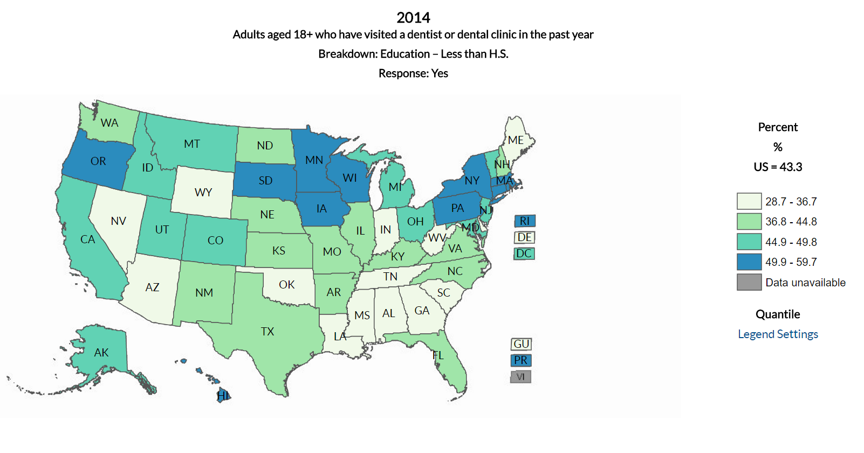Exhibit 2
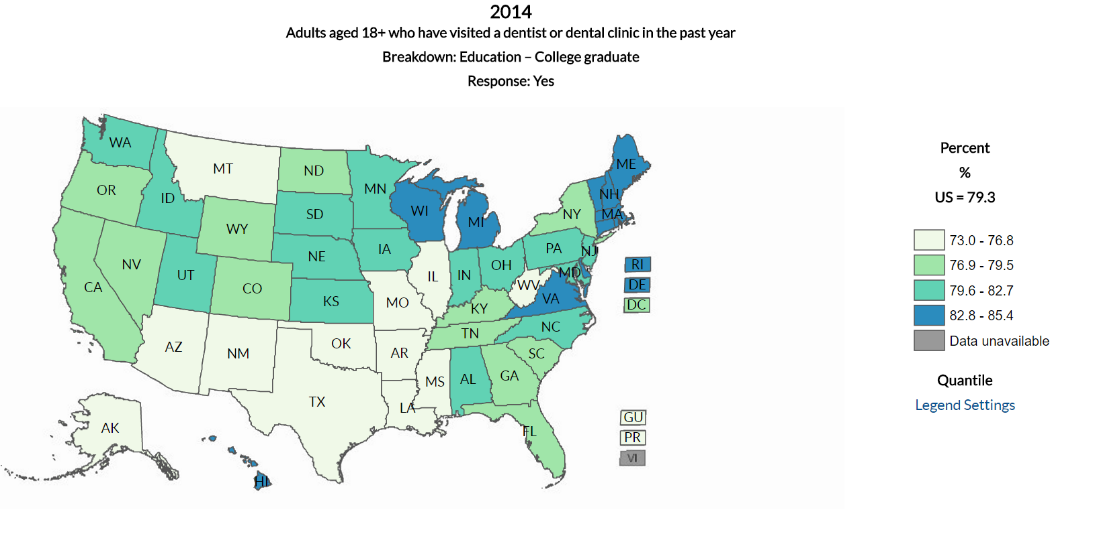
Exhibit 3
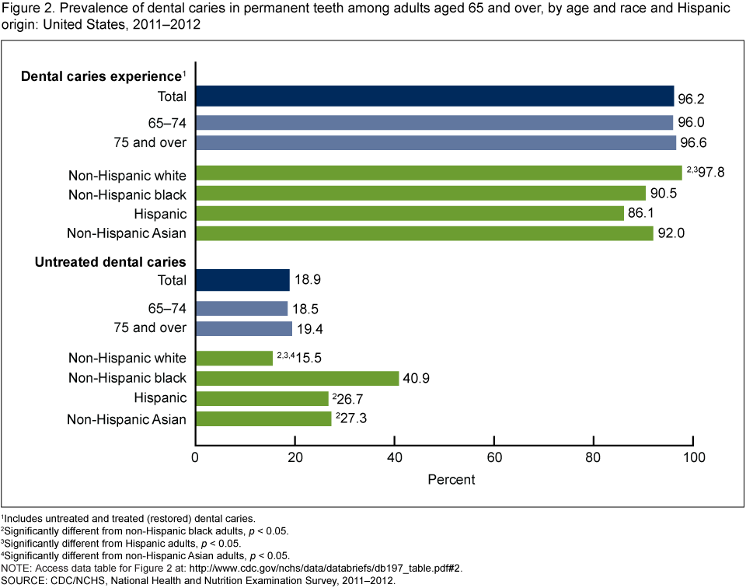

Exhibit 4
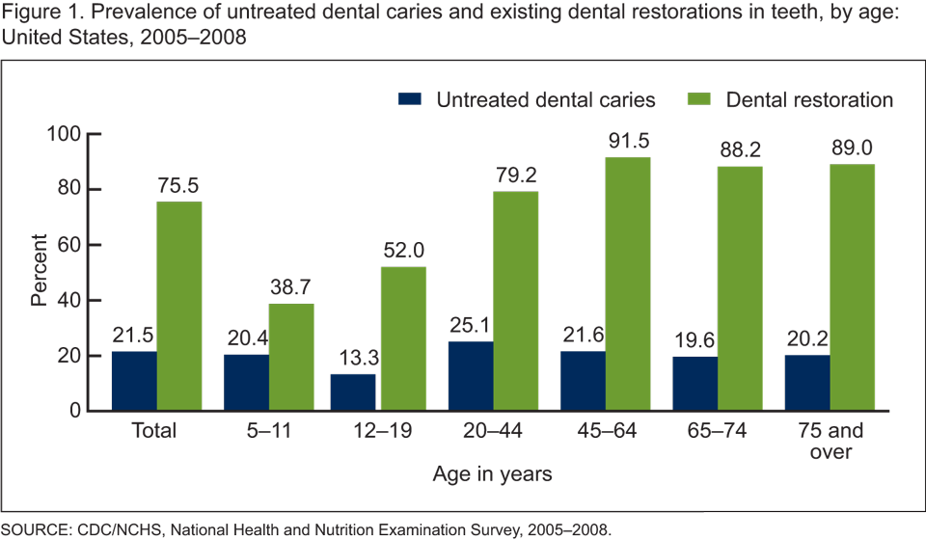
Exhibit 5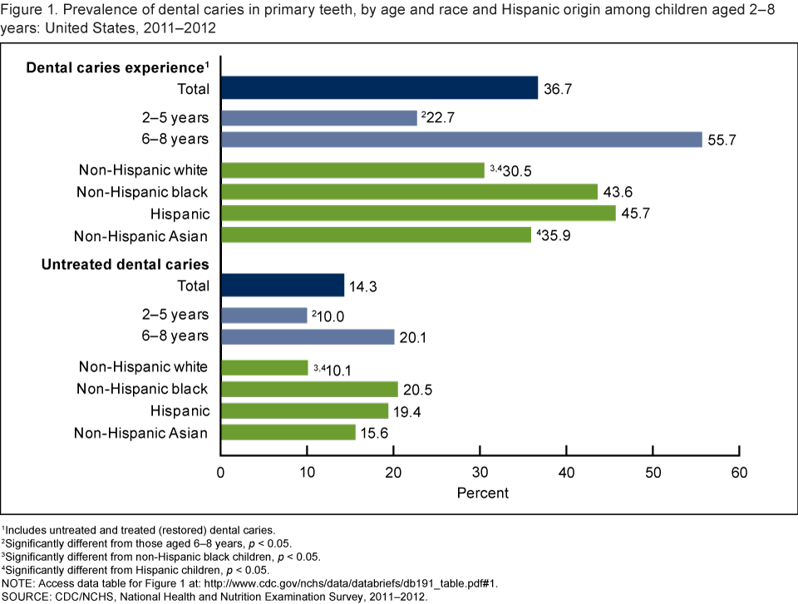

Exhibit 6
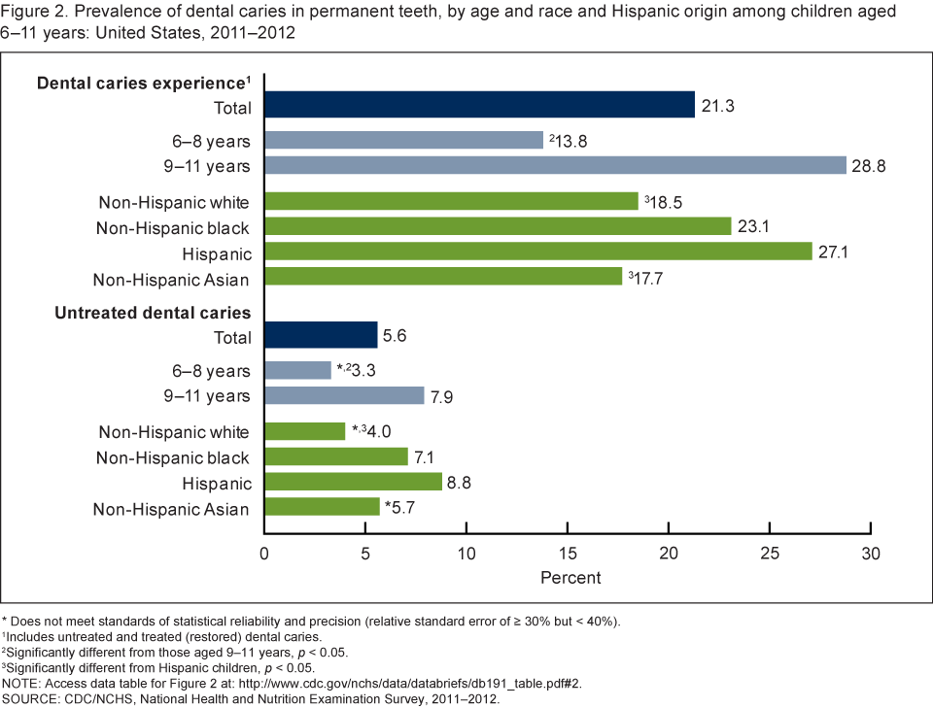
Exhibit 7
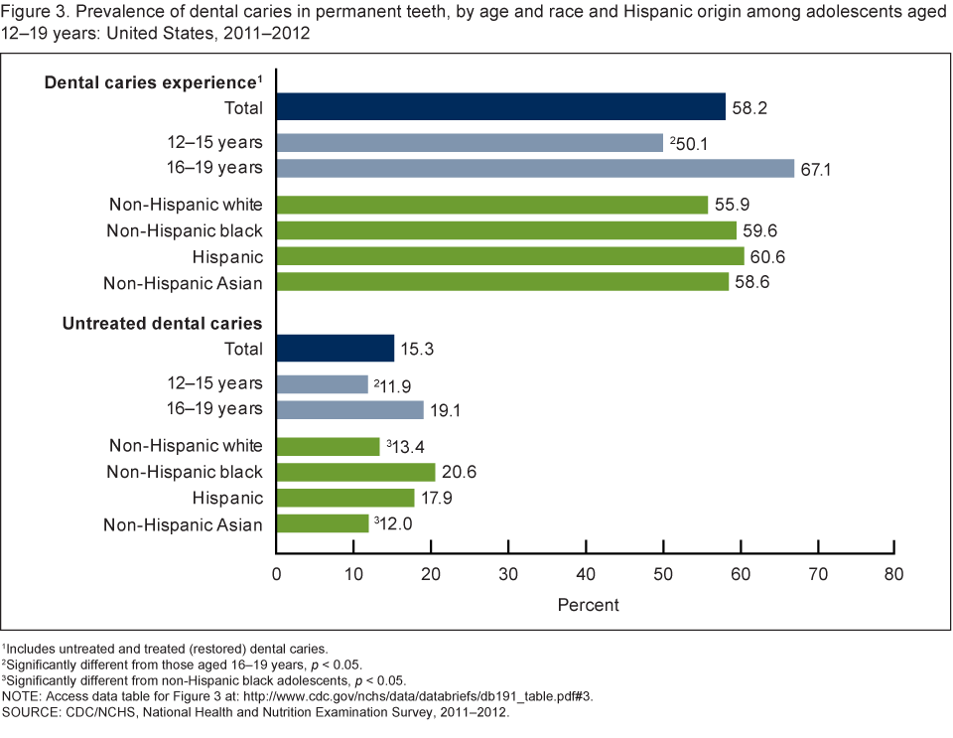

Exhibit 8
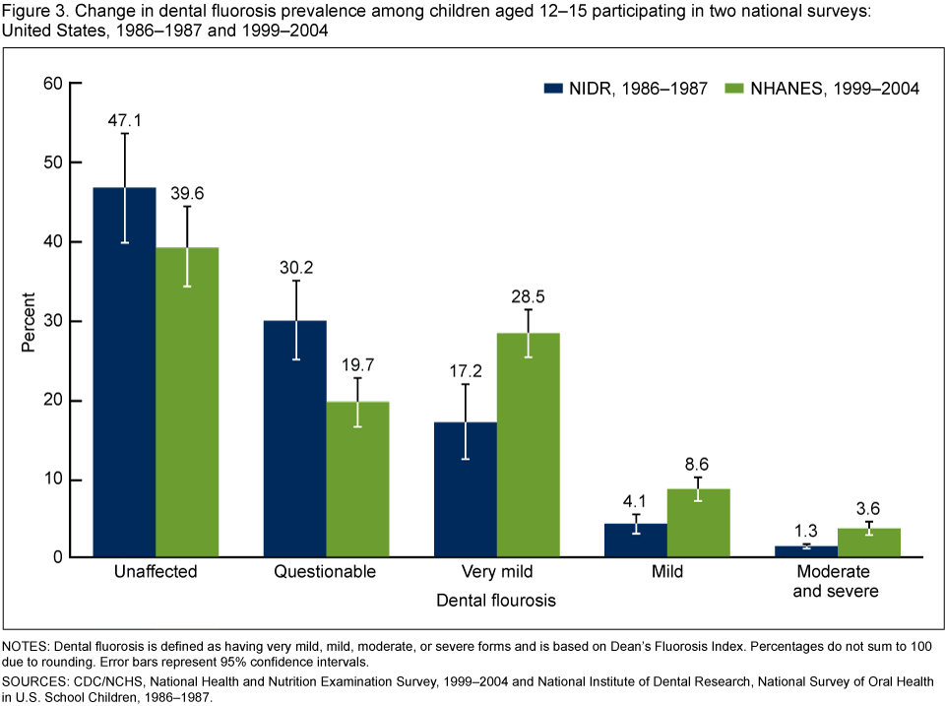

Exhibit 9
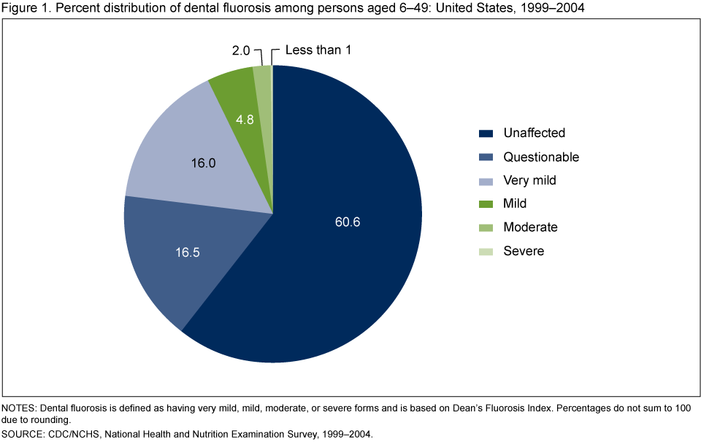
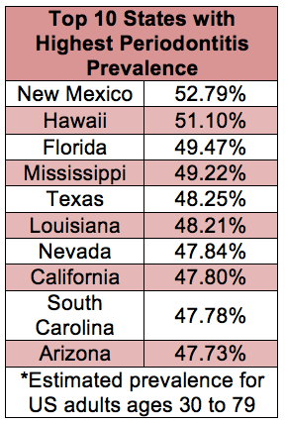

Exhibit 11
Prevalence of Moderate and Severe Periodontitis* Among Adults Aged 45–74 Years, by Race/Ethnicity and Age Group — National Health and Nutrition Examination Survey, United States, 2009–2010

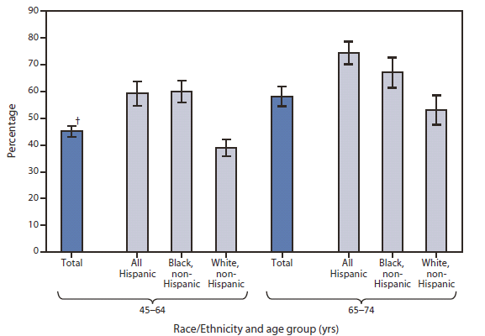

Exhibit 12

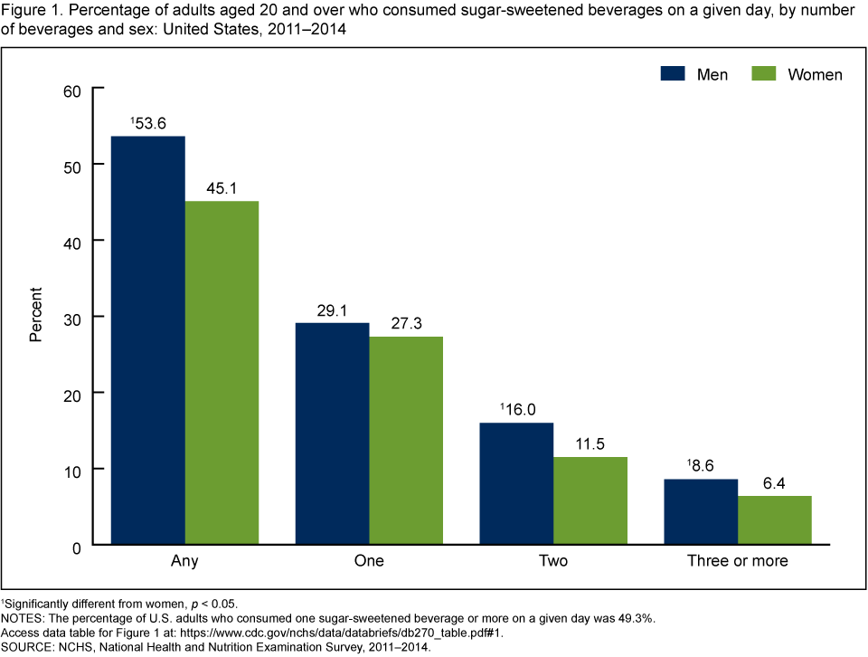

Exhibit 13
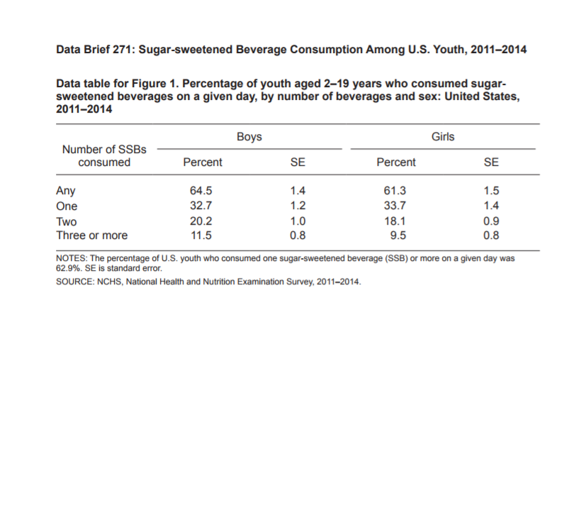
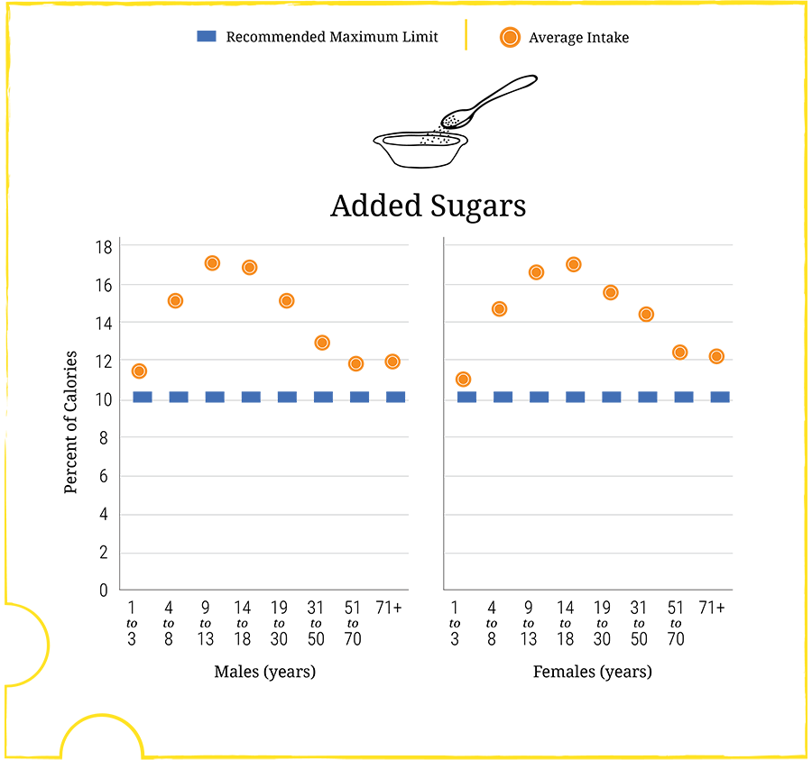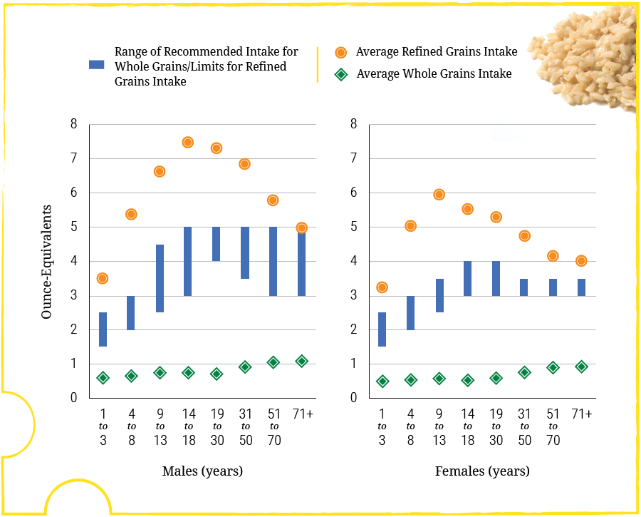
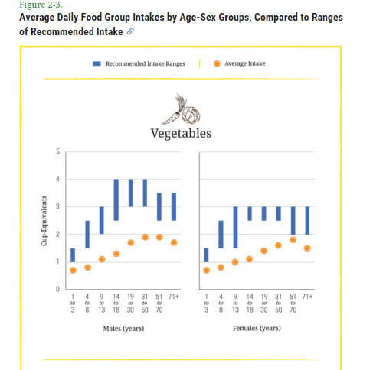Exhibit 14 a, b, c

Exhibit 15 a, b
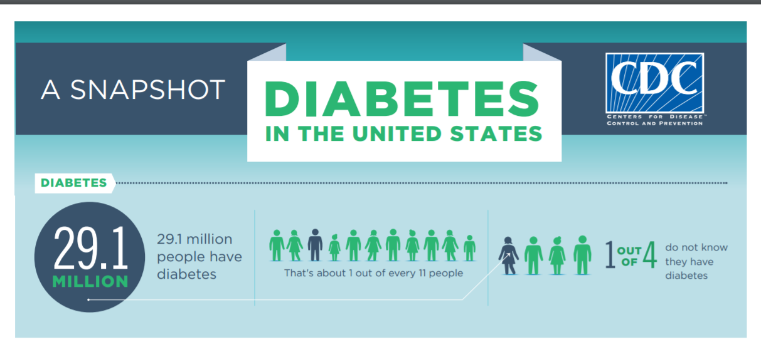
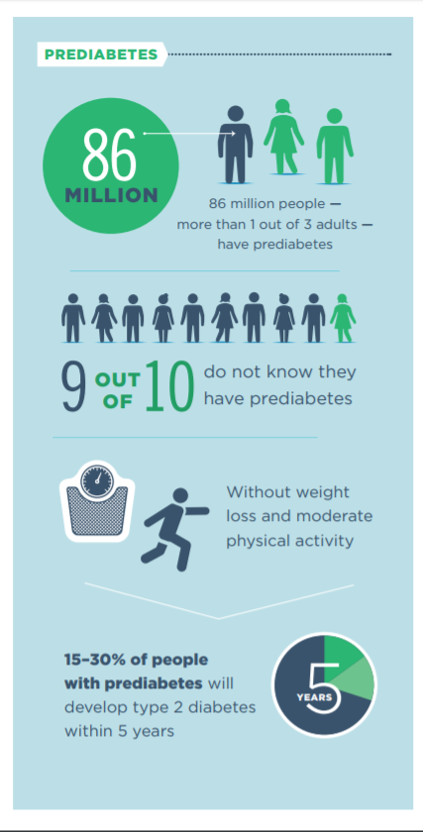

Exhibit 16
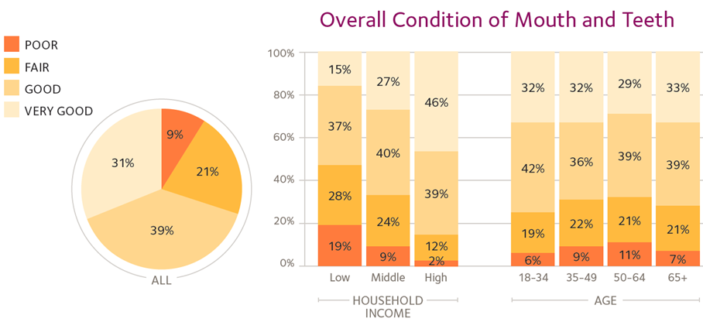Source: ADA Health Policy Institute “Oral Health and Well-Being in the US”
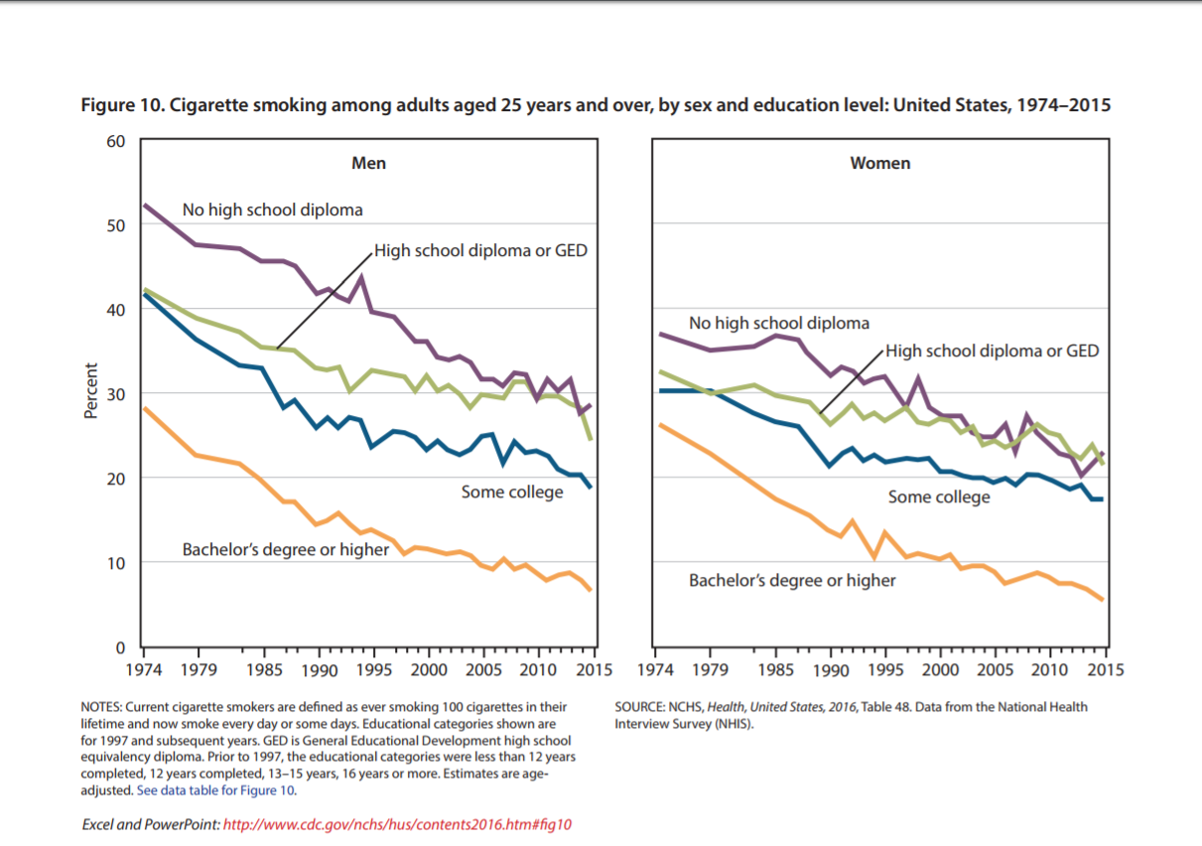

Exhibit 17

Exhibit 18
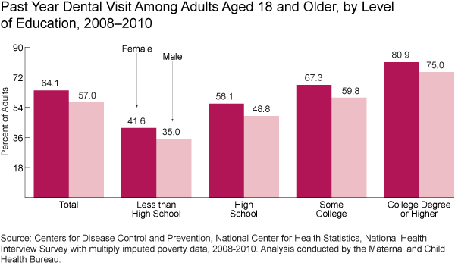

Exhibit 19
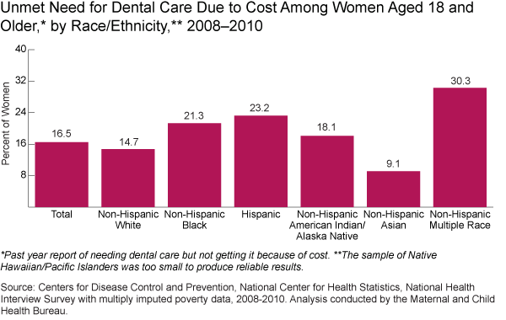

Exhibit 20

Exhibit 21
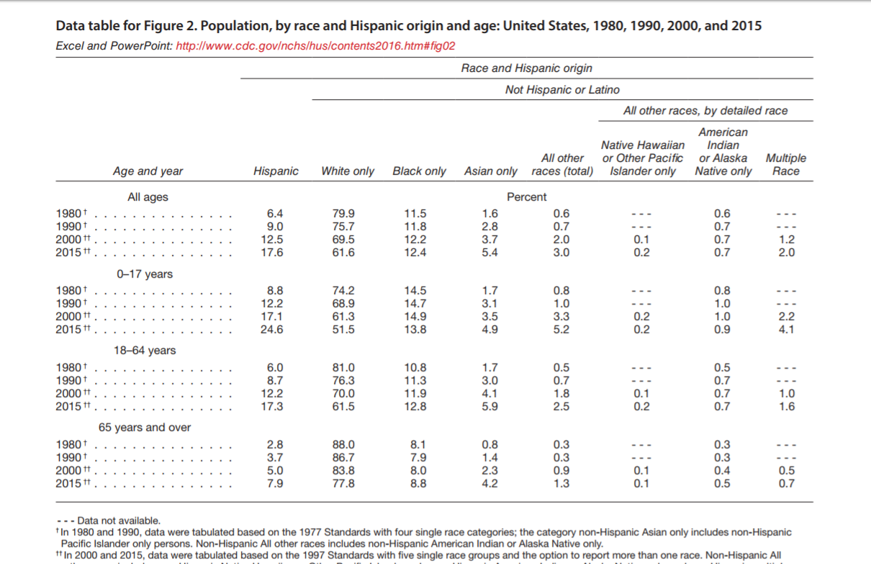

Exhibit 22
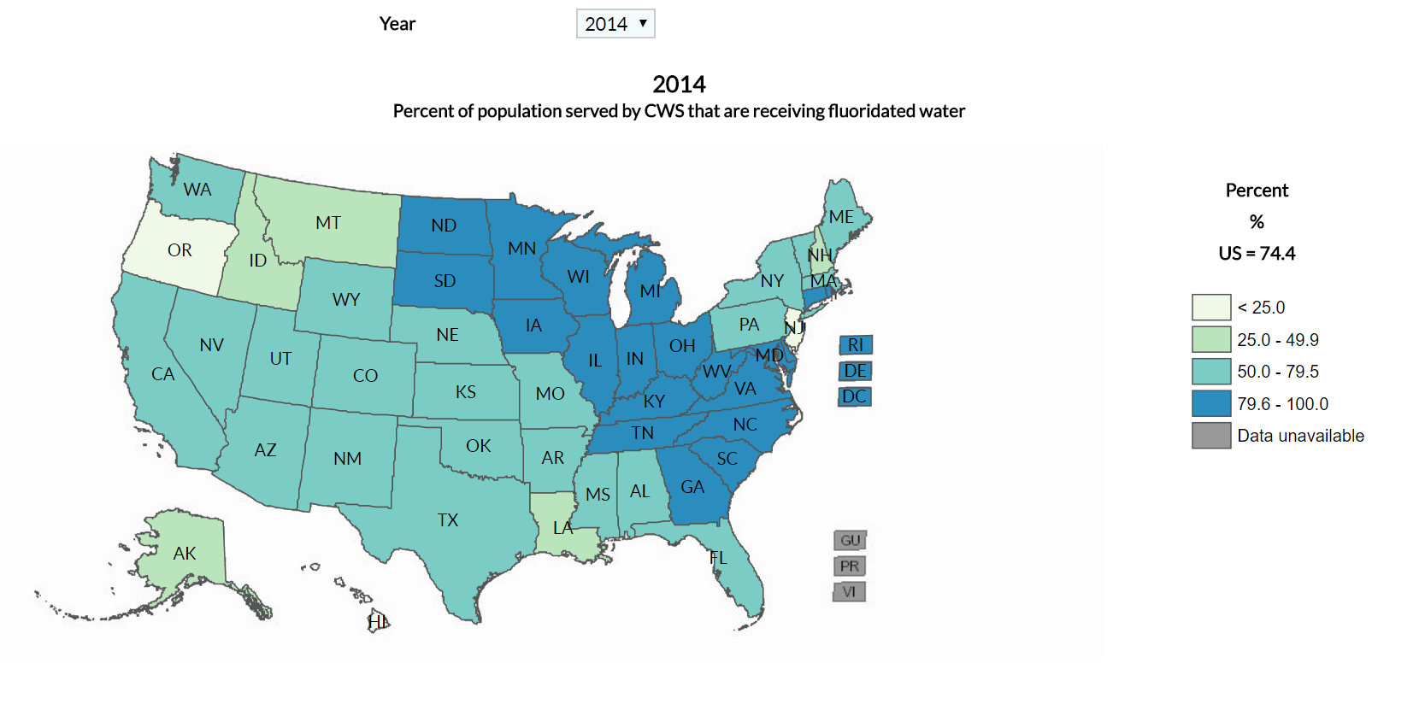

Exhibit 23
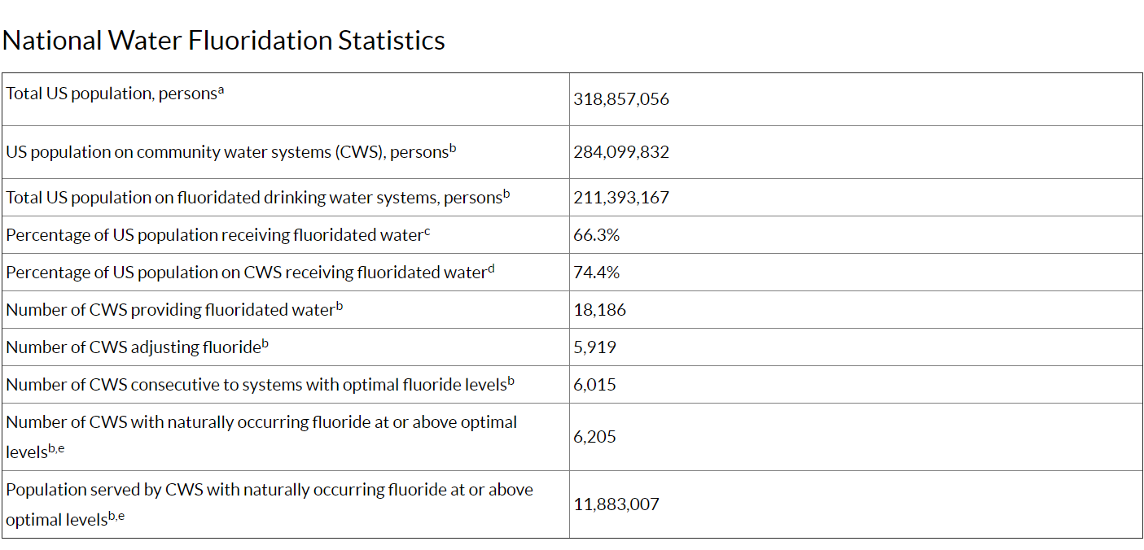

Exhibit 24

