CRJ 23 QR Goals

- Knowledge and conceptual understanding: Students will be able to define quantitative reasoning. Students will be able to correctly identify, interpret, and summarize data presented in selected charts/article(s)/videos.

- Thinking and other skills: Students will select and explain relevant data to support an argument/point from the article(s)/videos.

- Attitudes, values, dispositions and habits of mind: Students will be comfortable communicating (in writing or speaking) about numbers, percentages, and/or rates from the data in the article(s)/videos. Students will be able to appreciate and appropriately use evidence (numbers/percentages/rates) to support a point. Students will value the importance of QR skills in criminal justice.

CRJ 23 QR Assessment
This assessment is administered on www.surveymonkey.com

Select the response you think best describes the term and/or your perceptions of quantitative reasoning.

- True/False______ Quantitative reasoning is the application of basic mathematics skills to analyze and interpret real-world qualitative information in the context of a discipline or an interdisciplinary problem to draw conclusions that are relevant to students in their daily lives.

- True/False______ Quantitative reasoning is the application of basic mathematics skills to analyze and interpret real-world quantitative information in the context of a discipline or an interdisciplinary problem to draw conclusions that are relevant to students in their daily lives.

- How important do you think quantitative reasoning is in the field of criminal justice?
- very important
- somewhat important
- indecisive
- somewhat not important
- not important

This section measures your quantitative reasoning skills, please read the charts and select a response.
Prison Policy Initiative (Pie Chart)
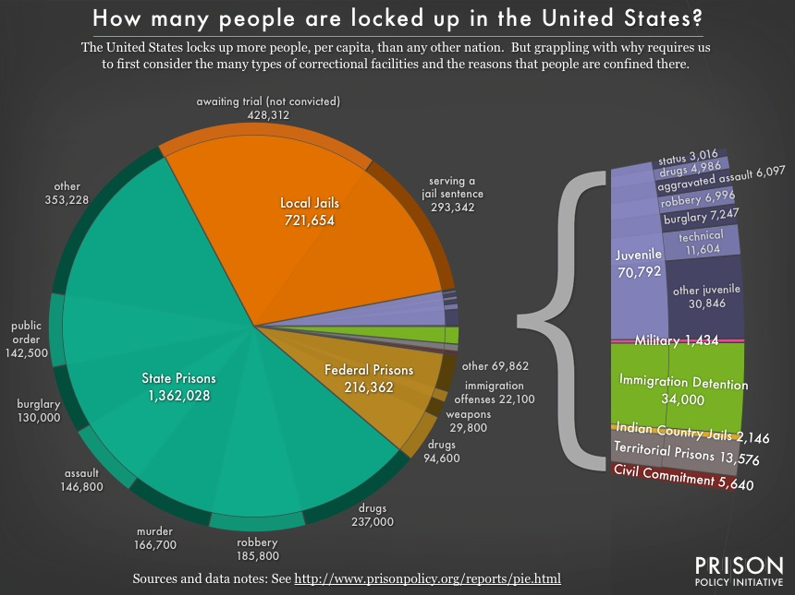
- According to the pie chart above (Prison Policy Initiative), what percentage of the state prison population is comprised of drug convictions? Include your calculation.
- 12%
- 10%
- 20%
- 16%

- According to the pie chart above (Prison Policy Initiative), what percentage of the federal population is comprised of drug convictions? Include your calculation.
- 44%
- 22%
- 33%
- 11%
- 2.3 million incarcerated adults in the U.S. is compared to (select your response):
-All military personnel
-Yankee Stadium old out 56 games
- Boston, Baltimore, and San Francisco combined
-All of the above
-None of the above

- How comfortable have you felt communicating with numbers prior to completing this Introduction to Corrections (CRJ 23) class, please select a response:
-Extremely Uncomfortable
-Somewhat Uncomfortable
-Comfortable
-Somewhat Comfortable
-Extremely Comfortable

- How comfortable do you feel communicating with numbers in criminal justice since completing this Introduction to Corrections (CRJ 23), please select a response:
-Extremely Uncomfortable
-Somewhat Uncomfortable
-Comfortable
-Somewhat Comfortable
-Extremely Comfortable

