Simonton Has A Problem!

William R. Dupre’
Department of Geosciences
University of Houston
Houston, Texas 77204-5007

email: wdupre@uh.edu

This assignment is based on a real situation faced by a small town west of Houston. Flooding and erosion along the Brazos River is forcing the town to consider de-annexing, as it doesn’t have the tax base to address this problem. Flood control measures proposed by the U.S. Corps of Engineers may not be feasible because of erosion issues. Students are asked to use real data to determine possible alternatives to deal with this problem.
Simonton Has a Problem

The City of Simonton is a small town located on the Brazos River floodplain, approximately 25 miles west of Houston, Texas. It was established in 1957 and incorporated in 1979. In 1997 it consisted of 195 homes with an assessed value of approximately $13.5 million dollars. Almost the entire city is located within the FEMA 100 year floodplain.

Floods along the Brazos River in October, 1991 and December, 1994 caused serious damage in the Simonton area (Houston Chronicle, March 23, 1977-attached). Approximately 100 homes were flooded in 1991; 125 homes flooded in the 1994 flood. The latter flood caused approximately $2.5 million dollars damage. Flood insurance claims for the subdivision since 1978 total approximately $4.5 million dollars. Clearly Simonton has a problem!

An interim report by the U.S. Corps of Engineers suggests that flood-control levees might be feasible for at least some of the houses (Figure 1). Levee system A would protect 156 houses in sections II and II; levee system B would protect the remaining 39 houses in section I. The town of Simonton is planning a meeting soon to discuss the frequency and magnitude of the flooding and erosion hazards posed to their community by the Brazos River, and to discuss the possibility of building levees. You have been requested to provide student input at that meeting.

Part A: Determining the Probability of Flooding in the Future?

Before any analysis can be done to evaluate alternative methods of flood control (e.g. levees, flood-proofing, buy-outs), we must determine how likely is it that floods, equal to or larger than those which occurred in 1991 and 1994, will occur in the future. Unfortunately, there is no gaging station at Simonton. For this reason, we must use the historical maximum annual daily discharge data (Table 1) obtained from the Richmond gaging station, where Highway 59 crosses the Brazos River, approximately 12 miles downstream from Simonton.

First rank the maximum annual daily discharge data provided in the table on the next page from largest (m=1) to smallest. (N.B. you only need to rank those floods with discharges equal to or greater than the 1991 and 1994 floods) Then use the equations provided below to determine the recurrence interval (RI) and annual exceedence probability (P) of each flood.

1) RI = (N+1) / m N = total number of years of record
m = rank (largest flood of record = 1)
2) P = 1/ RI
The recurrence interval (RI) of a flood of a particular magnitude is a measure of the average time between events of equal or greater than that discharge.
The annual exceedence probability (P) is the probability that a flood of that magnitude or greater will occur in any given year.
Extra credit option

Plot the recurrence interval and probability results on the logarithmic graph paper provided by your instructor, and include the plot in your report. How might such a plot be used to predict the probable magnitude of the 100 year flood-i.e. the flood with a recurrence interval of 100 years?

Table 1: Annual Maximum daily flood discharge

Water  Year | Max.  Discharge | Rank (m) | R.I. (yrs) | Annual Probability
1923 | 54900
1924 | 64800
1925 | 24200
1926 | 86900
1927 | 42500
1928 | 36800
1929 | 123000
1930 | 78800
1931 | 52100
1932 | 80500
1933 | 34000
1934 | 71400
1935 | 90900
1936 | 74700
1937 | 77100
1938 | 68600
1939 | 41900
1940 | 82100
1941 | 117000
1942 | 79400
1943 | 45500
1944 | 93800
1945 | 85000
1946 | 82500
1947 | 51000
1948 | 22100
1949 | 56000
1950 | 44500
1951 | 11100
1952 | 34400
1953 | 83100
1954 | 32400
1955 | 19300
1956 | 17900
1957 | 119000
1958 | 87600
1959 | 39200
1960 | 60300
1961 | 78800
1962 | 20600
1963 | 17400
Brazos River at Richmond, Texas

Water  Year | Max.  Discharge | Rank (m) | R.I. (yrs) | Annual Probability
1964 | 14400
1965 | 98800
1966 | 74400
1967 | 13400
1968 | 89600
1969 | 58100
1970 | 47800
1971 | 20100
1972 | 24400
1973 | 72500
1974 | 55300
1975 | 64000
1976 | 44300
1977 | 80500
1978 | 16100
1979 | 88100
1980 | 45500
1981 | 64700
1982 | 61300
1983 | 58600
1984 | 10600
1985 | 36400
1986 | 45600
1987 | 67800
1988 | 17100
1989 | 43800
1990 | 55800
1991 | 51400
1992* | 94000
1993 | 60100
1994 | 34000
1995* | 87600
1996 | 39,400
1997 | 60,800
1998 | 52,200
1999 | 78,700
2000 | 14600
2001 | 46700
2002 | 52300
2003 | 68300
2004 | 76700

14600

Part B: Delineating Areas of Critical Erosion

One of the major problems in the Simonton area is erosion of the river bank during floods. Your job is to delineate areas of critical erosion, and make estimates of rates so as to help predict the results of the erosion over the next few decades. In particular, you must evaluate the implications of the Corp. of Engineers requirement that any levee built for flood control must be designed to last 50 years.

Trace the east (Fort Bend Co.) side of the river in 1958 onto the 1995 map. Delineate areas of net erosion over that time interval (1958-1995) in RED, and areas of net deposition in GREEN. Calculate rates of erosion in area of concern by dividing the amount of river migration by the time interval over which that erosion has occurred. You may want to make a prediction, based on the historical erosion rates, as to the location of the east bank of the river 50 years from now. How does your prediction compare with the changes seem by comparing the 2008 image with the 1995 tracing? Any idea why the results may be different?

Recommendations:

Summarize your conclusions about the frequency and magnitude of flooding, as well as the likelihood and consequences of flood-induced erosion in a 1-2 page typed report (and attached map of erosional and depositional changes), addressed to the mayor of Simonton, to be presented at the up-coming town meeting.

Sources of Information:

Required:

1) Table 1: annual maximum daily discharge data collected at the Richmond, TX gaging station from 1923-1999 water years (U.S.G.S.)

2) Figure 1: map of proposed flood-control levees (U.S. Corps of Engineers, 1995) and 100 year floodplain (FEMA)

3) Map 1: 1958 topography from the Wallis 7 1/2 minute Quadrangle (scale = 1:24,000); published in 1960 by the U.S.G.S. 1’ = ? feet using this scale?)

4) Map 2: Tracing of 1995 digital orthophotograph (scale = 1:24,000) of the Simonton region.

5) Map 3: 1977 topography from the Wallis 7 1/2 minute Quadrangle (scale = 1:24,000); published in 1980 by the U.S.G.S.

6) Image 4: 2008 Google Earth Image (scale ~1:24000) of the Simonton region.



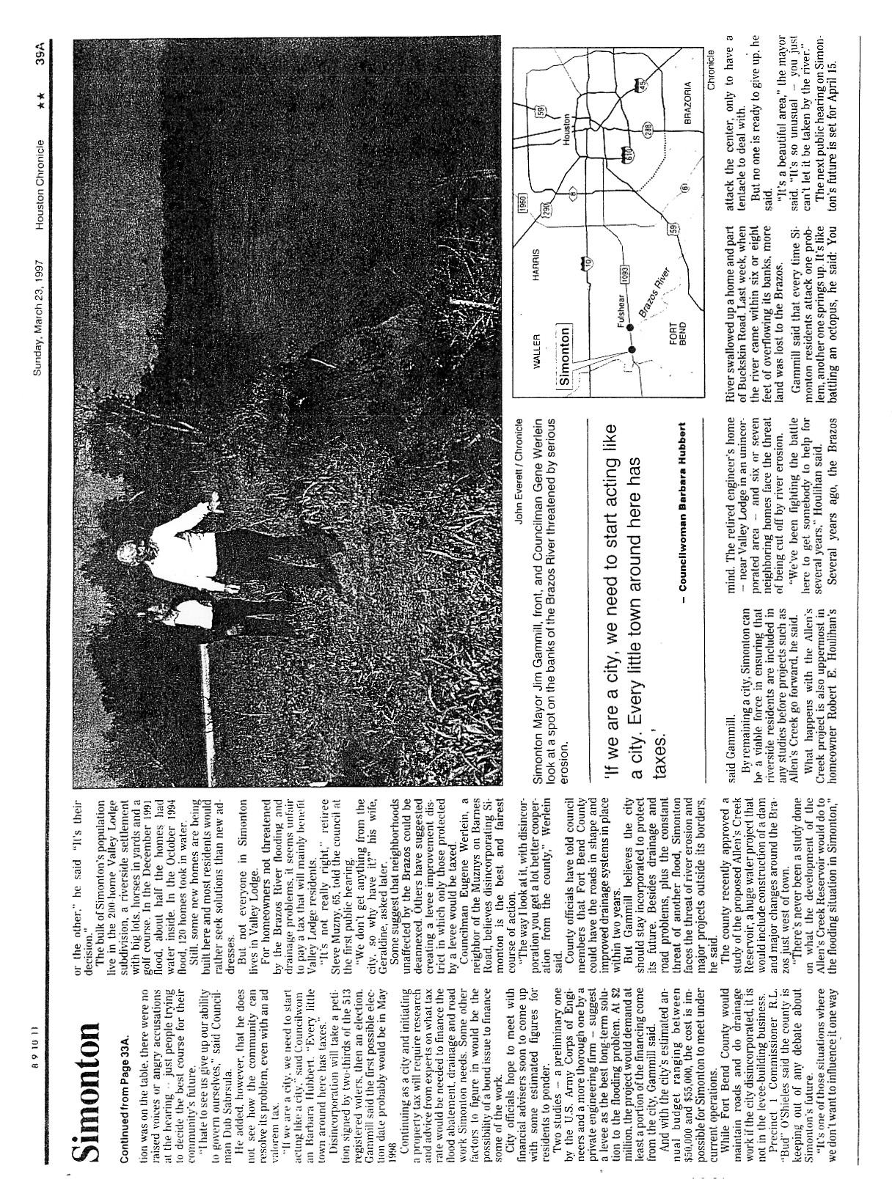

Map of proposed flood-control levees (Corps of Engineers ) and the 100 year floodplain (FEMA)

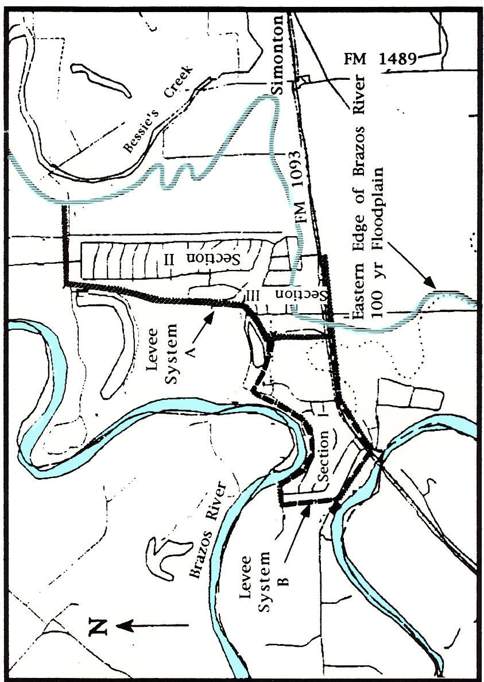

1958 Topographic Map (1:24,000)

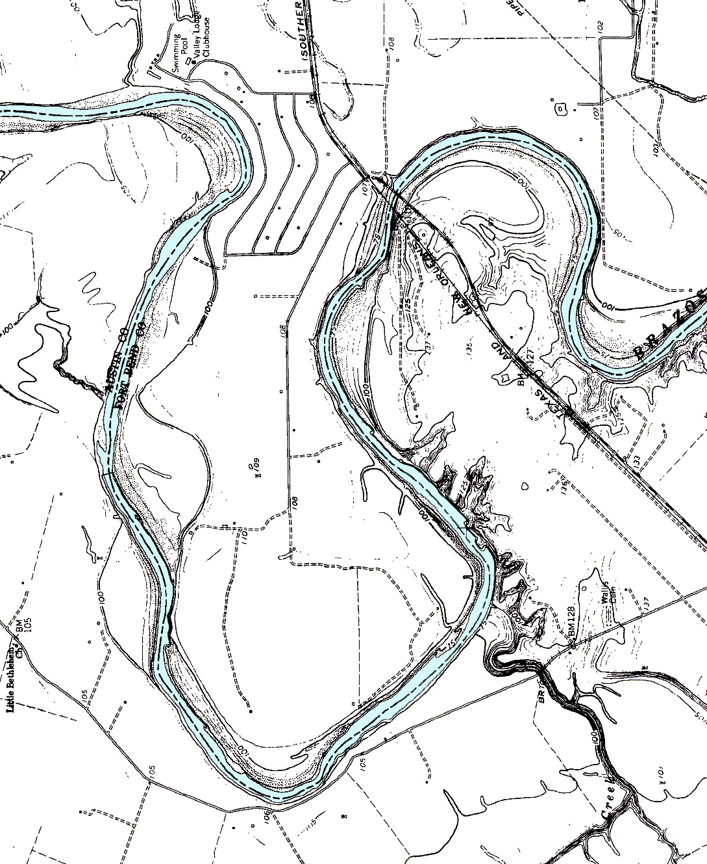

Tracing of 1995 Digital Orthophoto (1:24,000)

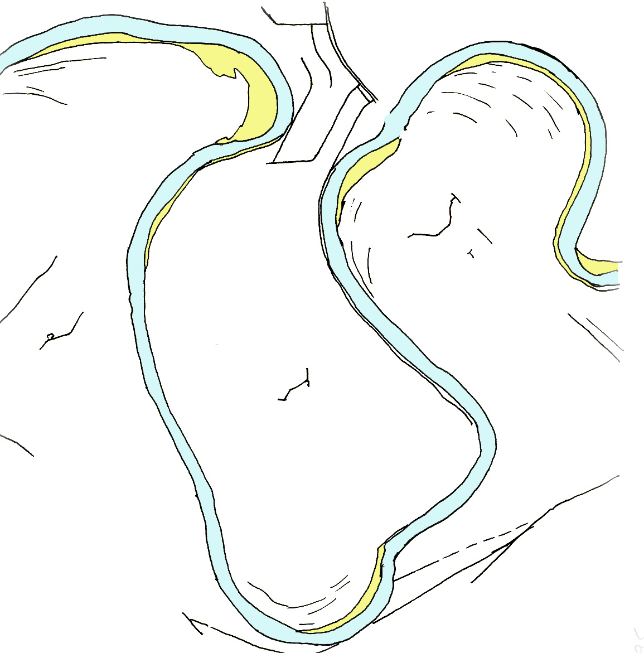

Tracing of 1977 Topographic Map (1:24,000)

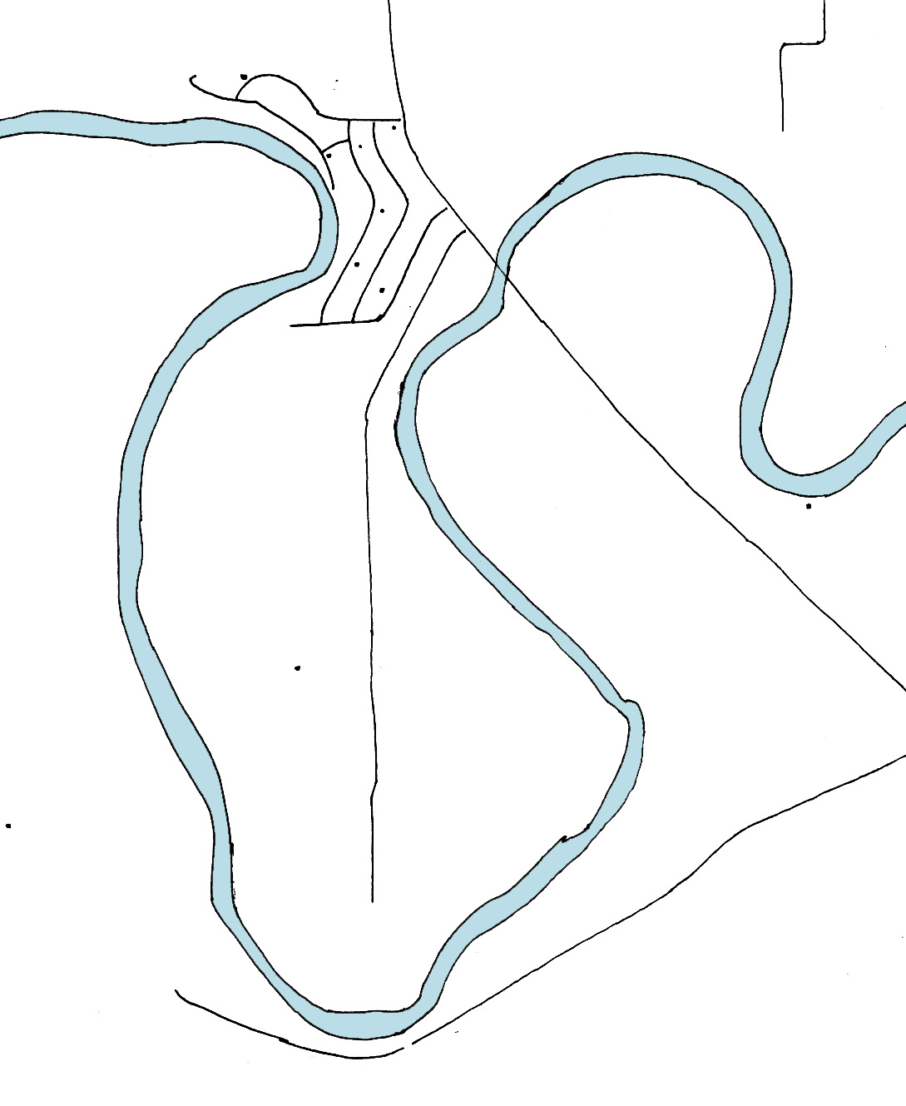

2008 Google Earth Image

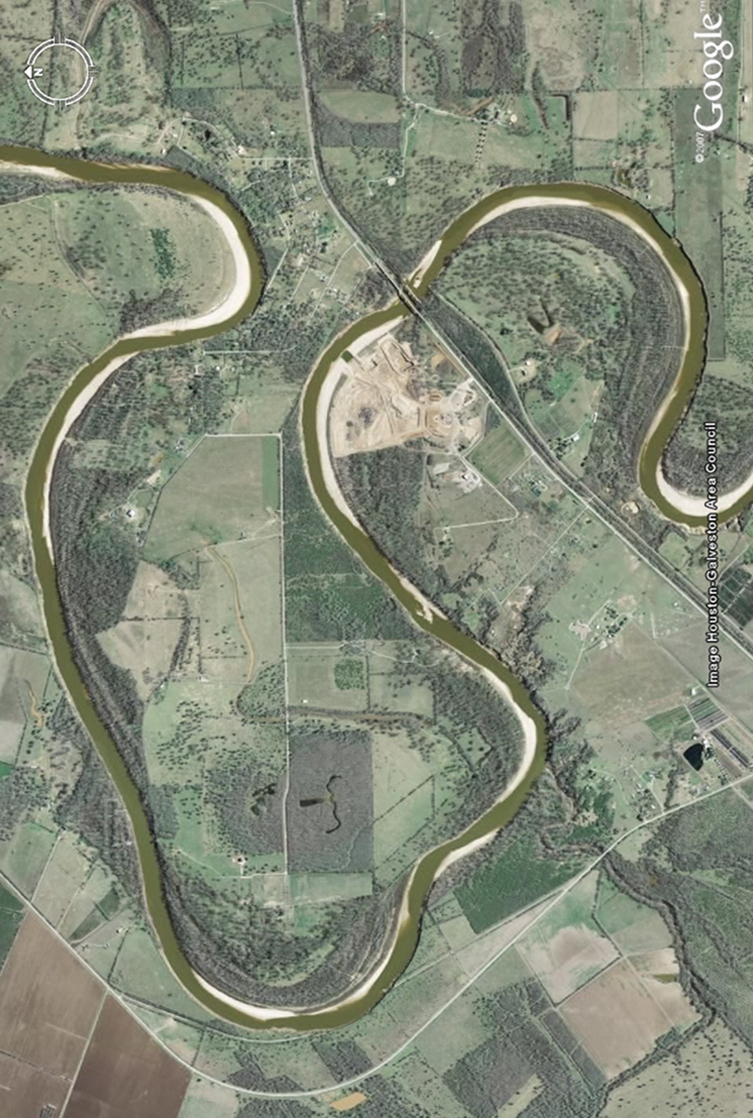

© 2004, William R. Dupre´, Department of Geosciences, University of Houston
The hydrologic community uses a water year which extends from Oct. 1 - Sept. 30. Thus the October 1991 and December 1994 floods occurred during the 1992 and 1995 water years respectively, and are so recorded on the table on the next page.

