Richmond’s Urban Heat Island

Donald M. Yow
Department of Geography and Geology
Eastern Kentucky University
don.yow@ eku.edu
(859) 622-1420

I use this assignment in my introductory physical geography course. The exercise I give to students begins on the following page. A second file (Richmond_UHI.xls) contains data that goes along with this assignment.

Note to instructors: You will need to teach students about urban heat islands and/or assign one or more readings about urban heat islands before students will have all of the information necessary to complete this lab. You may wish to start with the following: Yow, D.M. 2007, “Urban Heat Islands: Observations, Impacts, and Adaptation,” Geography Compass. Volume 2, October 2007, 1227–1251.
Also, if your students have no prior experience with MS excel, guiding them through a quick tutorial is advisable.

Name:_______________________________________ Date:_______________________

Richmond’s Urban Heat Island
"The urban heat island effect is both the clearest and the best documented example of
inadvertent climate modification by humans.”
- Tim Oke (1987)

Key concepts in this lab:
Local Climate and Microclimate
Land Use / Land Cover
Data Analysis and Display

Materials needed:
Microsoft Excel
Internet Access
Google Earth

Introduction: People have inadvertently modified local climate and microclimates within communities since the dawn of civilization. One of the most common results of these modifications is that urban air temperatures are often warmer than temperatures in surrounding rural areas. This phenomenon is called the urban heat island (UHI) effect, which is most commonly defined as the difference between urban and rural temperatures. Virtually all urban developments have measurable urban heat islands, including Richmond, KY. In this lab, we will use real air temperature data from two stations in Richmond to examine its UHI. We will also examine some of the UHI’s causes and impacts.

Part 1 - Causes: A number of factors contribute to UHI development. Most result from replacing natural land cover with artificial ones, and activity in the city. For the three factors listed below, provide 1-2 reasons why these things could contribute to the UHI. (2 points each).
A. Physical properties of construction materials

B. Decreased evapotranspiration

C. Anthropogenic heat sources

Part 2 – Site Description: We will be working with data from two weather stations in Richmond. Station #1 is located behind City Hall (37.7487°N, 84.2952°W) and is representative of Richmond’s urban environment (figure 1a). Station #2 is located approximately 7 miles east of downtown at EKU’s Meadowbrook Farm (37.7147°N, 84.1560°W) and is representative of the rural environment outside of Richmond (figure 1b). Please visit the following websites to view additional pictures of each site.
City Hall http://people.eku.edu/yowd//uhisite/city.htm
Meadowbrook Farm http://people.eku.edu/yowd//uhisite/farm.htm
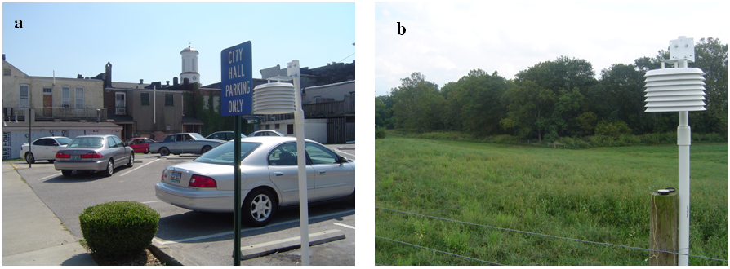Figure 1: Urban station at City Hall (a), and rural station at Meadowbrook Farm (b).

After viewing the site photos, open Google Earth and type each station’s coordinates into the “Fly To” area. Take special note of the land use/land cover in the vicinity of each station and consider how each station’s surroundings will affect local temperatures.

1. What features near City Hall do you see that will contribute to the urban heat island effect?
It may be helpful to contrast this area with the site at Meadowbrook Farm. (6 points)

2. Meadowbrook Farm is in a rural area and does not contain features that will contribute to the urban heat island effect. However, you will notice that the image on Google Earth looks distorted. Why? (i.e., what is different about the remotely sensed imagery in this area compared to adjacent areas further west?) Hint; think about how the imagery may have been collected, its intended purpose(s) and resolution. (4 points)

Part 3 - Data Analysis: Data from the two weather stations discussed in the previous section are available on this course’s Blackboard page.

Step 1: Download the file titled Richmond_UHI.xls from Blackboard and open it in MS Excel.
Step 2: Create hourly data for each station. Average the 10-minute data such that each hour is the average of the six observations collected from 00:10 to 1:00.
Step 3: Compute hourly UHI intensity for each hour (UHI = urban-rural) and complete the following:

1. Create a table showing the average hourly temperature for each station and the hourly UHI intensity. The first column should list the time, and the next 3 columns should list urban temp, rural temp, and UHI intensity. Print this table and attach it to your lab. (5 points)

2. Plot bar graph of hourly UHI intensity and attach it to your lab. (5 points)

3. Plot line graph of hourly UHI intensity and attach it to your lab. (5 points)

4. Do you think either graph is more informative and/or easier to interpret than the other? Explain your response with 1-2 complete sentences. (5 points)

5. What was the lowest hourly UHI intensity on this day? What time did this occur? (4 points)

6. What was the greatest hourly UHI intensity on this day? What time did this occur? (4 points)

7. What was the mean (average) hourly UHI intensity on this day? (2 points)

Part 4 – Impacts: Cities artificially alter local climates affecting atmospheric, economic, and biological processes. For each of the four items listed below, briefly explain how/why the UHI affects these things. (Short answer, 2 points each).
A. Heating and cooling costs

B. Human comfort and health

C. Plants and/or animals

D. Long-term temperature records

Part 5 - Critical thinking: As urban areas continue to expand there is a heightened awareness that scientific knowledge of the urban heat island must be more effectively communicated to appropriate professionals such as architects, engineers, and urban planners. What do you think is/are the best strategies to promote communication between these various groups? Why might one way of doing so be more or less effective than another? Write your answer using 3-5 complete sentences. (6 points.)

Bonus Opportunity: The quote at the beginning of the lab was made by Tim Oke. Using 2-3 complete sentences, describe who he is and/or what his major accomplishments are. (5 points)

