The Mississippi River System Lab
In this lab we will be looking at river channels using the stream table. We will have 3 types of river channels for which we will measure sinuosity, average sediment discharge rate, and average velocity of the stream. You will draw each channel before and after to observe the modifications that have been made through time to each channel.
Fluvial Geomorphology
Fluvial geomorphology focuses on rivers, how they transport sediment, migrate across the landscape, cut into bedrock, respond to environmental and tectonic changes, and interact with humans.
point bar – a depositional feature made of sand and gravel that accumulates on the inside bend of streams and rivers; crescent-shaped and located on the inside of a stream bend
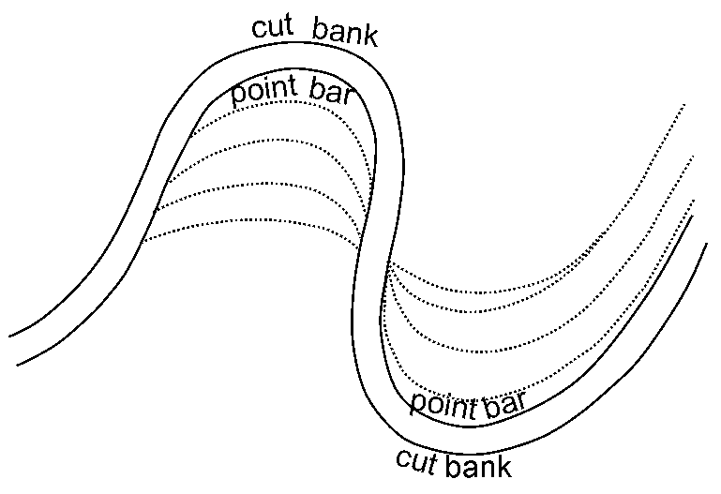
mid-channel bar – landforms in a river that begin to form when the discharge is low and the river is forced to take the route of less resistance by means of flowing in locations of lowest elevation
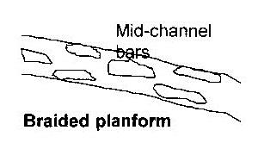
bank erosion – wearing away of the banks of a river channel
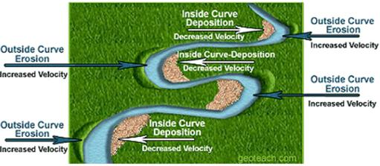
Channel Sinuosity
Channel sinuosity (SI) is the length of the channel divided by the downvalley length.
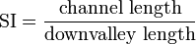
The channel sinuosity is the deviations from a path defined by the direction of maximum downslope. Bedrock streams with a flow directly downslope have a sinuosity value of 1. Meandering streams have a sinuosity value greater than 1.
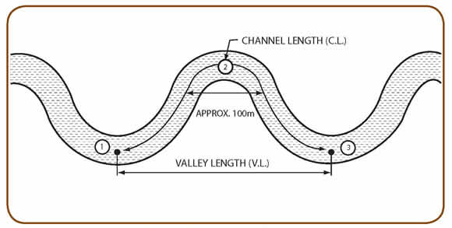
We will calculate the sinuosity for the 3 different channels.
Suspended Sediment Discharge
Suspended sediment discharge is an important factor in the Mississippi River system. Observations and calculations support that human intervention within the natural landscape has re-formed stream and water quality on the scale of the world’s largest river basins (e.g. the Mississippi River system). Land use such as farming has increased the amount of nitrogen entering the water systems and this subsequently creates eutrophication (phytoplanktonic blooms; depletion of oxygen) that severely affects aquatic ecosystems. Eutrophication leads to the reduction of most aquatic life, depletes fisheries, and kills immobile benthonic animals (e.g. clams).
1 oz = 29 mL = 29 cm³
We will be estimating the sediment discharge rate of each channel. We will measure the volume of sediment discharged from each channel, the time that each channel is run for, and the area of each channel. Then we will calculate the sediment flow rate and the velocity of the flow. We will assume that the channel behaves as a narrow tube, and that the cross-sectional area of the channel is a circle (πr²).
Channel 1 – Large Meanders
What do you expect to see? What is your hypothesis about changes in sinuosity, changes in channel morphology (shape, size, etc.), and sediment flow?

Sketch the channel.

Sinuosity
Initial Channel  Length in mm (CL) | Initial Downvalley  Length in mm (DL) | Initial Sinuosity  SI = CL/DL
Final Channel  Length in mm (CL) | Final Downvalley  Length in mm (DL) | Final Sinuosity  SI = CL/DL

Sediment Discharge
Volume of  Sediment (oz) | Multiply by 29 | Volume of Sediment  (mL = cm^3)
Discharge  Time (s) | Sediment Discharge  Rate (cm^3/s) | Area of Channel  (π*r^2)
Volume of  Water (mL) | Discharge Time (s) | Water Discharge Rate  (cm^3/s)
Velocity = (Flow Rate/Area)
(cm/s)

Sketch the modified channel.

Channel 1 Questions
- Is there evidence of a point bar or mid-channel bar in this system? Where? Indicate location on modified channel sketch with A.
- Is there evidence of bank erosion (cut-bank)? Where? Indicate location on modified channel sketch with B.
- Where do you think the highest velocity in this channel will be? Mark it with a C. Lowest velocity? Mark it with a D.
Channel 2 – Narrow Meanders
What do you expect to see? What is your hypothesis about changes in sinuosity, changes in channel morphology (shape, size, etc.), and sediment flow?

Sketch the channel.

Sinuosity
Initial Channel  Length in mm (CL) | Initial Downvalley  Length in mm (DL) | Initial Sinuosity  SI = CL/DL
Final Channel  Length in mm (CL) | Final Downvalley  Length in mm (DL) | Final Sinuosity  SI = CL/DL

Sediment Discharge
Volume of  Sediment (oz) | Multiply by 29 | Volume of Sediment  (mL = cm^3)
Discharge  Time (s) | Sediment Discharge  Rate (cm^3/s) | Area of Channel  (π*r^2)
Volume of  Water (mL) | Discharge Time (s) | Water Discharge Rate  (cm^3/s)
Velocity = (Flow Rate/Area)
(cm/s)

Sketch the modified channel.

Channel 2 Questions
- Is there evidence of a point bar or mid-channel bar in this system? Where? Indicate location on modified channel sketch with A.
- Is there evidence of bank erosion (cut-bank)? Where? Indicate location on modified channel sketch with B.
- Where do you think the highest velocity in this channel will be? Mark it with a C. Lowest velocity? Mark it with a D.
- What was the biggest difference between this channel (narrow meanders) and the channel with large meanders (Channel 1)?
Channel 3 – Straight Channel
What do you expect to see? What is your hypothesis about changes in sinuosity, changes in channel morphology (shape, size, etc.), and sediment flow?

Sketch the channel.

Sinuosity
Initial Channel  Length in mm (CL) | Initial Downvalley  Length in mm (DL) | Initial Sinuosity  SI = CL/DL
Final Channel  Length in mm (CL) | Final Downvalley  Length in mm (DL) | Final Sinuosity  SI = CL/DL

Sediment Discharge
Volume of  Sediment (oz) | Multiply by 29 | Volume of Sediment  (mL = cm^3)
Discharge  Time (s) | Sediment Discharge  Rate (cm^3/s) | Area of Channel  (π*r^2)
Volume of  Water (mL) | Discharge Time (s) | Water Discharge Rate  (cm^3/s)
Velocity = (Flow Rate/Area)
(cm/s)

Sketch the modified channel.

Channel 3 Questions
- Is there evidence of a point bar or mid-channel bar in this system? Where? Indicate location on modified channel sketch with A.
- Is there evidence of bank erosion (cut-bank)? Where? Indicate location on modified channel sketch with B.
- Where do you think the highest velocity in this channel will be? Mark it with a C. Lowest velocity? Mark it with a D.
- What was the biggest difference between this straight channel and the two meandering channels (Channels 1 & 2)?

Lab Write-Up
This lab write-up should be written in paragraph format with the headers for each section clearly labeled and all required information included. Please use Times New Roman, 12 pt font, with 1” margins. Cite any sources you use and create a Works Cited page.
- Introduction
  - Brief description of the experiment and purpose.
  - Hypothesis/hypotheses.
- Materials and Methods
  - A description or bulleted list of our materials.
  - A description or bulleted list of our methods. Be detailed and descriptive, so someone else can reproduce these methods!
- Results
  - Results for all three channels should be included in this section.
  - Changes in channel morphology (shape, size, etc.).
  - Sinuosity.
  - Sediment flow rate, velocity, volume of sediment.
- Discussion
  - Were your hypotheses disproved? How might you modify your hypotheses after seeing the results of our experiments?
  - Describe the similarities and differences you saw among the three channels.
  - What kind of sediment discharge rate did you see? What are the implications of this kind of rate on a major river system like the Mississippi River where it drains into the ocean?
  - What are the benefits/drawbacks to channelization (creating a modified stream shape)? Describe at least two.

