Laboratory Exercise: What Controls Rheology?
Dyanna Czeck
University of Wisconsin- Milwaukee
dyanna@uwm.edu

Type of Activity: Laboratory exercise
Brief Description: In order to understand the factors that control rock rheology, students conduct a series of activities with analogue materials. The activities are compared to real examples from the field and deformation experiments.

Context
Type and level of course in which I use this activity or assignment: undergraduate required structural geology course for majors
Skills and concepts that students must have mastered before beginning the activity: Students must be familiar with the following terms and concepts: rheology, force, stress, strain, elastic, plastic, competence, deformation experiments, yield strength, ultimate strength, and rupture
How the activity is situated in my course: This activity is one of many lab exercises students complete throughout the semester. It is followed by an in-class activity where the students use analogue materials to explore rheologic models such as Elastic, Newtonian, and Plastic.

Goals of the Activity or Assignment
Content/concepts goals for this activity: The students should gain an intuitive sense for the role of the following in determining the rheology of a deforming rock: lithology, stress, temperature, confining pressure, preexisting weakness, strain rate, and accumulated strain. They will also closely examine the important results of some deformation experiments and learn where natural deformation may help us learn more about rheology.
Higher order thinking skills goals for this activity: analysis of data, synthesis of ideas.
Other skills goals for this activity: critical reading of data presented in graph format, working in groups.

Description
A short laboratory exercise, conducted by students, is used to illustrate the multiple factors that contribute to rocks' varied responses to deformation. Analogue materials (play-doh, notebook springs, butter, silly putty, plastic bags, etc.) are used to illustrate many of the controlling factors such as lithology, stress, temperature, confining pressure, strain rate, preexisting weaknesses, and accumulated strain. The analogue experiments are presented in conjunction with parallel data from deformation experiments and field studies. The tandem presentation of analogue experiment and real data requires the students to obtain a natural "feel" for rheologic parameters and more exhaustively analyze the important conclusions obtained from field and deformation experiment data.
.
Evaluation
I help students with the exercises as needed. The students submit their written responses to the exercise for credit. The students use their understanding of rheology in future assignments.

Instructor’s notes for running the in-class laboratory
- Students best complete the laboratory if they are prepared (have read the assigned material from the textbook). In the preceding class, a short (15 minute) interactive discussion of rheology, using analogue examples, is presented. The students are reminded (warned) to read the textbook pages for the laboratory that are outlined on the syllabus. They are also encouraged to bring the textbook to class in case they need a refresher during the lab.
- Before class begins, I set up the stations around the classroom for each of the 7 factors. Each station has an identifying sign and the neccesary materials.
- I begin class by giving a short recap of important terms, soliciting the definitions from the students.
- I then hand out the lab exercise. Students choose their working groups of 3-4 students and begin the exercise at one of the stations. The students rotate stations at their leisure. (I have 7 stations and usually 3-5 working groups.) I walk around the class, helping where appropriate. I have chosen to have the entire class complete the butter exercise together. We complete this exercise at a natural break between stations for most of the groups.
- The exercises can easily be completed in a 2 hour class period. The students type their responses outside of class, and turn them in the following week.
- Most student problems arise from: A) forgetting definitions of terminology that they have (perhaps) read and discussed in class and B) analyzing graphical data with only a cursory glance. To help mitigate these potential problems, I encourage the students to teach one another and look up any terms with which they are struggling (reinforcing the reason for reading assignments).

Documentation
The following pages contain the laboratory exercise given to students.

LAB: WHAT CONTROLS RHEOLOGY????

GOAL: We have already analyzed strain to a great degree and have talked about the meanings and definitions of stress. Rheology is the way in which rocks respond to stress. One of the ultimate goals of structural geology is to predict how any rock will deform due to an applied stress. Today we will explore many of the different parameters (lithology, stress, temperature, confining pressure, preexisting weaknesses, strain rate, accumulated strain) that result in the deformation or strain that we see in rocks. Since we can’t watch rocks deform in nature, we must use analogue materials to understand the parameters that control rheology and compare these deformed analogue materials to information we have on real rocks.

WHAT YOU NEED TO TURN IN:
You need a group of 3-4 to complete this lab. Your group will need to turn in the answers (typed) to each question. You should hand in one set of answers and graphs per team. Where drawings are required, you may draw these neatly by hand (on graph paper if requested). You should organize your answers the same way that the experiments are organized in the lab handout regardless of the order in which you conducted the experiments.

FACTOR 1: LITHOLOGY

Part A: Analogue
Materials: play-doh, modeling clay, textbook
Procedure:
- Make two identical-sized blocks out of play-doh and modeling clay. (The blocks should be at least 5 cm x 5 cm x 5 cm.) Record the dimensions of your two blocks.
- Deform the two blocks by placing your textbook on top of each block and allowing the weight to deform the blocks.
- Remove the textbook and measure the dimensions of each of the blocks after deformation.

Questions:
- What are the new dimensions of each block (sketches are helpful here)?
- Was the applied stress equal for each deformation? Explain your answer.
- Which material is “stronger” (play-doh or modeling clay)? Explain your answer.
- Which material shows signs of brittle deformation? (You will probably see little fractures in one of the materials.) Do you expect the “stronger” (competent) material to behave more or less plastically than the “weaker” (incompetent) material?

Part B: Rocks
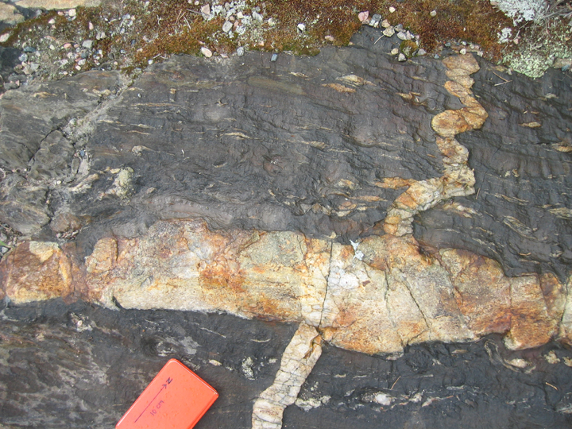
Figure 1: Deformed granitoid dikes within greenschist facies metasedimentary rock from Rainy Lake region, Ontario. The metasedimentary rock has a strong ductile fabric (foliation and lineation).
Questions:
- Figure 1 shows a competent rock and an incompetent rock. Which is which? How can you tell? (Hint: think about which shows evidence for brittle deformation and compare this to the analogue experiment above.)
- In figure 1, the granitoid dikes are both boudinaged and folded. How could both occur within the same deformation? (Hint: think back to the lab you did on strain!)
- There are several fractures within the boudinaged portion of the dike. In general, how are these fractures oriented? Do the fractures indicate the orientation of stress or strain?

FACTOR 2: STRESS

Part A: Analogue 1
Materials: play-doh, textbook, pencil, ruler.
Procedure:
- Make 2 identical towers of play-doh (10 cm tall, 5 cm wide, and 5 cm long). Measure and record all dimensions of the towers.
- Carefully balance the weight of your textbook onto one of the towers so that the weight of the book causes the play-doh to deform.
- Put the eraser end of the pencil on top of the second play-doh tower. Now, carefully balance the weight of the textbook on top of the pencil so that the weight of the book causes the play-doh to deform. (Yes, this is tricky, but use your hands to carefully guide the book without supporting its weight).

Questions:
- Choose the material line that has undergone the most shortening during deformation for each experiment. Calculate the percent shortening for that material line.
- Calculate the force of each deformation (ignore the weight of the pencil and assume that your book weighs about 2 lbs or 907 g- use metric units).
- Calculate the stress of each deformation.
- What can you conclude, from the two experiments, about the effect of increasing stress on the resulting deformation?

Part A: Analogue 2
Materials: “spring” from a notebook
Procedure:
- Like the last analogue experiment, we will conduct two similar experiments. Unlike the last experiment, we will vary the stress between the two experiments by keeping the same area, but increasing the applied force.
- Measure and record the length of the springs.
- Using a very small force, pull the spring apart enough so that it will change length, but bounce back to its original length when you release the force. Measure the length of the spring before you release it.
- Now, using a slightly larger force, pull the spring apart so that it will permanently change length. Measure the length of the spring after deformation.

Questions:
- Which experiment (first or second) had a higher stress?
- Which experiment(s) (first or second) had elastic deformation? Plastic deformation?

Part B: Rocks
Questions:
- Look at Figure 2. Draw this plot on your answer sheet and mark the yield strength, ultimate strength, and rupture. Indicate which parts of the curve represent elastic strain and which represent plastic strain.
- From your experiment with the springs, you noticed that by increasing the stress, you caused plastic strain to occur rather than only elastic strain (if not, think through that experiment again). Does this mean that by increasing stress, more plastic strain occurs in rocks? Use the schematic plot above to explain your answer.

Figure 2: Schematic plot of a rock deformation experiment.

FACTOR 3: TEMPERATURE

Part A Analogue:
Materials: 2 sticks of butter: one room temperature and one refrigerated
Procedure: So as not to waste too much butter, we will conduct this experiment together.
- Slightly open the warm butter package and slowly fold it with your hands.
- Slightly open the cold butter package and slowly fold it with your hands.

Questions:
- Based on your observations, is an increase in temperature more likely to cause materials to strain plastically or elastically?
- Based on your observations, is an increase in temperature more likely to cause materials to have brittle or ductile deformation?
- Where did you see fractures in the cold butter? (Explain the orientation- a sketch will make this easier.)
- Where did you see fractures in the warm butter? (Explain the orientation- a sketch will make this easier.)
- Consider what you know about deformation in another common household food, chocolate. Do all materials behave plastically at the same temperature?

Part B: Griggs et al. deformation experiment for basalt under various temperatures

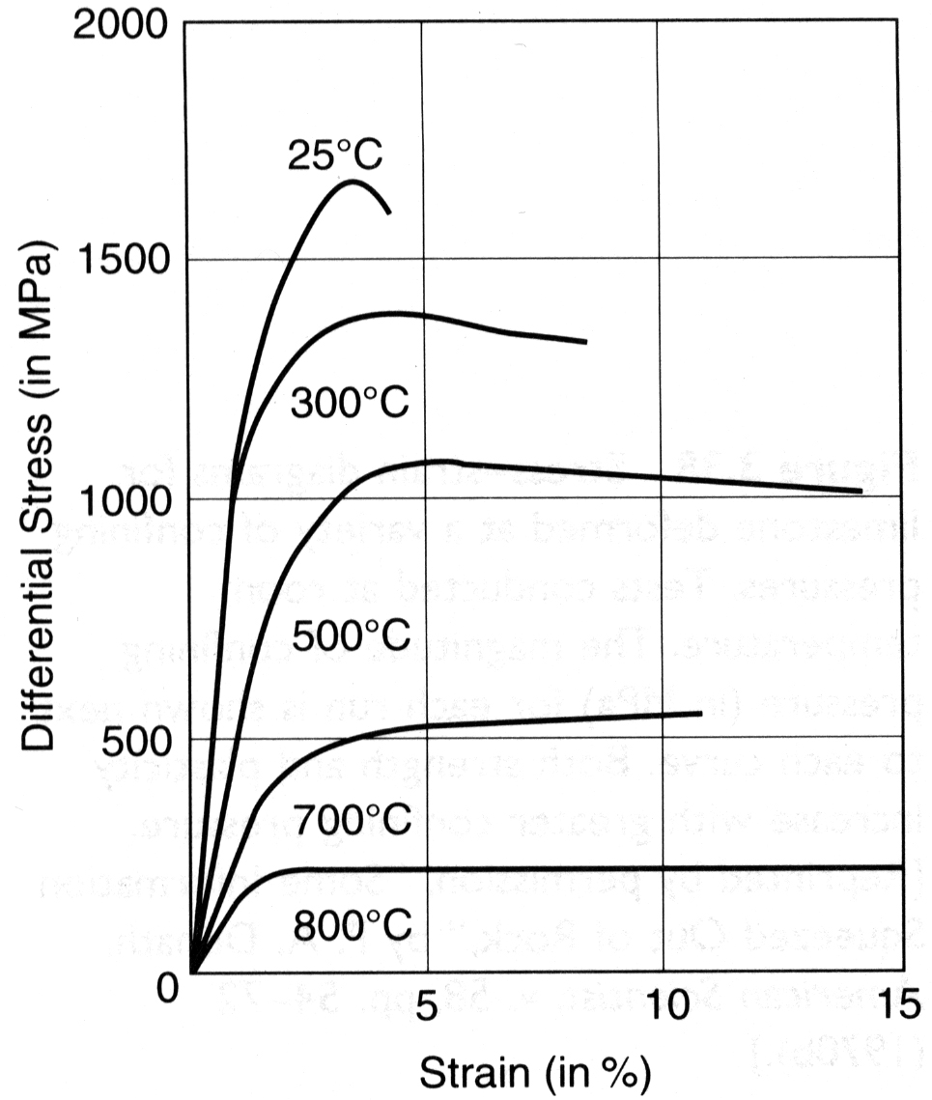
Figure 3: Stress-strain diagram for basalt deformed at 5 kbar confining pressure under a variety of temperature conditions. From Griggs, Turner, and Heard (1960). Graph copied from Davis and Reynolds (1996).
Questions:
- Review Figure 3. Under what temperature is the basalt “strongest?”
- Give the strain at which the basalt ruptured for each temperature experiment.
- What was the stess at which the basalt at 25°, 300°, 500°, 700°, and 800° ruptured? Describe the general trend. What factors do you think might make this general trend an imperfect relationship?

FACTOR 4: CONFINING PRESSURE

Part A Analogue:
Materials: wooden fault blocks, 3 heavy textbooks
Procedure:
- Set the fault blocks so that you can simulate strike-slip faulting (to do this, the bedding and the fault will be vertical).
- Move the fault blocks in a strike-slip fashion.
- Reset the fault blocks to their undeformed position. Place one of your heavy textbooks on top of the block and move the blocks in a strike-slip fashion.
- Reset the fault blocks to their undeformed position. Place two of your heavy textbooks on top of the block and move the blocks in a strike-slip fashion.
- Reset the fault blocks to their undeformed position. Place three of your heavy textbooks on top of the block and move the blocks in a strike-slip fashion.

Questions:
- Describe the change in the experiment as you increased the number of textbooks on top of the fault blocks.
- What you observed in this experiment was the result of changing the confining pressure. In nature, the confining pressure of deformation increases with depth into the earth. Do you predict that rocks are stronger (hold up against deformation) or weaker (deform easily) at depth?

Part B: Donath’s experiments for rocks under various confining pressures

Figure 4 is from a famous experiment by Fred Donath. It shows specimens of limestone that were deformed to approximately the same total strain (15%) at different confining pressures.

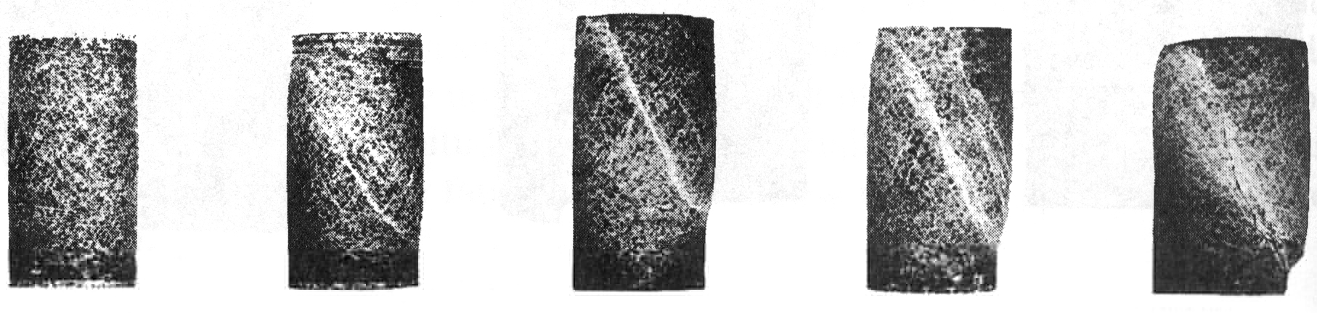
Figure 4: Specimens of limestone deformed to approximately the same total strain (about 15%) at different confining pressures. Increased confining pressure causes a transition fin deformational mode from brittle to ductile faulting. From Donath (1970). Figure copied from Davis and Reynolds (1996).

Figure 5 is also from Donath’s experiment. It shows a graph between the differential stress and strain for the limestone deformation experiment (specimens shown above).

Questions:
- Is it possible to strain the rock to 5% at any of the confining pressures shown? How about 15%?
- At what confining pressure is the rock “strongest?”
- At what confining pressure is there more ductile deformation?
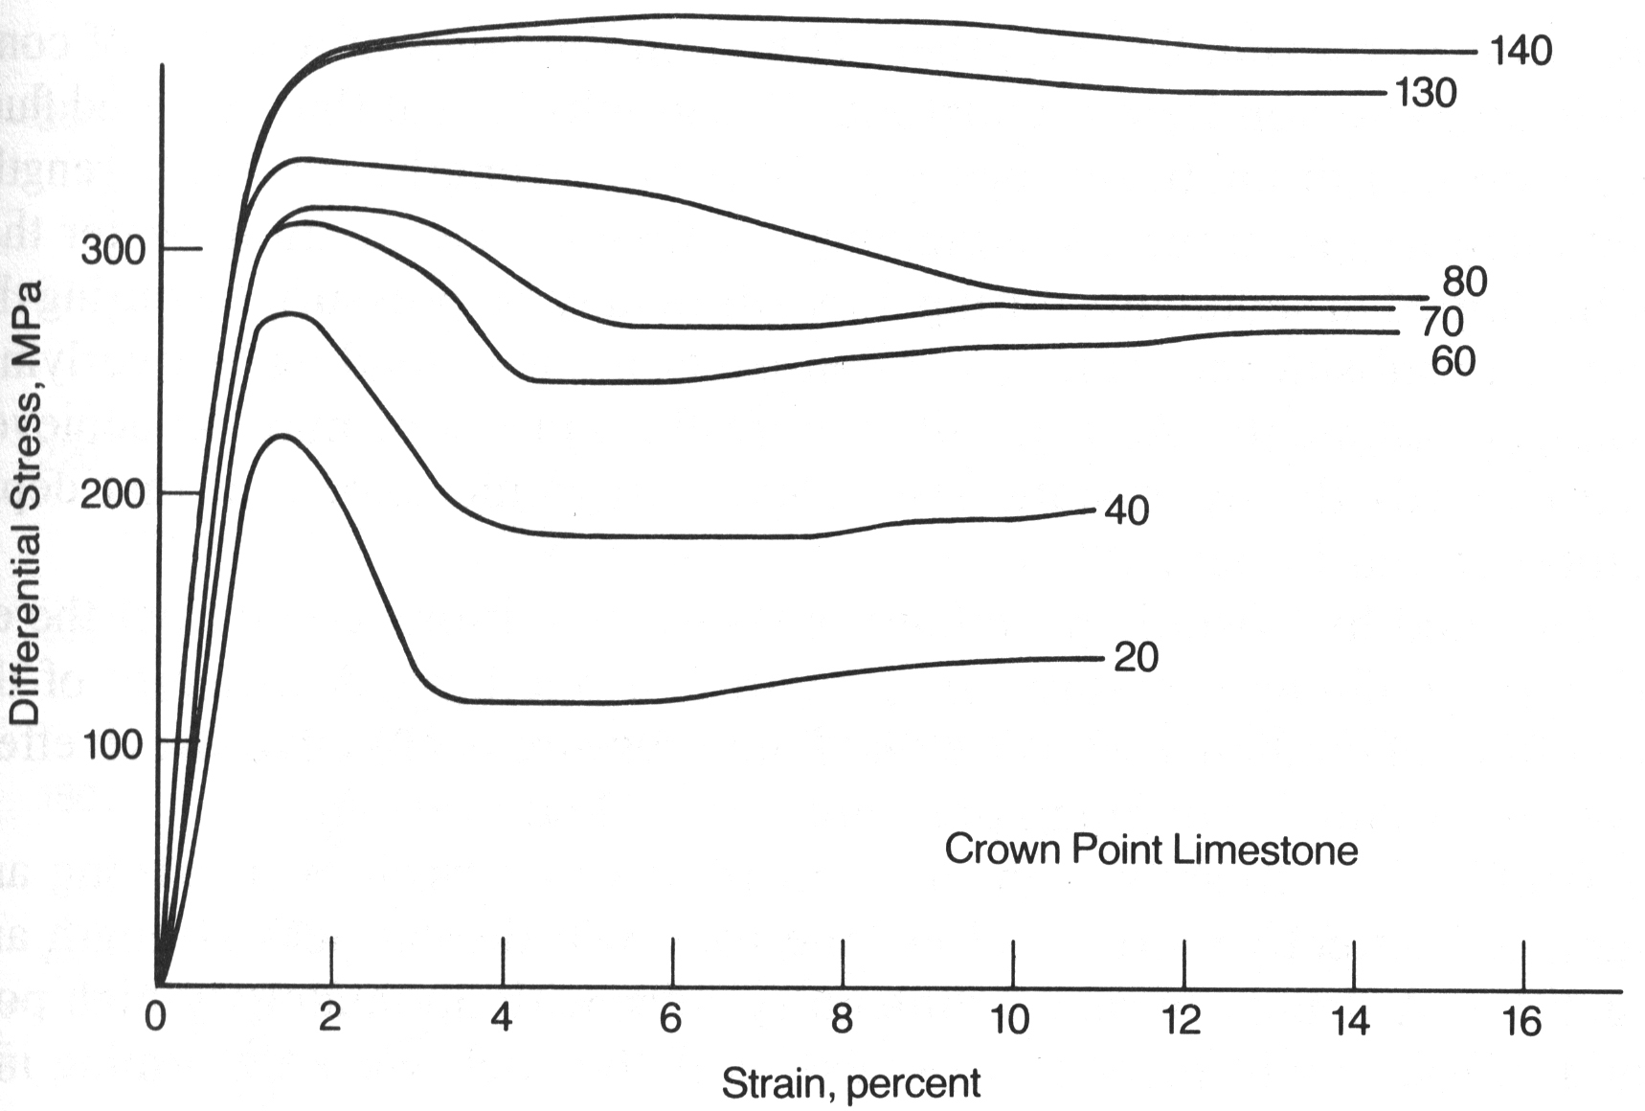
Figure 5: Stress-strain diagrams for limestone deformed at a variety of confining pressures. Tests conducted at room temperature. The magnitude of confining pressure (in MPa) for each run is shown next to each curve. Both strength and plasticity increase with greater confining pressure. From Donath (1970). Figure copied from Davis and Reynolds (1996).

FACTOR 5: PREEXISTING WEAKNESSES

Part A: Analogue
Materials: plastic bags, scissors
Procedure:
- Cut two strips of plastic bag (approximate dimension 5 cm x 15 cm)
- In one of the strips, at the half-way point, make a small cut partially through the strip.
- SLOWLY stretch each of the strips until they break.
- Measure the final length of the plastic bag pieces.

Questions:
- What is the overall stretch of each plastic bag strip prior to rupture?
- How do you expect preexisting weaknesses to affect the strength of rocks? The localization of structures?

Part B: Rocks
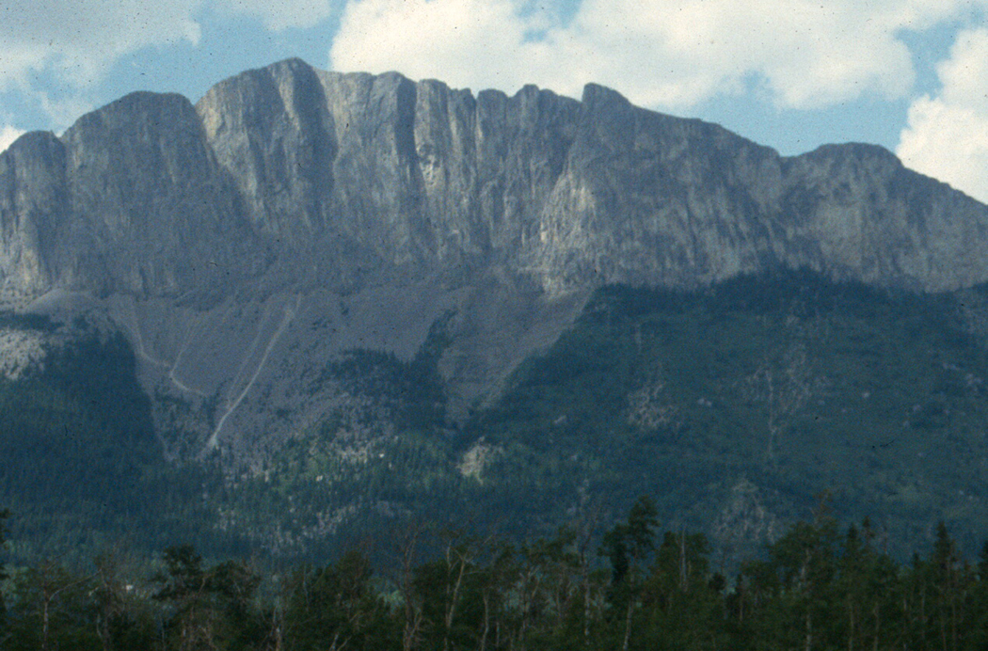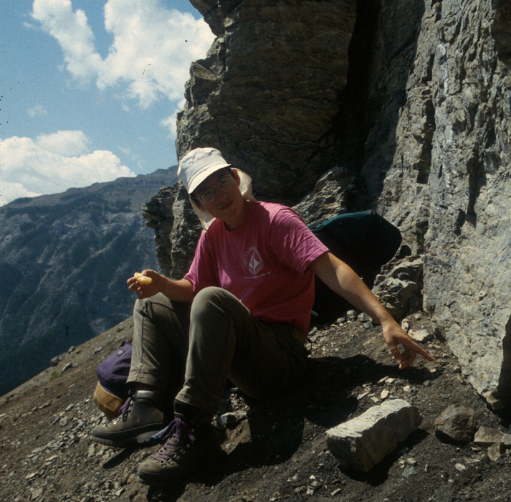
Figure 6:A) Famous McConnell Thrust Fault in Alberta. B) Carol Ormand points out the McConnell up close.
Questions:
1. Thrust faults such as the McConnell (shown above) often follow distinctive weaknesses in the rock. What do you think is the preexisting weakness?

FACTOR 6: STRAIN RATE

Part A: Analogue experiment
Materials: silly putty
Procedure
- Roll the silly putty into a small sausage shape.
- Pull QUICKLY on the silly putty and watch it deform.
- Roll the silly putty into a small sausage shape.
- Pull SLOWLY on the silly putty and watch it deform.

Questions:
- Does a slower strain rate favor plastic or elastic deformation?
- Does the prevalence of lovely ductile deformation structures (such as shear zones) at depth within deformed regions of the crust suggest that strain rates within the earth are typically fast or slow?

Part B: Yule Marble deformation experiments
Review Figure 7.

Questions:
- Are rocks “stronger” or “weaker” at faster strain rates? Explain your answer.
- Under the same stress, would you expect to measure more strain (such as in a deformed belemnite) at higher or lower strain rates?
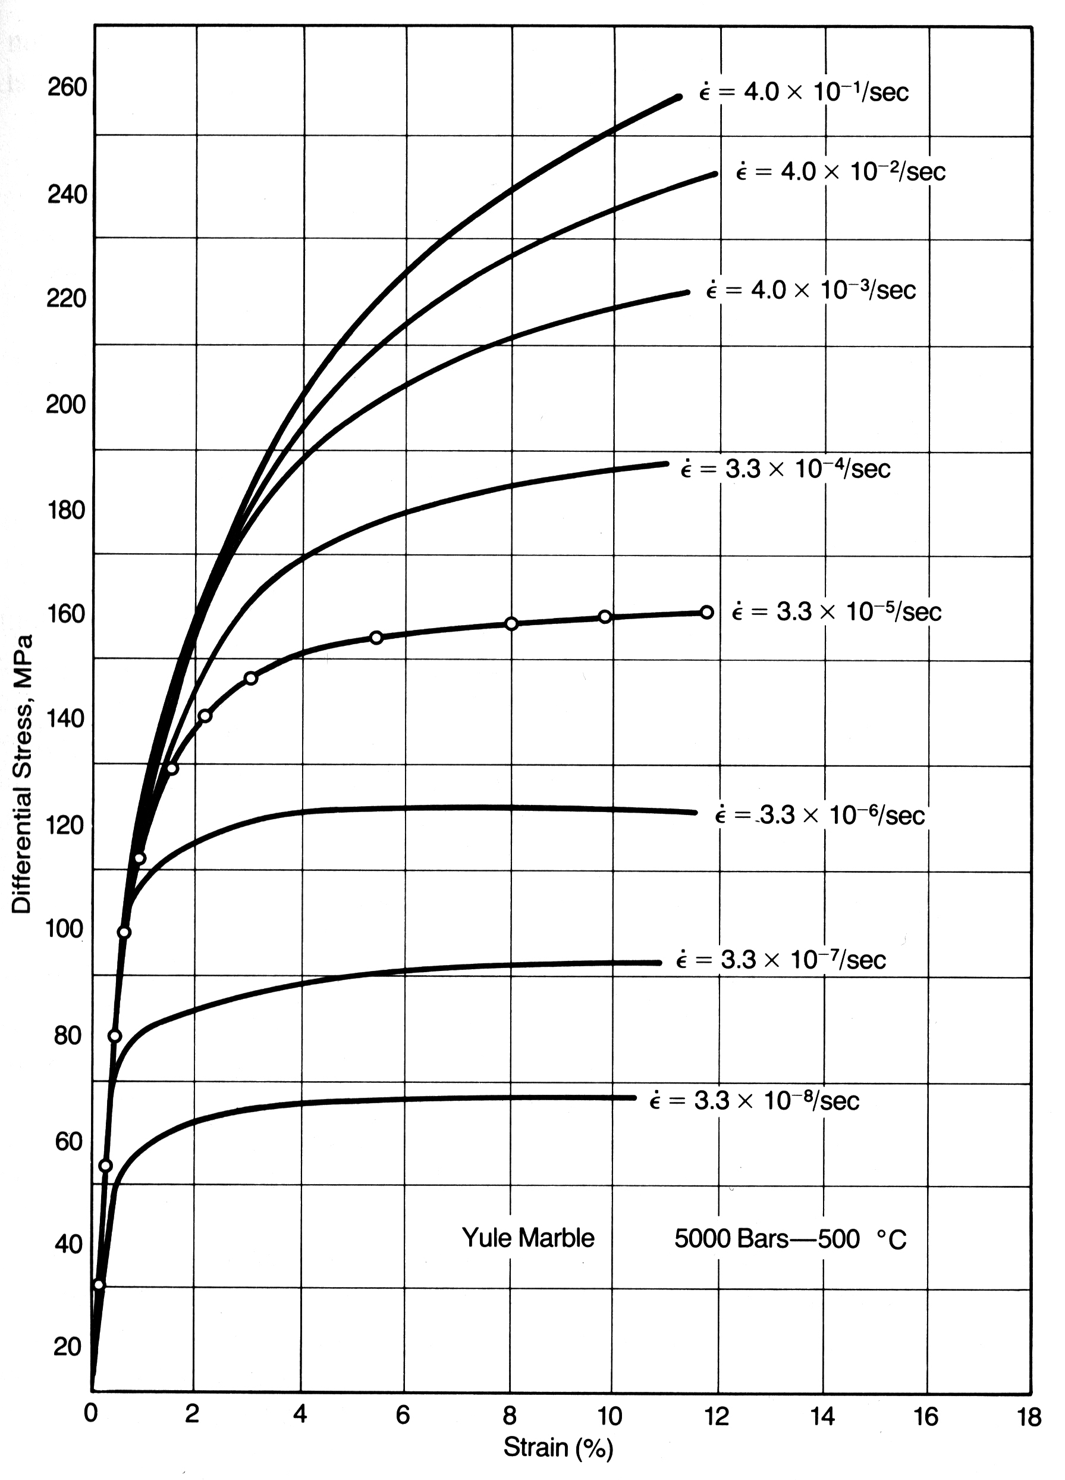
Figure 7: Stress-strain diagram for Yule marble deformed at different strain rate conditions. After Heard (1963). Figure copied from Davis and Reynolds (1996).

FACTOR 7: ACCUMULATED STRAIN

Part A: Analogue
Materials: 6-pack plastic strips
Procedure:
- SLOWLY pull on the 6-pack plastic strip. Observe deformation.

You experienced 2 changes in the strain with increasing deformation. First, you noticed that the plastic began thinning. This is known as “necking” due to strain softening. At some point, the plastic became more difficult to pull apart again. This is known as “strain hardening.” The same changes happen in rocks.
Questions:
- Ooh and ah appropriately.

SYNTHESIS
Once you have completed all of the analogue experiments and answered the associated questions, consider some of the ramifications of your work.

- You looked at seven parameters that may affect rheology. Explain any other factors that may also influence rheology (Hint: your textbook may help).
- Now, using all of the parameters discussed in this lab, consider a continental collision zone. Write several paragraphs describing the deformation conditions and structures prevalent in different levels of the crust (you may choose to divide the crust into the 1. upper and 2. mid-lower crust). Be sure to refer to all of the parameters you explored in this lab, explain whether you would expect ductile or brittle deformation, and suggest possible types of structures (e.g. faults, folds, shear zones) that may form.

References:
Davis, G. H., and Reynolds, S. J. 1996. Structural Geology of Rocks and Regions, 2nd edition. New York: John Wiley & Sons, p. 132-137.
Donath, F. A., 1970. Some information squeezed out of rock. American Scientist 58, 54-72.
Griggs, D. T., Turner, F. J., and Heard, H. C., 1960. Deformation of rocks at 500° to 800° C, in Griggs, D. T., and Handin, J. (eds.), Rock deformation: Geological Society of America Memoir 79, 39-104.
Heard, H. C., 1963. Effect of large changes in strain rate in the experimental deformation of Yule marble. Journal of Geology 71, 162-195.

