Instructor notes: Building a quick-and-dirty analog sandbox

Basic design
The basic design uses a workbench (Fig. 1) that can be expanded or contracted with a pair of hand cranks. Various metal sheets or wooden blocks can be clamped to the base to make it possible to model contraction (Fig. 2; Fig. 3), extension, strike-slip movement (Fig. 4), and various kinds of oblique movement. The basic set-ups for each type of setting are shown in the sections below.

- The workbench (Fig. 1) is the base for each model.
- Other materials (metal sheets, aluminum angle) are clamped onto the workbench (Fig. 2; Fig. 3; Fig. 4; Fig. 5).
- Clamp one sheet to each side, so that movement of the workbench creates the relative movement between the sheets.

Equipment needed

Basic materials:
- Black and Decker Workmate 225 bench
- Aluminum sheets (36 x 36 inches, 0.019” thick)
- 2-inch aluminum angle (1/8 inch thick)
- Various clamps (at least 4 clamps per workbench)
- Tin snips (to cut aluminum sheets)
- Tarp (to catch sand)
- Camera and stand (smartphones plus selfie sticks might work as well as the GoPro camera that I use)
- Modeling materials (see possibilities discussed below)

Optional materials:
- Silly Putty (for variations on the thrust belt)
- Pasta roller (for making layers of Silly Putty)
- Glue stick (to create higher friction beneath thrust wedges)
- Plaster of Paris (or flour) to show incipient fractures in sand

Modeling materials

Many different materials work for analog modeling. Granular materials show better faults when they have a little bit of cohesion. Clay shows folds nicely, but is messy to work with.

Sand
- Garnet sandblasting sand, 80 or 120 grit (In 2017, this was available for ordering online from a number of retailers, including Walmart and Home Depot. I have used the Black Bull brand. Search online for “garnet sandblasting sand.”)
- Garnet sand shows incipient faults better than playground sand (which is typically not as well sorted).
- Garnet sand appears to have a somewhat higher cohesion than quartz sand.

Clay
- Pottery clay, as fine and homogeneous as possible.
- Enough added water to make a similar consistency as cake batter.
- Thin layer (1 to 2 cm) to show small fractures and folds.
- Challenges: mixing water into clay ahead of time.
- Cleaning clay from the metal sheets is challenging. If there are rough edges, students may cut their hands on the metal sheets.
- Clay requires different measurements for scaling calculations.

Other commonly available granular materials:
- Flour has a very high cohesion. It shows initial fractures well, but tends to show open fractures rather than folding. The cohesion of flour also appears to vary with humidity.
- Cornmeal with a small amount of flour has a higher cohesion than cornmeal alone.

Teaching tips

- Groups of three to five students can see the developing structures relatively easily. I use three workbenches in each lab section, but smaller groups might be more ideal.
- The simple set-up of the models allows each group to repeat their experiment several times, trying different thicknesses of sand or different lengths and widths of their model. I encourage the groups to try several variations and decide which one gives interesting results before making their measurements and recording their video.
- Videos created during this lab can be used as examples later in the semester (for instance, when discussing bends in strike-slip faults, or when discussing thrust wedges).
- Reversing the crank directions for the bends in strike-slip faults makes it possible to simulate both restraining and releasing bends without unclamping anything.
- I put plastic sheeting (sold in hardware stores to cover things while painting) beneath each workbench to make the lab easier to clear up at the end.
- The edges of the models are problem areas for comparison with the real world. However, because they are obviously unrealistic, they provide an opportunity to talk about edge effects (in analog modeling) and boundary conditions (in numerical modeling).
- Smaller groups of students can do the measurements for scaling. Dividing the larger groups into teams of two or three students, each of which measures density and cohesion, would make it possible to replicate the measurements used in the scaling calculation, and have a discussion about the ways in which measurement uncertainty results in uncertainty in the scaling calculations.
- The scaling calcuations used in the lab frequently result in unreasonable distances (for example, the size of the entire state of California instead of the big bend in the San Andreas Fault). I have considered substituting a qualitative discussion about the differences in structural styles, combined with showing students the real-world examples on Google Earth.

Useful references:

Hubbert, M.K., 1939, Theory of scale models as applied to the study of geologic structures: Geological Society of America Bulletin, v. 48, p. 1459-1520.
Classic paper describing the theory behind scaling, with examples of how to simplify many different situations.

Schellart, W.P., 2000, Shear test results for cohesion and friction coefficients for different granular materials: scaling implications for their usage in analogue modelling: Tectonophysics, v. 324, p. 1-16.
Includes a table of coefficient of internal friction, angle of internal friction, and cohesion for various rock types. I used this reference for my range of reasonable values for real rocks.

Yuan, X.P., Leroy, Y.M., and Maillot, B., 2015, Tectonic and gravitational collapse in overpressured cohesive and frictional wedges: Journal of Geophysical Research: Solid Earth, v. 120, doi:10.1002/2014JB011612.
Example of a research paper using analog modeling. Uses the same equation for scaling using cohesion of granular materials as is used in this lab.

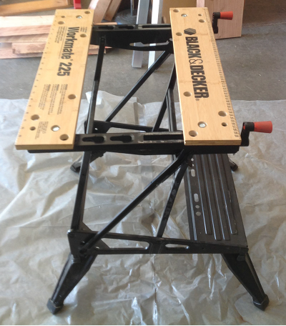

Fig.1. Workmate workbench. The cranks allow the bench to expand and contract.

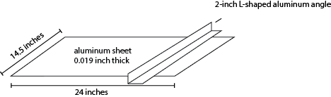

Fig. 2. Thrust fault set-up.

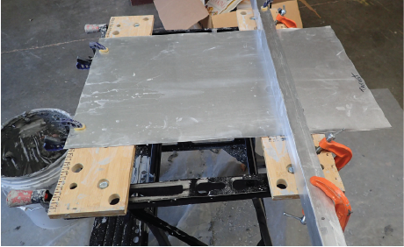

Fig. 3. Photo of thrust fault set-up. The aluminum angle (on the right) is loosely clamped to the workbench, and the clamps that go through the holes provide the primary backstop. The bracket is clamped loosely to allow the metal sheet to slide underneath the aluminum angle. Otherwise, the downgoing sheet bends.

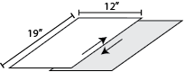

Fig. 4. Strike-slip fault set-up.

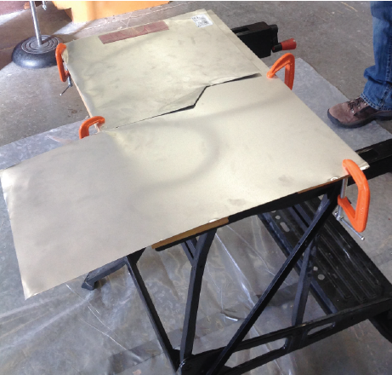

Fig. 5. Photo of set-up for a bend in a strike-slip fault.

