Week 3 Class activity write-up
Working together: Your team should be grouped around a single computer for viewing Google Earth or Excel. If you have another computer available, you could use it for filling out this answer sheet electronically. Otherwise you can start with filling it in on paper.
Deliverables: The person responsible for actually turning in this assignment should email the filled in version of this Word file by the deadline.

Part I: Investigating Plate Tectonics through Google Earth
Your task: In this investigation you will examine data sets of topography, bathymetry (ocean depth), volcano location, earthquake location, and ocean floor age to determine the location and attributes of different plate tectonic boundaries. After looking at global plate tectonics, you will look at our study regions more closely.

Tips
- When you bring files into Google Earth, make sure you save them to My Places and then FileSaveSave My Places. That way if Google Earth crashes, everything will reload automatically when you restart.
- You should uncheck data sets that you are not using for a given question because they may interfere with each other (particularly the Age-of-Ocean-Floor).
- Earthquakes and volcanoes will not show up until you are somewhat zoomed in. You will probably find that an eye altitude of 4000-5000km is best for balancing view scope with data visibility.

A. Atlantic Ocean
Double-click plate tectonics exercise part 1.kmz to open it in Google Earth (don’t load plate tectonics exercise part2.kmz yet or leave it not visible)
Make the Atlantic cross-section visible (located in the Cross-sections folder) and Show the Elevation Profile.
- On the cross-section, mark the transitions from continental crust to oceanic crust (Use what you know about plate thickness. The actual sea level line does not necessarily tell you where the edge of the continental crust is.)
- Mark the plate boundary between North American and African plates.
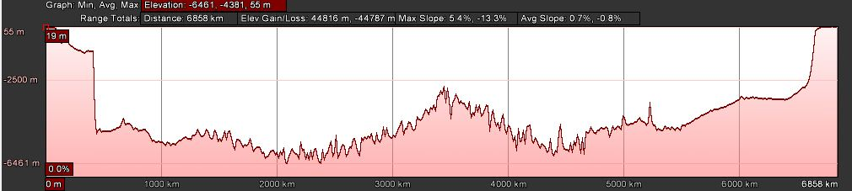
- Using earthquake, bathymetry, and ocean floor age data, describe the lines of evidence that support the location you have chosen for the plate boundary.
- What type of earthquake (shallow or deep) occurs along the plate boundary?
- Why does the plate boundary have an elevated profile (i.e. why the mid ocean ridge?) (Consider density and temperature)
- What rate (in mm/yr ) are each of the plates moving relative to the boundary? (You will need to use the ocean floor age data and the Ruler tool to determine this)
- What type of plate boundary is it?
- Where else on the globe do you observe the same types of boundaries?

B. Sumatra
Make the Sumatra cross-section visible and Show the Elevation Profile.
- Mark the boundary between the Indo-Australian and Eurasian plates at the Earth’s surface. Mark the location of volcanoes.
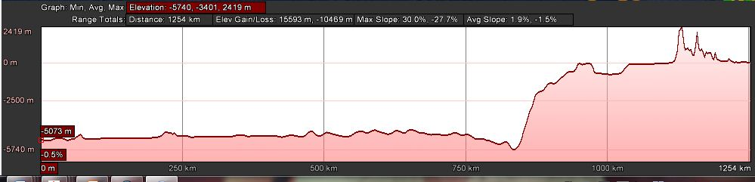
- Using earthquake, bathymetry, and ocean floor age data, describe the lines of evidence that support the location you have chosen for the plate boundary.
- On the cross-section, mark in the approximate location of the earthquakes (horizontally and vertically).
What are these earthquake locations demarcating?
- What is the rate of Indo-Australian Plate motion? (this can be found directly from the Plate Convergence data)
- What type of plate boundary is it?
- Where else on the globe do you observe the same types of boundaries?
C. California
Zoom in on California (there is no cross-section, just make sure that the Continental Transform Fault path is visible).
- The transform fault that is shown here is the famous San Andreas Fault that separates the Pacific Plate from North American Plate in this area. What type of earthquakes (shallow or deep) are associated with transform faults?
D. Pacific Northwest
Make the Juan de Fuca cross-section visible and Show the Elevation Profile.
- Based on what you determined in the first two sections, what type of plate boundaries do you see represented here? Mark where you think they are on the cross-section. What is your evidence for each?
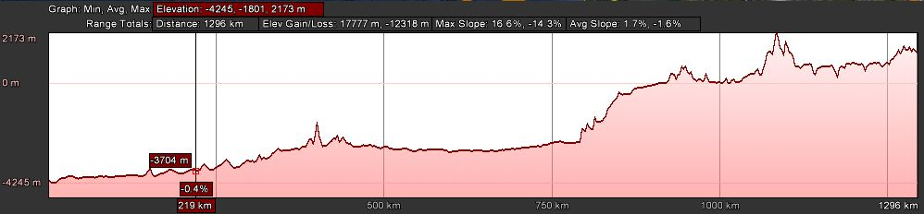
- If the first two sections showed more “typical” plate boundaries, what characteristics of this area seem unusual?
- The convergence rate between Juan de Fuca Plate and North America? (make sure Plate Convergence path is visible)
How quickly is new Juan de Fuca Plate crust being generated? (same way you did in #6)
Do you think the plate is getting bigger, smaller, staying the same, or cannot be determined?
- Now watch the Pacific_spreading.mov animation that came in your zipped file. How would you answer #18 now?
E. Himalaya
Make the Himalaya cross-section visible and Show the Elevation Profile.
- You know from the reading that this is a continent-continent convergent margin. Using topography, mark on the cross-section where you think the plate boundary is.
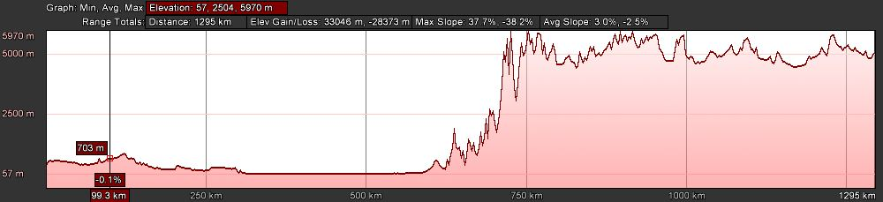
- Watch the animation IndiaAsiaCollision_EMVC2008.mov. Do you still agree with where you located the plate boundary?
- What has been the evolution of this plate boundary over the last 60 million years?
- Given that you know the major driving force behind plate tectonics is the downward pull of descending plates, how do you explain that India is still colliding with Asia at over 40mm/yr? What is keeping it going? (it may help to zoom out and consider the large tectonic plate that India is part of. Make part2.kmz visible to see plate boundaries.)
- What depth of earthquakes are associated with the Himalayan-Tibetan region?
F. Earthquakes in our study region
Make sure the part2.kmz file is visible.
- Using the Earthquake data (which includes Mag 6 since 2000 and about half a year of smaller quakes), which type of plate boundaries are associated with bigger earthquakes and more numerous earthquakes?
- Would you pick out either of our two case regions (Pacific Northwest and Himalaya) as being particularly seismically active based on the last decade of earthquakes?

