Case Example: The Faults at Delphi, the Oracle, and the Tectonic Setting of the Gulf of Corinth

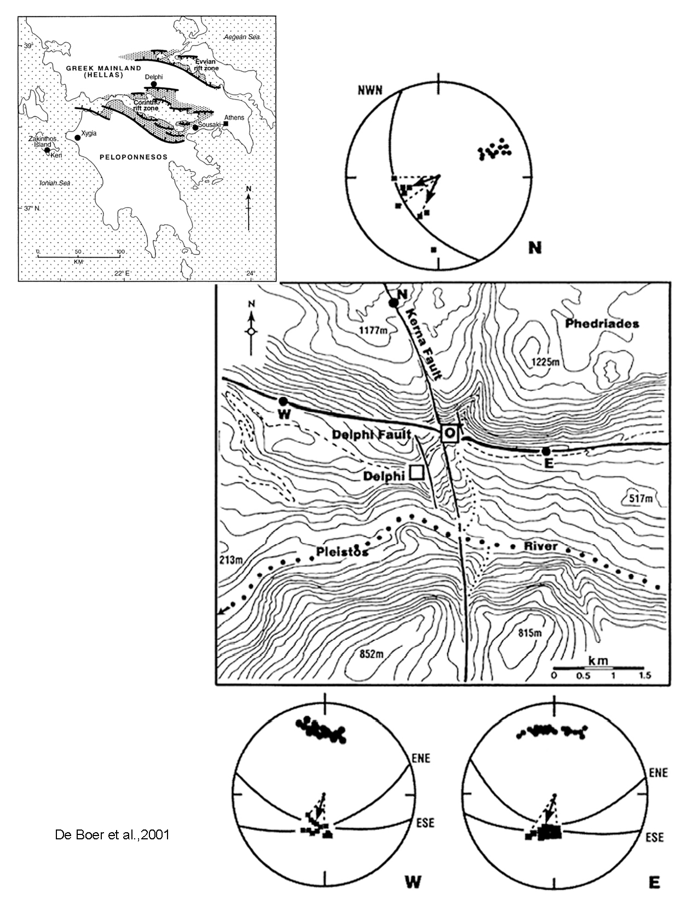
The famed Delphic Oracle of Ancient Greece was located in a temple lying at the intersection of two major faults in the vicinity of Delphi, Greece (see map below). Work by de Boer et al. (2001) proposes the intriguing hypothesis that groundwater with dissolved ethylene percolated upward along the fault intersection and that release of ethylene at the Oracle spring was responsible for inducing a trance-state in the Pythia (the woman at the Oracle who uttered the prophecies).

The figure at right shows two location maps plus stereonet data collected by deBoer et al. The stereonets each show either one or two planes plotted as great circles. If one great circle is plotted, it represents an average orientation for the fault. If two great circles are plotted, it indicates that field measurements of fault strike and dip range between the two values. The top stereonet is for the Kerna Fault. The left and right ones at the bottom of the figure are for the western and eastern portions of the Delphi Fault respectively. The poles to the fault planes are plotted as well.

The dots lying on or very near the great circles on the stereonets show field measurements that Jelle de Boer made on the trends and plunges of slip directions on each fault. Large areas of the fault surfaces are exposed in the field, and, although the article does not make it clear, de Boer likely measured features such as slickenlines (or perhaps slip fibers) on the fault surfaces to determine slip direction. The dots that plot on or very near the great circles for the faults in the diagrams represent the orientations of slip vectors.

The top figure on the page 3 shows the overall location of Delphi, as well as focal mechanisms for earthquakes in the Gulf of Corinth region. The bottom two figures show perspective views looking west (A) and NW (B) toward the main E-W Delphi Fault, which displays spectacular faceted spurs along the fault scarp.

Is the slip on the faults at Delphi consistent with the focal mechanisms for earthquakes in the larger Gulf of Corinth Region? Explain and provide convincing evidence.

How are regional plate motions in the eastern Mediterranean and Middle East manifested in the focal mechanisms in the Gulf of Corinth and the types of faults at Delphi?

Bonus: The Delphi and Kerna faults show minimal offset where they intersect under the Delphi Oracle Sanctuary. How can both be active without showing offset???

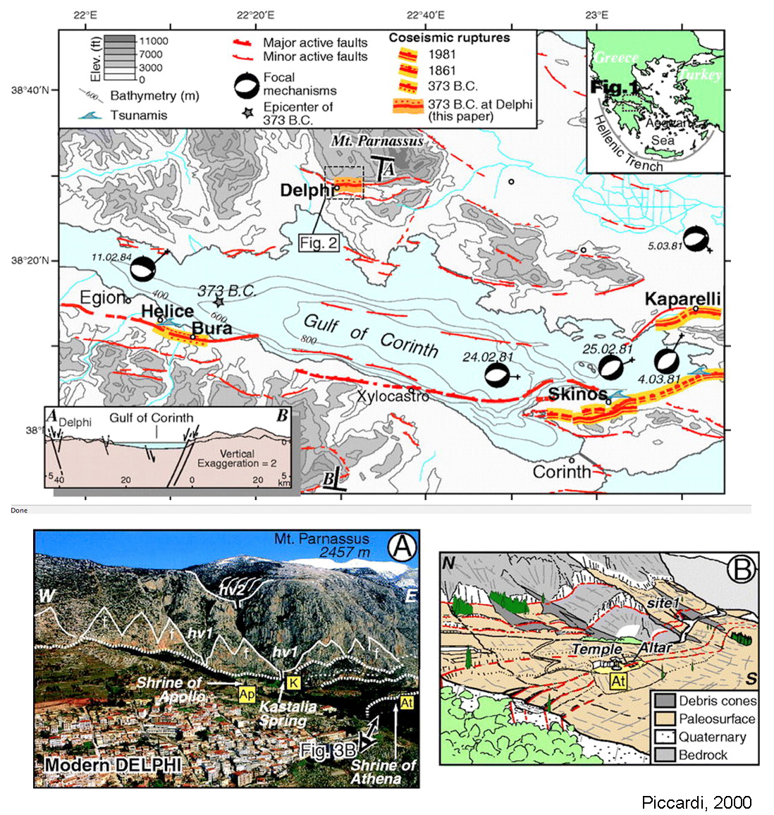

deBoer, J.Z., Hale, J.R., and Chanton, J., 2001, New evidence for the geological origins of the ancient Delphic oracle (Greece): Geology, v. 29, no 8, p. 707–710.

