EAS 423: Sedimentology and Stratigraphy
Measuring Sedimentary Structures for Paleocurrent Reconstruction
Objectives: Today’s exercise will incorporate several field data collection skills with some common analytical tools to help us develop our abilities to gain valuable information from sediment structures commonly found in our region. During this exercise, which will admittedly take more than just today, we will complete the following tasks:
- Use compasses in the field to measure sedimentary bedding and structures;
- Practice observing and sketching features at various scales;
- Take detailed, accurate field notes to document our data and experiences, including grain size and rock descriptions, stratigraphic relationships, and sedimentary structures;
- Compile directional (orientation) data using a Rose diagram;
- Use field measurements and rose diagram results for paleocurrent reconstruction.
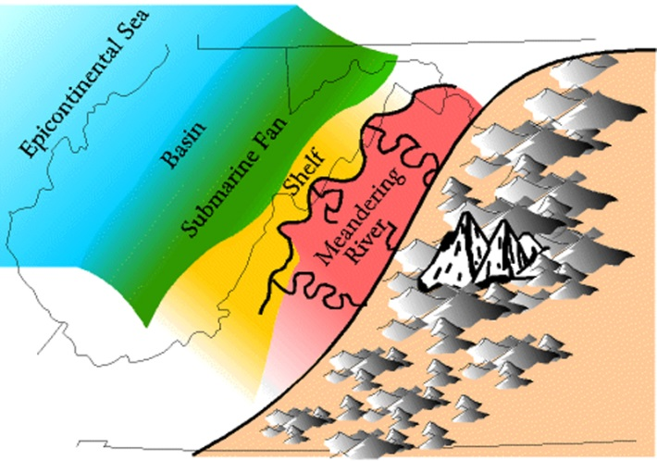
Background: As most of you know, the Allegheny Plateau and the Appalachian Basin are underlain by the Catskill Delta, which contains a diverse suite of sedimentary rocks, indicative of their depositional environment (Figure 1). During the late Silurian through the Devonian, the Acadian Orogeny built up an early stage of the Appalachian Mountains. Sediments were shed off the western slopes of this mountain belt into an inland sea, creating thick sequences of shales, limestones, and sandstones. Later, during the Pennsylvanian Period, these sediments were buried even deeper as Pangea was uplifting what we recognize as the modern Appalachian Mts. during the Alleghenian Orogeny. That is a lot of exciting geology! But how do we know all this?
Figure 1: Catskill Delta formation during Devonian Period. From SEPM STRATA, Society for Sedimentary Geology; Illustration by Lynn S. Fichter of the Department of Geology James Madison University, Harrisonburg, Virginia.
We’ve discussed basic sedimentology and stratigraphy at length, and the role that transgressions and regressions play in sedimentary environments. But there is more to the story which allows us to develop more detailed pictures of these past settings. Several of the rock units in our region preserve “paleocurrent” indicators. These are structures within the bedding of larger sedimentary packages that give clues to the energy and direction of depositional mechanisms (wind, water, ice, and mass movements). One such unit is the Pottsville Sandstone (Pennsylvanian) which, fortunately for us, outcrops in several convenient locations in Ohiopyle State Park!
Because the Pottsville Sandstone represents a changing near-shore environment, we must first identify the sedimentary structures and what they imply. You should look for (and be able to define) the following:
- Laminar bedding
- Graded bedding
- Ripple marks (various types)
- Cross-bedding
In the Field: Previously, we’ve worked with Brunton and Silva compasses to measure strike and dip of units. We will be using these functions for this exercise to measure the general orientation of the Pottsville Formation within Ohiopyle State Park. However, we will also use our compasses to measure the orientation of the aforementioned structural features in the field.
We will begin our day at Cucumber Falls in Ohiopyle State Park. Review the map of the park, provided as Figure 2 at the end of this packet. Our goal is to make 3-4 stops, of at least 1-2 hours. At each stop, you are to complete the following in your field notebook:
- Note and describe your map location;
- Measure and describe the rock units in general;
- Sketch the outcrop, paying particular attention to those units that have evident sedimentary structures;
- Measure and describe present sedimentary structures, keying them to your sketches;
Work in groups of 2-3 in completing this exercise. Each student should be completing steps 1-3 on their own. However the measurements should be done as a group with one or two people alternating the measurement and the other student writing down the results.
In the Lab: Now that you’ve got your measurements, we’ll compile them into a Rose diagram (Figure 3). This is simply a circular bar graph (histogram) that allows us to display orientation data in a way that matches that data with its compass direction. Rose diagrams offer a quick, clear visual aid to draw conclusions about trends in our data.
Ask your instructor for as many Rose diagram blank sheets as you’ll need, based on the number of rock units you’ll be analyzing. We’ll go through this simple procedure as a group. Once you’ve completed the diagrams, choose the three which give the clearest indication of trends. Using these three “best” examples, complete the following tasks and write up your results as a historical reconstruction of the time/space of the Pottsville Sandstone on which we focused. Your write-up should be 2-3 pages, and should be heavy on connections between your field observations and your paleocurrent and paleogeographic interpretations.
Your write-up should include:
- A BRIEF introduction explaining the project and general geology of our site(s);
- Explanation of your site selection and Justification for these diagrams as the “best;”
- Results – an explanation of the data including (not in the page count) any tabular data as well as the rose diagrams themselves;
- Analysis of results, including the interpretation and significance of the findings;
- Conclusion that includes the implications of this site evaluation in the historical context of the region.
Write-ups will be graded on a 25-point scale, using the following criteria:
- Neatness and Clarity: 5 points
- Completeness: 5 points
- Geological Reasoning/Accuracy: 15 points

