Trilobite Ontogeny Lab

Trilobites, being arthropods, undergo ecdysis, and hence have an ontogeny characterized by discrete growth stages. As a result, we can track their ontogeny by looking at changes through those growth stages in a variety of individuals (a cross-sectional rather than longitudinal approach). You’ll be looking at the question of trilobite allometry through ontogeny and across phylogeny. You’ll be asked to make a variety of plots. You can make these in excel or on actual graph paper; I don’t care how you do it, but turn in your plots with your answers to the questions.

First, here are a couple of generic trilobite growth series. The first is sort of a generalization for trilobites; the second is a series of agnostid trilobites.

1a. Make plots showing age (as indicated by number of thoracic segments) against total length (cephalon-to-pygidium).

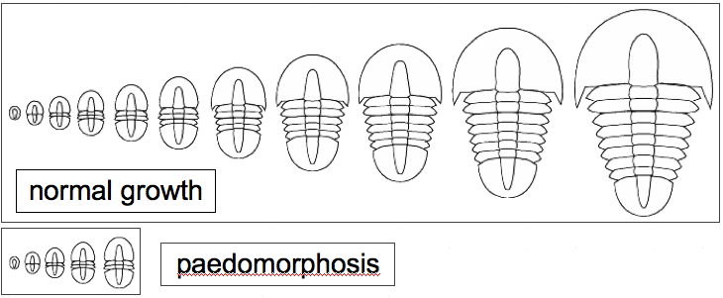

1b. How would you characterize the development of the agnostids relative to the generic trilobite pattern? Explain your answer.
1c. It is evident that the growth of the generic trilobite in the first series is not simply isometric; Choose a set of measurements to take to show how shape changes allometrically through the history of the trilobite illustrated here and use it to generate a plot of that allometric change. Explain your study, and describe how shape change is achieved in this animal.

2. Now, having described a couple of trilobite growth series, you get to design a little study of your own. For three of the species for which we’ve provided ontogenetic series, describe the evolution of the glabella, of the pygidium, and of spines through the ontogeny of the trilobite. Are any of these structures evolving allometrically relative to overall size? Is this allometry positive or negative? Do they change linearly with age, or is their change more complex? What is a reasonable explanation for the pattern you observe? Make sure you account for the fact that the images vary in magnification within each of the series. When you’re done, attach your plots and your explanation of what’s going on for each of the species.

References for ontogenetic series:
CLARKSON, E., AHLGREN, J, and TAYLOR, C.M. 2003. Structure, ontogeny, and moulting of the olenid rrilobite Cteopyge (Ectenopyge) angusta Westergard, 1922, from the Upper Cambrian of Vastergotland, Sweden. Palaeontology 46(1): 1-27.

DAI, T. 2013. Morphology and ontogeny of Hunanocephalus ovalis (trilobite) from the Cambrian of South China. Gondwana Research, 25(3): 991-998.

MCNAMARA, K.J., FENG, Y, and ZHOU, Z. 2006. Ontogeny and heterochrony in the Early Cambrian oryctocephalid trilobites Chanaspis, Duyunaspis, and Balangia from China. Palaeontology 49(1):1-19.

WHITTINGTON, H.B. 1959. Ontogeny of Trilobita, 127-145. In MOORE, R.C. (ed.) Treatise on Invertebrate Paleontology. Part O. Arthropoda 1. Geological Society of America & University of Kansas Press, Lawrence.

