Sedimentary Rock Descriptions and Scientific Communication

Name: ___________________________________________________

1. Part of being a professional geologist includes effectively describing what you observe. In the space provided write what you think and feel about your present personal ability to describe sedimentary rocks.

2. In your own words, describe why you think or feel reporting your observations to others is important in a professional context (as a practicing geologists or academic).

3. Write a thorough rock description for one of the rocks provided. Make sure your partner cannot see the rock during the description process!

4. After reading your peer’s rock description and attempting to identify the rock they described, what information do you wish you had about the rock that was not provided? Why?

5. Write some constructive criticism for your peer that explains what information was missing from your peer’s rock description, and explain why you needed to know that information to identify the unknown rock sample.

6. Reflect on the rock description you wrote for your peers. What should you have added to your rock description and why?

7. Do you find that the components missing from your peer’s rock description are similar to the pieces missing from your own rock description? Why do you think this is?

8. Over the course of the exercise how have your improved in your ability to write rock descriptions, and communicate geological data to your peers?

Sedimentary Rock Description Mechanics

Purpose:
This document is intended as a prompt or checklist you can use while describing sedimentary rocks so you cover the useful information in your rock descriptions.

Learning Goal:
Learn the component parts of a sedimentary rock description.

Introduction:
Describing sedimentary rocks is a basic geology skill that is expected of people employed in the earth sciences. As such you should know what should be included in a description as well as how to write one. The following list shows you what may be included in your rock descriptions, and is followed by advice for writing your descriptions. An example is provided for reference.

Things that can be Included in a Clastic Sedimentary Rock Description:

- Rock name
- Color
  - Fresh surface
  - Weathered surface
- Grain Characteristics
  - Size (range and mean)
  - Roundedness
  - Sphericity
  - Shape
  - Surface textures
  - Composition
  - Percent composition
  - Contacts
  - Deformation
- Texture
  - Grading
  - Sorting
  - Orientations/Imbrication
  - Matrix/grain supported
  - Bed/laminae thickness
  - Bed shape
  - Sedimentary structures
    - Primary
    - Secondary
  - Cement composition
    - Silica
    - Calcite
    - Iron oxides
    - Magnesium oxides
    - Etc…
- Contacts
  - Upper contact
  - Lower contact
- Effects of weathering
  - Physical
  - Chemical
- Special features
  - Fossils
    - Type
    - Abundance
    - Orientation
    - Taphonomy
  - Porosity/permeability
  - Fracture
  - Degree of induration
  - Weatherability (slope/cliff forming)
- Miscellaneous
  - Anything else useful

Writing a Rock Description:
Rock descriptions should be succinct because the goal is to communicate a vast amount of information quickly. They should be clear and directly support the name you gave the rock, and the interpretations you provide later in any analyses you perform. As such, cut out extraneous words, phrases, and make sentences densely packed with information. Ideally these descriptions will be dry and sterile. Start with a rock name and work from small scale observations to large, i.e. describe the clasts that make the rock, then the organization of the clasts (texture), followed by descriptions of bed scale features (bed thickness, upper and lower contacts, etc.), and weathering characteristics. Add in any other distinctive things about the rock that inform you about the rock’s formation process(es). Only include the information that is useful in interpreting the rock. That means you will not include everything from the list above. Keep in mind that the description should be just that, only a description. Do not interpret anything!

Example Rock Description: (The picture below is of this sample)
A tanish grey limestone pebble and cobble conglomerate comprised of coarse sand to cobble subangular irregularly shaped limestone clasts (30%). Sand and pebble clasts are angular equant lithic fragments (70%) with tangential contacts. A poorly sorted grain supported well indurated rock with calcite cement.
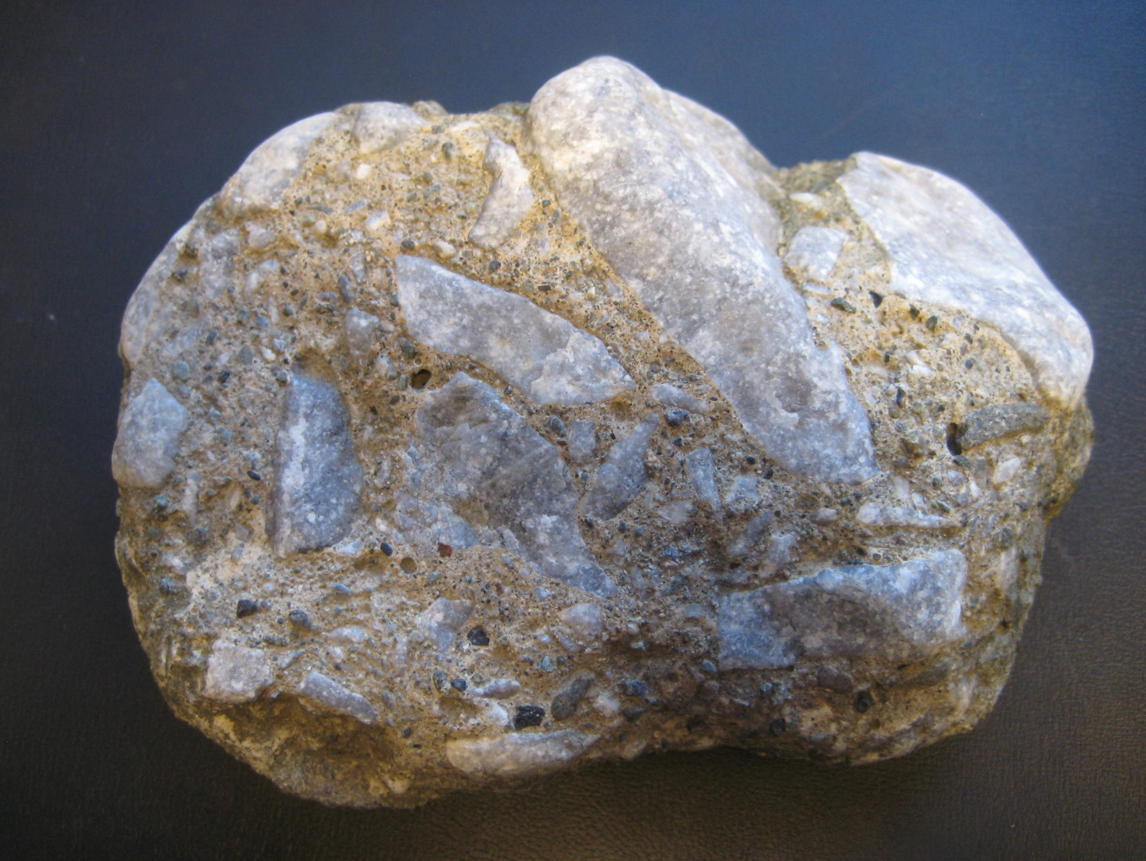
Common Mistakes:
Rock sample size is not useful. Mud/siltstones are well sorted by definition. “Very” and “a lot” are not useful. Composition is a function of transport AND/OR source rock. “This sample” is redundant.

