INTRODUCTION TO SEISMIC DATA I: WHAT IS A SEISMIC SURVEY?

Objective: This lab is the first in a three part series designed to introduce shallow seismic data. Seismic data is an important tool used by geologists and geophysicists to explore the subsurface. Although a comprehensive review of seismic acquisition and processing are beyond the scope of this undergraduate course, the following basic principles are important for a geoscientist to know:

1. Seismic Surveying – How is a 2D or 3D seismic volume oriented in space?

2. Seismic Interpretation – How is seismic data used to visualize geometries of rocks and fluids? What is the importance of travel time vs. depth?

3. Geological Application – How is seismic integrated with other data such as wireline logs or cores? How do geologists use seismic data in fields such as petroleum exploration?

Seismic data plays a critical role in the application of geologic principles to the subsurface. For example, Selley (1998) suggests that seismic data may be applied six different ways throughout the cycle of oil/gas exploration: regional mapping, prospect mapping, reservoir delineation, seismic modeling, direct hydrocarbon detection and the monitoring of petroleum production. Knowledge of seismic interpretation is a very practical skill. Moreover, it provides earth scientists the unique opportunity to ‘see’ into the subsurface!

The purpose of this lab is to introduce seismic surveys. You will use Google Earth and an open source seismic application, OpendTect, to investigate a 3D seismic volume from the North Sea.

Part I: LOCATION OF THE NETHERLANDS OFFSHORE BLOCK F3 SEISMIC SURVEY

The seismic survey you will work with is located in the North Sea. Let’s begin by exploring the geology via Google Earth. Be sure to check each step off as it is completed.

____ On your computer, open a browser window and navigate to www.opendtect.org. This is the home website of the software that we will use to view seismic data.

____ Along the top of the screen, select Products > Free Products > Share Seismic Data. Then, in the central right portion of the new page, select Download Surveys.

This will bring you to the Open Seismic Repository, which is a collection of free seismic data that OpendTect has made available for public use. Note that there are a number of free surveys – gas hydrates from offshore South Carolina, seismic lines from central Alaska, etc.

____ Select the first survey Netherlands Offshore F3 Block Complete 4GB. This will bring you to a page with information about the survey we will look at. Do NOT download the survey. It has already been loaded onto your machine.

____ Scroll through and read the information about the F3 Block seismic survey. Use this web page to answer the following questions.

Q1. What are the latitude and longitude coordinates for the Netherlands Offshore F3 Block?

__________________________________________________________________________________________

Q2. What year was this seismic data acquired? __________________________________________________

Q3. Read through the full survey description. What lithologies are present in the F3 seismic volume?

__________________________________________________________________________________________

__________________________________________________________________________________________

Q4. What is the interpreted depositional environment for these lithologies?

__________________________________________________________________________________________

__________________________________________________________________________________________

Q5. There are hydrocarbons (i.e., oil or gas) present in the seismic volume. What kind? What will they look like in the data?

__________________________________________________________________________________________

__________________________________________________________________________________________

Q6. How many wells have been drilled in this area? What types of logs are available with the wells?

__________________________________________________________________________________________

__________________________________________________________________________________________
Locating the Seismic Survey in Google Earth

____ Scroll back to the top of the information page. The coordinates of the seismic volume are listed under the general information. Select the option to view in Google Earth. This will launch Google Earth and bring up the location of the F3 volume.

____ In Google Earth, zoom out to see the location of the F3 Block seismic survey in a broader context. Locate the mid-ocean ridge that runs through Iceland and divides the Atlantic Ocean. Note the detail with which you can see the bathymetry of the ridge itself as well as transform faults that bisect the ridge.

Q7. Can you trace any of the transform faults into the North Sea? Why or why not?

__________________________________________________________________________________________

__________________________________________________________________________________________

Q8. On the figure below, from Overeem (2002), label the estimated location of the F3 seismic volume.
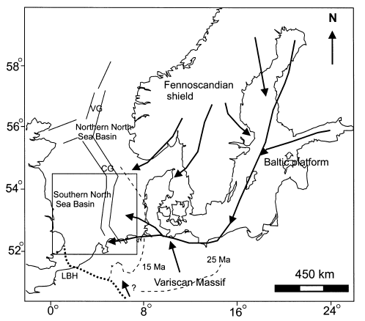

Q9. This figure shows the general geologic setting of the northwest European Basin. Arrows indicate sediment pathways through the basin. Dashed lines show old coastlines, labeled 15 Ma and 25 Ma. According to the figure, what is the dominant sediment transport direction for young sediments (< 25 Ma) in the F3 seismic volume? Circle your answer.

sediment moving west to east sediment moving east to west

Q10. What craton(s) are sediments in the F3 block sourced from?

__________________________________________________________________________________________

__________________________________________________________________________________________
Q11. In Google Earth, use the Tools > Ruler to measure the dimensions of the F3 Block in kilometers.

F3 seismic volume axis x (east-west): __________________

F3 seismic volume axis y (north-south): _________________

____ Once you have completed this section, you may close your browser window and/or Google Earth. The remainder of the lab will be completed using the OpendTect software.

Part II: VIEWING SEISMIC DATA IN OPENDTECT

Seismic data, most fundamentally, is a record of the amplitudes and travel times of compressional waves (p-waves) as they move through different media. Seismic processing refers to the techniques used to convert raw seismic data into a 3D volume. For example, processing can account for the distance of the signal receiver from the acoustic source; it can also remove excessive noise, etc. t’s important to note that the data you will view has already been processed.

____ To view the seismic volume, you will use an open source program called OpendTect. On your computer, navigate to the application OpendTect and launch it. Do not select extra plug-ins when prompted.
[Note: Your instructor may provide additional instructions on running the program.]

____ Once the application is open, choose Survey > Select/Setup from the top toolbar.

____ Select the F3_Demo Survey from the window and click OK. The seismic survey is now loaded for you to view in the main window.

____ In the Tree Scene on the left, click on the word Inline and select Add. A blank inline at position 425 has been added to the viewing window.

____ To display seismic data on the inline, right-click underneath the inline number (425) and choose Select Attribute > Stored Cubes > All Lines. Your screen should look like the one below.

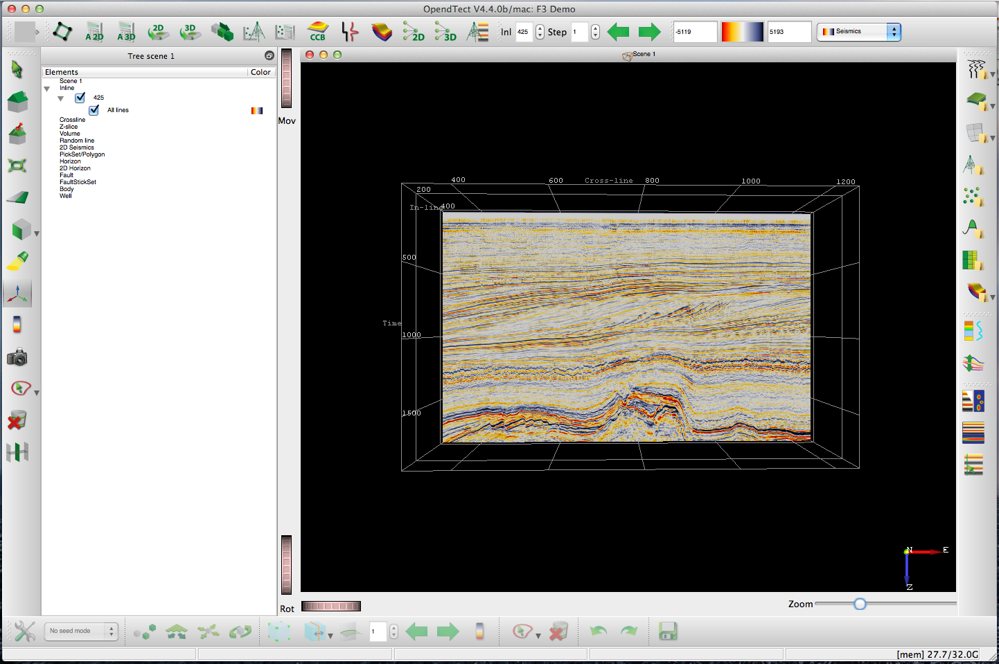

____ Inlines and crosslines are the x- and y- coordinates that seismic data is collected in. They may correspond to cardinal directions (north, south, east, west), but that is not always the case. In the lower right corner of the screen, locate the 3D compass.

Q1. Using the 3D compass, what is the general orientation of Inline 425?

__________________________________________________________________________________________

Q2. Refer back to the map on page 3 and the discussion of sediment routing in the F3 seismic volume. Carefully study Inline 425. What direction is the sediment coming from? Are there stratal geometries in the seismic data that support your interpretation this?

__________________________________________________________________________________________

__________________________________________________________________________________________

Q3. The z-axis is the vertical axis. Is this axis in time or depth in the Block F3 volume? What might the units of measurement be?

__________________________________________________________________________________________

____ Refer to the instructions on the previous page to display a crossline in addition to the Inline on your screen. In general, note that crosslines and inlines will be added in the center of the seismic volume.

Q4. What is the number of the new crossline? ___________________________________________________

Q5. What is the general orientation of crosslines in the F3 seismic volume? _________________________

To navigate in the seismic display window, you have two options. Try each option below.
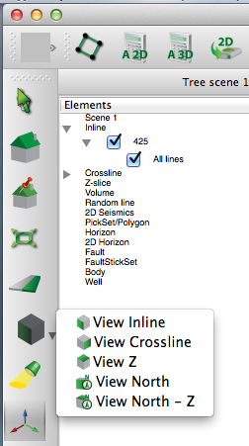
____ First, you may select the green arrow in the upper left corner,
shown to the right. After selection, the arrow will turn into a white
hand and you can freely rotate the view by holding down the left
mouse button.

____ Alternatively, you may hover over the green-sided box (also
at right) and the following options will appear: View Inline, View
Crossline, View Z, View North, View North Z.

____ Change the orientation to View North Z. You will notice that
the Z axis is perpendicular to your inlines and crosslines so they
do not appear.

Q6. Change the orientation to View Inline. Why does the
crossline you have displayed seem to disappear?

___________________________________________________

___________________________________________________

To change the displayed Inlines and Crossline, there are also two options. Try each option below.

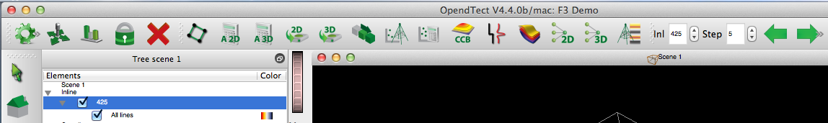

____ First, you may select the white hand in the the upper left corner (same button as used for navigation). The pointer becomes an arrow in the display window. Left click on either a crossline or an inline, and then drag the line to a new position within the seismic volume. The data on the new line will load - - this may take a minute. Do not try to navigate lines rapidly. This will cause the program to crash as it tries to load the data.

____ Alternatively, you may use the toolbar on the top of the screen to select a specific inline or crossline. First, be sure the line is selected (highlighted) in the Tree Scene. Then, define a line number in the box shown below and click enter. If you would like to move through the data in intervals, e.g., to look at every 5th crossline, use the Step tool with the green arrows.

____ Each seismic survey covers an area that will be defined by inlines and crosslines. Use the navigation tools you have learned to move through the seismic volume and answer the following questions.

Q7. What is the range of inlines in this seismic volume?

__________________________________________________________________________________________

Q8. What is the range of crosslines in this seismic volume?

__________________________________________________________________________________________

Congratulations! You have completed an overview of seismic surveys.
The next lab in this series will focus on seismic interpretation.

