GEL 341 Geomorphology Laboratory 8
Karst Landscapes of the Interior Low Plateaus
The Mississippian Plateaus of Kentucky and Mammoth Cave

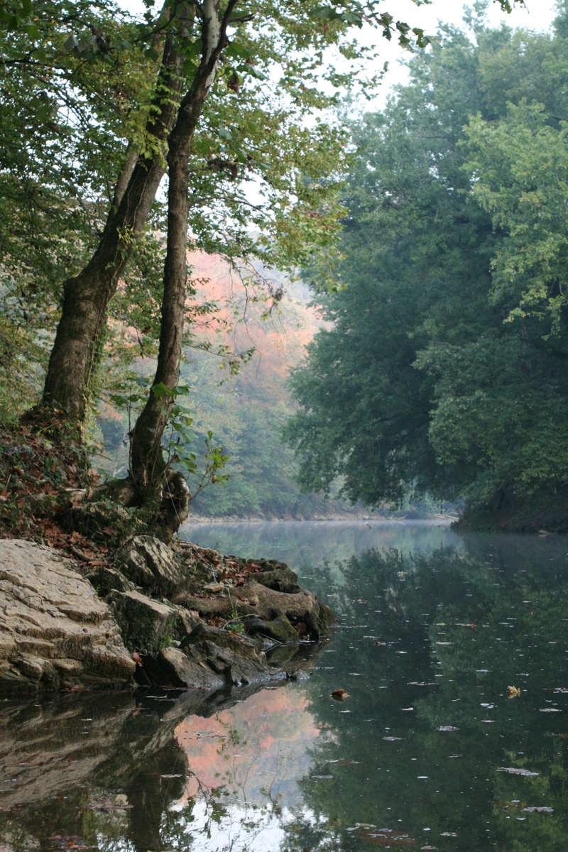
The Green River at Turnhole Bend in Autumn
Photo Credit: National Park Service

Name
Date:
Lab Section:

The Interior Low Plateaus
The Interior Low Plateaus region is the unglaciated eastern portion of the Interior Plains physiographic Province ( http://tapestry.usgs.gov/physiogr/physio.html ). The Interior Low Plateaus of Kentucky (Fig. 1) consist of complex dissected plateaus and low-relief plains (Newell, 1986). The Cincinnati Arch (Fig.2), a broad, low-relief anticline that marks the former position of the Acadian forebulge at the western flank of the Appalachian foreland basin, is a major feature in this region. The Nashville and Jessamine domes occur along the axis of the arch in Tennessee and Kentucky (Fig. 2). Physiographic subregions in Kentucky are often bounded by cuestas that form along the flanks of the arch.

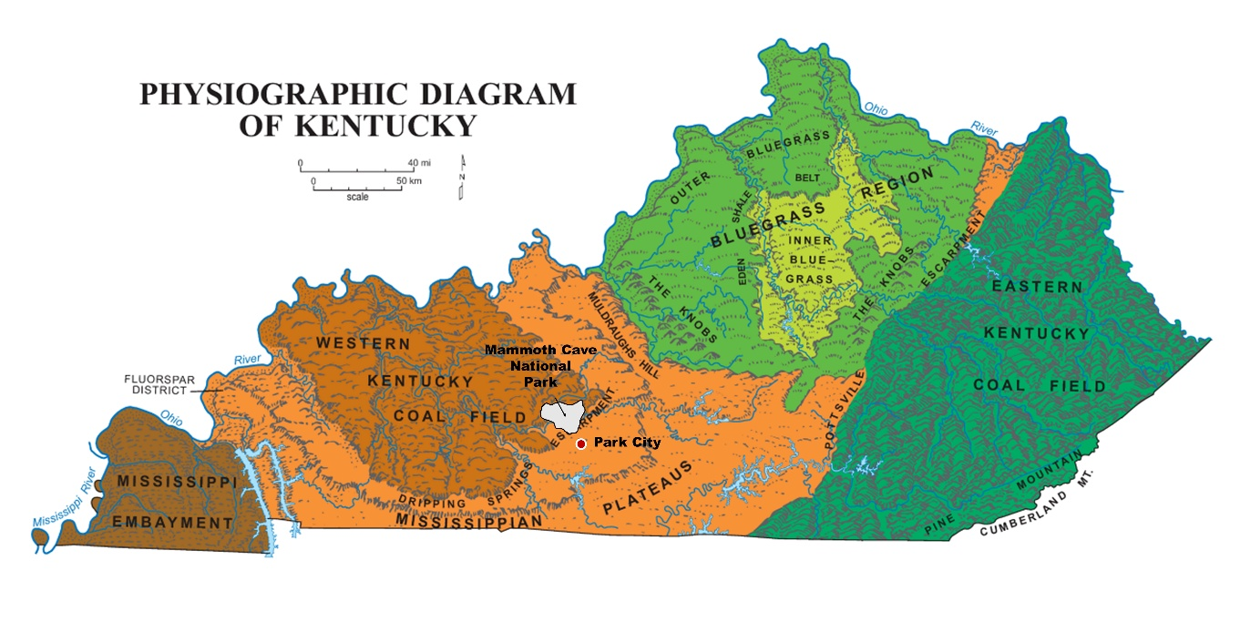
Figure 1. Physiographic map of Kentucky (image: Kentucky Geological Survey).
The Mississippian Plateaus of central Kentucky (Fig. 1) form a horseshoe-shaped upland region that is underlain primarily by Mississippian-aged limestones. The upland surface, also known as the Pennyroyal Plateau, is a low-relief karst landscape (Fig. 3) created by the dissolution of the underlying limestone (Newell, 1986). Its surface is pock-marked by sinkholes and is characterized by poorly developed drainage systems, sinking streams, elongate karst depressions (polje and uvalas) and small steep-sided hills or knobs of resistant limestone. Knobs commonly develop when insoluble rocks, such as sandstone, form resistant caps that protect the underlying limestone from erosion. Surface and ground water on the Pennyroyal Plateau drains via the Green River drainage system (Newell, 1986). The Dripping Springs escarpment separates the northern Pennyroyal Plateau and the southern Western Kentucky Coal Field (WKCF) subregion (Fig. 1). The WKCF is a hilly plateau of moderate local relief (50 to >100 meters) that is capped by the Big Clifty sandstone (Fig. 4) and rises more than 60 meters above the Pennyroyal Plateau.

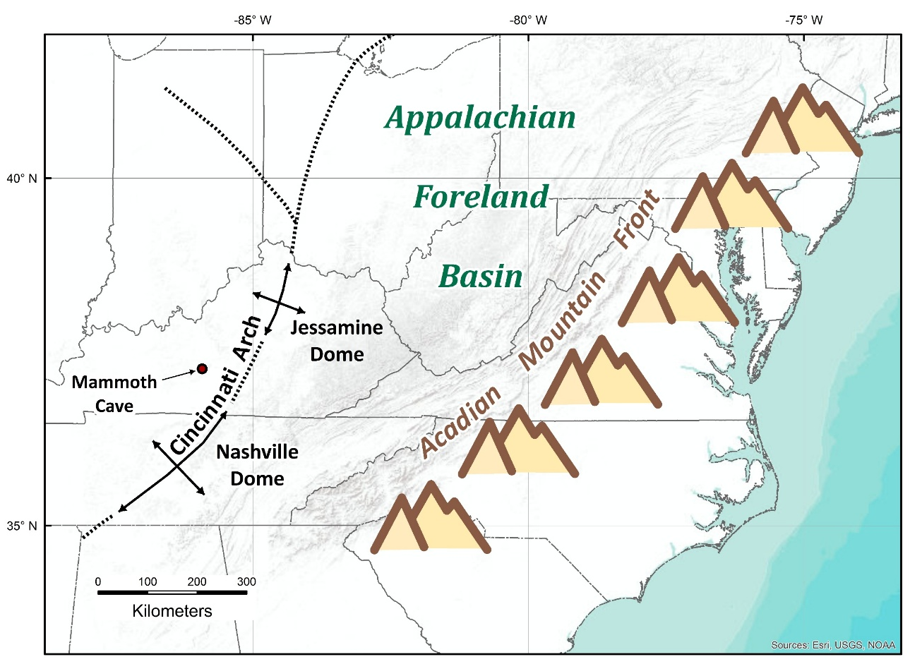
Figure 2. Physiographic map of the eastern Interior Lowlands the locations of the principal structural features of the Appalachian Foreland Basin (modified from Pope et al. (2009). Base map credit: ESRI, USGS, and NOAA).
  - Mammoth Cave
Mammoth Cave consists of more than 560 km of interconnected subterranean channels and passageways that encompass and area of more than 200 km² (Palmer, in Toomey and Olson, 2008). The cave underlies the Chester Upland along the southern margin of the WKCF. The cave is excavated in the St. Louis, Ste. Genevieve and Girkin limestones and is capped by the erosion-resistant Big Clifty sandstone (Fig. 4). The erosion-resistant caprock protects the underlying caverns from collapse (Palmer, in Toomey and Olson, 2008). The subterranean drainage system is fed by infiltration, sinkholes and sinking stream, some of which originate in the Pennyroyal Plateau Ray and Currens, 1998a, 1998b).

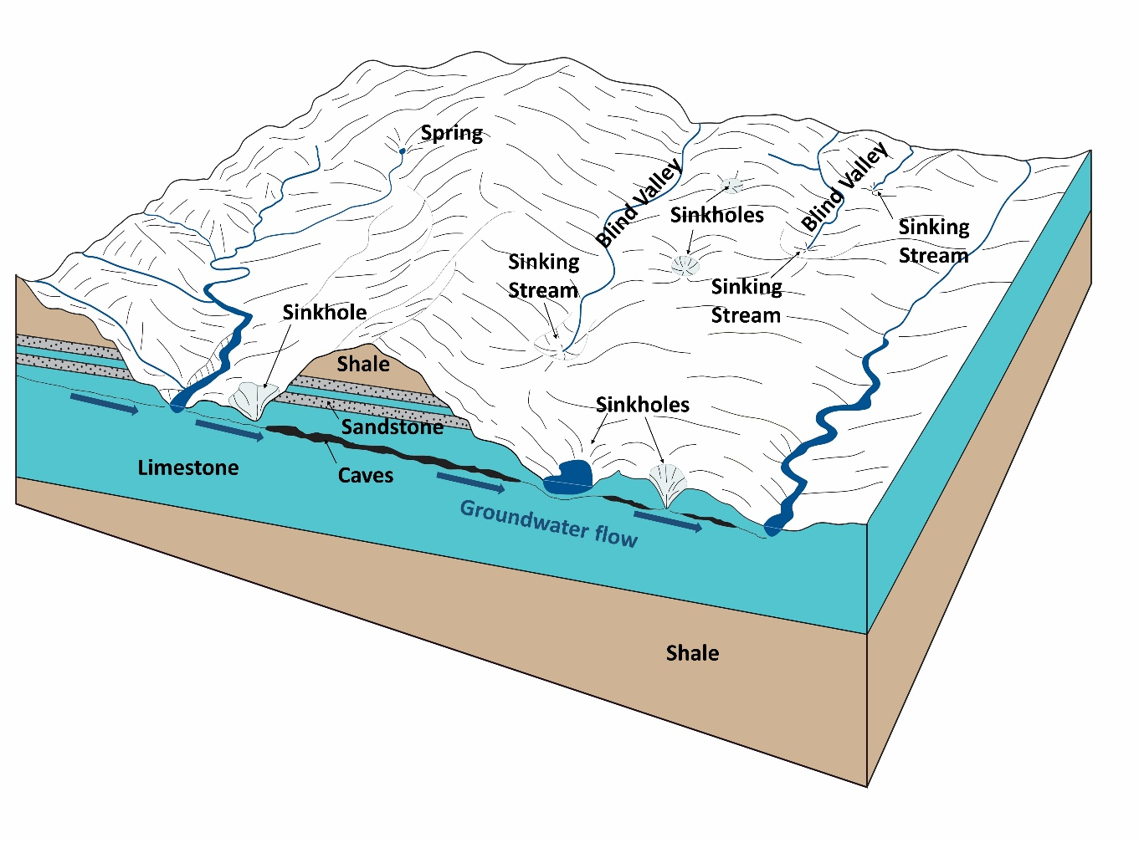
Figure 3. Examples of landforms found in karst terranes (modified from Llyod and Lyke (1994)).

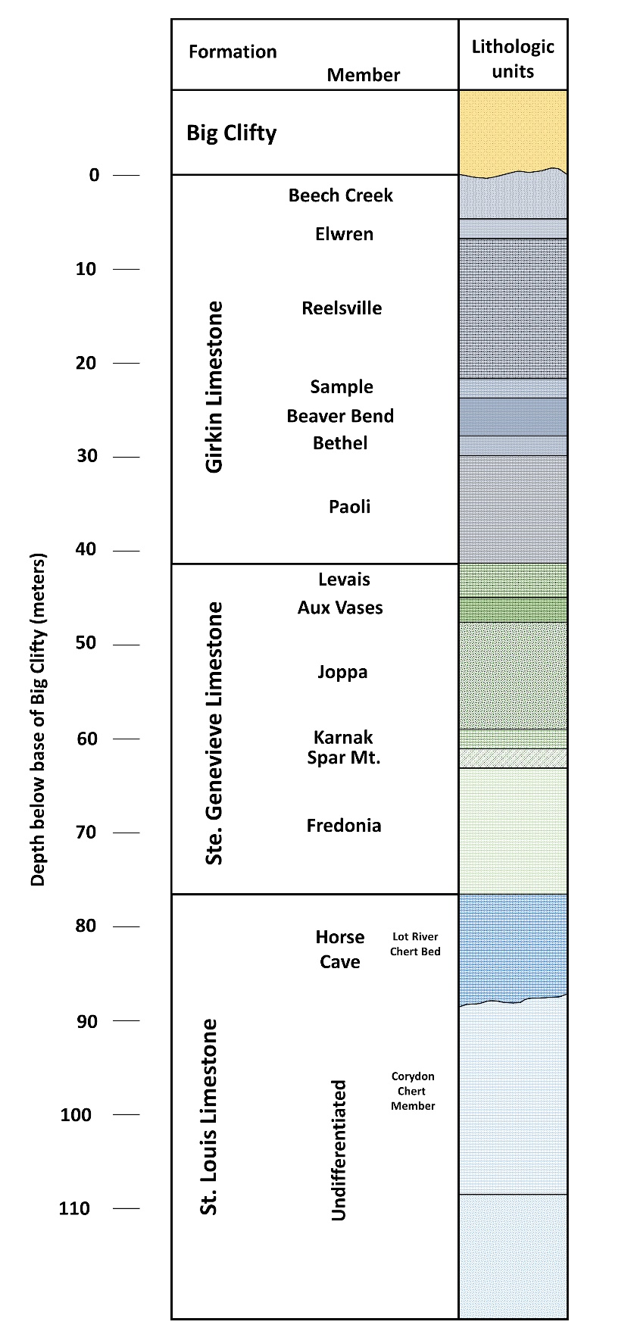
Figure 4. A generalized stratigraphic column for the Mississippian sedimentary rocks of the Mammoth Cave area (modified from Palmer, 1981).

Laboratory Exercise
This laboratory exercise examines the evolution of karst landscapes in the Interior Low Plateaus region. The lab examines geological controls on karst development, specifically focusing on the Pennyroyal Plateau, Chester Upland and Mammoth Cave, and the linkages between karst processes and climate change. By the end of this exercise you should be able to;
  - Extract morphometric data from GIS databases to measure linear dimensions, areas, volumes, elevation, relief and slope of landforms;
  - Construct shaded relief, slope and contour maps;
  - Construct topographic profiles and determine vertical exaggeration;
  - Digitize lines and polygons and create shapefiles;
  - Georeference unprojected raster images;
  - Export data from GIS databases for analysis by other analytical software (e.g. spreadsheets or modelling software)
  - Create accurate and effective graphics for presentations or final reports
< More Lab Report Information >
Laboratory Outline and Key Topics and Concepts
    - Introduction
      - The Appalachian Foreland Basin
      - Teays River
      - Controls on limestone dissolution
      - Karst landforms
    - Geomorphic Analysis
      - Surface and subterranean drainage systems
    - Geomorphic Synthesis
      - Vadose and phreatic groundwater flow pathways
      - Drainage changes in the Green River basin
      - Anthropogenic influences on karst ecosystems

Introduction
Geologic Setting
8-1 Describe the relationship between the craton, orogenic upland, a foreland basin and a forebulge (see Pope et al. 2009) as they pertain to the Mississippian stratigraphy in the central Kentucky karst region. Your explanation should clearly define these tectonic features. You may wish to create a diagram or paste a diagram of a foreland basin below. Be sure to properly cite all sources. | Rank | Wght | Score
 |  | 1

8-2 What was the Teays River, when did it exist and what was its relationship to the modern Ohio River? | Rank | Wght | Score
 |  | 1

8-3. Briefly discuss the major controls on limestone dissolution. | Rank | Wght | Score
 |  | 1

8-4. Briefly define the following karst landforms. | Rank | Wght | Score
 |  | 2

1. Clints (flackkaarren) and Grikes kluftkarren):

2. Sinking stream:

3. Collapse doline:

4. Solution doline:

5. Uvala:

6. Polje:

7. Tower karst:

8. Travertine:

9. Speleothems:

Geomorphic Analysis
8-5. In this step you will map the locations of the subterranean, and surface drainage systems near Mammoth Cave. When completed your map should depict the Mammoth Cave subterranean drainage basin and stream lines, the existing surface drainage system (use the NHD hydrologic data provided) and the courses of dry valleys on the Chester Upland north of the dripping springs escarpment (Your instructor will provide some assistance with these steps). | Rank | Wght | Score
 |  | 4
Note: this step will be an important part of your discussion under the Gemorphic Synthesis section so take time and effort needed to make a good quality map.
Open ArcMap and upload the digital elevation model provided. Set the data frame projection to UTM, NAD83, Zone 12N. Upload topographic and orthoimage base maps from the Add Basemap and Add Data from ARC GIS online options in the Add Data tab.
Create a base map of the area around Mammoth Cave; approximately bounded by UTM NAD83, Zone 12N coordinates; 561000m E to590000m E and 4081000m N to 4120000m N. Use some creative judgment in the map format (e.g. orthoimage, topographic, or shaded relief) but you will add data to the map in subsequent steps so avoid making the map too busy with unnecessary lines.
Create a raster image file of Figure 1 from Glennon and Groves (2002) in tagged image format (.tif). Note: The original data for this figure comes from dye-tracer studies published by the Kentucky Geological Survey (Ray and Currens, 1998a, 1998b). Open the georeferencing toolbar and import the image to ArcMap. The file name should appear in the georeferencing toolbar dropdown box. Choose “fit to display” under the georeferencing options and the figure should appear on the screen. Georeference your raster image.
Create polygon and line shapefiles using the “create feature class” option in the data management toolbox. Name these files “hydropoly” and “hydrolines”, respectively. Add a field in the hydrolines attributes table that will allow you to assign a code to classify the river lines by type. Carefully digitize the drainage basin polygon and the river lines for the Mammoth Cave subterranean drainage basin. Add the files to your basemap (Fig. 5).
Locate and digitize the trends of the dry valleys on the Chester Upland (e.g. Woolsey Hollow, Owens Valley and Cedar Spring Valley).
Paste your map as Figure 5 in the space provided on the next page.
What do the stream-channel patterns and drainage densities in these regions indicate about the underlying bedrock? What do the stream-channel patterns and drainage densities in these regions indicate about regional controls on surface and ground water drainage (i.e. where are major sources (recharge areas) and sinks (discharge areas) for surface and ground water runoff)?

Figure 5. < add your caption >

Geomorphic Synthesis
8-6. Draw a NNE-SSW oriented topographic profile through Pilot Knob (573608m E, 4099174m N) and Turnhole Bend on the Green River. The profile should extend from the uplands north of the Green River (575171m E, 4117835m N) to a point south of Barren River (572345m E, 4083750m N). | Rank | Wght | Score
 |  | 3
Make the profile a geologic cross section by adding the geologic formations that occur in the subsurface.
Sketch in the water table and possible flow paths for vadose and phreatic ground water (refer to Palmer (1981, 1991) or Toomey and Olson (2008)).
Label the profile, determine its vertical exaggeration and paste it as Fig. 6 in your report. Mark the location of the profile on your base map (Fig.5).
Use figures 5 and 6 to describe the relationship between ground and surface water drainage systems and the role they play in the formation of the large caves found in this region.

8-7. Describe the nature of the Green River Valley. What does the character of this valley indicate about the stage of development of this landscape? Is there evidence for renewed stream incision in this region? How might have the Green River been affected by Pleistocene drainage changes in the Ohio River basin? How might have these changes affected karst development (ref. Granger et al. (2001); Toomey and Olson (2008))? | Rank | Wght | Score
 |  | 3

Figure 6.

8-8. How might anthropogenic activities affect cave ecosystems or future karst development in this region (ref. Toomey and Olsen (2008)? | Rank | Wght | Score
 |  | 2

General Information on Laboratory Reports
< Back to Introduction >
Report Format
Geomorphology laboratory exercises follow the format of a technical report and consist of three sections; Introduction, Geomorphic Analysis (i.e. Results) and Geomorphic Synthesis (i.e. Discussion). Each section contains questions or tasks that address a unique aspect or perspective of the subject landform or landscape.
The introductory questions provided in this laboratory exercise are designed to review basic terminology and reinforce your understanding of the geologic setting and geomorphic evolution of the subject landscape. In a technical report the Introduction contains all the information the reader will need to understand the content and significance of the research being presented in the text. A good Introduction stimulates the reader’s interest in the research while a poor one may cause the reader to lose interest, even if the research and its conclusions are well founded and relevant.
The Geomorphic Analysis section examines specific landforms or landscapes in the region. The word “analysis” refers to breaking an entity apart for the purpose of examining its essential components. It is in this section that you will be asked to do most of the quantitative measurement of the landscape elements. It is not necessary, or even desirable, to include all the results obtained during the course of the investigation. Carefully summarizing the data to emphasize important relationships will help to make this section more readable and informative. The effective use of figures, tables and graphs often benefits the overall presentation. The text should address the important results without reference to interpretations, opinions or speculation.
The Geomorphic Synthesis section is where you attempt to integrate and interpret the results of your analysis. From a geomorphic perspective, the word synthesis refers to bringing together the constituent pieces of landform information into a comprehensive model for system function and landscape evolution. The questions in the synthesis section generally carry high point value because they are the best gauges of your knowledge and understanding of the subject.
Grading Rubric
The answers to each question or task will be evaluated on a four-point scale i.e.; 4 = exemplary, 3 = proficient, 2 = satisfactory and 1 = unsatisfactory; and that rank will be multiplied by a weighting factor to obtain the total score for the question or task. Your answers must be accurate, succinct and should convey your level of understanding of the subject. Some primary reference material has been provided to help you and it is strongly recommended that you consult these materials before immediately browsing to an online source.
The laboratory should be well organized and neat before you submit it for grading. Be aware that as you enter information into the laboratory report the document’s layout may change. Eliminate large blank areas and, if possible, reformat figures and tables so they display neatly on a single page.

Citations
You must acknowledge all sources of information that are not your own. Several conventions are used to cite published sources of information. The Geological Society of America uses the “Name and Year” system as demonstrated throughout this document and in the in the references section at the end of this document. Online sources of information can be cited using the Harvard referencing style.
Figures and Tables
Figures refer to any graphical depiction of data such as line drawings (diagrams), graphs, photographs or maps. Figures should be numbered sequentially, with Arabic numbers, and have a caption that describes their content. The figure number and caption are generally placed immediately below the figure. Avoid using figure titles. All of the figure information should be contained in the caption. Figures should be placed in the document after their reference in the text to avoid confusing the reader. For example, you should not have a figure on page 5 that is first referred to on page 6.
A table is a compact, orderly list of related facts, figures, or numerical data generally arranged in rows and columns. Like figures, tables are numbered sequentially and have concise captions that describe their content. They should be placed in the document after their reference in the text with the number and caption immediately above the table.
References
References Cited
Glennon, A., and Groves, C., 2002, An examination of perennial stream drainage patterns within the Mammoth Cave watershed, Kentucky. Journal of Cave and Karst Studies 64(1): 82-91.
Granger, D.E., Fabel, D., and Palmer, A.N., 2001, Pliocene‒Pleistocene incision of the Green River, Kentucky, determined from radioactive decay of cosmogenic 26Al and 10Be in Mammoth Cave sediments: Geological Society of America Bulletin, v.113, No.7, p.825-836.
Lloyd, O.B., and Lyke, W.L., 1995, Groundwater Atlas of the United States: U.S. Geological Survey Professional Paper HA-730K, pp.66-101.
Newell, W., 1986, Physiography, in McDowell, R.C. (ed.), The Geology of Kentucky‒A text to accompany the Geologic Map of Kentucky; U.S. Geological Survey Professional Paper 1151-H, 69p.
Palmer, A.N., 1981, A geological guide to Mammoth Cave National Park: Zephyrus Press, Teaneck, NJ, 196p.
---------------, 1991, Origin and morphology of limestone caves: Geological Society of America Bulletin, v.103, No.1, p.1-21.
Pope, M.C., Holland, S.M., and Patzkowsky, M., 2009, The Cincinnati Arch - a Stationary Peripheral Bulge During the Late Ordovician: Swart, P.K., Eberli, G.P., and McKenzie, J.A., eds., Perspectives in Carbonate Geology, IAS Special Publication 41 Honoring Bob Ginsburg, Sussex, UK, p. 255-276.
Ray, J.A. & Currens, J.C., 1998a, Mapped karst ground-water basins in the Beaver Dam 30 x 60 Minute Quadrangle, Kentucky Geological Survey.

---------------, 1998b, Mapped karst ground-water basins in the Campbellsville 30 x 60 Minute Quadrangle, Kentucky Geological Survey.
Toomey, R.S., and Olson, R., Mammoth Cave National Park Tour; Proceedings of the 2008 U.S. Geological Survey Karst Interest Group, Bowling Green, Kentucky, May 27-29, 2008, (USGS Scientific Investigations Report 2008-5023), p.117-138.

Other Sources
(under construction)

This section is being revised to include more information about the origin of limestone caves.

