Postprocessing Base Station Position
Sharon Bywater-Reyes (University of Northern Colorado)
Adapted from Static GPS/GNSS Survey Methods Manual Ian Lauer (Idaho State University), Static GPS/GNSS Data Processing with OPUS Manual Ian Lauer (Idaho State University), and Kinematic GPS/GNSS Methods Manual Ian Lauer (Idaho State University) Unit 2: Kinematic GPS/GNSS Methods https://serc.carleton.edu/getsi/teaching_materials/high-precision/unit2.html
This assignment accompanies materials from UNC’s 2020 Geoscience Field Issues: Using High-Resolution Topography to Understand Earth Surface Processes. Students will post-process data collected in a survey campaign to establish a base station at Sheep Draw (Greeley, CO – see Sheep Draw Vignette and Field Site video). Students interpret the associated result that was used to establish a control point for a kinematic survey used in placing ground control points for a drone flight used in Sheep Draw Structure from Motion activity).

Overview of Survey-Grade GPS: Static vs. Kinematic Survey

Static
- Static GNSS surveys deliver the highest-accuracy positions available in a system and rely on long occupation times to produce high-accuracy positions. A static survey typically consists of a single receiver and antenna combination, which individually records satellite observations that are post-processed, in our case with
- When the survey is complete, data is downloaded from the receivers, transformed into a RINEX file, and processed using proprietary software or a service such as OPUS (Online Positioning User Service).
- Static surveys occupy a single location for occupation times ranging from 2 to 48 hours. When processed through OPUS, static surveys have a maximum accuracy of ~1–2 cm, depending on the quality and length of data collection.
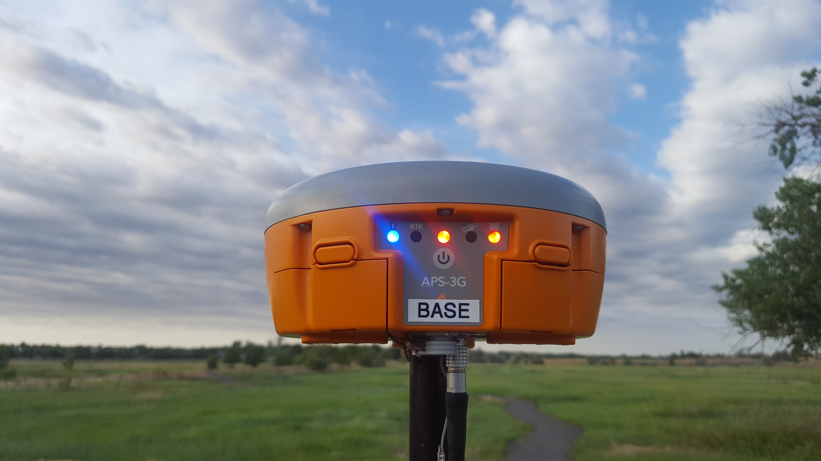
Using a Septentrio brand receiver, Dr. Bywater-Reyes occupied a point for >4 hrs such that an OPUS solution could be determined for a future kinematic survey to establish ground control points. The Base Receiver was set up over a survey marker and data collected for >4 hrs.

Kinematic
- Kinematic GNSS surveys are used to rapidly collect large numbers of high-precision survey positions, which are post-processed against a static base station. The system is composed of a base station, a rover, and potentially a radio system.
- The basis of the kinematic system is a mobile rover, which takes initial positions, and a base station, which allows for corrections of the rover’s position. The rover is carried to each measurement site and is stabilized during a short occupation, typically 5–30 seconds, to acquire an initial position.
- The rover’s position is processed against the static base station’s position to remove several types of error including integer ambiguity and atmospheric delays. This results in a high-precision position for the rover on the order of several centimeters.
- Real-time kinematic surveys (RTK) take advantage of constant radio communication between a static base station and the roving antenna to provide signal correction for increased positioning accuracy of the rover in the field. The real-time correction has the advantage of processing and viewing corrected, centimeter-accuracy measurements in real time while in the field.
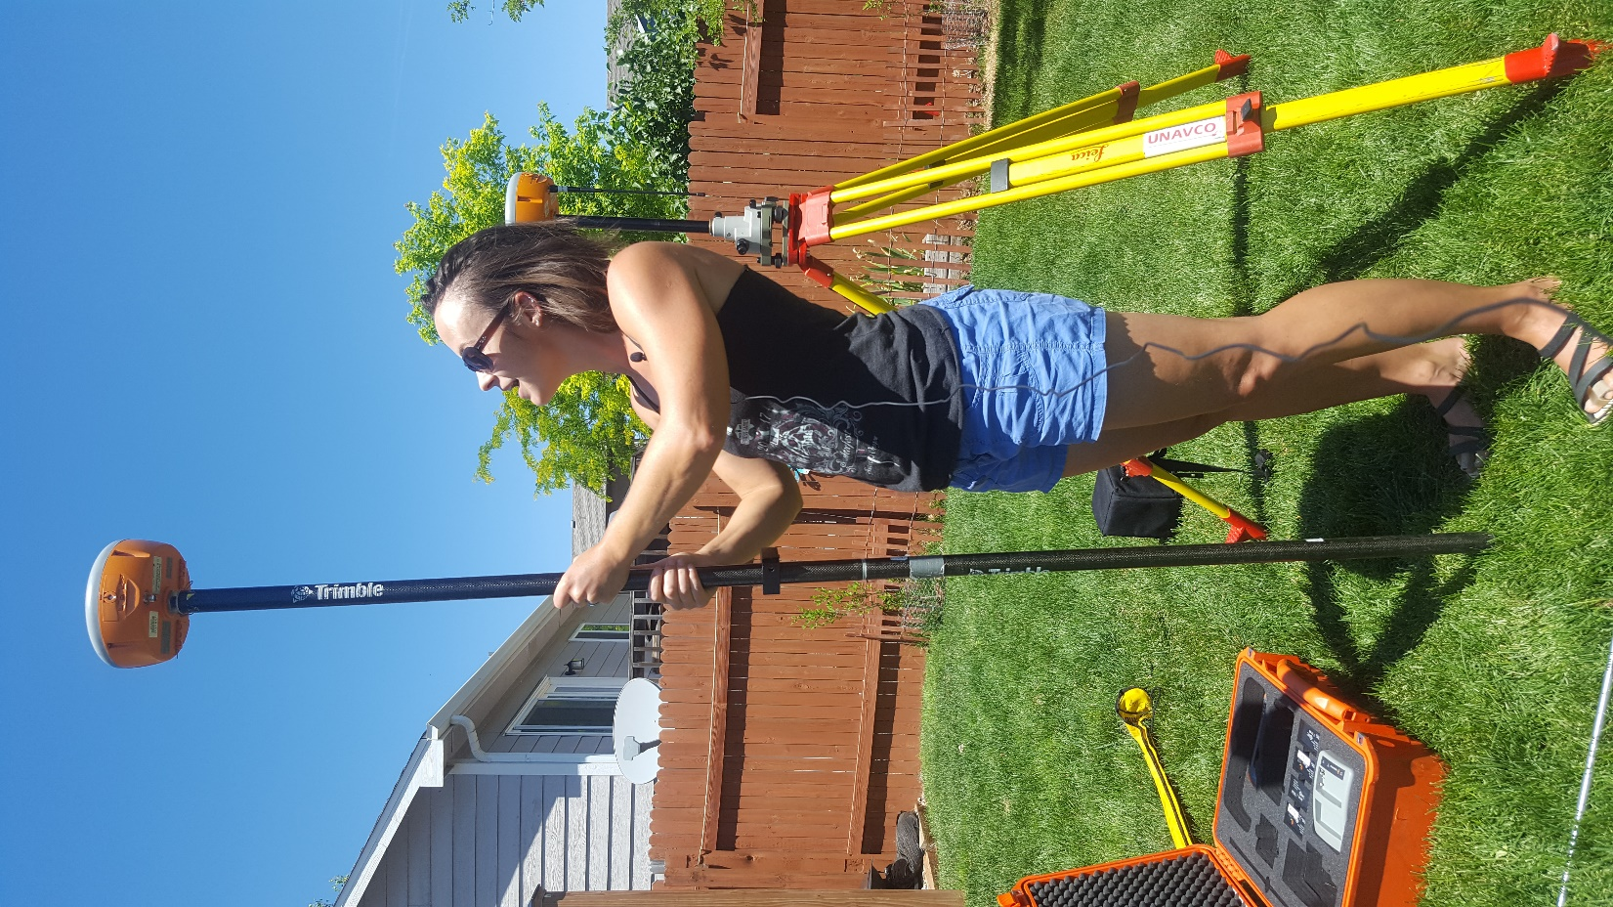

Using a Septentrio brand receiver, Dr. Bywater-Reyes and the UNAVCO team measured ground control points at Sheep Draw. With this rover setup, the Rover allows for collection of real-time kinematic (RTK) positions with cm accuracy.

Post-processing the Base fine for High-Resolution Coordinates

OPUS Solution
- OPUS (Online Positioning User Service) is a National Geodetic Survey (NGS)–operated system for baseline processing of standardized RINEX files into fixed positions.
- A GNSS survey records a string of positioning observations and metadata records that are typically stored in a proprietary format and converted to RINEX files.
- The RINEX files are uploaded to OPUS, and your survey’s observations are compared to known positions and observations recorded at CORS (Continuously Operating Reference Station). This establishes a baseline between your survey location and the chosen CORS site and allows errors in positioning to be minimized.
- OPUS then returns a single, corrected position for your observed location – this is the Base Station location in our case.
- You have been given the RINEX file (SHPD1700.20O) for the Sheep Draw Base Station
- Your job will be to post-process this file to get the high-resolution coordinates of the base station needed to conduct the RTK-GPS survey used to collect the ground control points for the drone flight we will use to construct a Structure from Motion (SfM) point cloud.

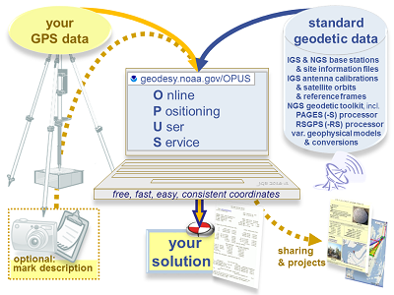
Image: Description of OPUS processing

Instructions
- Visit the OPUS webpage at https://www.ngs.noaa.gov/OPUS/.
- Select the observation file (RINEX) you are uploading.
- Fill out basic metadata, including the antenna model and antenna height.
  - The antenna model is APSAPS-3 NONE
  - You will need to calculate the CORRECTED antenna height about the reference point (Height of Antenna Reference Point, ARP), using the slant height measurement and correction equation, shown in the blue box:

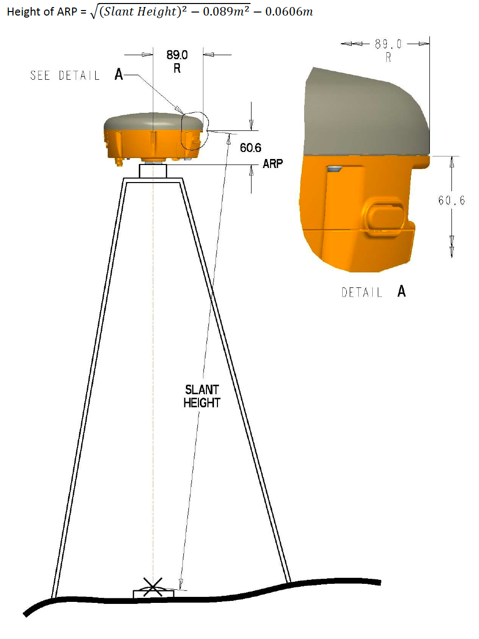
Image: ARP height correction using slant height measurement

The slant height is shown by the thumb mark, below (left), as is the entire measuring rod (in centimeters).

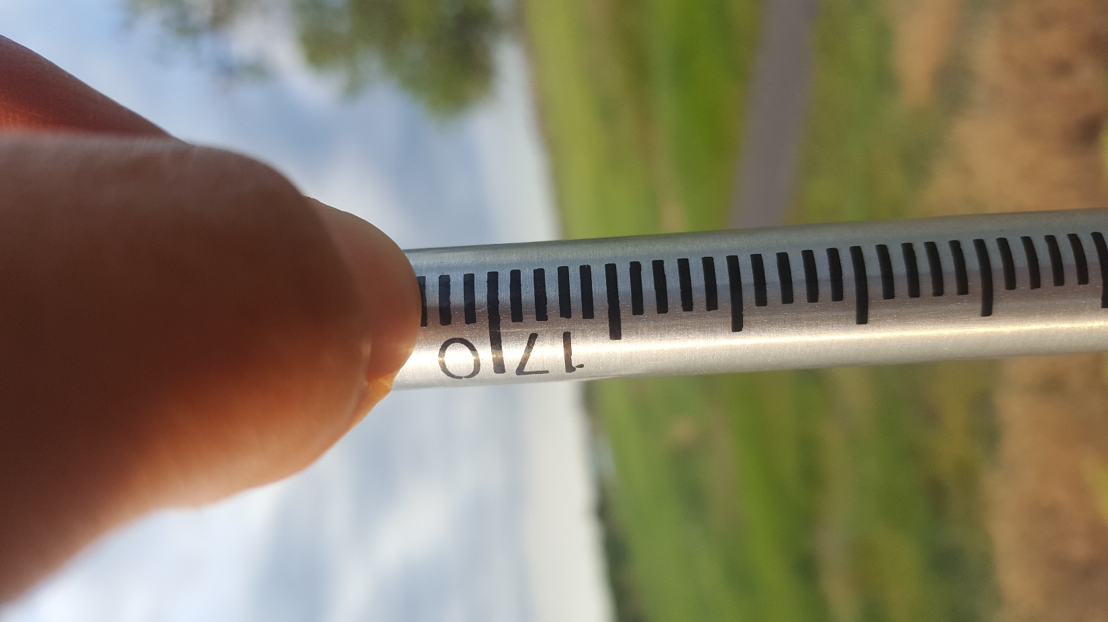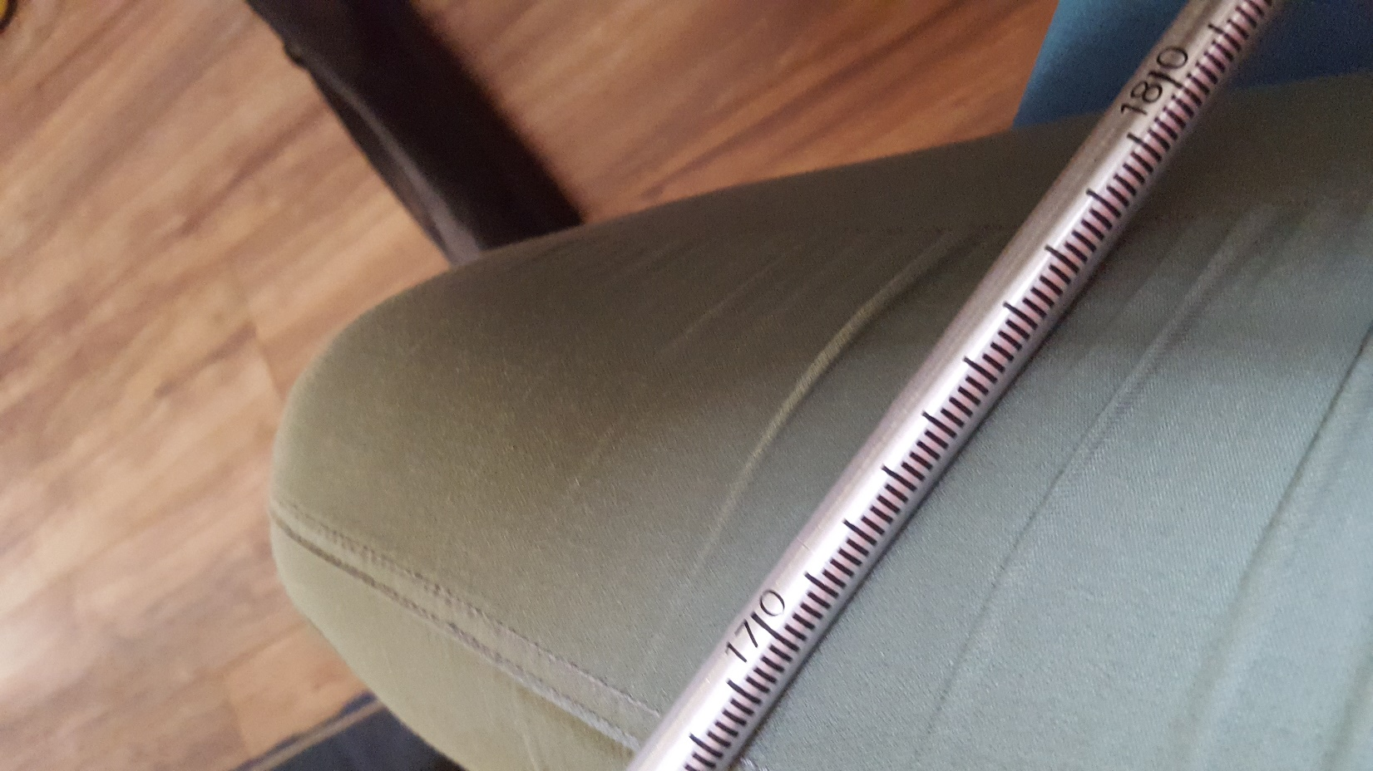

Record the following to help you get the Height of ARP

Large tick interval: _________________ (cm)

Small tick interval: ___________________ (mm)

Slant height:___________________________ (m; record to the nearest mm at least)

Corrected Height of ARP (use the equation):_________________ (m)
This is the value you need to enter in online when prompted for height.

- When you are finished, select static: 2–48 hours.
- You should receive an email within several minutes, but it may take several hours, if there is heavy traffic or you submitted a large file. The email will be either a position solution or a failure message.
- Locate your position on the report. Note that the report has positions in multiple systems, ellipsoid and orthometric heights, and errors.
  - We are using UTM Zone 13N
- Notice there is an example report on the OPUS website.

Assignment (10 pts)
Turn in your interpretation of the UTM coordinates, including:
Coordinate system:
Easting (m) +/- error
Northing (m) +/- error
Ellipsoid Height (m) +/- error
Orthometric height using Geoid 2018 +/- error
Paragraph explaining what you have done, what the data mean, the difference between ellipsoid height and orthometric height, and anything that was surprising or confusing to you. You may wish to look at the example solution on the OPUS website (referenced in slides) to help you interpret the solution. Write a robust paragraph with complete sentences. Review today's lecture notes and the videos linked in this module to review coordinate systems, projections, and GNSS as needed.

Day 2 Rubric - Postprocessing Base Station Position

This rubric covers the material handed in for Day 2 student exercise and is the summative assessment for the unit.

Component | Exemplary (75-100% points) | Basic (50-75% points) | Minimal effort (25-50%) | Nonperformance (0-25%)
General Considerations | Exemplary work will not just answer all components of the given question but also answer correctly, completely, and thoughtfully. Attention to detail, as well as answers that are logical and make sense, is an important piece of this. | Basic work may answer all components of the given question, but answers are incorrect, ill-considered, or difficult to interpret given the context of the question. Basic work may also be missing components of a given question. | Minimal performance occurs when students answers simply do not make sense and are incorrect. | Nonperformance occurs when students are missing large portions of the assignment.

