Magnetometry at home: a hands-on survey with your smartphone
by Carl-Georg Bank, Department of Earth Sciences, University of Toronto, Canada

your name: ______________________________

Geophysical surveys, including magnetometry, take advantage of contrasts in physical properties between targets in the subsurface and the material surrounding them. These property contrasts allow us to measure variations in some quantity at or above the surface and then interpret what may be present in the subsurface. My team has used magnetometry for example to locate buried firearms or to determine depth to bedrock or for a historical archaeology project.

What are other (maybe more common) targets for magnetometry? Do an internet search, or check a geophysics textbook, to find an interesting discovery that was made using magnetometry, and share it on the discussion board.

This exercise will allow you to think through the process of a magnetic survey; however it was designed during the COVID-19 pandemic so assumes minimal ability to move about. To accommodate your particular situation (are you able or allowed to leave your home? can you run a survey in the yard or the driveway if you live in a house? can you access a park?) you are asked to use a known magnetic target (a fridge magnet, a car, a fence, a lamp post) and measure its magnetic effect. The main goal of this exercise is to have you perform and document a survey. You will be completing a worksheet, and can look at an example we created from a tabletop survey (Toronto is under lockdown as I am preparing this). In a follow-up exercise you are given magnetic data that was collected in a field survey and will be analysing that by comparing it to a model you create. If you are lucky and have access to a backyard with a known buried target (for example a near-surface buried metal pipe) you can follow this exercise by running a survey there.

Learning outcomes:
This exercise will allow you to
1. select a target and design a magnetic survey,
2. collect field data (with field being very broadly defined) using a free app,
3. document your survey,
4. graph the data you obtained,
5. complete a simple quantitative analysis, and
6. communicate your findings.
Preparation

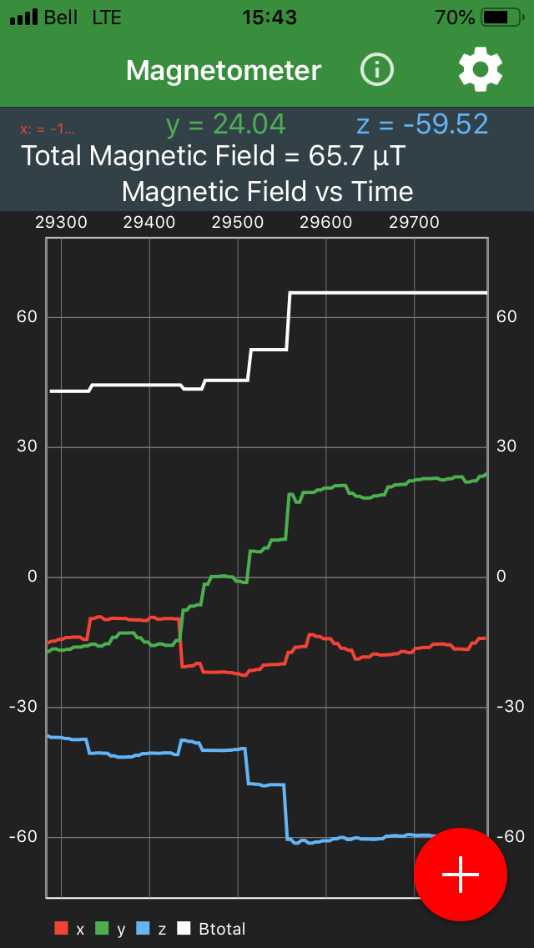
a) Download and install the free "physics toolbox" app, available for both Android and iOS devices (see https://www.vieyrasoftware.net/ for info and link to download). For this exercise you will just need the "Physics Toolbox Magnetometer" that you can download individually. You may be surprised how many sensors are included in your device: accelerometer, sound detector, barometer, GPS... though not all tools may be supported (eg, my iPad cannot run the proximeter).

b) After download, start the app. You should see a screen similar to the one in figure 1, the different colours mark the 3 components (x, y, z) and the total value of the magnetic field. By pressing the red button you can record the measurements and save them as a spreadsheet (.csv) file.

c) Print a copy of this worksheet (this would resemble working with a field notebook). You may also complete it on your computer device (if you can take the computer to your survey location and have a stylus, or you can scan and insert any drawings).
Figure 1: Screenshot of "Physics Toolbox Magnetometer" app

And here is a question to start you off:
What feature or app on your smartphone may make use of the built-in magnetic sensor?

your answer: _____________________________________________________

Brief background

Magnetic surveys allow us to locate buried objects or features if they distort the Earth's magnetic field that we measure at the surface or from an aerial vehicle. These objects can be either a permanent magnet or a material that acts like a magnet because it is within a magnetic field. A magnet can both attract and repel another magnet, and the direction of force around a magnet changes. We describe a magnet as a dipole and find that the force does not point towards the magnet and that it drops off with the cube of the distance if we move in a straight line away from the dipole. This exercise allows you to confirm this relationship.

Variations in the Earth's magnetic field that are caused by a buried magnetic object are called anomalies. Because of the dipole nature of magnets most anomalies are paired (that is a positive, larger than the ambient field, and a negative anomaly arise from the same target), and anomalies for similar objects will look different depending on the latitude where we measure them. This exercise does not explore such relationships, because some of you may have to run the experiment in a very "noisy" environment (I live in a downtown apartment building), and geophysicists use more sensitive magnetometers than that in your smartphone because they need to measure very small anomalies. If you want to learn more about magnetic surveys in geophysics check out http://appliedgeophysics.berkeley.edu/magnetic/index.html (Berkeley Course in Applied Geophysics) and/or https://www.eoas.ubc.ca/ubcgif/iag/methods/meth_3/index.htm (UBC Applied Geophysics Learning Objects), the latter includes some self-test questions.

A few background questions linked to magnetic surveying in geophysics:
- What is the difference between remanent and induced magnetization? How could you distinguish between the two on a magnetic map?
- Why do we need to know the latitude of our survey to make sense of the data?
- What are key processing steps typically applied before interpreting the data?
- What are key advantages and shortcomings of magnetic surveys?
- Can magnetometry surveys be used to find buried objects on other planetary bodies?
Please share your thoughts on the discussion board. Answers to these questions are not crucial to complete this exercise. Therefore you may think about them afterwards, especially if you are doing this exercise as part of an introductory geophysics course or if it will be followed by a field survey.
Task 1: What is the objective of your survey?

Most decisions (where to go, what equipment to take, how to set up, how large a survey) hinge on this question. In this exercise we ask you to collect magnetic data along a survey line. If you can go outside find something (a parked vehicle, a fence,...) and check with the magnetometer app that values are changing. Note that if you turn around on the spot, or tilt your device readings probably will change, so make sure you hold it steady while you explore for a target.
Briefly state your survey objective:

____________________________________________________________________________

Task 2: General considerations

It is a good idea to consider some general questions: what are the date and time of day? Who are you with? If you are outside, what is the current weather? What are the ground conditions (did it rain, covered in snow, muddy)? Anything else noteworthy before you start?

____________________________________________________________________________

____________________________________________________________________________

____________________________________________________________________________

Task 3: Documenting your location

Your need to communicate to another person the location (and layout) of your experiment as accurately as possible so they could exactly recreate your experiment.

3a) Handheld devices can provide your location. To find it on either iOS Maps or Google maps open the app, hold a finger on the screen at your location which "drops a pin" and scroll down (in Google maps) or tap "My Location" (in iOS) to view your latitude and longitude.
What are your GPS coordinates, and what did you use to determine them?

____________________________________________________________________________

3b) Describe your exact location in point form. If you are outside look around, are there any remarkable features (a corner in a fence, a large rock, an odd-shaped tree, buildings nearby) that can help someone else find the exact spot where you are?

____________________________________________________________________________

____________________________________________________________________________
3c) Are there any features that may impact your survey (power lines, parked equipment, buildings, mountain, canyon, closeness to industrial operation, airport)?

____________________________________________________________________________

____________________________________________________________________________

3d) Draw a map sketch of your location. This should include the features you noticed in 1b. Also include a scale and the North direction. Make your sketch large enough so you can add the layout of your experiment afterwards.

You now have documented your location in three ways: by GPS coordinates, in words, and by a sketch. This may seem redundant, but consider that these are complementary and all helpful for someone else to exactly recreate your survey.
Task 4: Setting up you survey

Typically in magnetometry the deeper the buried object is, the larger an area at the surface will be affected (ie. measurements deviate from the background reading, that is called an "anomaly") and you can space your data collection points further apart. In this exercise you are asked to work very close to the object (car, fence,...). Your preliminary survey (Task 1) should have shown you where the magnetic field starts to change. You should start your measurements further out to have a few data points for the background value, and aim for about a dozen measurement points (in easy to recreate metric steps). Note your thoughts for setting up the survey here

____________________________________________________________________________

____________________________________________________________________________

Add your survey setup to the sketch (Task 3d).

Task 5: Taking measurements

The magnetometer app can record the components and total value of the magnetic field with time. However, for more accurate positioning we suggest you use a tape measure (or take small steps, one foot touching the other, that can be recreated) and take screenshots at the intervals you predetermined (Task 4). It is crucial that you are able to link the screenshots to the position, unless you use a different device to take images that allow you that unique correlation between measurement and position.

5a) Please note here how you choose to make this correlation.

____________________________________________________________________________

5b) How accurate are your distance and magnetic measurements? To get an estimate of the latter you may repeat some measurements (to obtain an experimental error), and/or run a timeseries at a certain location to capture the random noise in the data. If you are surveying within a building or in a busy city that noise level may be substantial. The accuracy of your measurements are
for distance ___________________ estimated from ____________________

for magnetic data _________________ estimated from ____________________

5c) What are other settings someone else may need to reproduce your survey (ex: device is kept horizontally pointing towards target, device held at height of your hip)?

____________________________________________________________________________
Task 6: Viewing and analyzing the data

Now you can transcribe your data from the screenshots into a spreadsheet or textfile.

The name of your data file is _________________________

Create a plot of your data and copy it into this space (and if you can, add error bars using the info from Task 5b):

Give a brief description of your data (with a focus on the total field value). What are the highest and the lowest value? Where along your survey do they occur? What is the average (background) value? How far away do you start seeing the anomaly?

____________________________________________________________________________

____________________________________________________________________________

____________________________________________________________________________

Task 7: Preliminary interpretation

During and at the end of a survey the geophysicist will want to ensure good quality of the data. Often this is done with a quick and simple interpretation. For this experiment you can ask:

7a) Do the variations in Bx, By, and Bz values make sense? If yes, why?

____________________________________________________________________________

____________________________________________________________________________

7b) Does the decay of the total field with distance confirm with a simple model? It should follow a r⁻³ curve (see for example http://physicsinsights.org/dipole_field_1.html ). Recalculate your distance values as difference from the maximum, and your total field values as difference to the background value. Plot these recalculated values. Then try to fit a quadratic equation to those values. Show this combined graph.

Task 8: Archiving the data

Typically there will be some protocol for how raw data has to be archived during a field campaign (eg, in a daily directory that gets backed up). For this experiment I suggest you collate all spreadsheet data, copies of your screenshots (in this experiment these are your raw data) into one directory, and create a simple text file summarizing key information about the survey (when, who, where, how); I even suggest including a scan of your field notes (in this experiment this workbook).

Your raw data are precious. You want to have a backup of all your data and a backup of the backup to ensure that they cannot be accidentally overwritten, deleted, or lost. You or someone else may want to use your data much later when your memory is no longer fresh or they cannot get a hold of you.

Short reflection

What in this activity or your results surprised you?

______________________________________________________________________________

______________________________________________________________________________

Give three examples where geophysicists may use a magnetic survey:

1. ___________________________________________________________________________

2. ___________________________________________________________________________

3. ___________________________________________________________________________

Looking forward

Congratulations! You have run your first real geophysical survey even if you, like me, had to do it in your kitchen. You know now the importance of planning, documenting, controlling, and archiving your data and should feel curious how to work with data collected with a real geologic/archaeologic/environmental/... question in mind. If this is indeed your next step I encourage you to revisit the questions in the background section.

"Single-point" rubric to assess the Magnetometry at home exercise

for _________________________________

component \ level | developing | competent | excellent
objective  __ of 3 | 0-1 pt | 2 pts  - objective is logical  - objective is achievable | 3 pts
documentation  __ of 6 | 0-2 pts | 3-5 pts  - fieldnotes reflect pertinent considerations  - survey area seems clearly described (GPS, in point form, as map)  - sketch map includes features, scale, N arrow | 6 pts
survey  __ of 4 | 0-1 pt | 2-3 pts  - survey is included in sketch map  - survey parameters are obvious  - instrument settings are noted  - thoughts about accuracy of measurements are included | 4 pts
data plot  __ of 5 | 0-2 pts | 3-4 pts  - data graph follows convention (eg, units and labels on axes)  - data plotted correctly  - different components clearly identifiable | 5 pts
results and interpretation  __ of 3 | 0-1 pt | 2 pts  - preliminary interpretation is thoughtful  - reasonable match of total field values to a cubic decay curve | 3 pts
archive  __ of 4 | 0-1 pt | 2-3 pts  - directory contains all raw data with an explanatory file  - scan of field notes is included, or clear where to find  - image of quality control (and source file) may be included | 4 pts
total: __ of 25

Deng, E. A., K. O. Doro, and C-G Bank, 2020. Suitability of magnetometry to detect clandestine buried firearms from a controlled field site and numerical modeling, Forensic Science International, 314: 110396, https://doi.org/10.1016/j.forsciint.2020.110396
Papadimitrios, K., C.-G. Bank, S. Walker, and M. Chazan, 2019. Paleotopography of a Paleolithic landscape at Bestwood 1, South Africa, from ground-penetrating radar and magnetometry, South African Journal of Science, 115(1/2), Art. #4793, 7 pg., https://doi.org/10.17159/sajs.2019/4793
Wadsworth, W., C.-G. Bank, K. Patton, and D. Doroszenko, 2020. Forgotten Souls of the Dawn Settlement Project: A geophysical exploration of unmarked graves in Southwestern Ontario. Historical Archaeology, Vol 54, https://doi.org/10.1007/s41636-020-00251-7

