Introduction to Terrestrial Laser Scanning
Sharon Bywater-Reyes (University of Northern Colorado)

Overview
The first unit of this course introduced Structure from Motion (SfM) starting with an introduction and progressing through point cloud manipulation and classification. Today you will work with the same Cache la Poudre River at Sheep Draw site with the second method investigated in this class: Ground-based Light Detection and Ranging, also known as ground-based LiDAR or Terrestrial Laser Scanning (TLS)
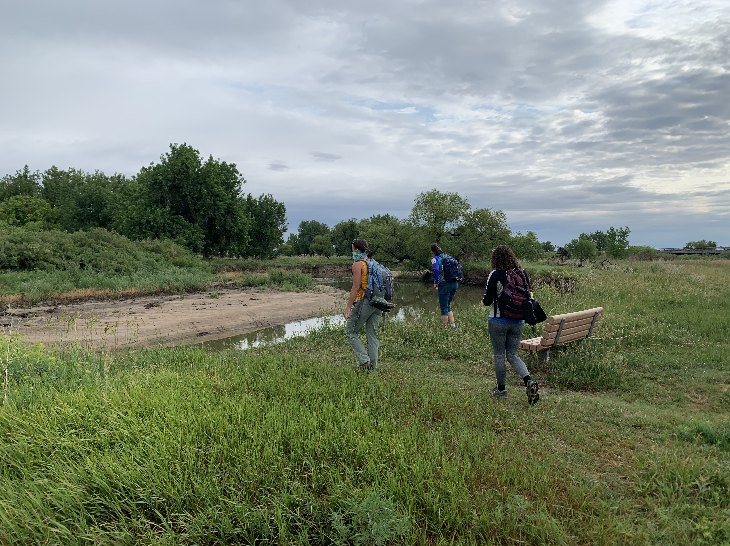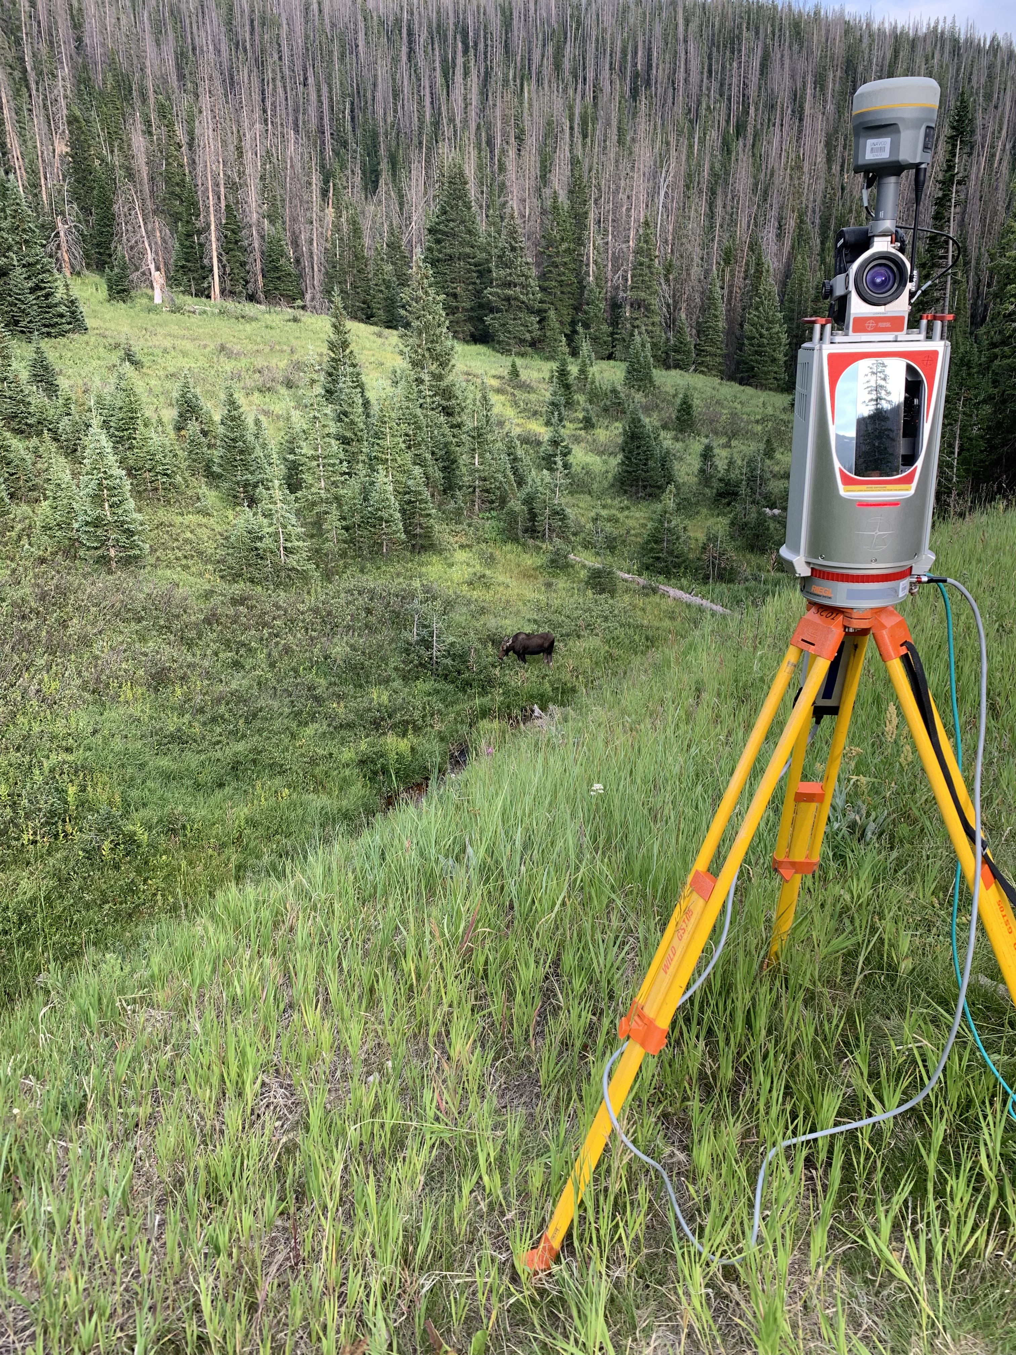

Left: Dr. B and crew look at Area of interest 2. Right: Scanner implemented with GNSS receiver for georeferencing.

Introduction
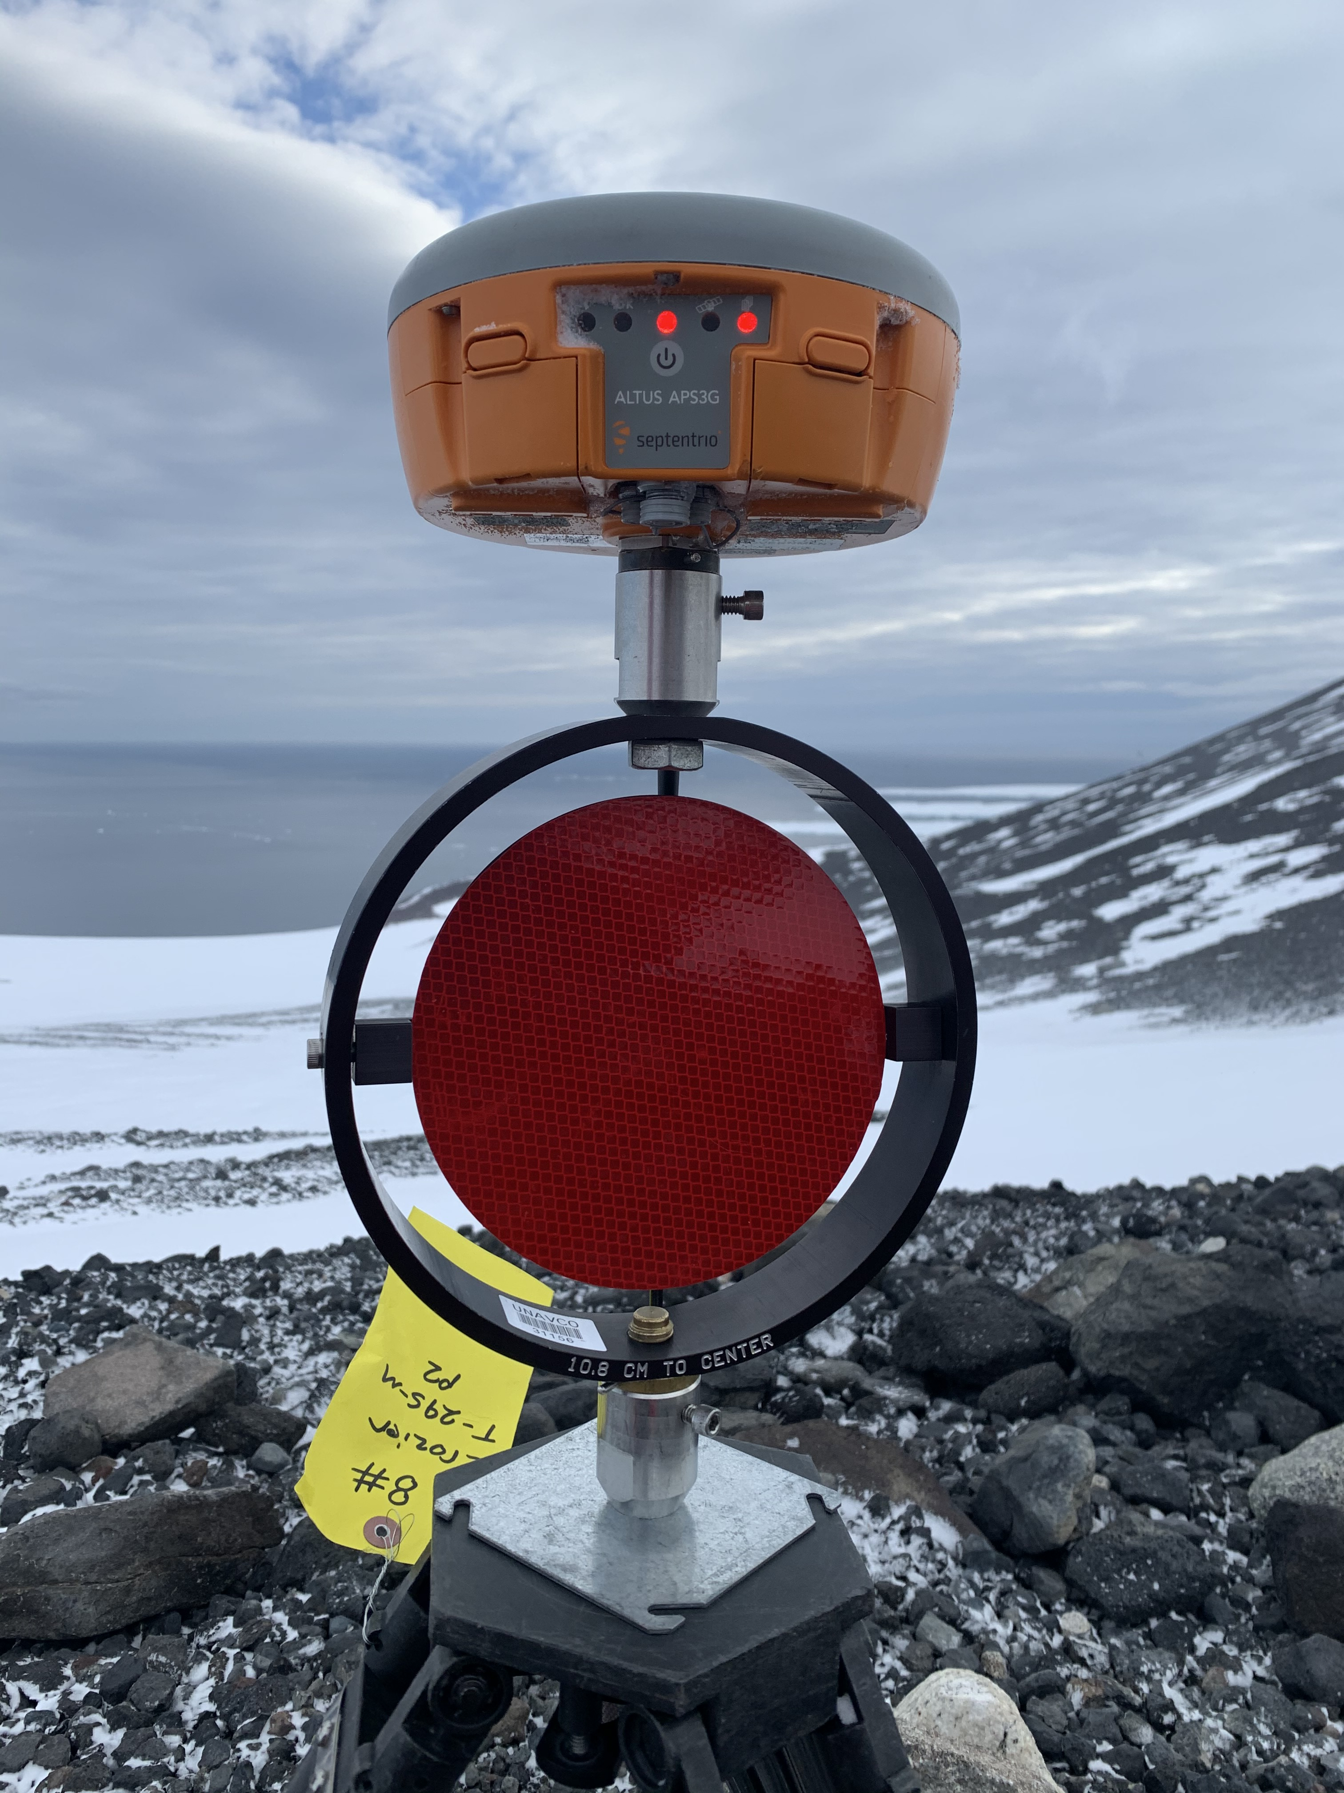
At the Sheep Draw location, TLS targets with GNSS receivers were setup throughout the site. In contrast to SfM, geoferencing uses GNSS on targets and TLS scans are stitched together (in this case a software called Riscan Pro), matching up targets visible in each scan. Refer to the TLS Field Methods Manual for more details:
Example of a reflective TLS target with GNSS receiver for georeferencing
“Terrestrial Laser Scanning (TLS) is based on LiDAR (Light Detection And Ranging) technology and may also be called Terrestrial LiDAR or Tripod LiDAR (T-LiDAR). It is a ground-based, remote-sensing tool that is similar to Radar and Sonar, but uses visible to near-infrared light emitted from a laser instrument that then records the reflected light waves from its targets. These recorded light waves can then be converted into points with X, Y, Z coordinates that can be georeferenced with a GPS unit to produce highly precise and accurate three-dimensional images called point clouds, which can then be analyzed for scientific research. TLS is a tool that is quickly becoming very popular in the geosciences for topographic mapping as well as for detection of temporal and spatial geomorphic and tectonic change such as earthquakes, volcanoes, landslides, in addition to stream morphology studies, glacier mass balance, and snow depth measurements. TLS is also used widely for biomass investigations in forestry, and for numerous engineering applications.”
Similar to SfM, TLS allows for collection of high-resolution topography for a range of applications. One main difference (besides collection technology and post-processing workflow) is a side-ways or oblique view, as seen from the ground, compared to the top-down view of the drone used in SfM at the same site. Today we will compare the datasets visually and inspect for obvious differences. We will then follow a similar workflow as we used for the SfM data including inspection in CloudCompare, classification with CANUPO, and the derivative raster products.

Top: Scan position 1 image compared to Bottom: Point cloud from scan position 1, showing the oblique nature of the scan.

Workflow
Since you are familiar with the workflow of manipulating, classifying, and creating raster products from a point cloud, the instructions here are terse. Please refer back to the CloudCompare, CANUPO, and Working with Rasters instructions you followed on Day 4.

Step 1
Choose either Area of Interest 1 (collapsed trail) or Area of Interest 2 (cut bank and point bar). Download the clouds for SfM and TLS for your area. Import both into CloudCompare. Toggle the clouds on and off to view each. First focus on the TLS cloud. Zoom in to the cloud, change your view angle, and use the left view toggles to view from the side and rom the top. Then repeat with the SfM cloud for the same area. Finally, zoom into the cloud and attempt to compare some features visually.
Discuss the main differences you see in a thorough paragraph. Where are the holes in the TLS cloud compared to the SfM? What did the TLS method capture well that the SfM didn’t and vice versa. Focus on the side view and zoom in on vegetation. What is different about the vegetation cloud between the methods? Include a few snips of the main differences between the methods for each view, with annotations. (10 pts)

Step 2
Find the same feature in both clouds and use the measure tool to measure the difference in coordinates. What is the difference in X, Y, and Z direction? Define what feature you are measuring and which is the reference cloud (which on are you comparing to). Repeat for three features. Include a snip of each feature to show what you measured. (15 pts)
Reference Cloud:
Feature:
X:_____________
Y:_____________
Z:_____________

Reference Cloud:
Feature:
X:_____________
Y:_____________
Z:_____________

Reference Cloud:
Feature:
X:_____________
Y:_____________
Z:_____________

Step 3
Classify your TLS cloud into vegetation and ground, using the CANUPO classification in CloudCompare. Export the ground cloud as a text file. Create a raster that matches the specifications as the one you made with the SfM data. Have these things ready for Day 8.

Unit 2 Rubric – Intro Terrestrial Laser Scanning
This rubric covers the material handed in for Intro Terrestrial Laser Scanning exercise and is the summative assessment for the unit.

Component | Exemplary (75-100% points) | Basic (50-75% points) | Minimal effort (25-50%) | Nonperformance (0-25%)
General Considerations | Exemplary work will not just answer all components of the given question but also answer correctly, completely, and thoughtfully. Attention to detail, as well as answers that are logical and make sense, is an important piece of this. | Basic work may answer all components of the given question, but answers are incorrect, ill-considered, or difficult to interpret given the context of the question. Basic work may also be missing components of a given question. | Minimal performance occurs when students answers simply do not make sense and are incorrect. | Nonperformance occurs when students are missing large portions of the assignment.

