Structure from Motion at Sheep Draw
Sharon Bywater-Reyes (University of Northern Colorado)
Students were introduced to Structure from Motion (SfM) photogrammetry methods with the activity: “Getting started with Structure from Motion (SfM) photogrammetry”. As a reminder, the SfM method involves taking overlapping photographs of the same area or object. The processing software then creates a 3D model from changing position of the same points. SfM requires less expensive equipment and less field time but more processing time than Terrestrial Laser Scanning (TLS). In low-vegetation field areas, it can yield a similarly valuable high-resolution topographic model applicable to a variety of geologic research questions.

Introduction

This exercise applies Structure from Motion (SfM), a photogrammetric technique that uses overlapping images to construct 3D models with widespread research applications in geodesy, geomorphology, structural geology, and other sub-fields of geology. SfM can be collected from a handheld camera or an airborne platform such as an aircraft, tethered balloon, kite, or UAS (unmanned aerial system). You will practice the basics of SfM including developing a ground-control plan and following SfM workflow to post-process photos to generate a SfM model and explore the data using data visualization software to answer questions about a geomorphic feature.

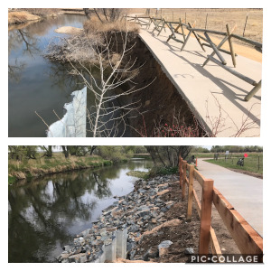
Project Description:
Figure 1. Before and after of a portion of the Poudre Trail impacted by 2013 flooding (https://greeleygov.com/activities/natural-areas)
Educators visited the Cache la Poudre River at Sheep Draw Open Space (City of Greeley Natural Areas) in northern Colorado. According to the Coalition for the Poudre River Watershed, “The Cache la Poudre River Watershed drains approximately 1,056 square miles above the canyon mouth west of Fort Collins, Colorado. The watershed supports the Front Range cities of Fort Collins, Greeley, Timnath and Windsor. In an average year, the watershed produces approximately 274,000 acre feet of water. More than 80 percent of the production occurs during the peak snowmelt months of April through July.” https://www.poudrewatershed.org/cache-la-poudre-watershed

In 2013, the Front Range and plains of Colorado experienced extensive flooding. The region experienced the average annual rainfall in one week. There was extensive damage to infrastructure and in some cases the erosion of 1000-years’ worth of weathered material (Anderson et al., 2015). Near Greeley, significant portions of the Poudre trail were impacted as the river topped its floodplain and eroded its banks. An example of an eroded bank “fixed” by riprap is shown in Figure 1.
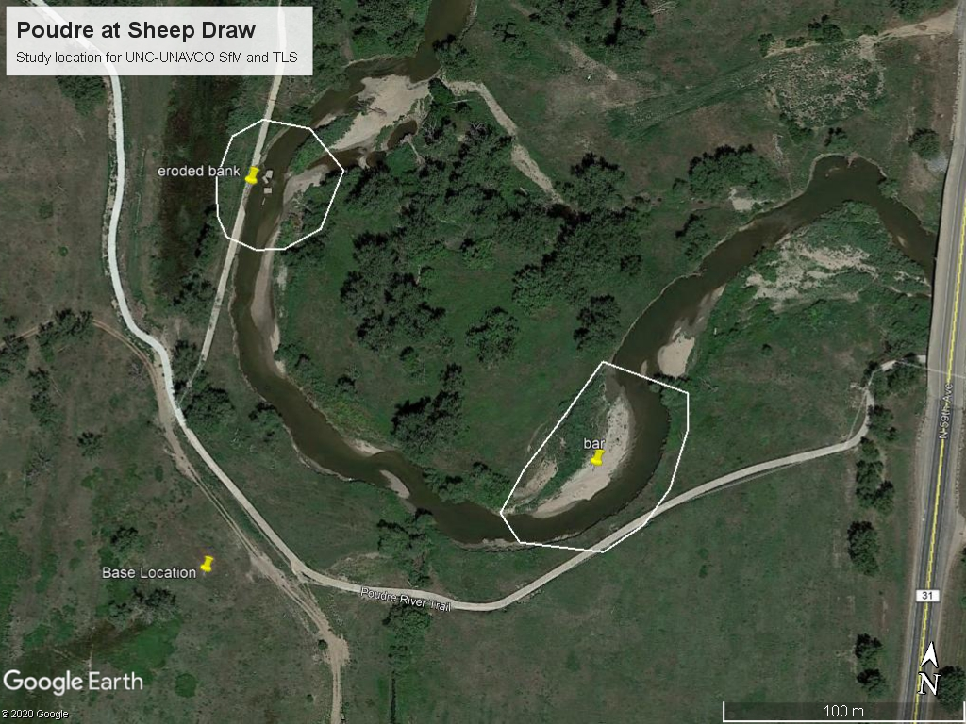
Another reach of the Cache la Poudre River that experienced significant erosion is located at Sheep Draw Open Space, owned and managed by the City of Greeley (Figure 2).
Figure 2. Inset: Map of the Cache la Poudre River Watershed, located in northern Colorado. The study site at Sheep Draw has two areas of interest, Area of Interest 1 on an eroded bank and Area of Interest 2, a cutbank and point bar.
Area of Interest 1
Area of Interest 2

Step 1:
The team visited the site equipped with ground control targets and a GNSS system. In a companion assignment, “Post-processing GPS/GNSS Base Station Position”, students have the opportunity to post-process the static GNSS position to determine the coordinates of the Base Station survey marker. If this assignment is used, complete this assignment first. Watch the videos “Introduction to Field Site” and “Method 1: Structure from Motion” for background on the methods used to collect data at the field site. In a second optional companion assignment (“Ground Control at Sheep Draw”), students discuss appropriate placement of the ground control network, map the actual locations of the ground control network that was collected using RTK GNSS, and discuss whether the chosen locations were appropriate. If using “Ground Control at Sheep Draw,” complete it before completing the rest of this assignment.

Step 2:
For this project, images were collected using a DJI Mavic 2 Pro drone. Two flight paths were conducted at altitudes of 40-m (Figure 3) and 50-m (Figure 4) and different orientations. The flight was completed with an app that allows for automatic flight with specified overlap of photos. (70% side and 80% forward).
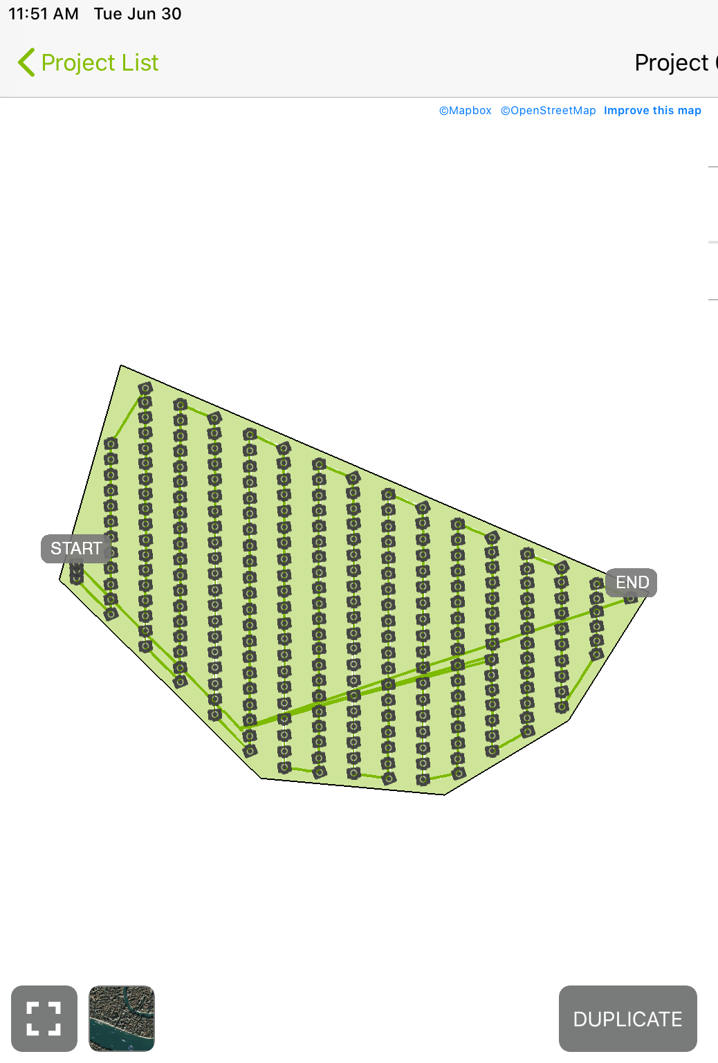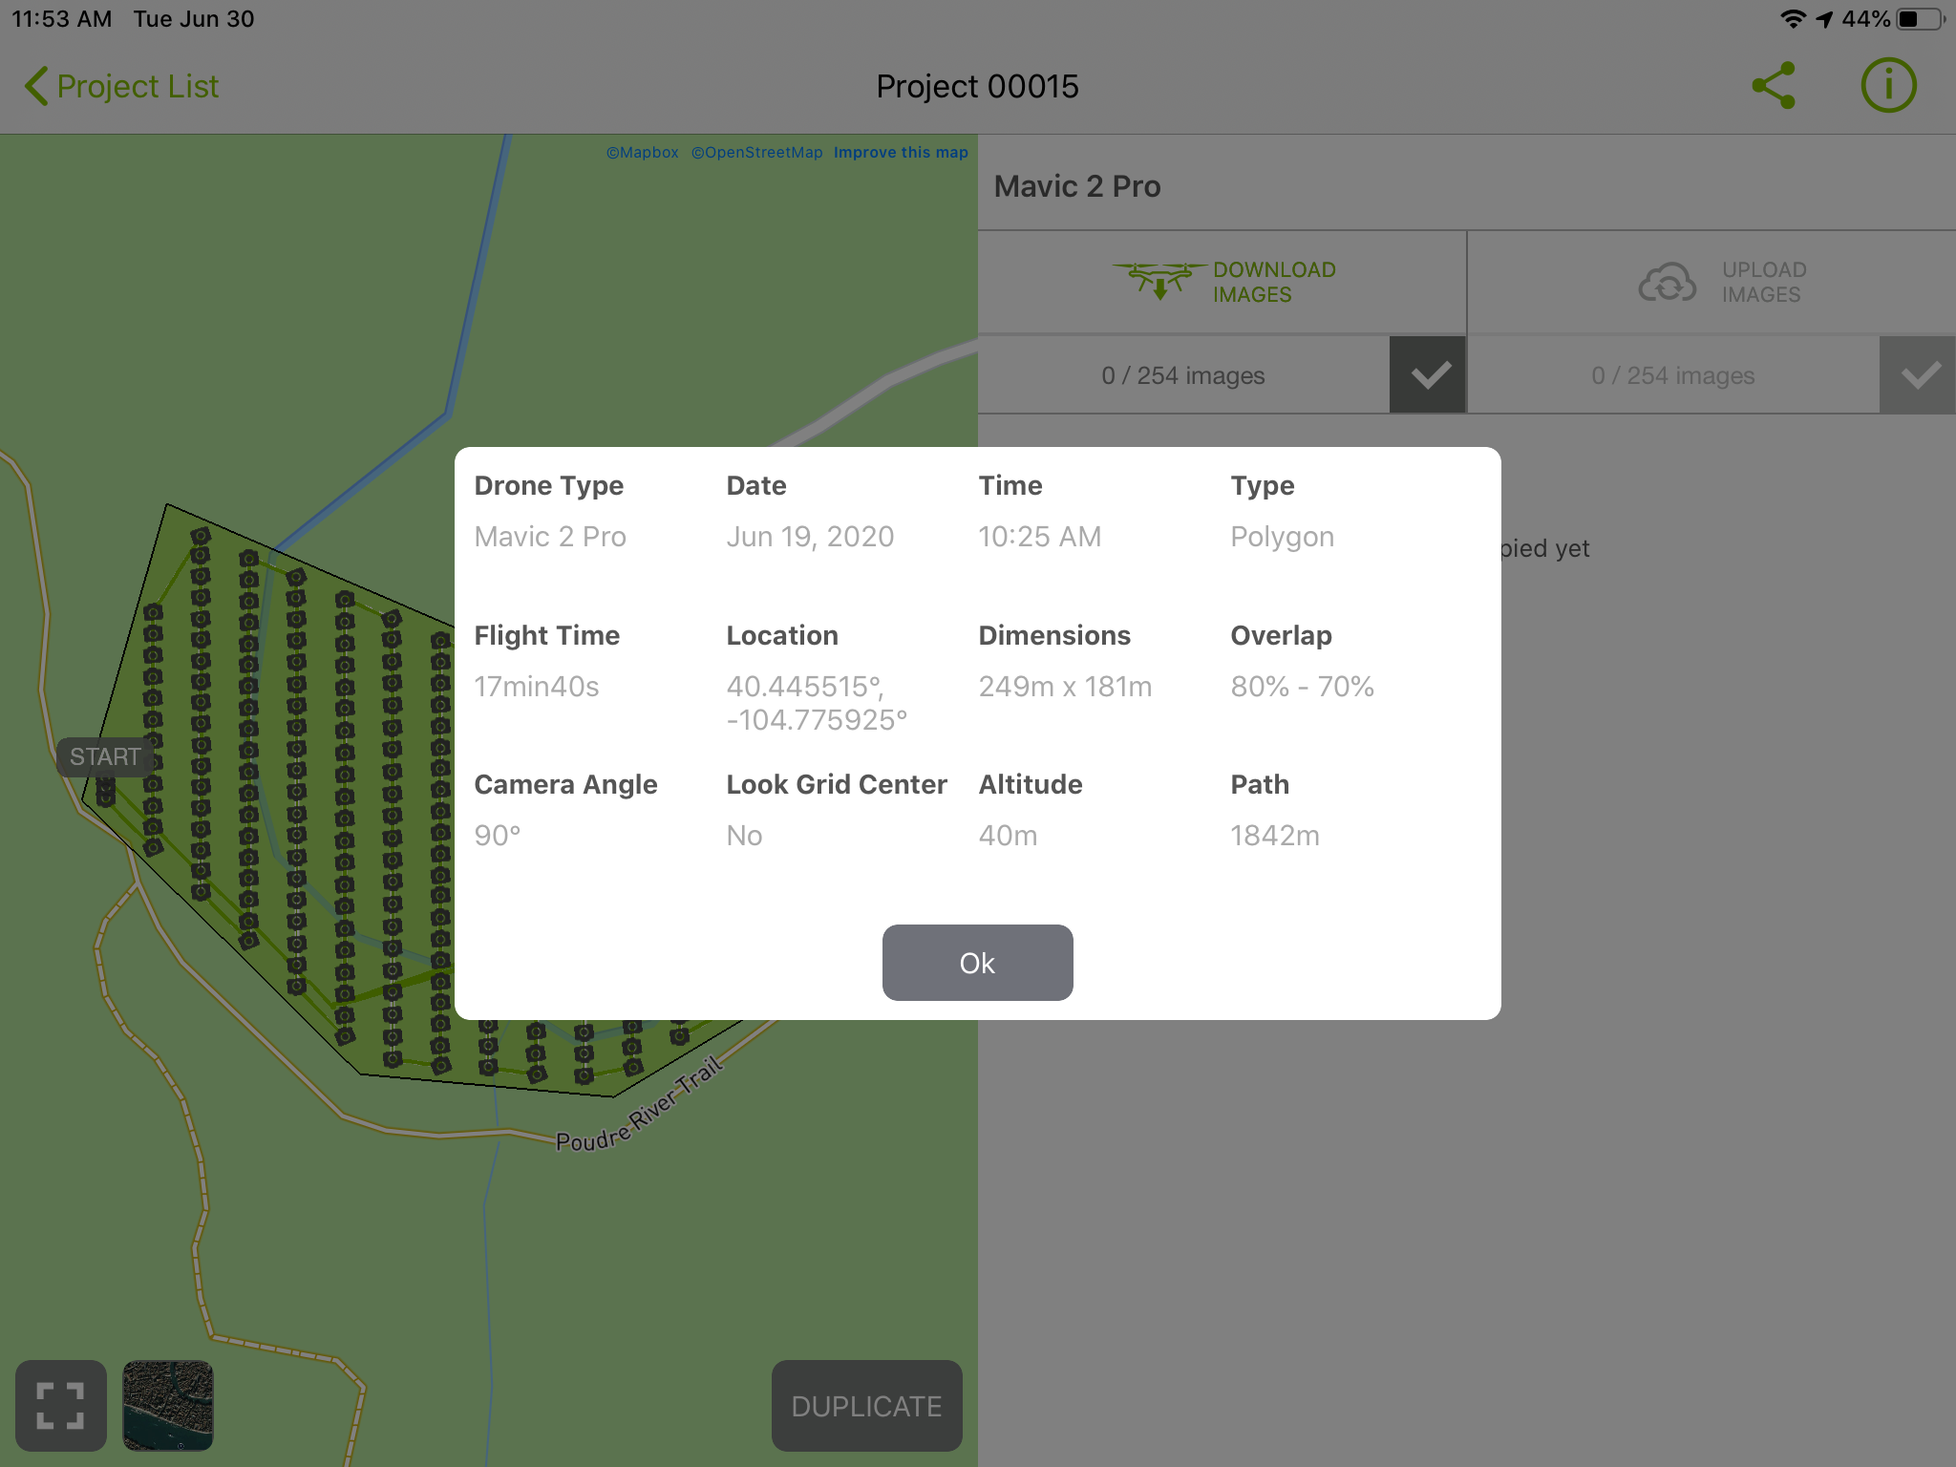
Figure 3. Flight 1 was completed at 40-m altitude with the application Pix4D Capture.

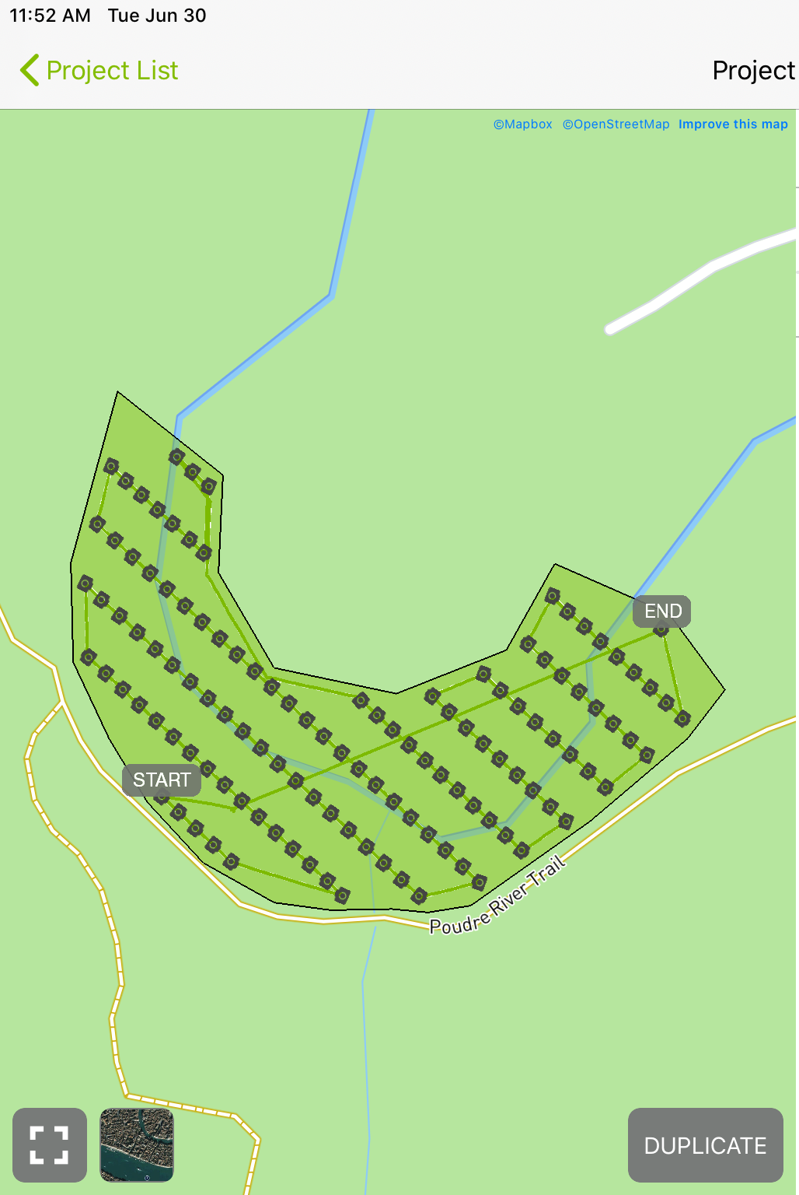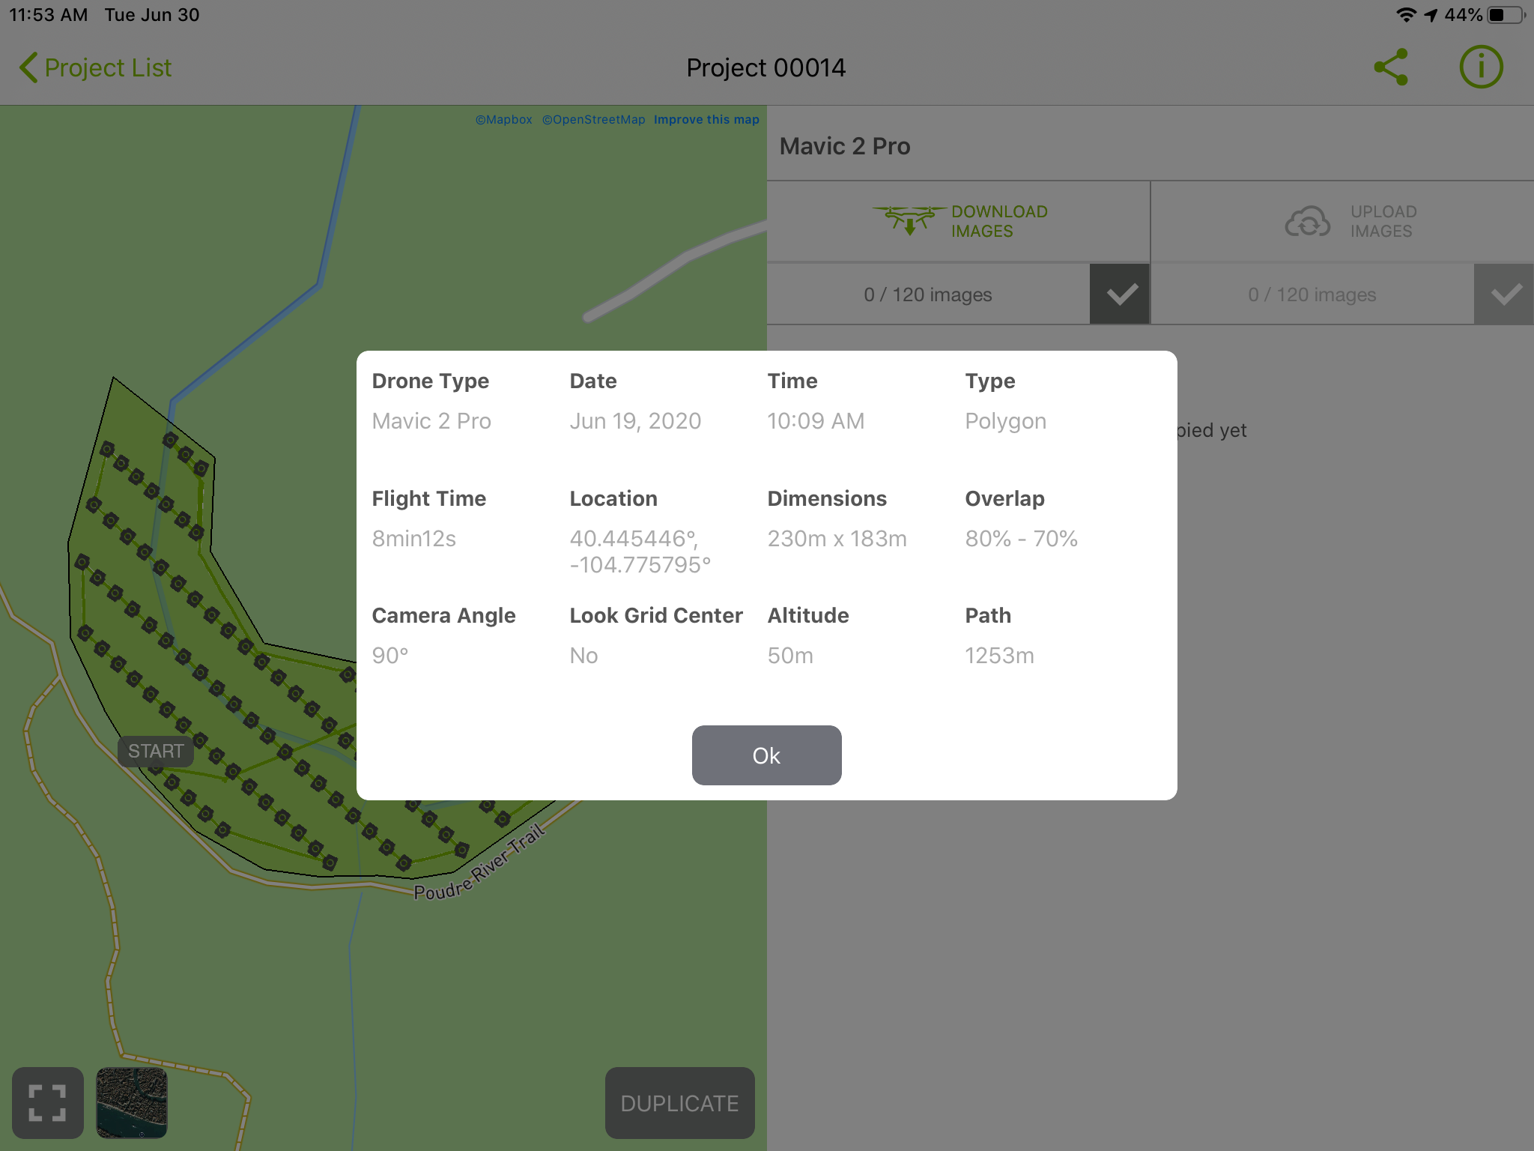
Figure 4. Flight 2 was completed at 50-m altitude with the application Pix4D Capture. Approximate locations of areas of interest.

Calculate the expected resolution of the point cloud resulting from the SfM workflow using the Pix4D_GSD_Calculator.xlsx.
Camera Specs:
Width = 13.2 mm
Focal Length = 28 mm
Width = 5472 pixels
Height = 3648 pixels

A) 40-m flight altitude (1.5 pts)
Ground Sampling Distance (cm/pixel) ______________
Width of single footprint on the ground (m) _____________
Height of single image footprint on the ground (m) _____________

B) 50-m flight altitude (1.5 pts)
Ground Sampling Distance (cm/pixel) ______________
Width of single footprint on the ground (m) _____________
Height of single image footprint on the ground (m) _____________

C) Given the ground sampling distance of the pixels from the flights, discuss what types of features of the river at Area of Interest 1 and Area of Interest 2 you expect can be resolved with this resolution (1 pts)

D) What geomorphic questions do you have about the areas of interest? Do you think you could answer any of them with a 3D datasets of the site? What would you measure or what else would you need to answer this question? Write at least 5 sentences in your response. (2 pts)

Step 3:
Pick an area of interest to post-process (Area of Interest 1 or Area of Interest 2). Download the images for your site and put them in a folder designated for this class. Follow the instructions “SheepDrawAgisoftQuickStartGuide.doc” to create and export a 3D point cloud. Once you are done and have a dense point cloud, take a print screen or snip of a cool view and include the image here. (5 pts)

Step 4:
Answer the following questions about model errors. (1 pt each question; 5 pts total)
Refer to step 9 of the “SheepDrawAgisoftQuickStartGuide.doc” and take a screenshot or snip of your Survey Statistics error map for your site “Ground Control Points” tab and any others you think are insightful. Include your map and a response to the following questions. Be sure to answer in complete sentences and answer all prompts in the questions.
A) How do the x,y errors vary for the ground control points? Be specific, including a description of which ones are highest, lowest, what sign (negative or positive) are the errors? Do x,y errors vary in a systematic way? E.g., greater in certain areas? Smaller in certain areas? Do these systematic patterns correspond to certain features (e.g. vegetated, bar region, floodplain, etc.)? Recall the footprint of the entire flight plan (Figures 3 and 4) versus your area of interest. Are errors greatest on the edges of the flight plan? In the center?
B) How do the z errors vary for the ground control points? Be specific, including a description of which ones are highest, lowest, what sign (negative or positive) are the errors? Do x,y errors vary in a systematic way? E.g., greater in certain areas? Smaller in certain areas? Do these systematic patterns correspond to certain features (e.g. vegetated, bar region, floodplain, etc.)? Recall the footprint of the entire flight plan (Figures 3 and 4) versus your area of interest. Are errors greatest on the edges of the flight plan? In the center?
C) How to x,y errors and z errors compare? Which are larger? Are they correlated (e.g. higher errors in x,y in same locations as z)?
D) Recall your reading discussions and lectures. What should be considered in developing a ground control plan and why is one needed in the first place? Given your Day 2 exercise developing a ground control plan and the class discussion about comparing your plan with the actual plan, was the ground control plan that was actually implemented in the field adequate? What were the strengths and weaknesses of the plan?
E) Recall James et al. (2019):
James, Mike R., et al. "Guidelines on the use of structure‐from‐motion photogrammetry in geomorphic research." Earth Surface Processes and Landforms 44.10 (2019): 2081-2084.
And Sanz-Ablanedo et al. (2020):
Sanz‐Ablanedo, Enoc, et al. "Reducing systematic dome errors in digital elevation models through better UAV flight design." Earth Surface Processes and Landforms (2020).

Were the general guidelines suggested in these papers followed? Were some missed? Do you expect “doming” has occurred in your model? How would that effect the accuracy of your model?

Step 5:
Refer to Step 15 of “SheepDrawAgisoftQuickStartGuide.doc”
Did the Metashape classification adequately classify vegetation and ground points? What did it do well? What were the weaknesses? (1 pt)

Step 6:
Think about the questions you posed in Step 2D about your area of interest. Given the errors and limitation of your model, discuss whether you will be able to answer any of the questions you were interested. List at least three you think you can answer. For one, develop a testable hypothesis. For example, it could be about maximum stable bank heights, erosion or deposition rates (Can this be measured? Why, why not? What else would be needed, if anything?), etc. (2 pts)

Rubric
This rubric covers the material handed in for Sheep Draw SfM student exercise and is the summative assessment for the unit.

Component | Exemplary (75-100% points) | Basic (50-75% points) | Minimal effort (25-50%) | Nonperformance (0-25%)
General Considerations | Exemplary work will not just answer all components of the given question but also answer correctly, completely, and thoughtfully. Attention to detail, as well as answers that are logical and make sense, is an important piece of this. | Basic work may answer all components of the given question, but answers are incorrect, ill-considered, or difficult to interpret given the context of the question. Basic work may also be missing components of a given question. | Minimal performance occurs when students answers simply do not make sense and are incorrect. | Nonperformance occurs when students are missing large portions of the assignment.

