Poudre at Sheep Draw Vignette
Sharon Bywater-Reyes (University of Northern Colorado)

In spring 2020, the world was hit by a pandemic that spread globally by March, causing universities and most of the world to move to remote means. Summer field camps, long hailed as a rite of passage in the geosciences, were cancelled throughout the US. The community moved quickly, with NAGT developing remote learning tools and arranging for sharing and collaboration between instructors and institutions. As such, UNAVCO (GETSI) and University of Northern Colorado embarked on a data collection campaign for a summer field course entitled “Geoscience Field Issues Using High-Resolution Topography to Understand Earth Surface Processes” – originally slated for in-person teaching. The team collected GNSS data, drone imagery for use in structure from motion, and terrestrial laser scanning from a site near Greeley, Colorado on the Poudre River.

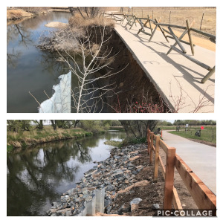
Site Description
Figure 1. Before and after of a portion of the Poudre Trail impacted by 2013 flooding (https://greeleygov.com/activities/natural-areas)
Educators visited the Cache la Poudre River at Sheep Draw Open Space (City of Greeley Natural Areas) in northern Colorado. According to the Coalition for the Poudre River Watershed, “The Cache la Poudre River Watershed drains approximately 1,056 square miles above the canyon mouth west of Fort Collins, Colorado. The watershed supports the Front Range cities of Fort Collins, Greeley, Timnath and Windsor. In an average year, the watershed produces approximately 274,000 acre feet of water. More than 80 percent of the production occurs during the peak snowmelt months of April through July.” https://www.poudrewatershed.org/cache-la-poudre-watershed

In 2013, the Front Range and plains of Colorado experienced extensive flooding. The region experienced the average annual rainfall in one week. There was extensive damage to infrastructure and in some cases the erosion of 1000-years’ worth of weathered material (Anderson et al., 2015). Near Greeley, significant portions of the Poudre trail were impacted as the river topped its floodplain and eroded its banks. An example of an eroded bank “fixed” by riprap is shown in Figure 1.

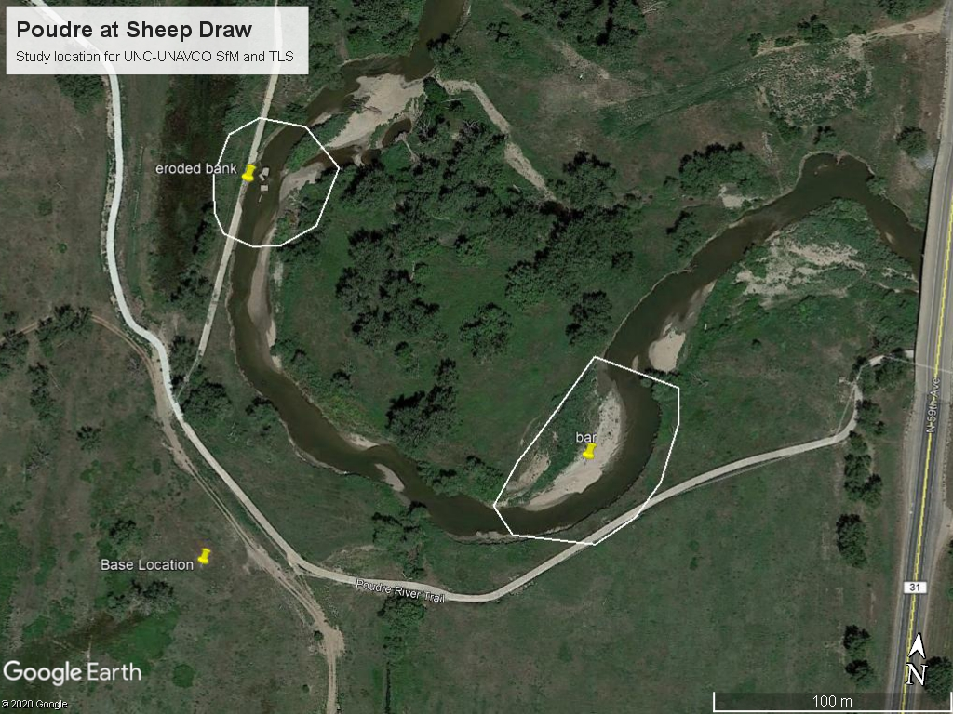
Another reach of the Cache la Poudre River that experienced significant erosion is located at Sheep Draw Open Space, owned and managed by the City of Greeley (Figure 2).
Figure 2. Inset: Map of the Cache la Poudre River Watershed, located in northern Colorado. The study site at Sheep Draw has two areas of interest, Area of Interest 1 on an eroded bank and Area of Interest 2, a cutbank and point bar.
Area of Interest 1
Area of Interest 2

Overview of Materials
The team visited the site equipped with ground control targets and a GNSS system. In Unit X, students had the opportunity to post-process the static GNSS position to determine the coordinates of the Base Station survey marker. In a companion assignment (Unit X), students discussed appropriate placement on the ground control network, mapped the actual locations of the ground control network that was collected using RTK GNSS, and discussed whether the chosen locations were appropriate.

Watch the videos, “Introduction to Field Site,” “Method 1: Structure from Motion,” and “Method 2: Terrestrial Laser Scanning” for more background on the methods used to collect data at the field site.

Datasets collected include drone photos for SfM processing and terrestrial laser scanning (TLS).

Activities:
- Postprocessing Base Station Position
- Ground Control at Sheep Draw
- Structure from Motion at Sheep Draw
- Working with Point Clouds in CloudCompare; classifying with CANUPO
- Working with Rasters in ArcGIS
- SfM Feasibility Report
- Intro Terrestrial Laser Scanning at Sheep Draw
- Point Cloud and Raster Change Detection
- OpenTopography Data Sources

