Introduction to Structure from Motion (SfM) for remote field
Beth Pratt-Sitaula (UNAVCO)
In this exercise you will learn the basics of how to process a set of photographs into a 3D point cloud model. This process is called Structure from Motion (SfM) photogrammetry. You will georeference the point cloud to a local coordinate system. In a subsequent exercise you will collect or use photos taken by others that address an actual geological research question. In this exercise, you will just learn the process using the software (that you should have installed on your computer already) – Agisoft MetaShape Pro.

Collect a set of photos with GCPs
You will collect a set of photographs from something easily accessible in or nearby your home using whatever digital camera you prefer. A smart phone can work great. I suggest a sofa, two adjoining walls, a small berm, or perhaps the corner of a shed. It really does not matter that much, you should just have some surfaces at different angles so your final 3D model is more than a flat surface. Before you actually start taking the photos, you will need to place targets or ground control points (GCP) in the field of view so that you can establish a coordinate system and known points for the model.

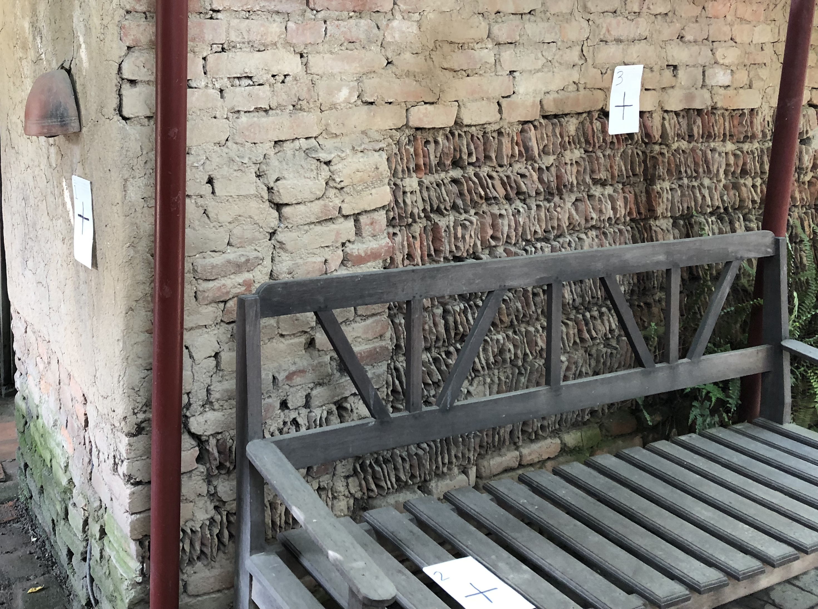
Place ground control points (GCPs)
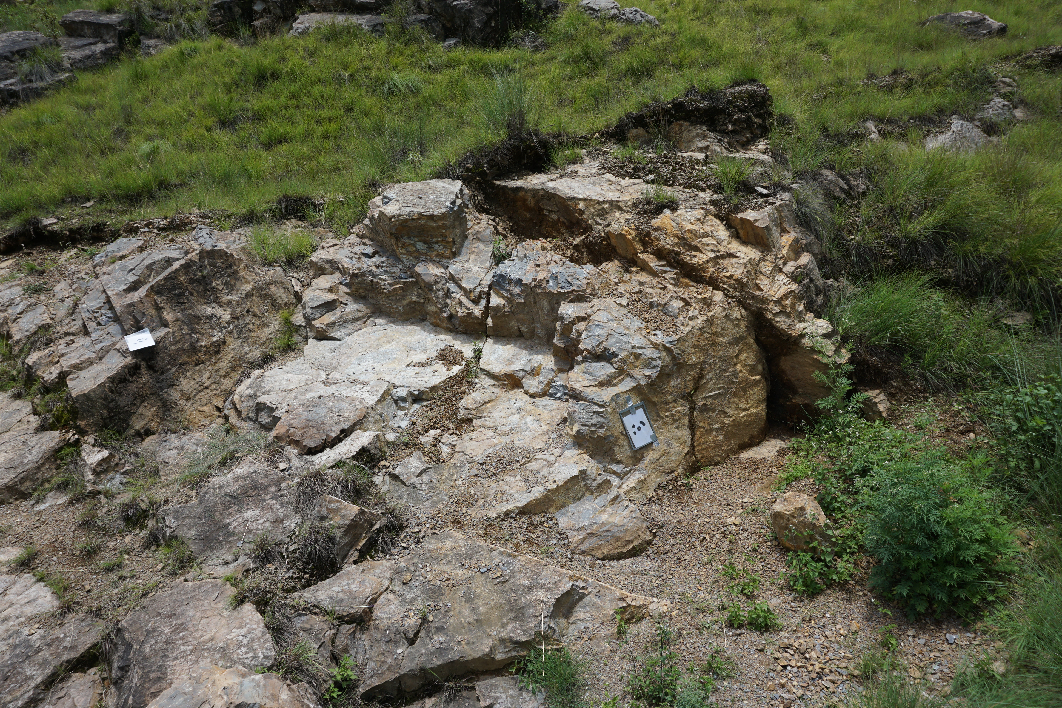
In a proper geological SfM project, you would use five or more GCP, but for this exercise, we will just use three so you can learn the process more quickly. GCPs can really be anything that had a clear center point. Agisoft provides targets with specific shapes but a simple ✚ and a number can work great. Grab your paper, marker, and tape and put three GCPs on different faces of the item you plan photograph.
- Do spread your GCPs out.
- Do NOT bunch them all together in the same location.
- If your surface has multiple angles aim to put the GCPs on different surfaces.
Figure 1. Examples of GCPs on a wall and a real geologic outcrop. They are also used when SfM is done with drones but they must be a lot bigger to be viewed from further away. In the case of a drone, all the GCP will probably be laid flat.

Sketch your “field site”
All good geologists carefully sketch their field area. This case is no different. Make a quick sketch of your “field site” and include the general location of the GCPs. This may seem a little silly in your living room or back yard but this is an essential step in any larger study. It can be a major pain if you cannot remember which GCP is where.

Measure your GCPs
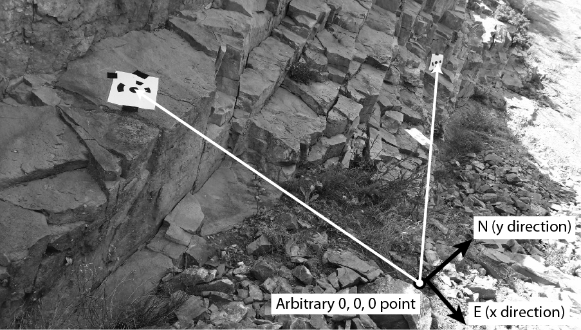
In a larger field site, you would probably use a survey-grade GPS unit (much much better GPS than your phone has in it) to carefully measure the location of your GCPs in the global reference frame – i.e. latitude and longitude – so that you could find the spot from anywhere on the globe. For a small project like this and some other projects where absolute location does not matter so much, we can use a local reference frame. That means we need to determine an arbitrary 0-0-0 location and measure the GCPs from that spot.
Figure 2. SfM targets on an outcrop. You will determine their position from an arbitrary 0-0-0 position by measuring the distance and angle.
Take the measurements needed so that you can later determine x-y-z values for each SfM GCP (also called a “target”) from a local 0-0-0 point that you decide.
From the 0-0-0 point, you will need to measure for each GCP:
- linear distance – you can do this with a measuring tape OR a string on which you have made 10-cm marks using a marker and ruler
- azimuth of the line between the 0-0-0 and the GCP – use your compass or compass app
- vertical angle from 0-0-0 point to the GCP – use your compass or inclinometer/protractor app
Although you can do these measurements by yourself with a bit of ingenuity, tape, and/or knots, if you can recruit a family member or roommate for a few minutes, it will be easier.
You will later determine x-y-z values of the GCPs using trigonometry.
GCP # | Distance to GCP* | Azimuth to GCP | Slope to GCP
*If your measuring device is not metric, convert to meters.

Take the photos
Some tips:
- Take 15-25 (max!) pictures for this exercise (this is to keep the processing times short)
- Aim for ~70% overlap between photos
- Move camera horizontally or vertically between photos; do not take multiple photos from the same spot.
- Do not change the zoom or other settings on your camera; keep it the same for all photos
- While it is good to have GCP in many of your pictures, it is not necessary to have them in all photos.

Process the photos into a 3D model using MetaShape Pro
You will follow the directions in the MetaShape Quick Guide in order to process these photos into a 3D point cloud. In order to include the GCP, you will need to convert the distance-azimuth-inclination into x-y-z coordinates using trigonometry.
GCP: Do the needed trigonometry to convert the GCP angles and distance to x-y-z coordinates for each GCP. x is east, y is north, z is vertical. Hint: you need to use first determine the horizontal distance before you can calculate x and y; then consider which quadrant the azimuth is in. North is positive, south is negative. East is positive, west is negative. Once you have determined x-y-z coordinates for your three GCP, step back and review them – DO THEY MAKE SENSE? You will need them in Step 4 of the MetaShape Quick Guide.

Deliverables
Annotated screen shot of your final model and answers to discussion questions.
Take a screen shot of your final model (dense point cloud and/or mesh). Label it to show areas of higher quality, lower quality, missing data, and anything else you think is of note.
Answer the following questions:
- What are some errors associated with the local coordinate system GCP measurement method we used?
- What are some shortcomings of the model you built? Explain why they are short comings.
What are some better parts for the model you built? Explain why they are better.
(these should match the labels you have on your screen shot)
- What else (in geoscience and beyond) could you apply this SfM method to?
- What are at least two pros and two cons of the SfM method?
- Knowing you will need to do SfM again, what is at least one piece of advice you want to leave for yourself?

Assessment
Annotated screen shot – total 10 points
- Screen shot shows completed dense point cloud or mesh – 2 pnts
- Annotation shows at least 4 areas of credible interest (2 pnts each)
Questions – 2-4 points each depending on complexity of components
- Fully credit – correctly and/or credibly answers the question with evidence provided.
- Partial credit – answer may be correct but insufficient evidence is provided or answer is only partically correct
- No credit – no answer or answer incorrect or off base

