DEM of Difference (DoD)
Joel Sholtes (Colorado Mesa University)
Edits and formatting by Sharon Bywater-Reyes (University of Northern Colorado)

Introduction
You will be creating a “DEM-of-difference” (DoD) between two Digital Elevation Models (DEMs) surveyed using LiDAR over the same location and bracketing the 2013 Front Range Colorado Flood event. Substantial channel movement and floodplain erosion and deposition occurred along this stretch of South St. Vrain Creek, just downstream of a confined, canyon section of the creek. Large quantities of sediment (including up to boulder sized material) supplied from upstream channel and valley margins and from debris flows fell out of transport along this reach and downstream (Rathburn et al., 2017, Sholtes et al., 2018). This resulted in a high degree of fluvial geomorphic change in the stream corridor in response to the 2103 flood event.
The DEM-of-difference (DoD) will estimate the cell-by-cell change in elevation between these two LiDAR surveys. With it, you will be able to calculate the volume and mass of sediment movement from reach to reach. In addition, you will estimate the bias in the DoD as well as its uncertainty.
The DEMofDiff zipped geodatabase provided with this assignment. It contains:
- Two DEMs created from LiDAR data surveyed over South St. Vrain Creek near Lyons, CO: one surveyed in 2011 (SV_2011) and one in 2013 after the Colorado Front Range flood (SV_2013).
- A polygon shapefile delineating the extent of fluvial geomorphic change along three reaches of South St. Vrain Creek (ReachPoly).

Deliverables
Complete the following steps and provide a screen shot of the output of each major step to submit online. For this assignment turn in one document with the following:
- A brief introduction summarizing background information, data sources, geographics scope of and purpose of effort, and overall description of data processing work flow. (200-300 words).
- Responses to all prompts (in italics) in complete sentences.
- Screen shots and captions of crucial steps.

Workflow
- Load the two DEMs into a new ArcGIS map.
  - For each, note the cell size, cell length units, elevation units, and coordinate system. Include this information in a table in your writeup.

  - We will use the 2013 DEM as the reference DEM.

  - Project the 2011 DEM into the coordinate system of the 2013 DEM.
    - Select the spatial reference of the 2013 raster
    - Set the output cell size to be the same as the 2013 raster (note that when you project it into the 2013 raster coordinate system, it will take on the liner units of that projection).
    - Resampling Technique: Bilinear (never use nearest neighbor for continuous data).
    - Under Environments in the Project Raster Tool, go to Snapping Raster and select the 2013 DEM raster.
    - Click on the info button for this option and describe what it does.

  - Note the elevation units of the 2011 DEM. If you need to convert these to match the units of the 2013 DEM do so using Raster Calculator.

- Now that you have two DEMs with the same coordinate system, elevation units, cell size, and cell alignment, you can create the DEM of Difference
  - Use the Raster Calculator to create a DEM of Difference.

  - Which year should be subtracted from the other to create a raster where negative values represent areas that eroded or lost elevation as a result of the flood and positive areas represent areas that gained elevation? Explain why and provide a basic symbolic equation for this based on the elevation differences of a raster cell.

- Create a map of the DEM of Difference
  - First, create a hillshade image of the 2013 DEM

  - Overlay the DoD with a transparency of 50 % and a color scheme that goes from red (negative) to blue (positive) with white or no color in the middle (classified raster symbology). Be sure to make the classification scheme numerically symmetrical so that there are equal intervals above and below zero. See example below.

  - Create and export a Map Layout and include appropriate items (north arrow, scale bar, etc).
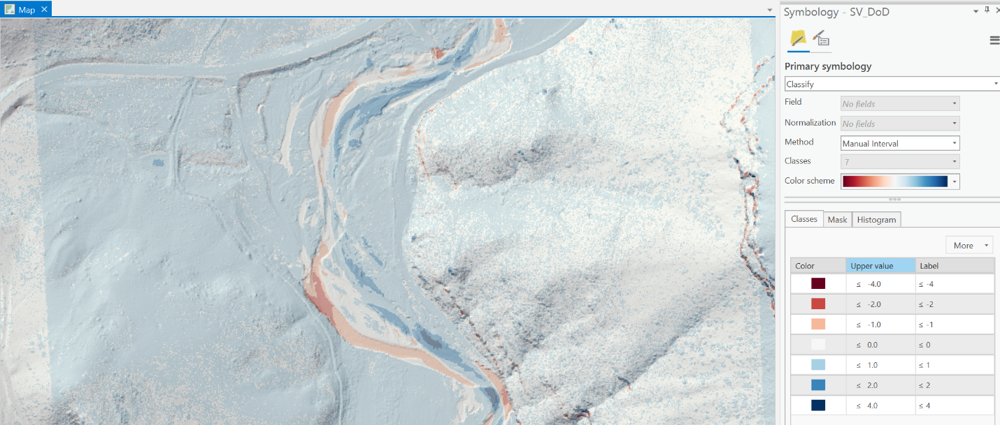
Color classification scheme for the DEM-of-Difference.
- Estimate the net change in volume for the reaches outlined in the included ReachPoly.shp
  - Bring the ReachPoly shapefile into your map. There are three reaches included in the ReachPoly shapefile.

  - Use the Zonal Statistics as Table tool using the ReachPoly polygon as the “zone” to calculate the mean DoD value within each polygon (mean elevation change). Use the ID field of the ReachPoly to summarize the statistics of the DoD.

  - Use the mean value of elevation difference from this table to calculate the net change in volume within the ReachPoly polygon. Think about how you would calculate volume here. Note that the area of each polygon is reported in the XY units of the shapefile. You may need to refer to the projected coordinate system of this shapefile. Report this value in cubic meters and metric tons assuming a specific gravity of 2.65 (quartz sand).
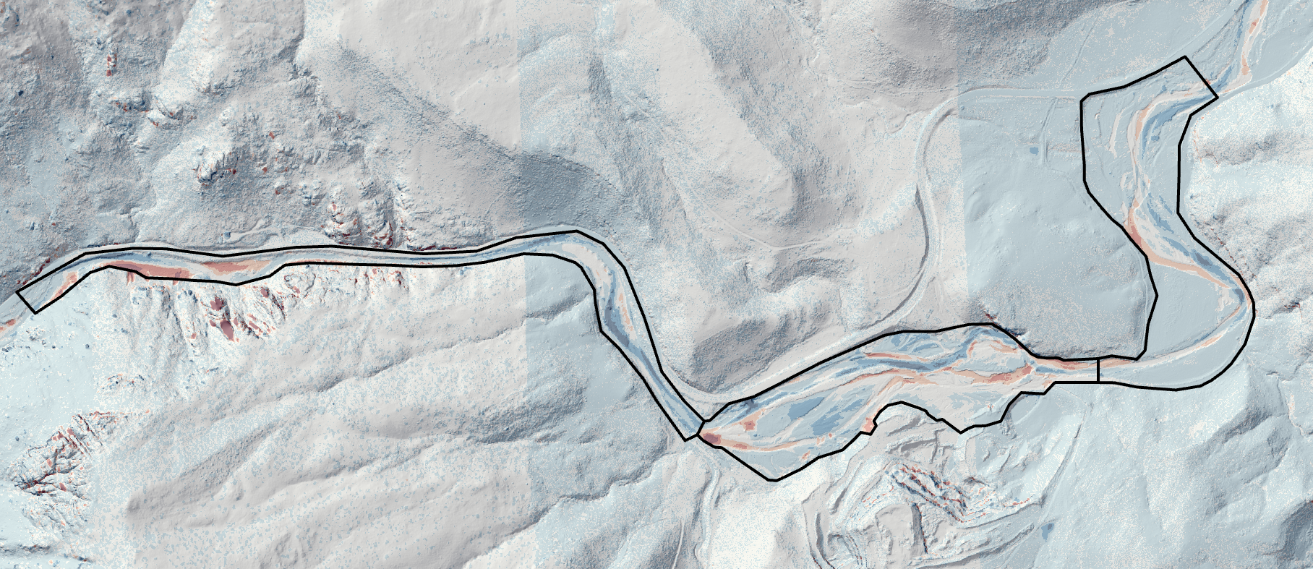
DEM-of-Difference sampled by ReachPoly polygon shapefile to estimate total volume change.
- Calculate the uncertainty and bias of the DEM-of Difference values.
  - Create and save a DoD_Sample polygon shapefile to sample a location where we do not expect change to have occurred along both a relative flat and relatively steep area (away from the river, see example below).
    - First create a new shapefile under Catalog, import it into the map, then create the polygons over several acres under Edit > Create.
    - Run Zonal Statistics as Table and use the polygon shapefile you created as the Input raster or feature zone data and your DEM-of-difference raster as the Input value raster.
    - Use Zonal Statistics as Table to calculate summary stats of the raster values within each polygon (by ID).
    - Find the standard deviation and the mean of the DoD within each polygon.
    - Take the average of these values and report these.
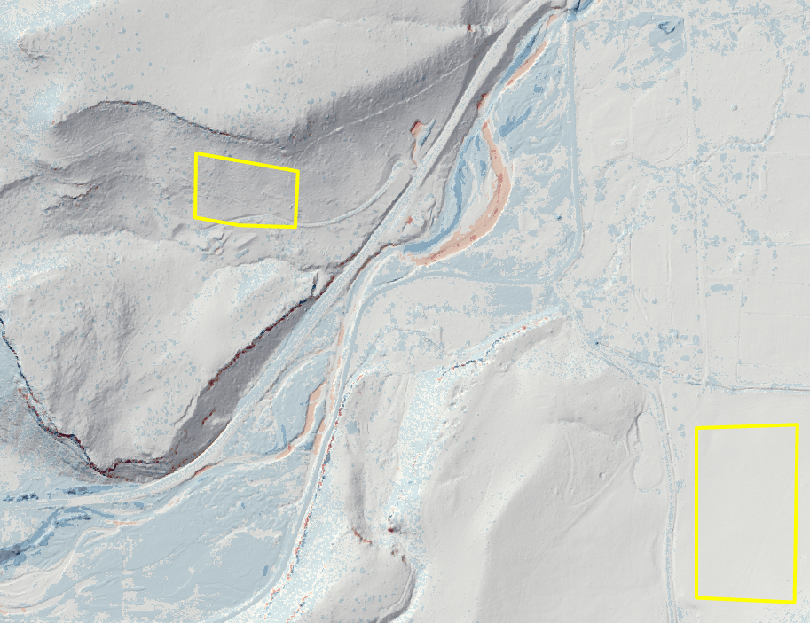
Sampling polygons to estimate uncertainty in DoD.
  - Correct for bias in the DoD by adding or subtracting the average of the mean values you sampled from the DoD in Raster Calculator. An unbiased DoD should have an average value of zero in an area where changed is not expected to have occurred. By adding or subtracting this mean error or bias you will shift the entire DoD “up” or “down” depending on the bias.
    - (negative bias → add mean value to DoD raster, positive bias → subtract mean value)

  - Remove values from the DoD that fall within two standard deviations of the error. Use the “bias-corrected” DoD from the previous step. Two standard deviations above and below the mean (which should theoretically be zero) approximates a 95 % confidence interval assuming the errors are normally distributed.
    - Use Raster Calculator to create a “True/False” or “1/0” raster
    - For example, if 2σ = 0.14 m, then use the following command in Raster Calculator: ("sv_dod" < -0.14) | ("sv_dod" > 0.14)
      - Be sure to include the parentheses above for this command to work properly. The vertical bar can be found above the backslash “\” on your keyboard. It means “or” and is a logical operator.
      - This creates a raster in which any cells that are outside of the ±2σ window centered on zero will have values of one and any cell within that window (or confidence interval) will have values of 0.
    - Then use Raster Calculator again to multiply this “masking” raster you just created with your bias-corrected DoD. This will convert any DoD values within two standard deviations to zero. All other values will remain the same.

  - Calculate Zonal Statistics as Table as before and note the new mean of the data within these DoD_Sample polygons. Compare these with previous values.

  - Re-calculate the change in volume and mass from the ReachPoly boundary to compare as well. How much does your estimates change?

  - How does reach volume and mass change as a result of the flood compare from reach to reach moving downstream? Do you notice a pattern? Read Sholtes et. al. (2018) and Rathburn et al. (2017) to learn more about what happened to the sediment moved by the 2013 flood!

References
Rathburn, S.L., Bennett, G.L., Wohl, E.E., Briles, C., McElroy, E., Sutfin, N. 2017. The fate of sediment, wood, and organic carbon eroded during an extreme flood, Colorado Front Range, USA. Geology. 45 (6): 499–502. doi: https://doi.org/10.1130/G38935.1
Sholtes, J.S., Yochum, S.E., Scott, J.A. and Bledsoe, B.P., 2018. Longitudinal variability of geomorphic response to floods. Earth Surface Processes and Landforms, 43(15), pp.3099-3113. https://doi.org/10.1002/esp.4472
2011 Denver, CO Lidar, FEMA Region VIII, Collected Apr 27-Oct 2, 2011.
USGS LPC CO SoPlatteRiver Lot2a 2013 LAS 2015, Collected Oct 25, 2013 to May 31, 2014.

Unit 2 Rubric – DEM of Difference (DoD)
This rubric covers the material handed in for DEM of Difference (DoD) exercise and is the summative assessment for the unit.

Component | Exemplary (75-100% points) | Basic (50-75% points) | Minimal effort (25-50%) | Nonperformance (0-25%)
General Considerations | Exemplary work will not just answer all components of the given question but also answer correctly, completely, and thoughtfully. Attention to detail, as well as answers that are logical and make sense, is an important piece of this. | Basic work may answer all components of the given question, but answers are incorrect, ill-considered, or difficult to interpret given the context of the question. Basic work may also be missing components of a given question. | Minimal performance occurs when students answers simply do not make sense and are incorrect. | Nonperformance occurs when students are missing large portions of the assignment.

