Point Cloud and Raster Change Detection
Sharon Bywater-Reyes (University of Northern Colorado) adapted from Unit 4: High Resolution Topography for Geomorphic Change Detection – Student Exercise Assignment design by Katherine Shervais (UNAVCO), Ramon Arrowsmith (Arizona State University), Christopher Crosby (UNAVCO), Nathan Niemi (University of Michigan) and Marin Clark (University of Michigan). https://serc.carleton.edu/getsi/teaching_materials/high-rez-topo/unit4.html

One way to assess a geomorphic system and to understand active processes is to compare repeat topographic data to detect change. Structure from Motion (SfM), Terrestrial Laser Scanning (TLS), and Airborne Laser Swath (ALS) mapping are ideal tools for capturing topographic data for use in geomorphic change detection because it can quickly produce a georeferenced “snap shot” of a system or feature at a certain point in time. As a result, you can easily calculate how far a channel or landslide has moved over the past year, the evolution of a dune crest over a decade, or how much a fault scarp has eroded since it formed. You could also compare point clouds of the same area and same time collected using different methods. In this case, the differencing between the clouds would be an error assessment.

Overview
In this exercise, you will explore point cloud and raster differencing used in error analysis and geomorphic change detection. This can be completed by comparing cloud-to-cloud (e.g., with a point cloud), mesh-to-mesh, or by differencing rasters. If you are interested in the 3D direction of change, cloud-to-cloud or mesh-to-mesh differencing is the best option, conducted in CloudCompare. If you are more interested in the vertical change, then working with rasters is best option. If you are confident in your georeferencing and errors of your model, then differences are interpreted as geomorphic change. In contrast, if you are interested in exploring errors in two different datasets, you can use the same process in error analysis. This process can be conducted with all forms of high resolution topography (SfM, TLS, and ALS).

Cloud Differencing (interested in changes in X, Y, and Z directions)
With the advent of CloudCompare, differencing can be conducted cloud-to-cloud, allowing for more understanding of where changes are between clouds in three dimensions.
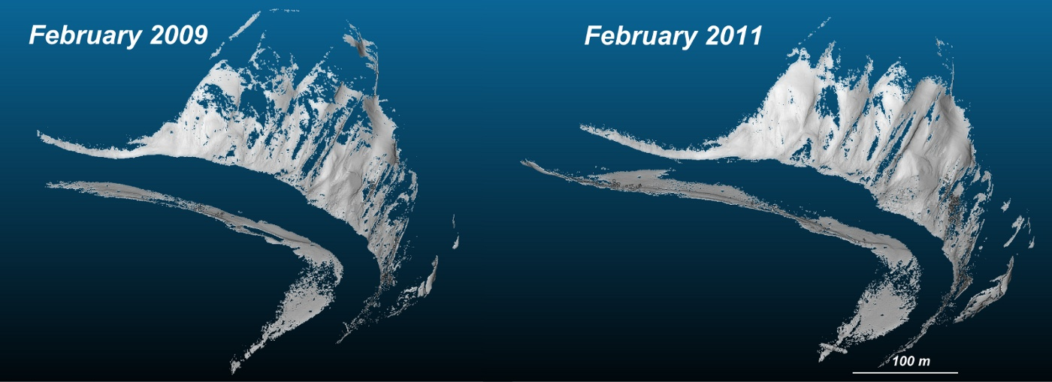
Example of two clouds from different times; http://nicolas.brodu.net/en/recherche/m3c2/index.html
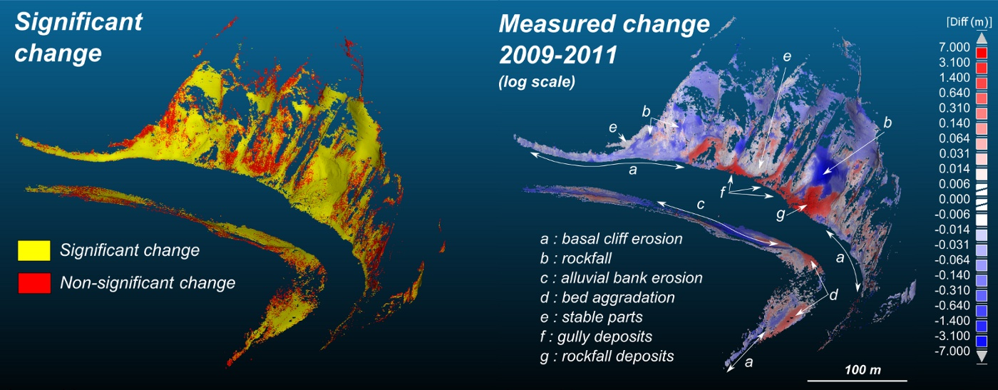
Example of cloud differencing showing change; http://nicolas.brodu.net/en/recherche/m3c2/index.html

This process can be done easily in CloudCompare. https://www.cloudcompare.org/doc/wiki/index.php?title=Distances_Computation

Follow the “Point Cloud Differencing” PowerPoint instructions.

Raster Differencing
This method subtracts one raster from another, giving the vertical component of change. It is important that the rasters have the same extent, cell size, and are orthogonal. See lecture “Raster Differencing.” We will use ArcGIS raster calculator to characterize our errors (Sheep Draw SfM vs TLS methods) and to conduct a geomorphic change detection with a repeat dataset in the afternoon session.

Example Geomorphic Change Detection (DEM of Difference; DoD) with a minimum level of detection of 0 (left) and 20 cm (right). Courtesy Joe Wheaton.

Cloud Differencing Deliverables

Step 1
Align your SfM and TLS clouds and show a screenshot of the alignment. Describe how well the alignment seems to have “fixed” the georeferencing issues. Do you trust your updated alignment? Will you be able to use these clouds for differencing? What do you think your ability to detect change between the two methods is? (5 pts)

Step 2
Conduct a cloud-to-cloud differencing between the SfM and the TLS clouds. Include a screenshot of you difference. What are the magnitude of differences? Interpret them. What differences or errors in the methods give rise to the trends you see? What is your ability to detect change between the two methods? This is an error or detection threshold – for example, would you have to have 1 mm of change? 10 cm of change? A meter? What types of events would correspond to this magnitude of change? (5 pts)

Raster Differencing Deliverables

Step 1
Ensure that your SfM and TLS rasters for Sheep Draw are orthogonal and use the raster calculator workflow to subtract your rasters from one another. If they are not orthogonal, you can go back to the CloudCompare raster workflow conducted on Day 4
https://serc.carleton.edu/dev/NAGTWorkshops/online_field/activities/240357.html and re-export the raster or you can or using the Resample Tool in ArcGIS. Note that this method (resample) is NOT the best option as it can introduce errors. You will need to specify the same cell size and same extent.
In ArcGIS, add your rasters and use the Raster Calculator to subtract one raster from the other. Make sure you know which one is subtracted from which (what is the reference) so you can interpret the results.
Include a map of the rasters showing their elevations and one that shows the differences (include north arrow, scale, legend, title). (5 pts)

Step 2
Interpret the DEM of Difference (DoD). What do the values mean? Do they surprise you? Do they show you any additional insight in raster format that wasn’t visible in point cloud format and vice versa? What is your model accuracy and what is your limit of detection given your methods if you were to use them in a geomorphic change detection workflow? (5 pts)

Step 3
Discuss the appropriateness of using cloud to cloud differencing versus raster differencing. Under which applications, scientific questions, methods, limitations, would each be appropriate? Discuss pros and cons applicability of each. (5 pts)

Unit 2 Rubric – Point Cloud and Raster Differencing
This rubric covers the material handed in for Point Cloud Differencing exercise and is the summative assessment for the unit.

Component | Exemplary (75-100% points) | Basic (50-75% points) | Minimal effort (25-50%) | Nonperformance (0-25%)
General Considerations | Exemplary work will not just answer all components of the given question but also answer correctly, completely, and thoughtfully. Attention to detail, as well as answers that are logical and make sense, is an important piece of this. | Basic work may answer all components of the given question, but answers are incorrect, ill-considered, or difficult to interpret given the context of the question. Basic work may also be missing components of a given question. | Minimal performance occurs when students answers simply do not make sense and are incorrect. | Nonperformance occurs when students are missing large portions of the assignment.

