OpenTopography Data Sources and Topographic Differencing
Sharon Bywater-Reyes (University of Northern Colorado)

This exercise uses open data sources, focusing on Airborne Laser Swath Maping (ALSM) using OpenTopography. Information from https://opentopography.org/about

About OpenTopography (OT)
OpenTopography facilitates community access to high-resolution, Earth science-oriented, topography data, and related tools and resources.

The mission of the OpenTopography Facility is to:
- Democratize online access to high-resolution (meter to sub-meter scale), Earth science-oriented, topography data acquired with lidar and other technologies.
- Harness cutting edge cyberinfrastructure to provide Web service-based data access, processing, and analysis capabilities that are scalable, extensible, and innovative.
- Promote discovery of data and software tools through community populated metadata catalogs.
- Partner with public domain data holders to leverage OpenTopography infrastructure for data discovery, hosting and processing.
- Provide professional training and expert guidance in data management, processing, and analysis.
- Foster interaction and knowledge exchange in the Earth science lidar user community.
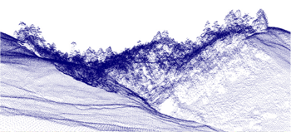
The OpenTopography Facility is based at the San Diego Supercomputer Center at the University of California, San Diego and is operated in collaboration with colleagues in the School of Earth and Space Exploration at Arizona State University and at UNAVCO.
Core operational support for OpenTopography comes from the National Science Foundation Earth Sciences: Instrumentation and Facilities Program (EAR/IF), Geoinformatics and EarthCube. OpenTopography was initially developed as a proof of concept cyberinfrastructure in the Earth sciences project as part of the NSF Information and Technology Research (ITR) program-funded Geoscience Network (GEON) project.

Motivations and Philosophy:
Over the past decade, there has been dramatic growth in the acquisition of publicly funded high-resolution topographic and bathymetric data for scientific, environmental, engineering and planning purposes. Because of the richness of these data sets, they are often extremely valuable beyond the application that drove their acquisition and thus are of interest to a large and varied user community. However, because of the large volumes of data produced by high-resolution mapping technologies such as lidar, it is often difficult to distribute these datasets. Furthermore, the data can be technically challenging to work with, requiring software and computing resources not readily available to many users. OpenTopography aims to democratize access to high-resolution topographic data in a manner that serves users with varied expertise, application domains, and computing resources.

OpenTopography data access levels:
Google Earth:
Google Earth provides an excellent platform to deliver lidar-derived visualizations for research, education, and outreach purposes. These files display full-resolution images derived from lidar in the Google Earth virtual globe. The virtual globe environment provides a freely available and easily navigated viewer and enables quick integration of the lidar visualizations with imagery, geographic layers, and other relevant data available in KML format.
Raster:
Pre-computed raster data include digital elevation model (DEM) layers computed from aerial lidar surveys and raster data from the Satellite Radar Topography Mission (SRTM) global dataset. DEMs from aerial lidar surveys are available as bare earth (ground), highest hit (first or all return), or intensity (strength of laser pulse) tiles. Some datasets also have orthophtotographs available. The DEMs are in common GIS formats (e.g. ESRI Arc Binary) and are compressed (zipped) to reduce their size.
Lidar point cloud data and on-demand processing:
This aspect of OpenTopography allows users to define an area of interest, as well as subset of the data (e.g. “ground returns only"), and then to download the results of this query in ASCII or LAS binary point cloud formats. Also available is the option to generate custom derivative products such as digital elevation models (DEMs) produced with user-defined resolution and algorithm parameters, and downloaded in a number of different file formats. The system will also generate geomorphic metrics such as hillshade and slope maps, and will dynamically generate visualizations of the data products for display in the web browser or Google Earth.

Data:
As an NSF-EAR-funded data facility, OpenTopography’s primary emphasis is on Earth science-related, research-grade, topography and bathymetry data. The scope of data that falls within this domain is not specifically defined, and data priorities are dictated by feedback from the OpenTopography user community, as well as our Advisory Committee. For those data that OpenTopography does not have the resources to host, we encourage registration of these in our data catalog so that they are discoverable by the community.

Workflow 1 (Data Download and Viewing)

Part 1: Downloading data from OT
Watch the video about downloading data from OT:
https://youtu.be/Wt8Png9ogSk
A more specific workflow for getting high-resolution topography is shown here:
https://youtu.be/jsWiVuN_zCo

Go to the Data Catalog https://portal.opentopography.org/datasets and find the Santa Maria dataset
https://doi.org/10.5069/G9QR4V2S awarded to Dr. B through an NCALM seed grant for her PhD research and stored in OT. Click on the “Point Cloud Data” download.
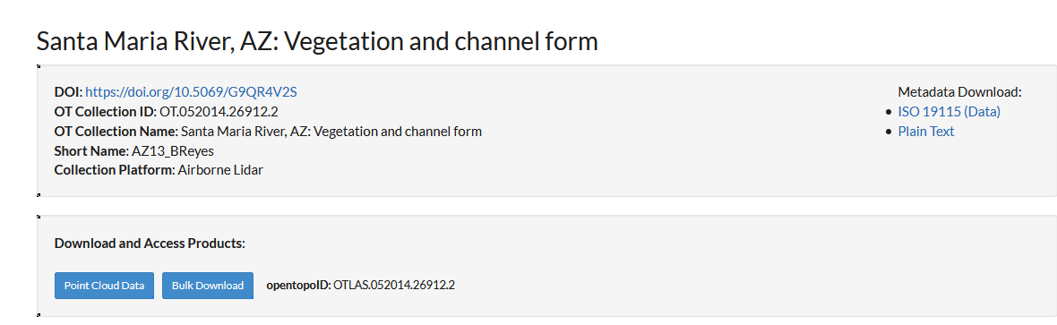

Zoom in to the covered area and select a region to download. Make sure your area is pretty small, so you don’t crash your computer!
In the download parameters, choose the following:
1. Check “Ground”
2. Point Cloud Data Download in ASCII format (a text file)
3. DEM Generation, check “Calculate TIN” and choose a grid resolution of 1 m. For grid format, use GeoTIFF.
4. Derivative products, check “Generate 3D point cloud browser visualization” and check “Generate hillshade images from DEMS” and “Generate additional Google Earth KMZ files.”
Enter the job description parameters and wait for the email with the data.
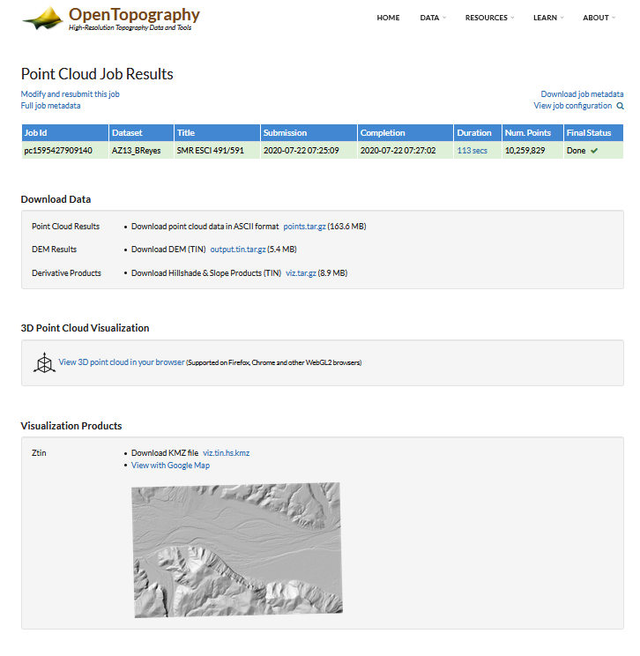

Example data download.

Part 2: View your lidar with the browser tool
Include a screenshot/snip of your output (5 pts).

Part 3: Viewing your LiDAR in Google Earth
This video shows how to export data into Google Earth for viewing.
https://youtu.be/A0s3l_wxdHA
View your hillshade KMZ in GoogleEarth. Export a map image to turn in (5 pts).

Part 4: Viewing your LiDAR in ArcGIS
Download your DEM and Derivative Products Note: we won’t use the ASCII file, but other applications you might want it. The files will be .tar.gz files. You will have to extract them with a tool such as 7-zip. Right click >> 7-zip >> extract files. You will then have to open the .tar folder and extract one more time. Eventually you should have a folder with the .tif file with a path similar to this: output.tin.tar\output.tin.
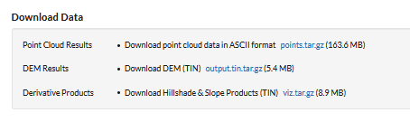
Add your GeoTIFFs (DEM and hillshade) to ArcGIS and make at least two maps (with title, legend, scale bar, north arrow), for example a DEM and a hillshade, of DEM overlaid onto hillshade, etc. (5 pts each; 10 pts total).

Deliverables
All indicated maps from Workflow 1 and the answers to the following questions (5 pts)
- What were some of the advantages and disadvantages of using OpenTopography data compared to conducting our SfM and TLS workflows? (2 pts)
- When would using ALSM be advantageous over SfM and TLS workflows? (2 pts)
- In viewing the data in the browser, Google Earth, and ArcGIS, what were your impressions of the utility of each? (2 pts)

Workflow 2 (Geomorphic Change Detection)
OT allows for geomorphic change detection, which they call Topographic Differencing
https://opentopography.org/learn/differencing
As part of OpenTopography's digital training resources, this page lists the material that we have developed about topographic differencing. The resources include several video tutorials, blog posts with examples of differencing results processed on OpenTopography, material presented at workshops, links to GitHub code repositories, and a differencing exercise designed for undergraduate courses.
Topographic differencing reveals surface change from a variety of tectonic, geomorphic, and anthropogenic processes including earthquakes, volcanic eruptions, river erosion, landslides, sand dune migration, and urban development. Differencing techniques have grown in popularity over the past decade as the number of multi-temporal topographic datasets has increased.
Vertical differencing is the subtraction of gridded elevation data (a.k.a. raster or digital elevation models (DEMs)) that span an event of interest. Early application of this method focused on rivers, although the technique has since been applied to a broader case set. 3D differencing is calculated with a windowed implementation of the Iterative Closest Point (ICP) algorithm. This approach works best when the landscape shifts laterally, for example in surface rupturing earthquakes.

Step 1
Watch video about how to perform change detection within OT:
https://youtu.be/BlDx66AQ3G0

This site shows the datasets that have differencing available:
https://portal.opentopography.org/dataCatalog?differencing=true
Choose “Northern San Andreas Fault, CA” and click “Differencing” 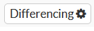
You will be given the option of 2D differencing (rasters) versus 3D differencing (points). This is in effect equivalent to our work with 2D raster differencing in ArcGIS and cloud-to-cloud differencing in CloudCompare. Choose “Vertical Differencing” and click “Start Differencing”.
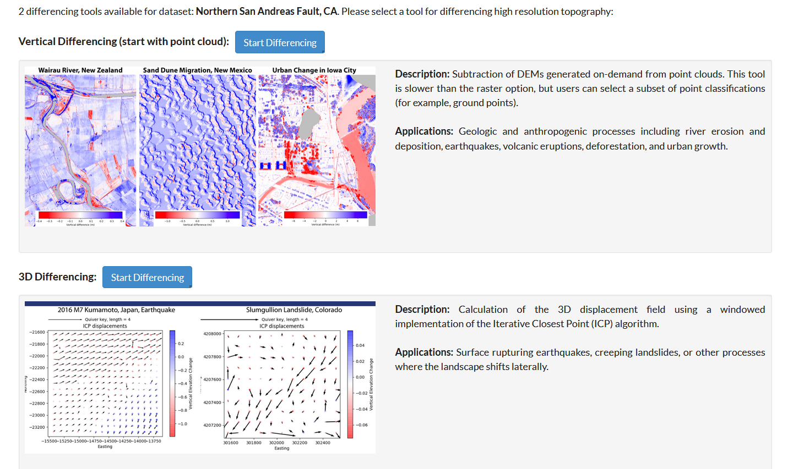

Step 2
In the next page, you can choose to switch the reference and compare dataset. Select your bounding area that includes BOTH datasets. Change the error threshold to something reasonable based on what you have learned thus far. State your choice. Submit your job.

Step 3
Create a series of maps similar to Workflow 1 showing each DEM and a DEM of Difference. (15 pts)

Deliverables
Maps and answers to questions:
- Interpret your topographic difference map. Where was there erosion and where deposition or uplift, etc.? What is the likely cause of the changes? (2 pts)

- Defend your level of detection (error threshold) choice. How reliable are your results? (2 pts)

- Under which conditions are you likely to use Open Topography for topographic differencing? What are the pros and cons of this method compared to our workflow from Day 8? (3 pts)

Unit 2 Rubric – OpenTopography Topographic Differencing
This rubric covers the material handed in for OpenTopography Topographic Differencing exercise and is the summative assessment for the unit.

Component | Exemplary (75-100% points) | Basic (50-75% points) | Minimal effort (25-50%) | Nonperformance (0-25%)
General Considerations | Exemplary work will not just answer all components of the given question but also answer correctly, completely, and thoughtfully. Attention to detail, as well as answers that are logical and make sense, is an important piece of this. | Basic work may answer all components of the given question, but answers are incorrect, ill-considered, or difficult to interpret given the context of the question. Basic work may also be missing components of a given question. | Minimal performance occurs when students answers simply do not make sense and are incorrect. | Nonperformance occurs when students are missing large portions of the assignment.

