Analytical datasets
For this part of the course, you will choose a set of previously collected data associated with this field locality, analyze it, and integrate it into your mapping from Part I. This will also be done in small groups. What topic you choose could depend on your interests and/or your course background, but all data are from the same field area where the mapping takes place. So, once we’ve all come together to share what we’ve learned in the oral presentations, it will be like doing actual science instead of just mapping! The topics for the second part of the course will be in the general realms of:
1) Advanced structural analysis of field data
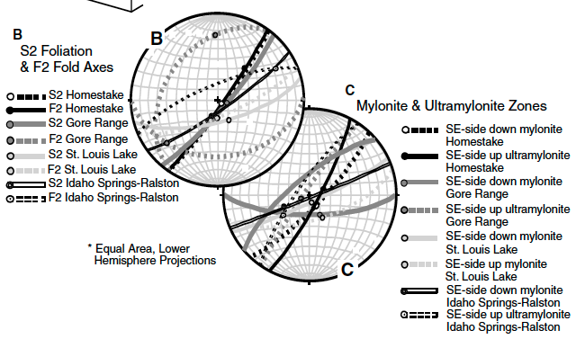
This option would involve exploration of some more advanced structure concepts based on the field data – including constructing stereonets of all fabric elements (including the lineations) using a software program and explaining what they mean and how they relate to the small and large scale structural pattern that everyone is familiar with from the Part I mapping. It will also involve a closer evaluation of the ductile shear zone and its movement history. It will also involve construction of an additional cross-section. A related publication by Shaw et al. (2002) will also be assigned to provide some additional context on the regional structure, and they include some data from our mapping area for comparison.

Source: the complete field data set (excel file), Shaw et al. (2002)
2) Microstructural analysis and mineralogy (optical microstructures and analysis with MATLAB of quantitative data collected from a Scanning Electron Microscope [SEM])
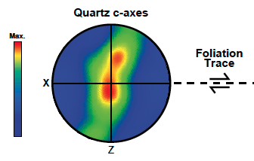
This option will involve evaluating quartz microstructure in the shear zone – from one of the samples of mylonitic quartzite -specifically from station GG2. This is from a published paper. It will involve understanding quartz crystallography, and depiction of crystallographic axes on stereonets. These data can inform on the mechanisms that accommodated recrystallization of the quartz during shear zone formation, the temperature conditions under which it occurred, and the kinematics (SE-side-up or down, etc.). There is the possibility of making some simple plots with data in MATLAB if one wants to but that would not be required.
Source: Ward et al. (2012)
3) Metamorphic petrology and mineralogy (nature of metamorphic grade and Pressure-Temperature history)
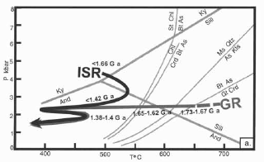
This option would involve synthesizing what is known about the diagnostic metamorphic minerals in the Coal Creek schist and quartzite. It will involve learning about what it means to have different polymorphs of the alumino-silicate minerals Andalusite, Kyanite, and Sillimanite in a rock. Hint: the Coal Creek schist/quartzite has had all three at some point in its history. The same publication and MSc thesis mentioned above for the monazite geochronology includes some photomicrographs and descriptions of petrology from the schist and quartzite.
Source: McCoy et al. (2005) and McCoy (MSc thesis, 2001), Ward et al. (2012).
4) Metamorphic geochronology (timing of metamorphism and deformation),
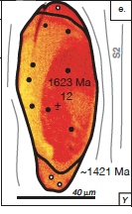
This option will involve synthesizing the results of a published monazite geochronology dataset on the Coal Creek quartzite, schist, and Xbg. The data was collected by Th-U-total Pb (non-isotopic) method on an electron microprobe, and it addresses the timing of movement in the ductile shear zone and of metamorphism in the Xcq and Xcs. There is a published paper and a MSc thesis with useful information.

Source: McCoy et al. (2005) and McCoy (MSc thesis, 2001)

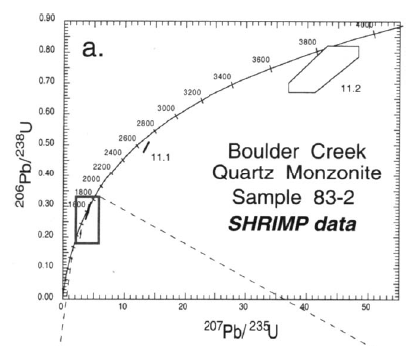
5) Igneous zircon geochronology (timing of pluton crystallization),
This option will involve synthesizing the results of a published igneous zircon geochronology dataset from the Boulder Creek granodiorite (the Xbg unit in your map). This is U-Pb isotope data that was collected by a Sensitive High Resolution Ion microprobe (SHRIMP) as part of a study of a range of Proterozoic granitoids in northern Colorado -the Xbg is one of several.
Source: Premo and Fanning (2000)

6) Detrital zircon geochronology (timing of deposition of sediment),
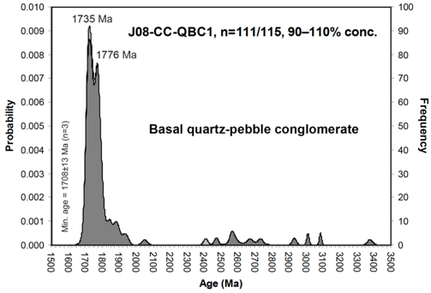
This option will involve synthesizing the results of a published detrital zircon geochronology dataset from the Coal Creek quartzite. This addresses the source area of the sediment that made up the original sandstone that later became a quartzite, and it addresses the timing of deposition relative to the granodiorite. It also helps constrain the timing of deformation (folding and shear zone development).

Source: Jones and Thrane (2012)

