Karst Hydrogeology: A virtual field introduction using Google Earth and GIS
By Rachel Bosch, University of Cincinnati karstgeomorph@gmail.com

Teaching Notes
Here are screenshots for a walk-through using Smiths Grove, Kentucky as the karst area. First the area is located using Google Earth:
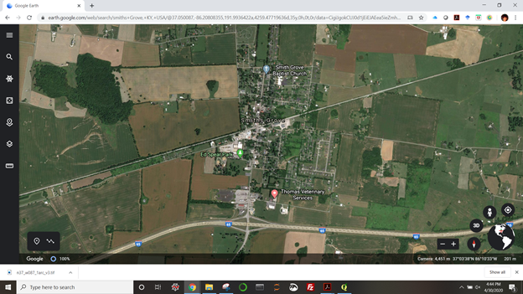
Then to USGS EarthExplorer:
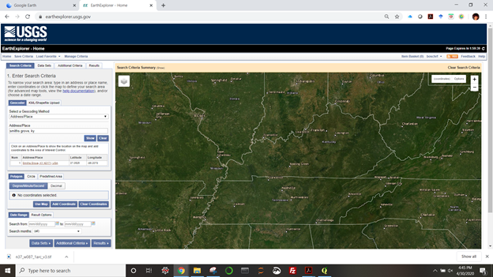
Click on “Data Sets>>” then “Digital Elevation”>”SRTM”>”SRTM 1 Arc-second Global”>”Results>>”
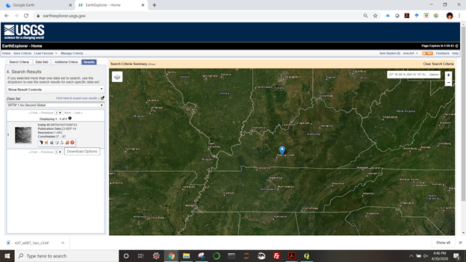
then “Download Options.” You will be prompted to Log in. If you do not have a USGS account, create one for free. Log in. You may need to reselect “Download options.”
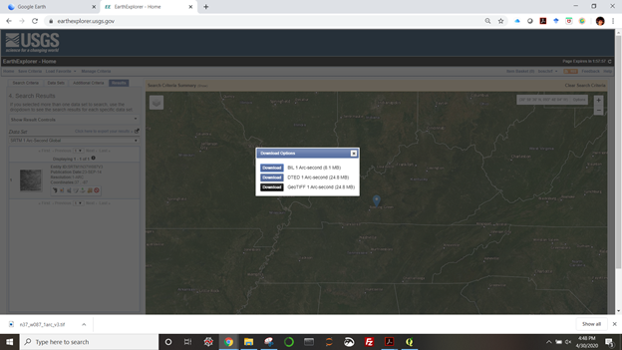
Download the DEM as a GeoTIFF to your working space folder. Open a new project in QGIS.
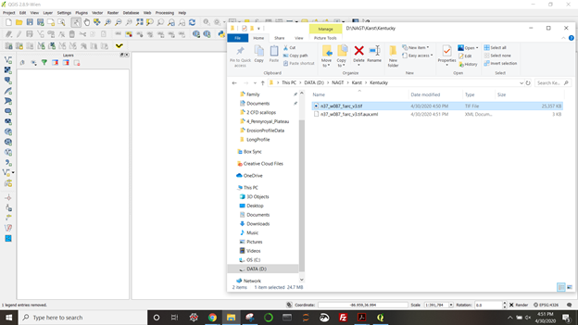
Drag the DEM tif file from your working space file folder to the visualization window in QGIS.
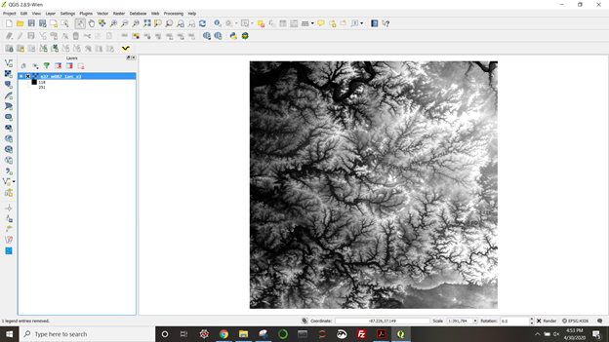
The image shows up in that main window while the file name appears as a raster in the layer list to the left.
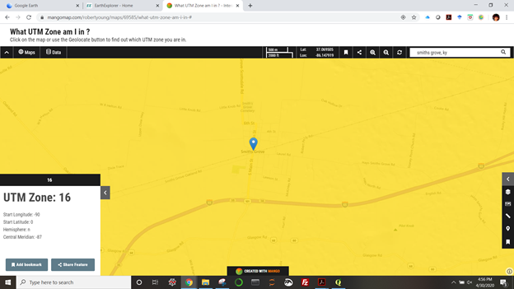
Determine your UTM Zone. This site is in 16N. Back to QGIS. . .
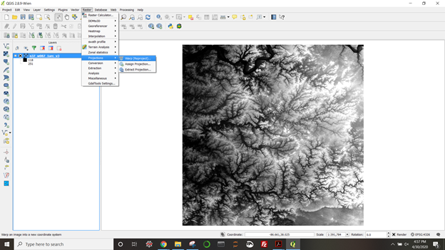
Raster menu > Projections > Warp (Reproject)

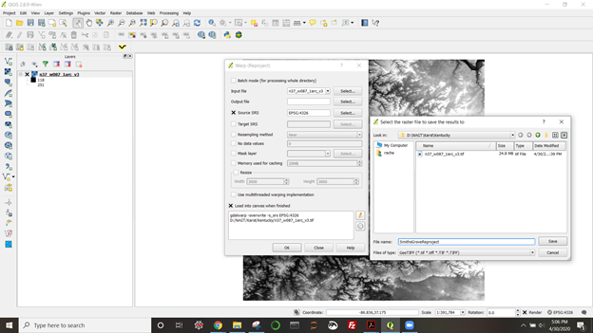

Select the DEM raster layer as input file, select the working space folder for output and name the output file
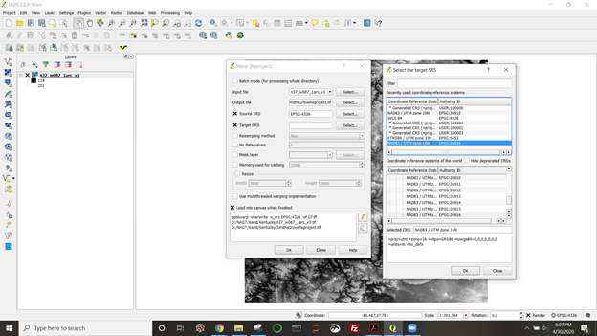
Click on the box for source CRS and Target CRS. Select Target CRS (in this case 16N). Click OK for target selection. Make sure “Load into canvas when finish” is selected, and click OK for reprojection.
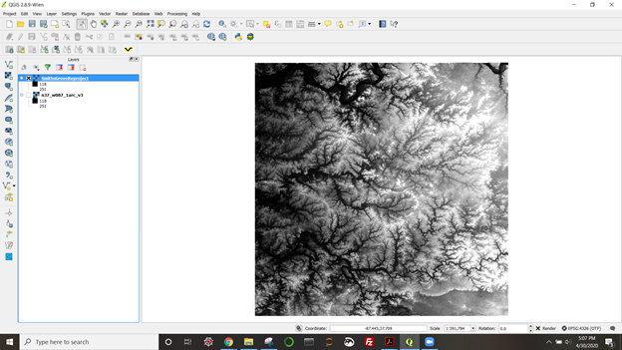
Deselect the original DEM layer so you are only viewing the reprojected layer.
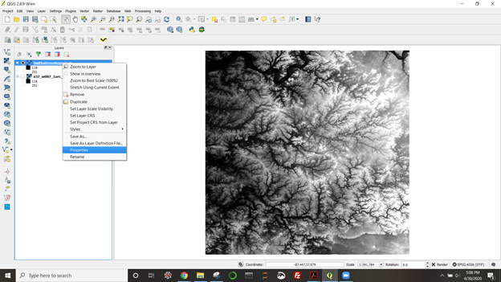
Right click on the reprojected layer and select properties.
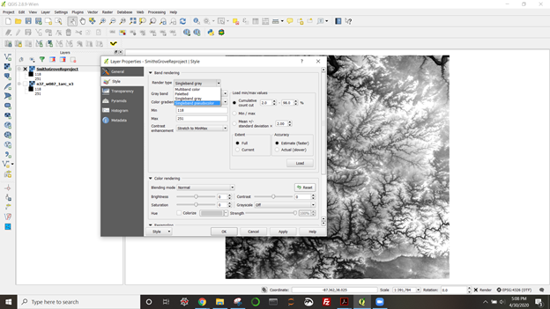
This is where you can change the color scheme to one you find more intuitive.
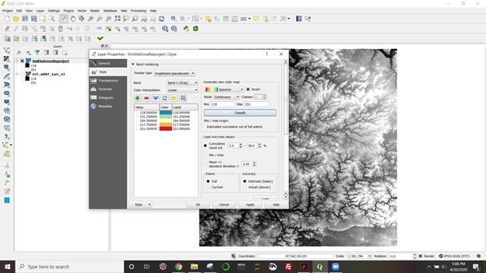
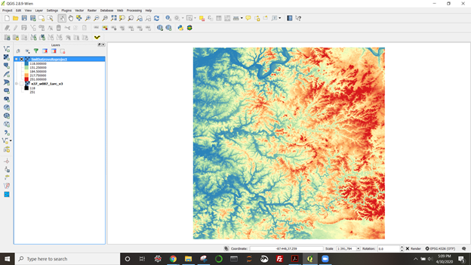
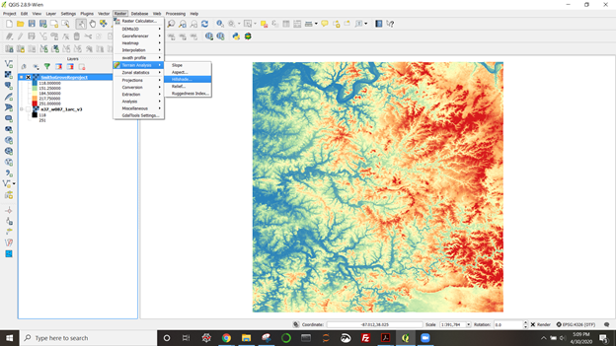
Raster menu. Terrain analysis > Hillshade.
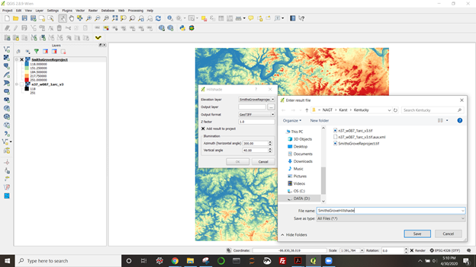
Use reprojected DEM as elevation layer. Click on the “…” button to select your working space folder and name the output layer. Make sure “Add result to project” is selected. Click OK.
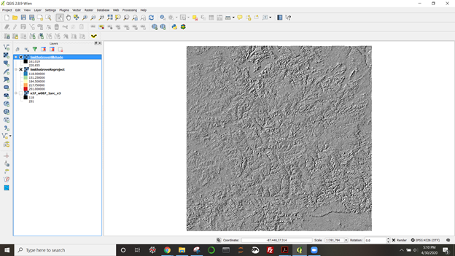
The Hillshade layer will present as opaque over your DEM.
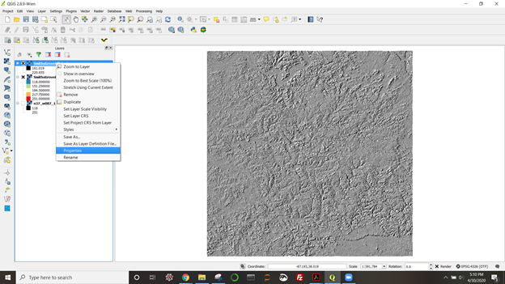
Right click on the Hillshade layer to manipulate its properties.
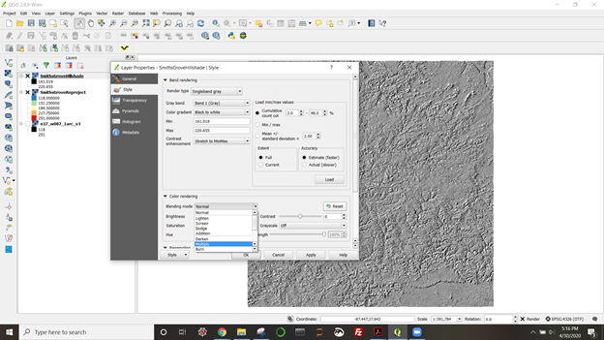
Select the “Multiply” blending mode to view both rasters simultaneously.
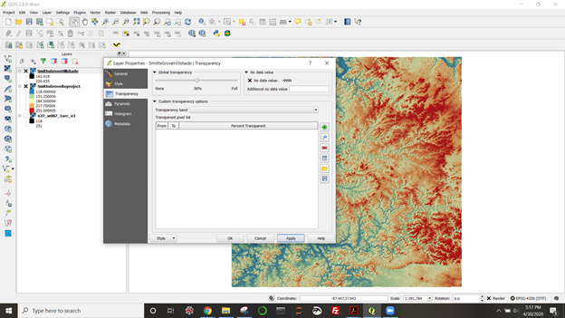
If you like, play with the transparency of the Hillshade layer to make the map as bright or dark as your want.
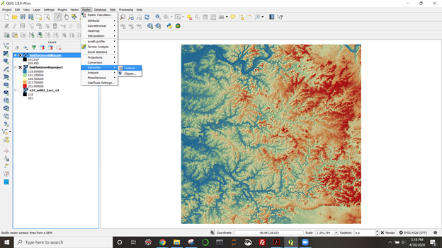
Building a contour vector layer. Rater menu, Extraction > Contour.
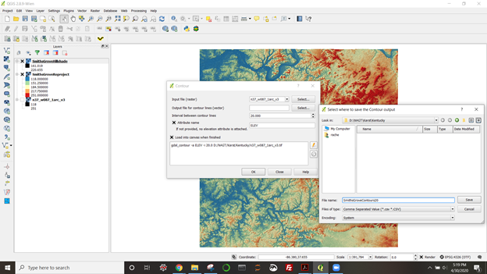
For input layer, select the reprojected DEM. Select your working space folder for output and name your output file. The contour lines here will be extracted every 20 m. Click to select “Attribute name” if you want elevation data stored with the lines in this layer. Select “Load into canvas when finished,” and then OK.
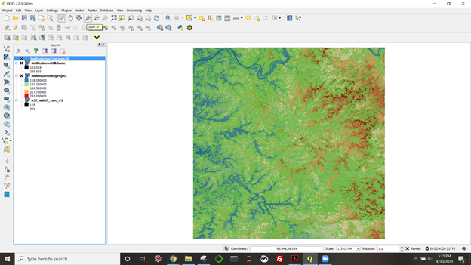
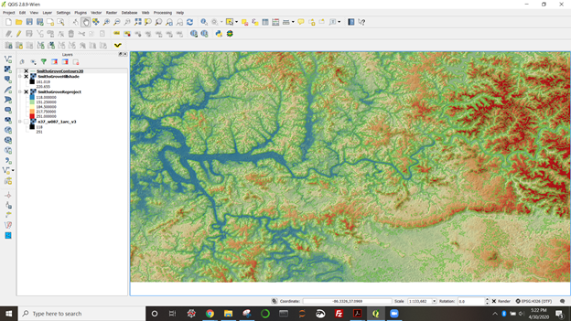
Zooming in, it’s still hard to see contours. Can use vector layer properties to change color.

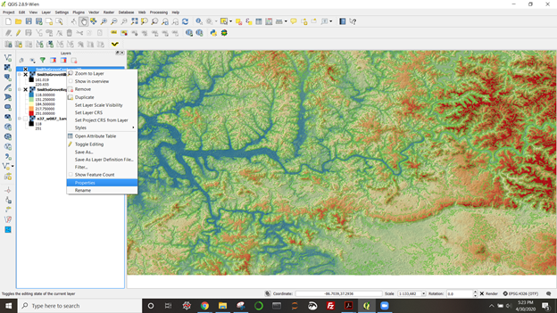
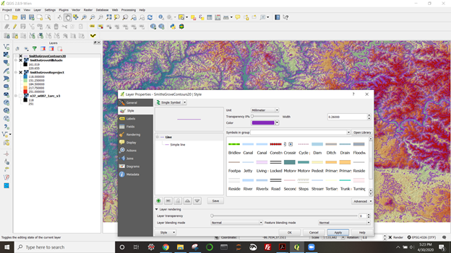
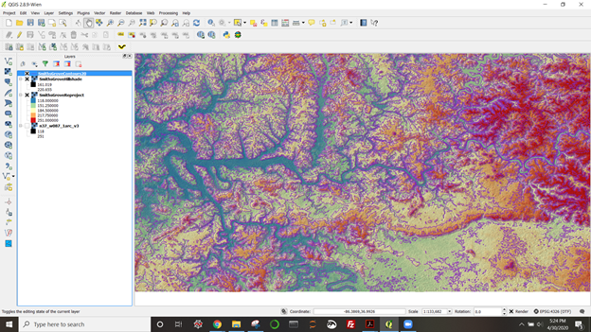
Perhaps you want more closely spaced contours. . . every 5 m, labeled every 20 m.
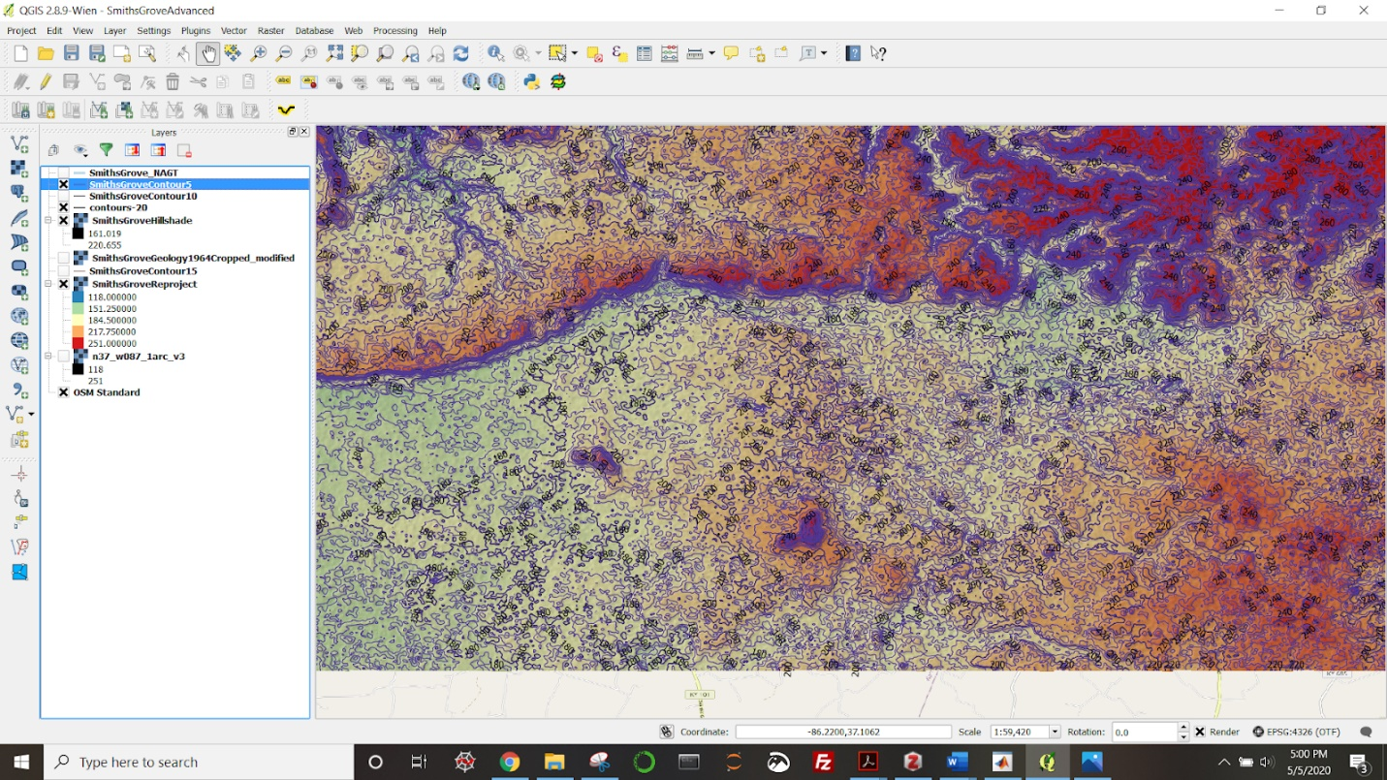
Built a new contour layer with 5 m spacing and then worked with the labels tab in that layer’s properties to choose the spacing for index contours.

