Day 2, Activity 3: Exploration of granite fabrics
For Geology of the Sage Hen Flat pluton, White Mountains, California
1:24,000 scale
By B.J. Bilodeau and C.A. Nelson
We are going spend today dealing with the internal fabrics and composition of the Sage Hen Flat pluton. We are using the map byBilodeau and Nelson, because it addresses the fabric within the pluton. The pluton is, in general, a medium-grained biotite granite; local variations in composition exist. You will be using new data that was generated by Dr. Michel de St Blanquat (University of Toulouse, France) to try to understand how the Sage Hen Flat pluton intruded into the crust (pluton emplacement). This assignment is divided into three parts. Each part has a different type of uncertainty. For all parts, you will be using GoogleEarth.
Activity 3a: Anisotropy of Magnetic Susceptibility (AMS) fabrics in the Sage Hen Flat pluton: The role of dispersion.
For this exercise, you will need to use the data in the “AMS” folder in Google Earth.
The AMS technique is a very useful method to determine fabrics in weakly deformed granites. In particular, lineation is a very difficult measurement to make. This part allows you to evaluate the quality of the AMS data. You do not need to know how AMS works, except that it is a magnetic-based technique. Rather, the quality of the data can be treated in a most statistical way, because a minimum of 5 samples from any one location are measured with the AMS technique. The consistency of those samples will provide the measure of data quality. In our case, we will only use three categories
- Compelling = Blue symbols. Less than10°of dispersion of all of the samples.
- Presumptive = Green symbols. Less than 20°of dispersion of all of the samples.
- Suggestive = Yellow symbols. Less than 45°of dispersion of all of the samples.
We are treating this categorization, because it is instrument derived, as largely an issue of precision. The difficulty with granite samples is that they could be so isotropic that a large dispersion is an accurate characterization of a particular rock. So, simply treat the dispersion as analytical error for your current purposes.
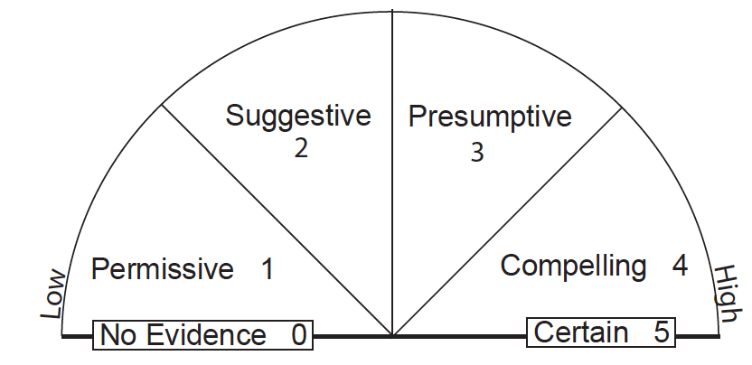

1. Investigate the AMS foliation. Look for the overall pattern of the foliation. Bias your interpretation based on the quality of the data: Ignore the least certain data if necessary. What is the overall pattern?

2. Are the data that show low certainty consistent with the overall patter in some cases? All cases?

3. Investigate the AMS lineation. Look for the overall pattern of the foliation. Bias your interpretation based on the quality of the data: Ignore the least certain data if necessary. What is the overall pattern?

4.Are the data that show low certainty consistent with the overall patter in some cases? All cases?

5. Now compare the AMS fabrics (foliations only) to the field-based fabrics by Bilodeau and Nelson (1993). This will take some time. Do you see, more-or-less, the same patterns? Are the AMS fabrics more consistent or are the

6. Do you trust the AMS results or the field-based fabrics more? Why? Choose one or the other. Then, explain why you trust that data set more.

Activity 3b: Minerals in the Sage Hen Flat pluton: The role of interpolation
Thin sections were made at each of the spots where the AMS technique was conducted. Thus, there is a Google Earth Map that contains the information about the mafic minerals and accessory phases in the rock. For this dataset, we are going to assume that the scientist can identify the particular minerals. However, there is still uncertainty with the maps, because it is not clear how to interpolate between the different data points.
For this exercise, please use the “Mineralogy” data in your Google Earth file.
1. Investigate the distribution of the phases. Look for the overall pattern. Describe the overall pattern in words.

2. Compare those results to the published results by Bilodeau and Nelson (1993). Do the two patterns agree with each other? If so, explain why. If not, explain how they differ.

3. Which dataset do you trust more? As before, explain why you trust one more than the other.
4. How confident are you drawing the boundaries between the two zones? Go ahead and drawn them. Explain your uncertainty in drawing those contacts.
Activity 3c: Microstructures in the Sage Hen Flat pluton: The role of interpretation
For this exercise, please use the “Microstructures” data in your Google Earth file.
The microstructures in the Sage Hen Flat pluton are divided into these divisions; 1) Magmatic fabric; 2) High-Temperature Solid-State fabric; and 3) Low-Temperatue Solid-State fabric. The thin sections can be seen by going to the various points on the map and looking at the data.
This dataset is different from the other two data sets: It requires an inference or an interpretation. The developer of the dataset must come up with a criterion and then apply it. The professional geologists is observing reality and then filtering it. An inference is an interpretation, but one that would be agreed to by >90-95% of professional geologists. An interpretation, in contrast, implies legitimate differences of opinion.
No one else has collected this data set, so there is no basis for comparison.
1. Describe the pattern, but without an interpretation. Just describe the pattern of the observations.

2. Now, interpret the data. Why are the fabrics arranged the way that they are?

3. Evaluate your explanation. How would you rate it?

4. For the evaluation above, are you evaluating your data? Or, are you evaluating a model of your data? Explain your answer.

