Plankton – REVIEW
Read from lecture textbook the chapter on Plankton. In Marine Biology Coloring Book (bring to class!!!), read chapters 14 (Photic Zone – specifically the plankton section), 19 (Phytoplankton), 35 (Crustacean diversity: Copepod only), 75 (Planktonic Larval Forms), 79 (Gastropod larvae, especially snail and abalone), 81 (Barnacle and Copepod Life Cycles), and prereading below.
Test: shell or skeleton
Phytoplankton: free-floating, nonswimming autotrophs  Holoplankton: organisms that spend their entire life spans as plankton. | Size
Diatoms | 0.005 to 1 mm
Dinoflagellates | 0.05 to 0.2 mm

Zooplankton: free-floating, nonswimming heterotrophs  Holoplankton: organisms that spend their entire life spans as plankton. | Size
Copepod (adults and larvae) | 1 to 10 mm
Foraminiferans | 0.1 to 1 mm
Radiolarians | 0.1 to 1 mm
Dinoflagellates | 0.05 to 0.2 mm

Zooplankton: free-floating, nonswimming heterotrophs  Meroplankton: organisms that live as plankton or only part of their life cycle. | Size
Crab larvae (arthropods) | 1 to 10 mm
Barnacle larvae (arthropods) | 0.5 to 2 mm
Polychaete larvae | 0.5 to 2 mm
Gastropod larvae | 0.5 to 2 mm

PHYTOPLANKTON: AUTOTROPHIC PROTISTS
Diatoms
Diatoms are single-celled, autotrophic protista: Planktonic diatoms are mostly centric and are collected and eaten by zooplankton and by benthic feeding animals such as mussels. Benthic diatoms are mostly pennate. Planktonic diatoms seem to favor turbulent conditions with high nutrient availability. Some diatom species are known to generate toxins that have caused illness and deaths in pelicans and some people. Toxins are transferred to vulnerable consumers by organisms (like anchovies) that are not harmed by it, but concentrate it.

Chain diatoms:
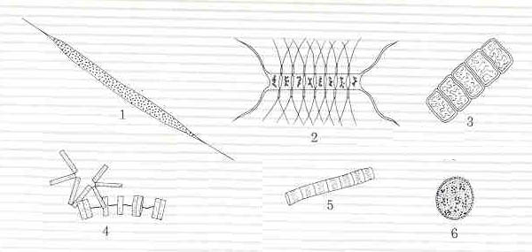 | - Rhizosolenia  - Chaetoceros  - Navicula,  - Thalassiosira,  - Skeletonema,  - Coscinodiscus.  (Not to scale.)  Graphic from Nybakken, J.W., 2001, Marine Biology: An Ecological Approach, Addison-Wesley Publishing.

PLANKTON PICTURES TAKEN BY MELISSA DUBOSE, 2010, CHRISSY FIELD SEAWATER SAMPLE
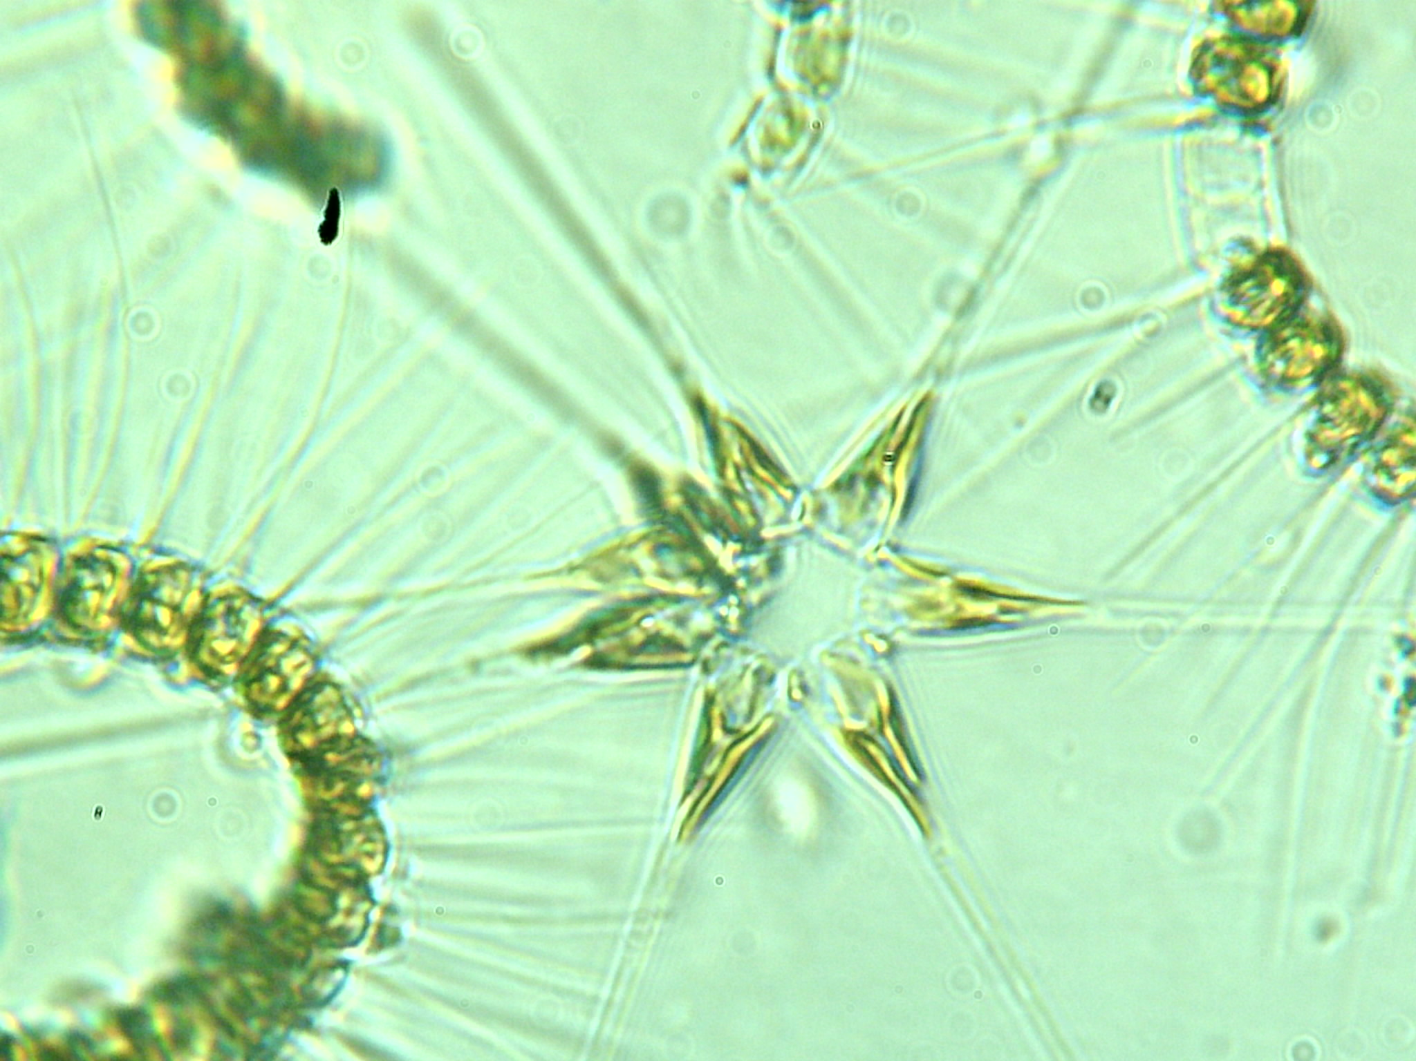  Diatom, Asterionella with Chaetoceros on right and left  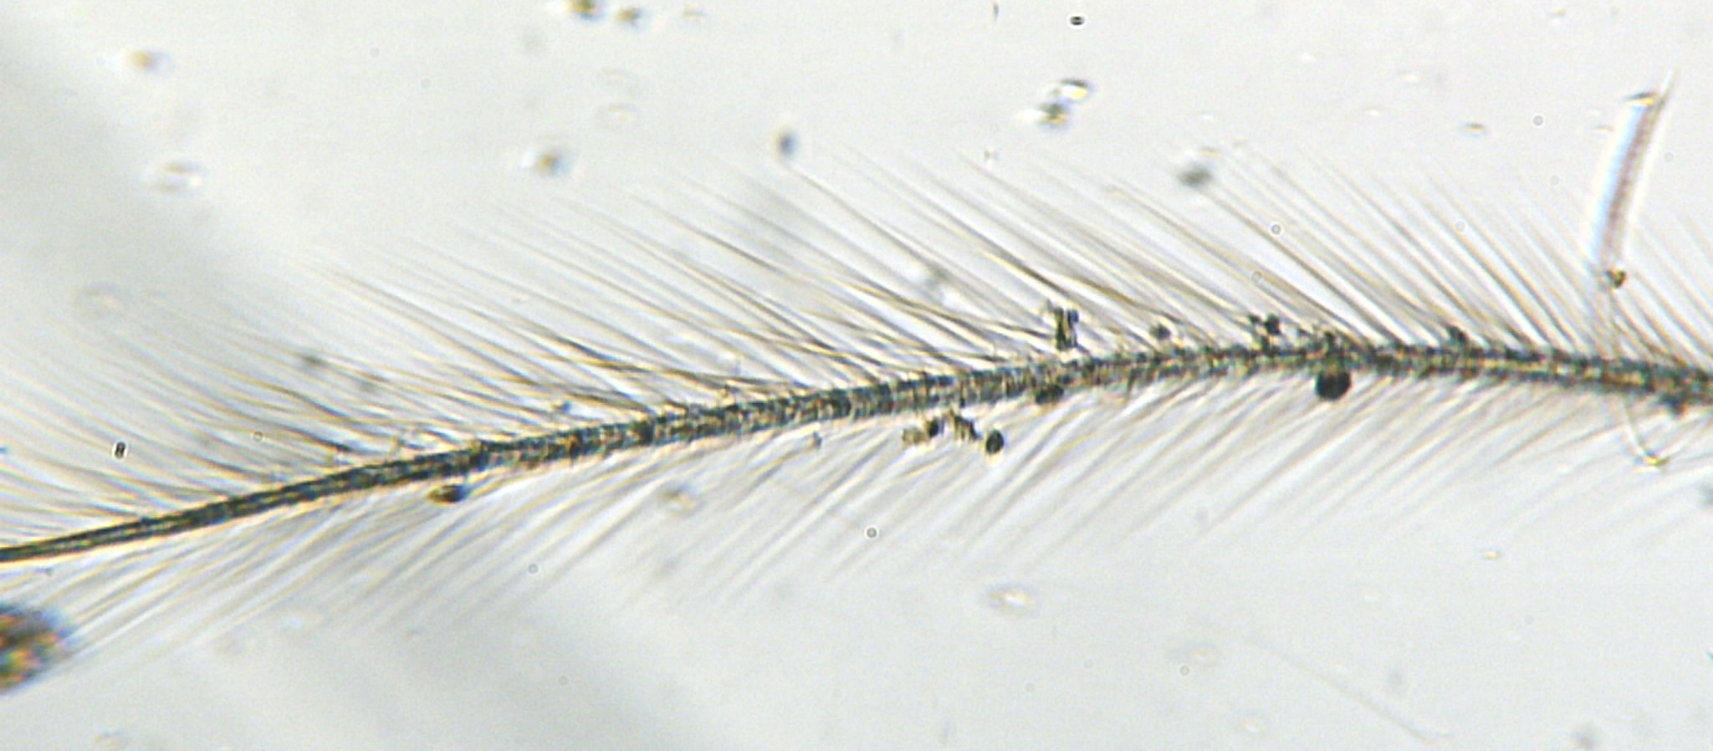  Diatom, Chaetoceros socialis | 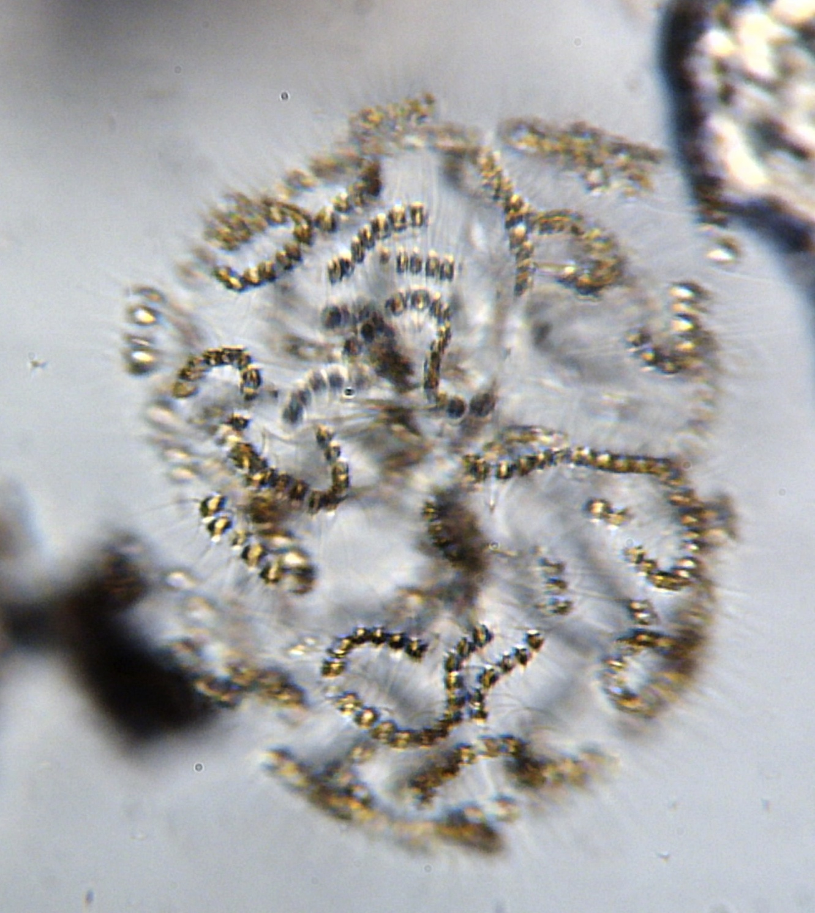  Diatom, Chaetoceros socialis
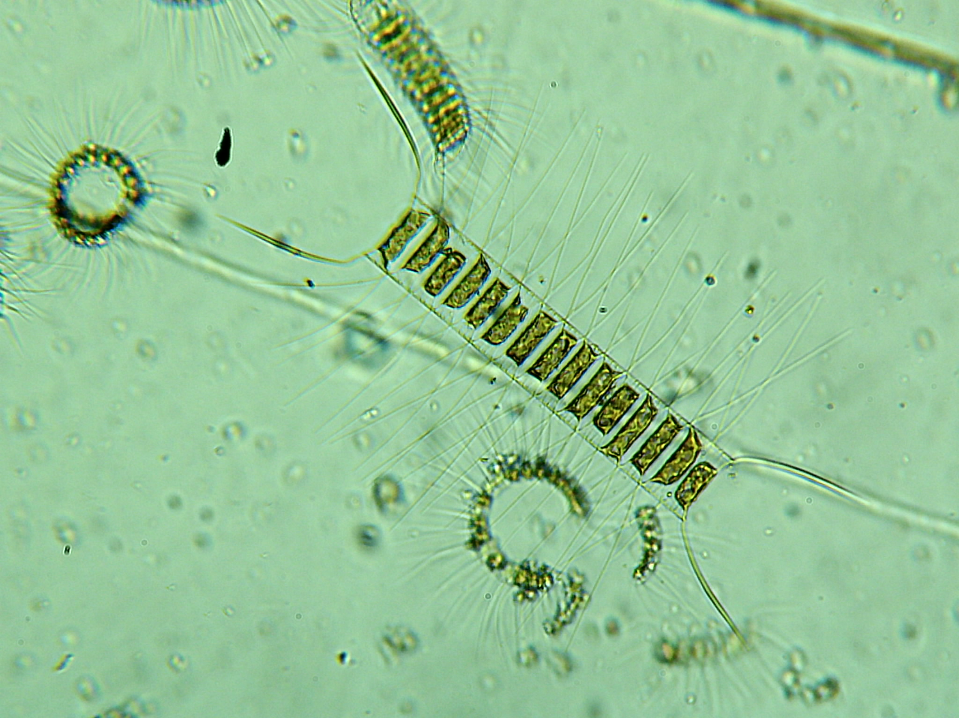  Diatom, Chaetoceros | 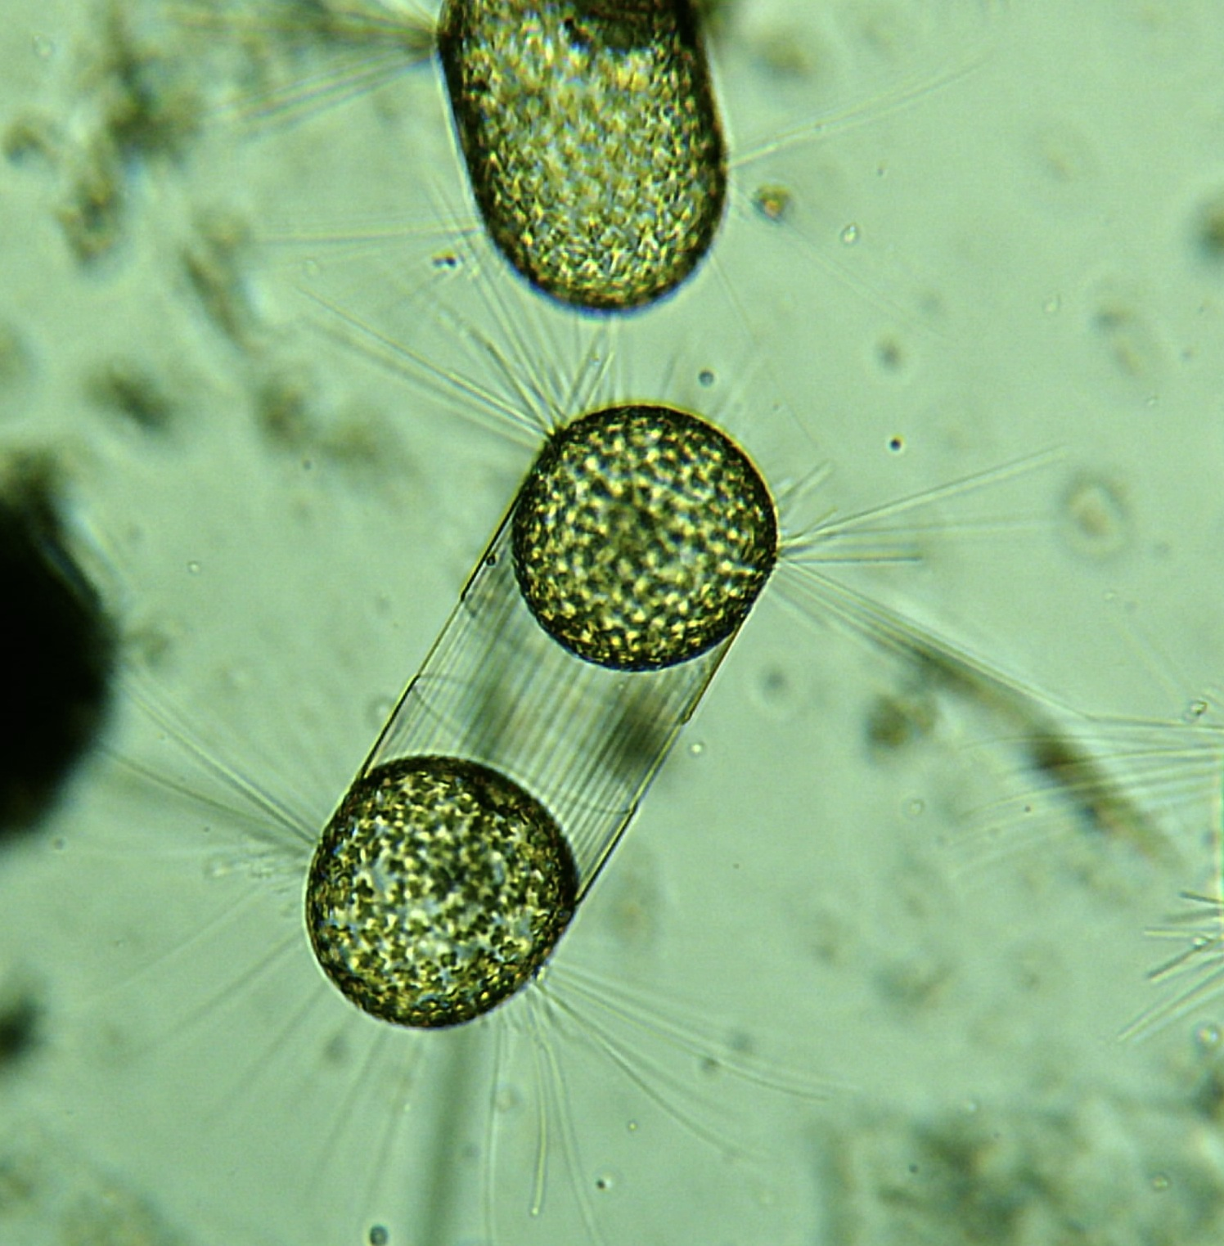  Diatom, Corethron
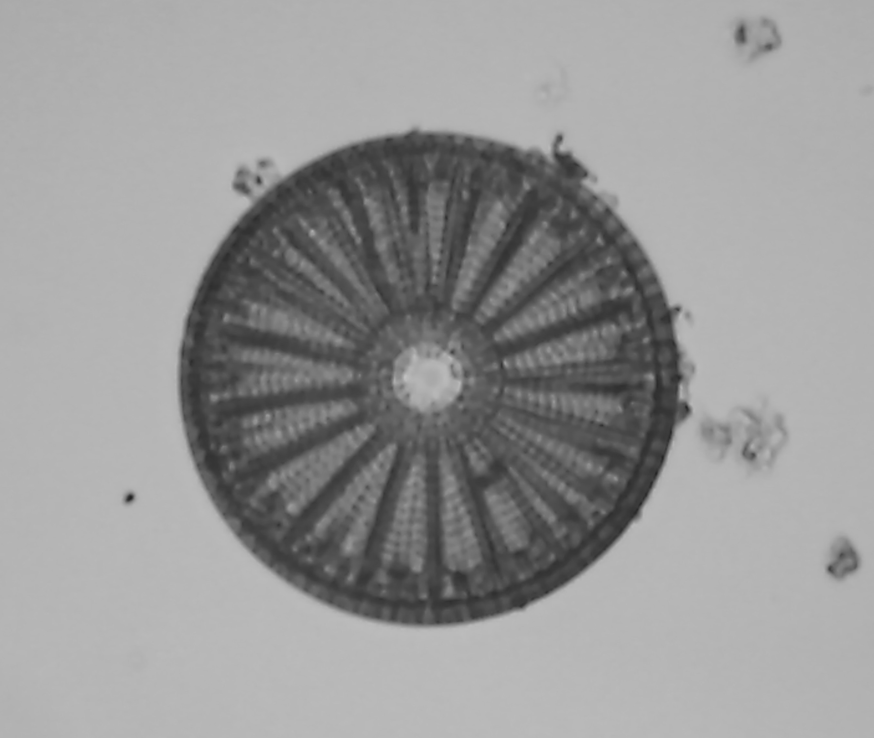  Diatom, Coscinodiscus | 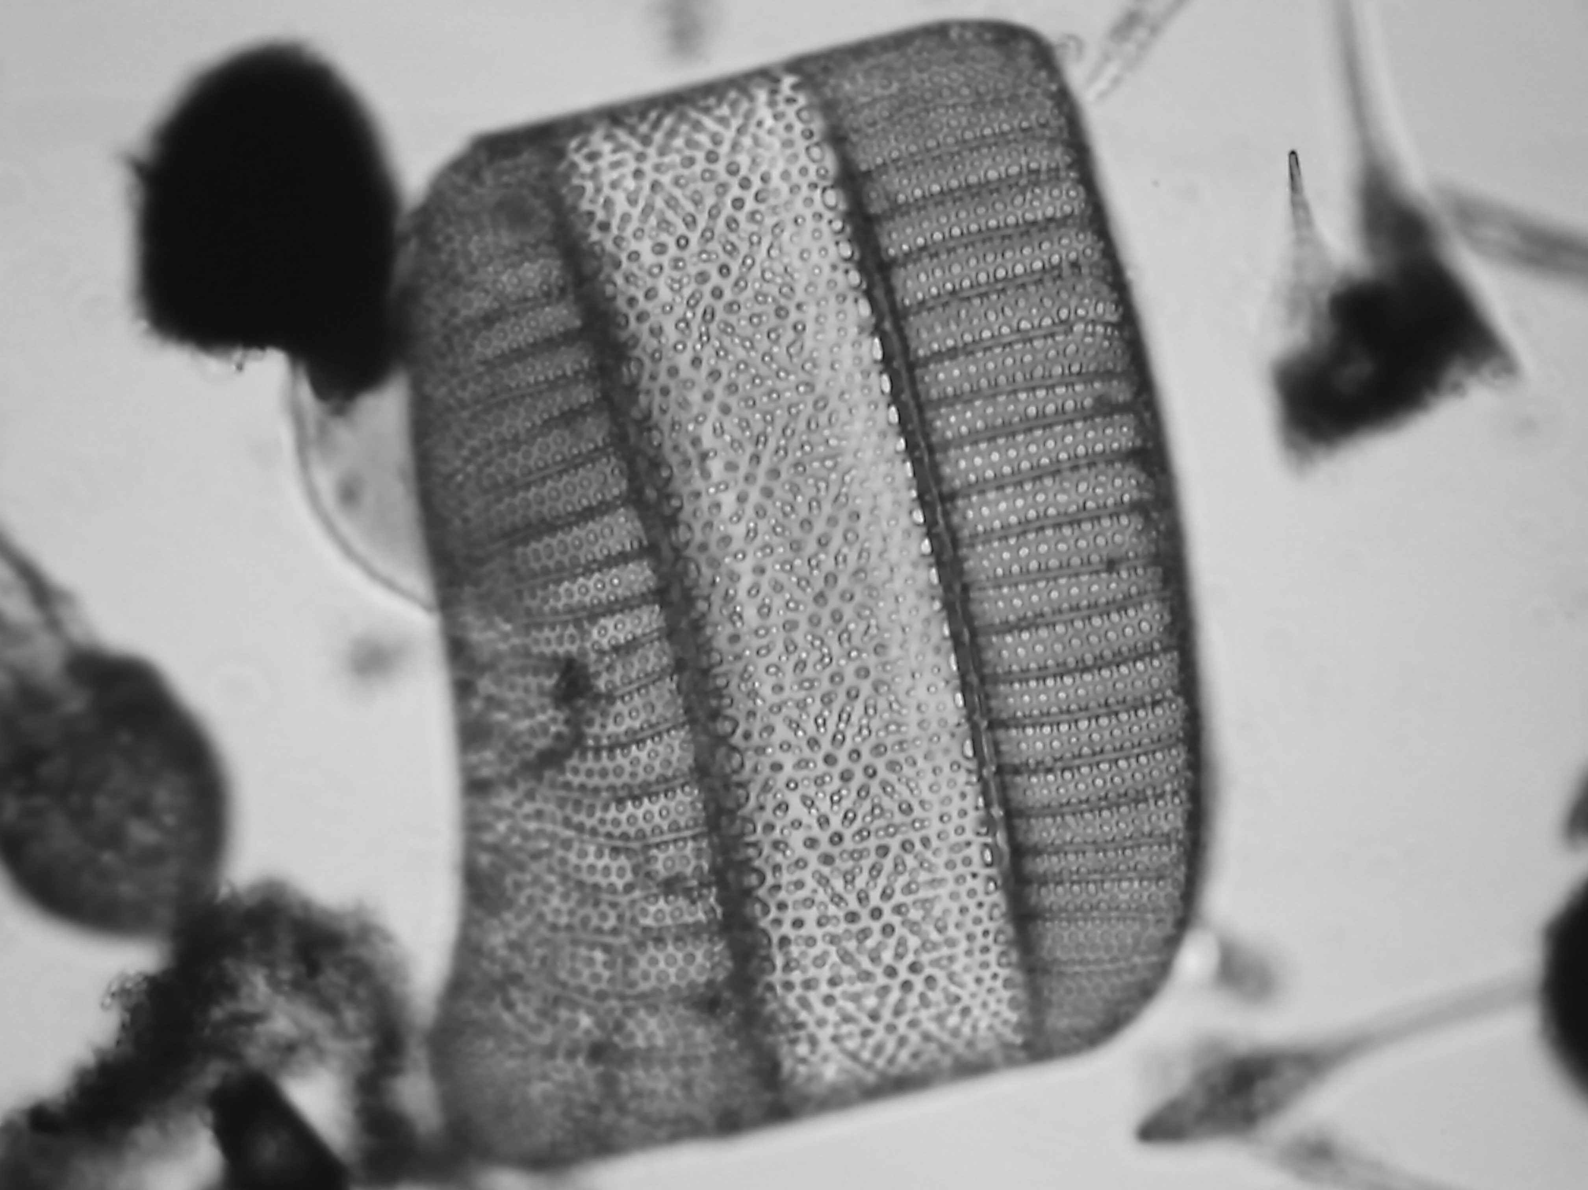  Diatom, Isthmia nervosa
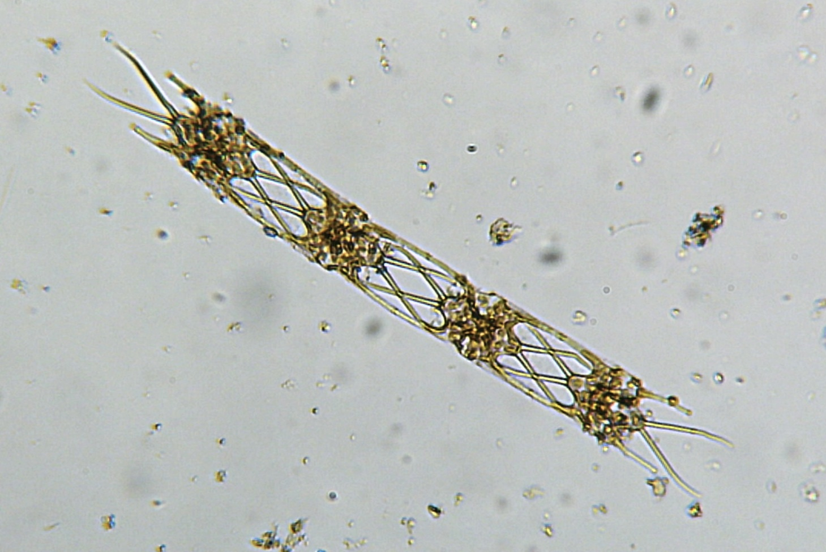  Diatom, Odontotella | 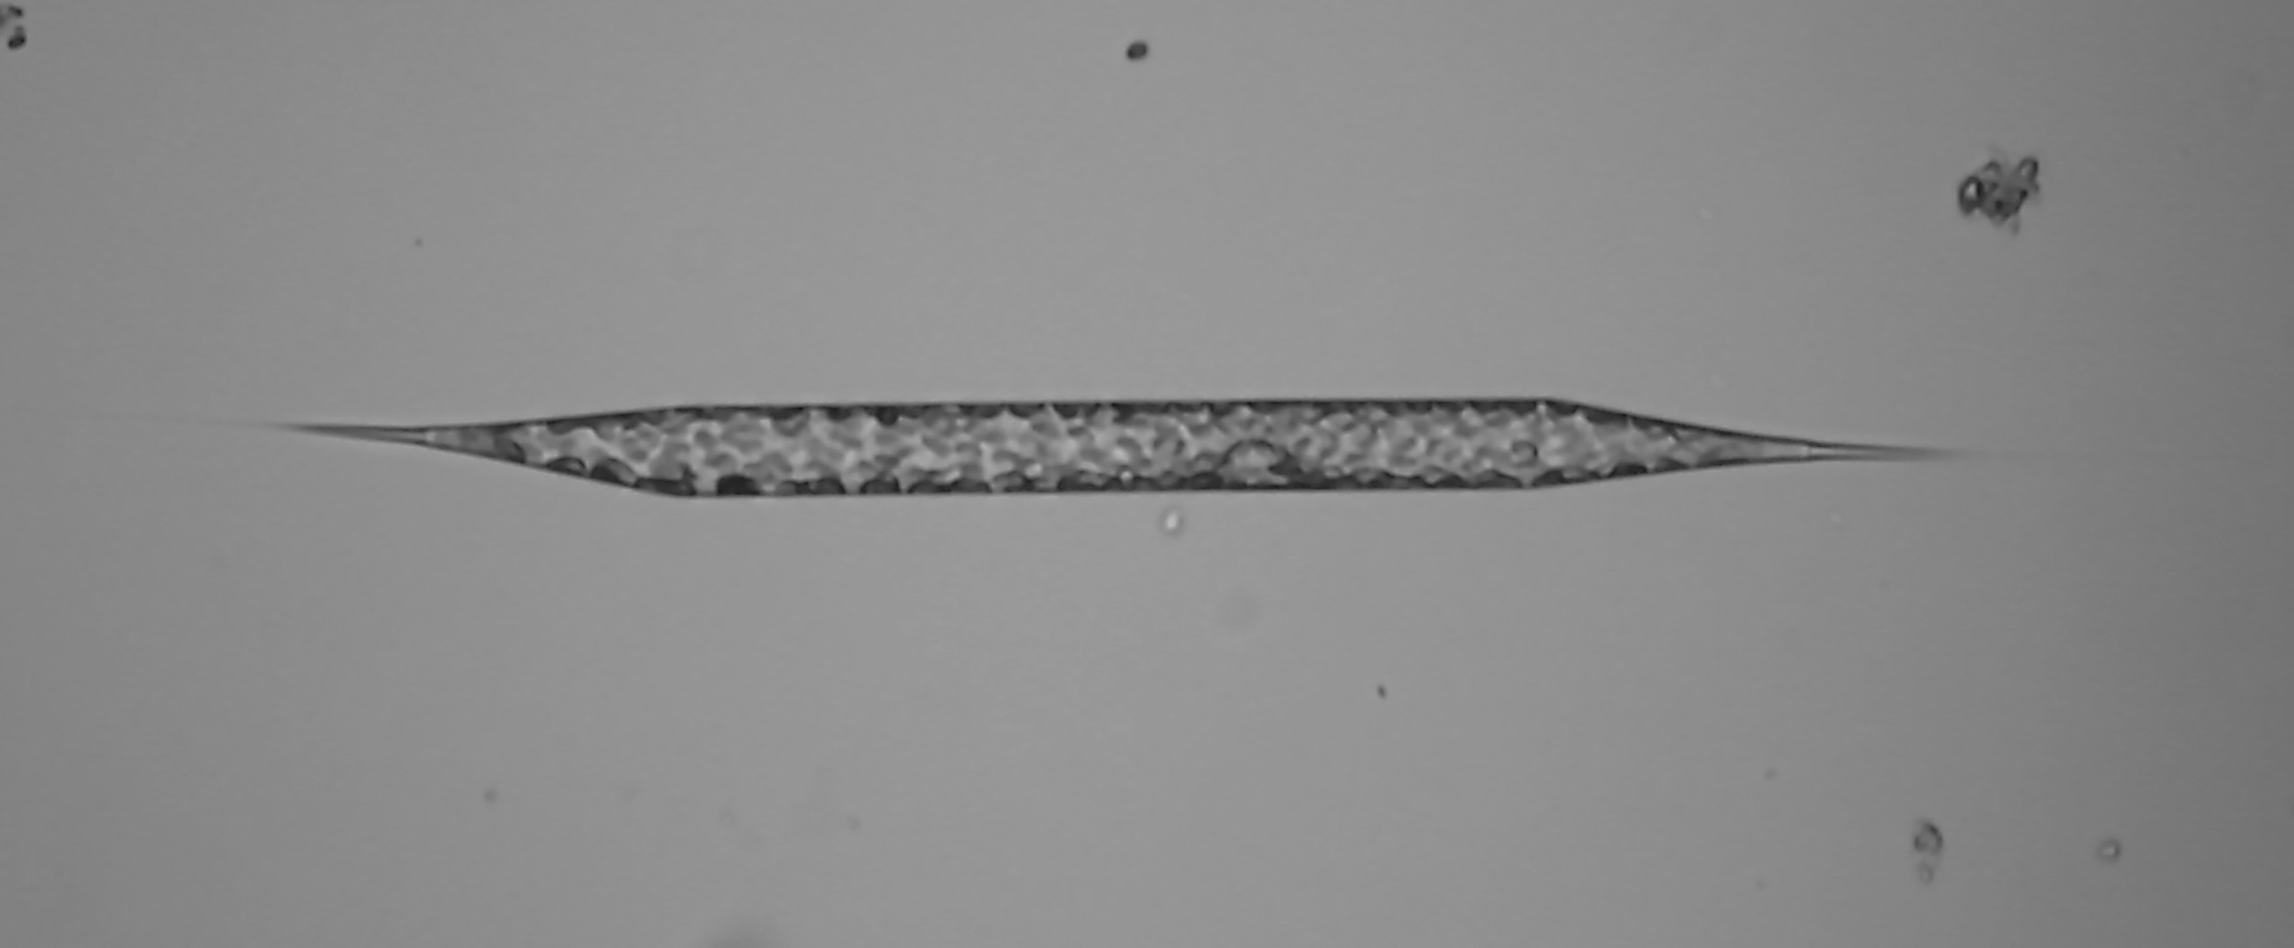  Diatom, Rhizosolenia
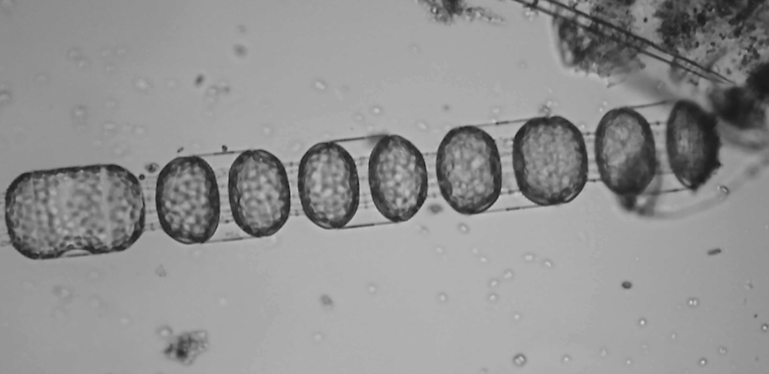  Diatom, Stephanopyxis | 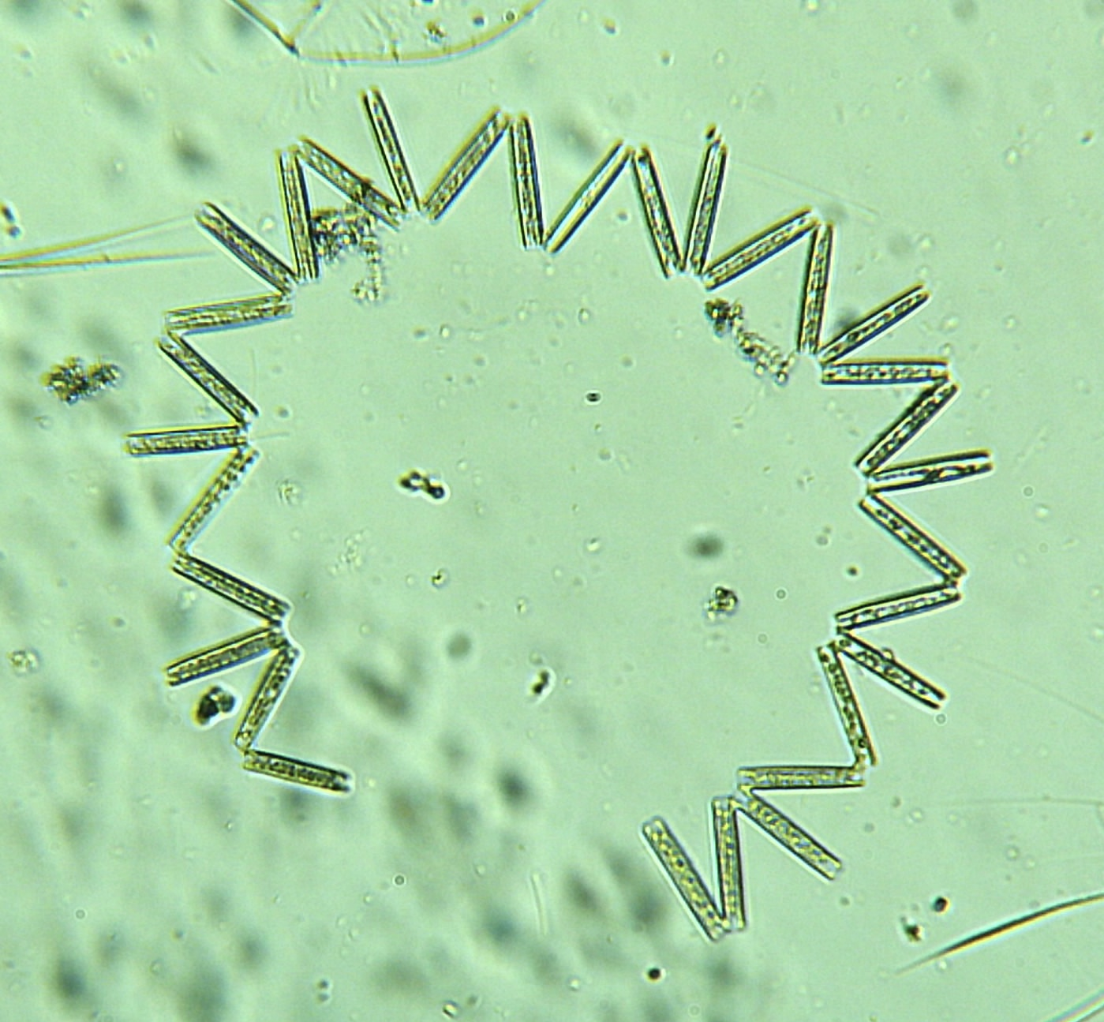  Diatom, Thallassionema

Dinoflagellates
Dinoflagellates are protista: Most dinoflagellates are single-celled autotrophs with two flagella. One flagella trails free in the water; the other is wrapped around the waist of the cell like a belt, confined to a groove in the plates. These flagella let the cells swim, sometimes as much as a few meters in one day. Planktonic dinoflagellates seem to favor stratified water with low nutrient supply. They are conspicuous year-round in warm seas (where nutrients are typically scarce) and seasonally in colder seas during the summer (after diatoms and other photsynthesizers have reduced the nutrient supply). Where nutrients are abundant, dinoflagellates are usually outnumbered by diatoms. The ability of dinoflagellates to swim from a locally exhausted microneighborhood to a nearby place where nutrients are slightly more abundant may contribute to their success in low-nutrient waters. Note: some dinoflagellates are heterotrophs, and therefore also zooplankton.

A few species of dinoflagellates manufacture powerful toxins (such as species shown in figures b and c – b is the Atlantic variety; c is the Pacific variety). These species become fantastically abundant under some conditions, increasing from a typical 100 or fewer organisms per milliliter of water to some million or more and giving the water a reddish cast known as red tide. The toxins liberated during these episodes causes widespread kills of fishes and other organisms. Shellfish collect these dinoflagellates and concentrate toxin without being harmed by it. Someone eating the shellfish (raw or cooked) experiences paralytic shellfish poisoning, characterized by numbness of the lips, dizziness, nausea, and (sometimes) death. There are other illnesses that dinoflagellate toxins are also associated with. Some dinoflagellates, such as the common Noctiluca species, are also highly bioluminescent and when present in large numbers, can actually light up the waves of boats and the breaking waves on a beach. Also, some (such as Noctiluca) are not photosynthetic.
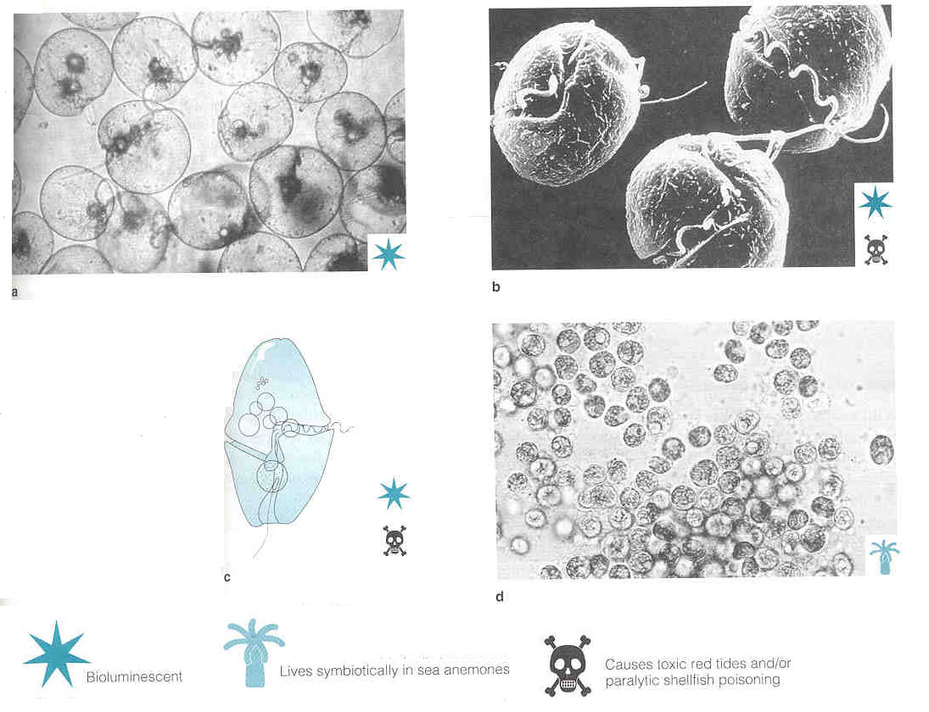
a) Notiluca species. (1 mm) b) Gonyaulax species, showing flagellum in the body groove and a second flagellum. This species causes red tides in the Pacific Ocean. (60 μm) c) Gymnodinium species, which causes red tides in the Pacific Ocean. (80 μm) d) Zooxanthellae from a West Coast sea anemone. (9 μm)
Graphic from Milne, D.H., 1995, Marine Life and the Sea, Wadsworth Publishing.

PLANKTON PICTURES TAKEN BY MELISSA DUBOSE, 2010, CHRISSY FIELD SEAWATER SAMPLE

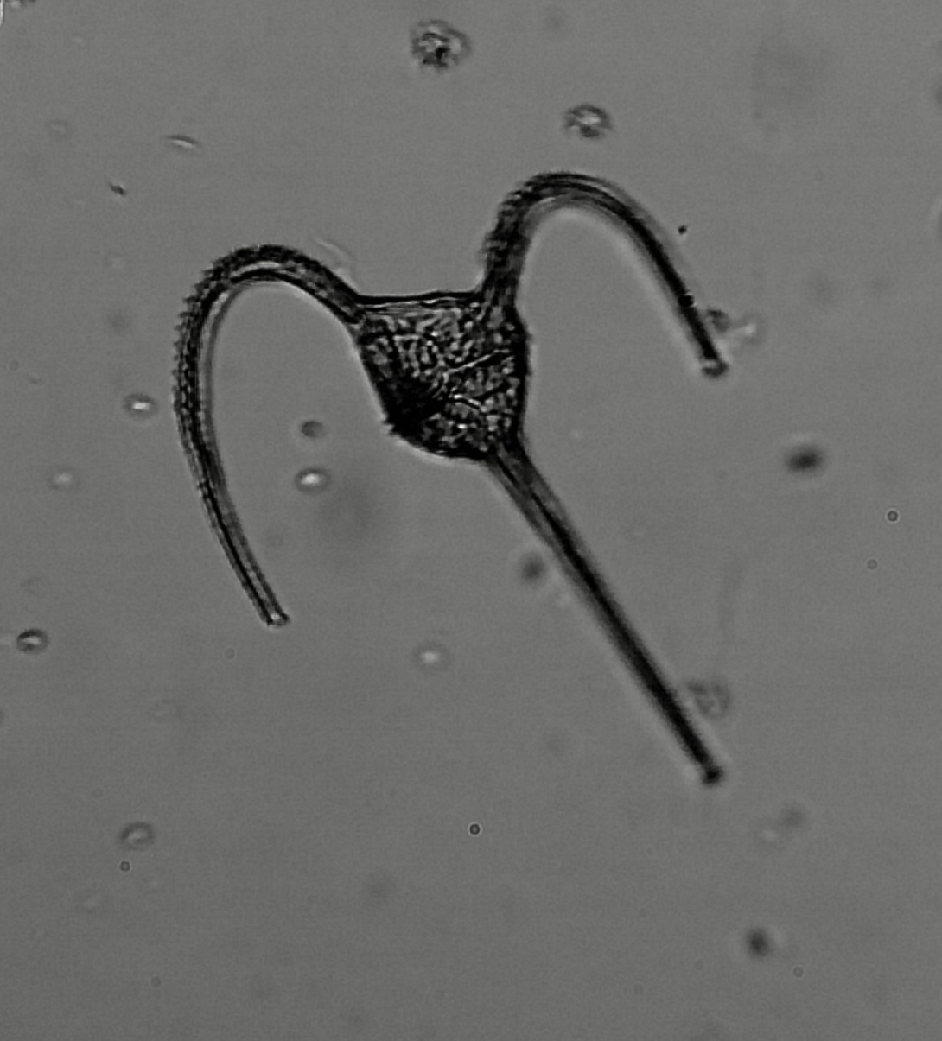  Dinoflagellate, Ceratium longpipes | 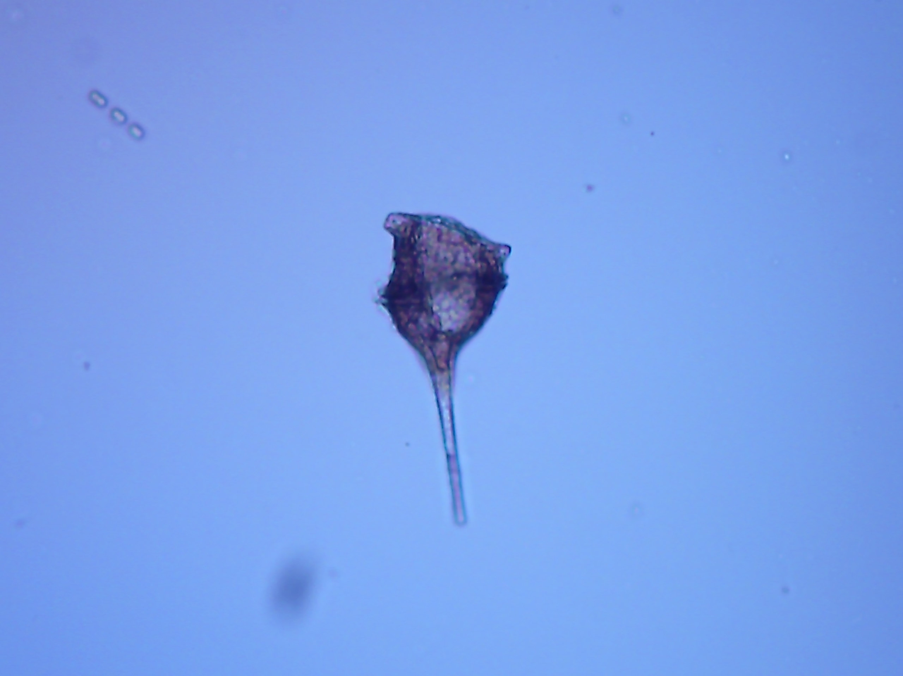  Dinoflagellate, Ceratium
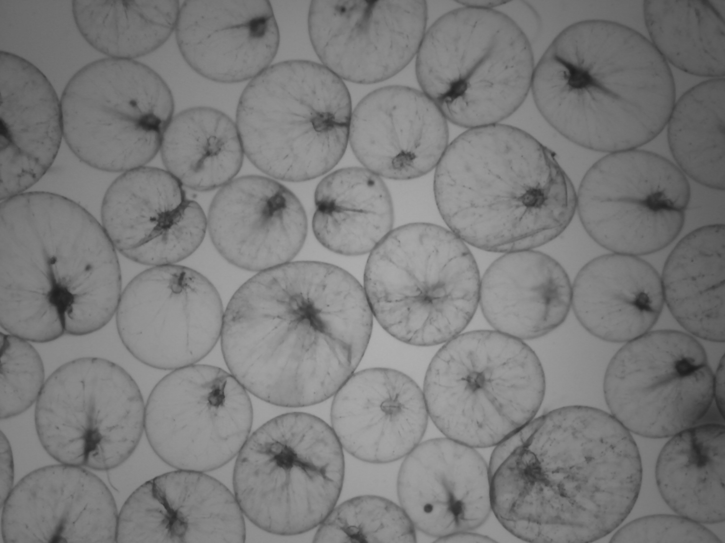  Dinoflagellate, Noctiluca | 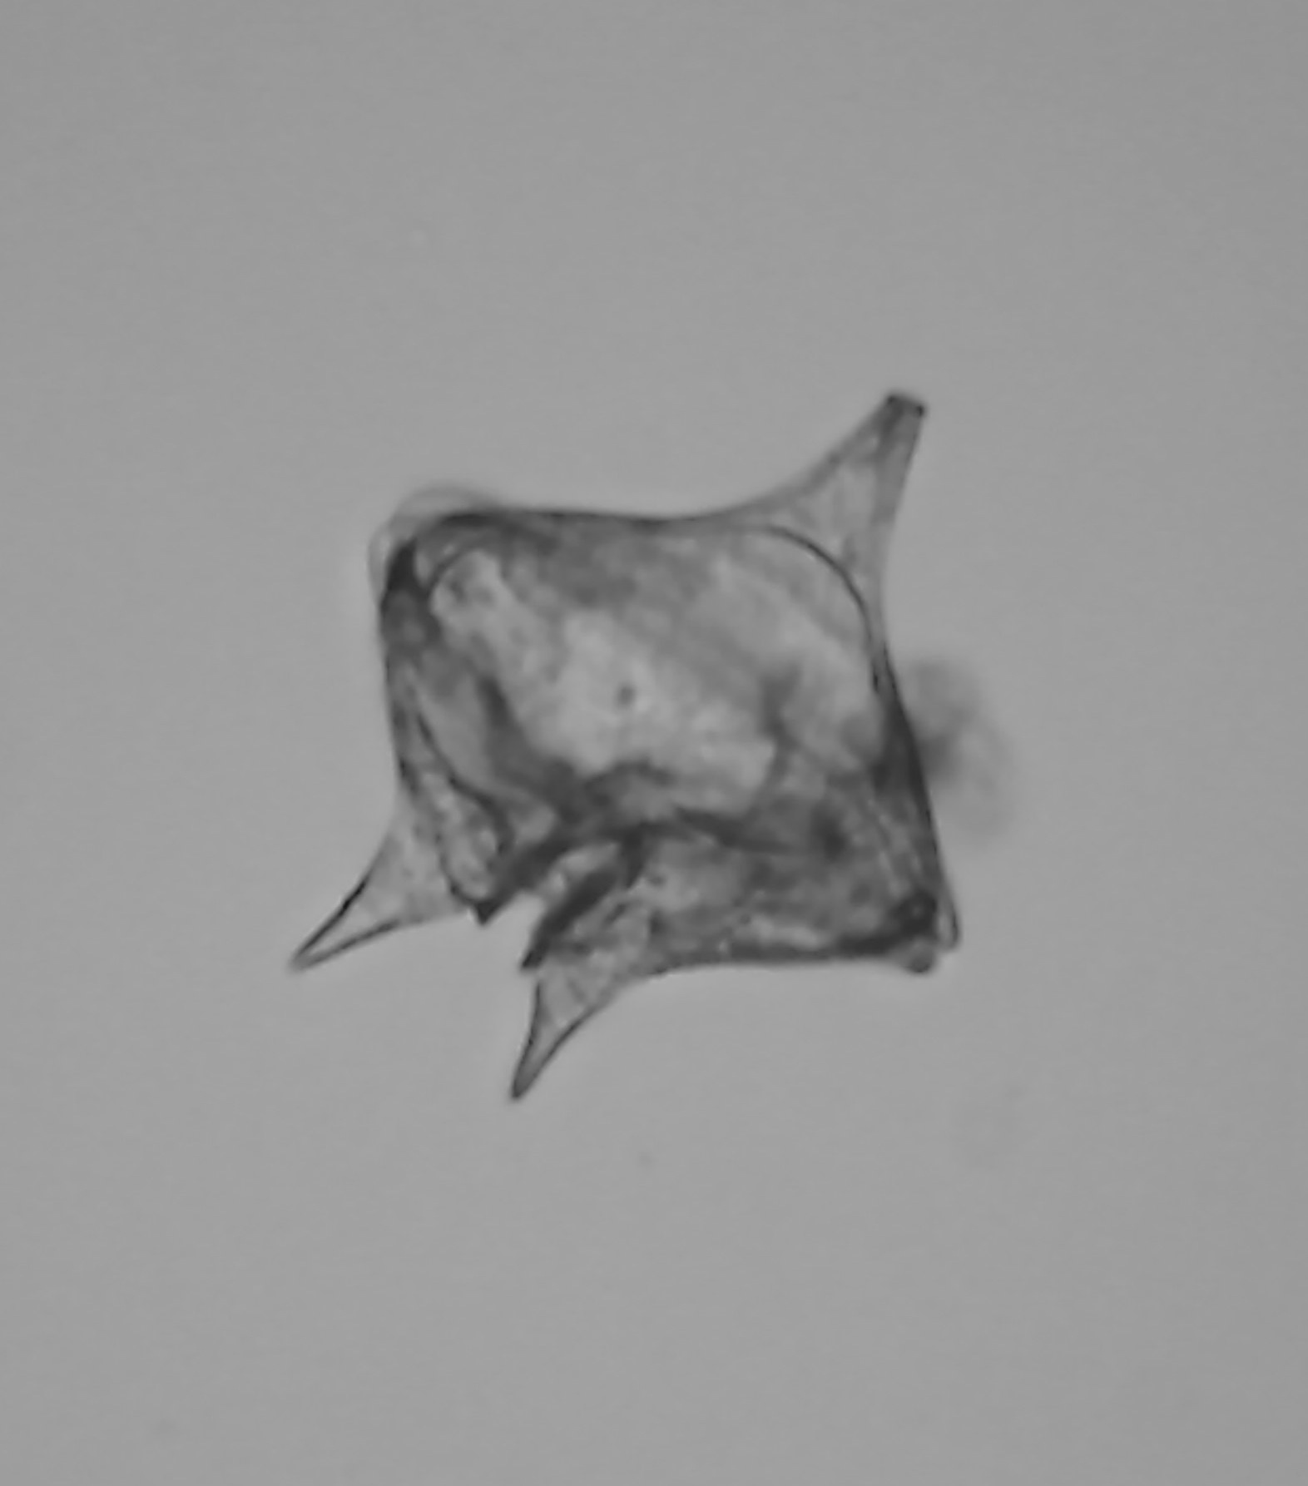  Dinoflagellate, Protoperidinium

ZOOPLANKTON
Radiolaria
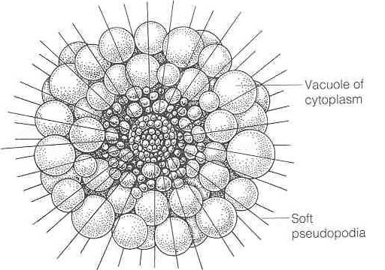  Thalassophysa pelagica (center has been cleared to give view of interior). Graphic from Milne, D.H., 1995, Marine Life and the Sea, Wadsworth Publishing. | 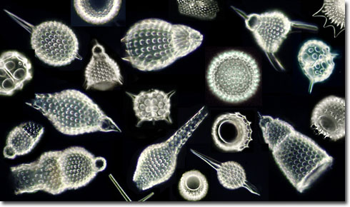  Radiolaria are single-celled, unclassified Protista. They are all heterotrophs with ornate shells riddled with holes and made of SiO₂.

Foraminifera
Foraminifera are single-celled Protista. They are all heterotrophs with ornate shells riddled with holes and made of CaCO₃. Tests consist of several chambers segmented together in a pattern of spirals, zigzags, or concentric spheres. As a foram grows, it adds larger chambers to its test.
Globerigina bulloides species. Globular skeleton (hidden in interior) has thin spines, each covered with cell cytoplasm. The spines dissolve after the organism dies; inset shows the skeleton as seen in seafloor sediment.  Graphic from Milne, D.H., 1995, Marine Life and the Sea, Wadsworth Publishing. | 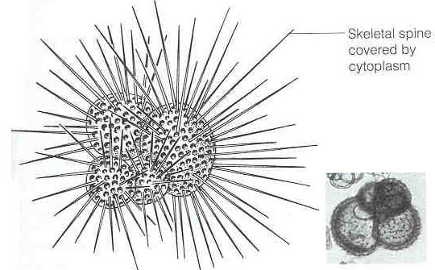
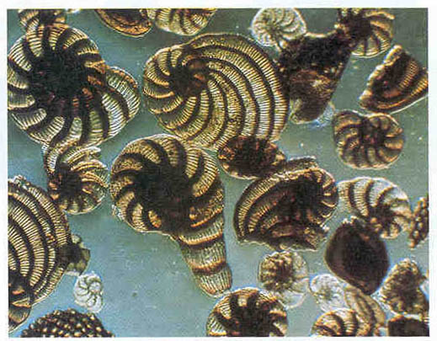  Light streams through thin parts of the foraminifera shells. Foraminifera means bearers of windows.  Graphic from Garrison, T, 1999, Oceanography, Wadsworth Publishing. |  | 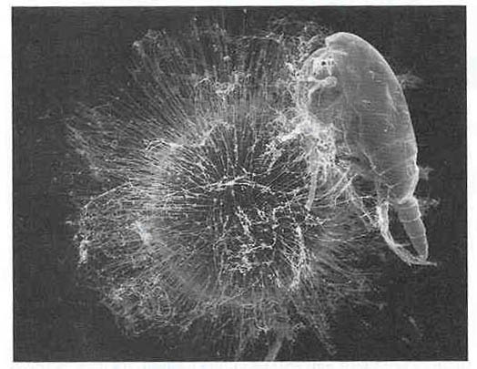  Orbulina feeding on a copepod. The foram’s spines have a sticky layer on their surfaces. Zooplankton that bump into the spines stick to them and are digested.  Graphic from Garrison, T, 1999, Oceanography, Wadsworth Publishing.

PLANKTON PICTURES TAKEN BY MELISSA DUBOSE, 2010, CHRISSY FIELD SEAWATER SAMPLE

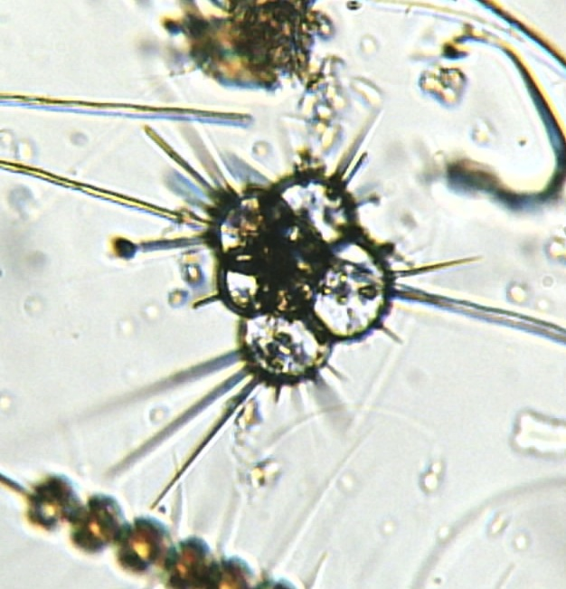  Foraminifera, Globigerina | 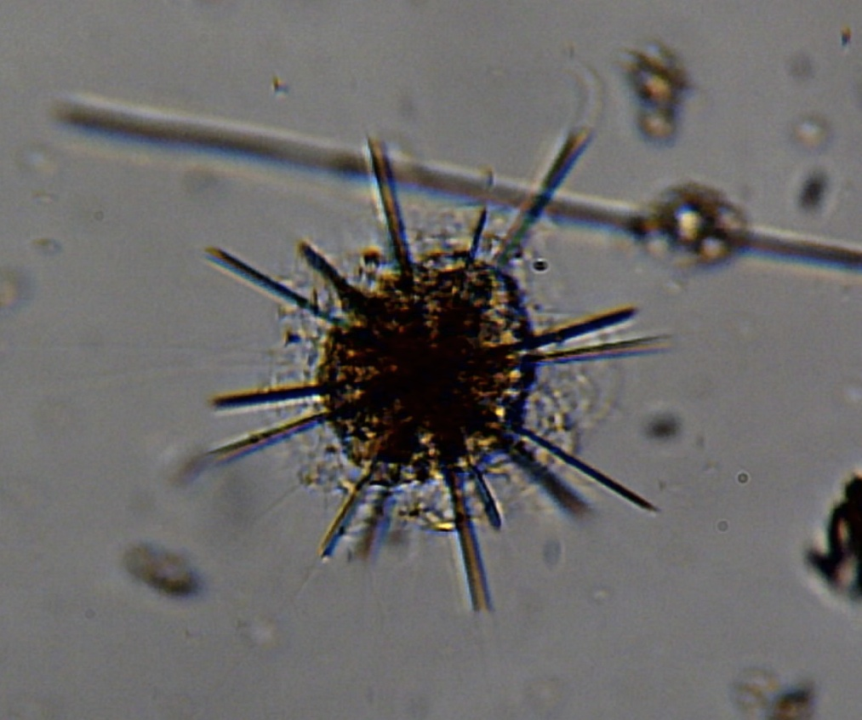  Radiolaria

Other organisms you might see in this lab:
Unless otherwise stated, all the following images come from students and professors in this lab or from:
An Introduction to the World’s Oceans, Sverdrup and Armbrust, 10th Edition, McGraw Hill Publ.
A Guide to Marine Coastal Plankton and Marine Invertebrate Larvae, Deboyd L. Smith, 1977, Kendall/Hunt Publishers.

TINTINNIDS  Kingdom: Protista; Phylum Ciliates; Single-celled heterotrophs. No shells. Cilia (hairs) create water flow into mouth. They swim in a jumping pattern. Vase-shaped shells. Up to 0.2 mm wide. | 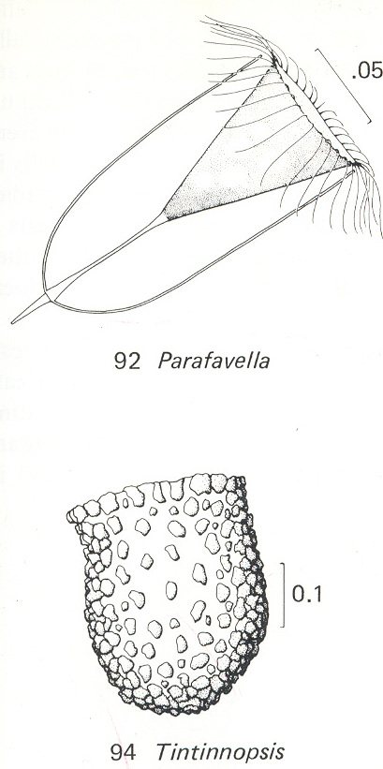
ANNELID POLYCHAETE WORMS
Kingdom Animalia. Phylum Annelida: Segmented bilaterally symmetrical worms. Each segment has its own circulatory, excretory, nervous, muscular, and respiratory systems. Some are specialized, such as the head. 5400 species. Primary Class: Polychaetes (many bristles). Brightly colored or irridescent with pairs of bristly projections extending from each segment. Can be herbivores, carnivores, deposit feeders, filter feeders (tube dwellers). Feather Duster worm.
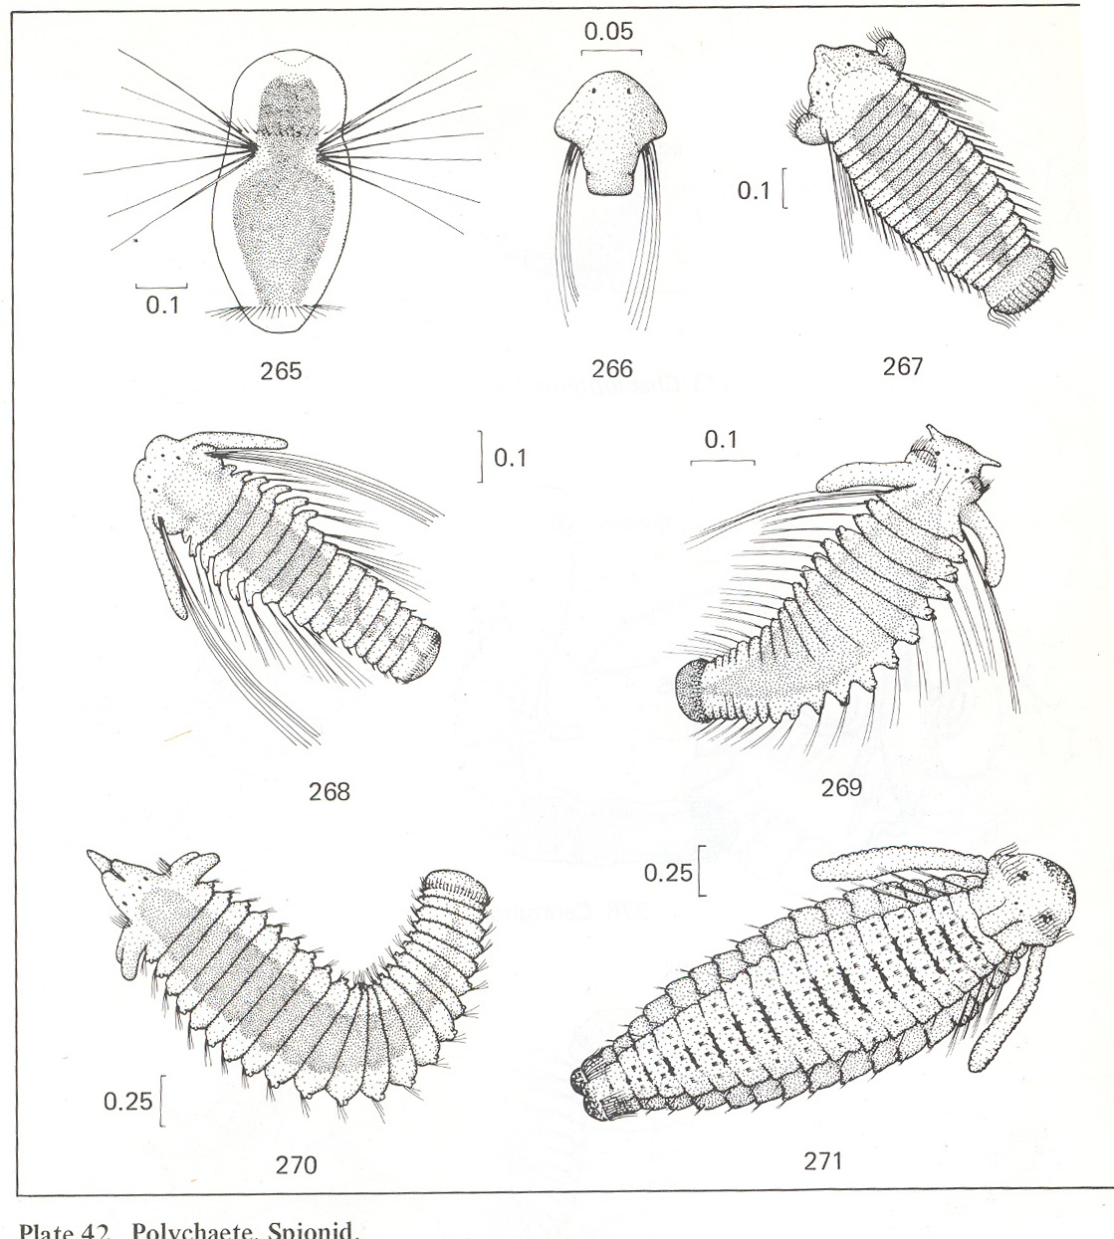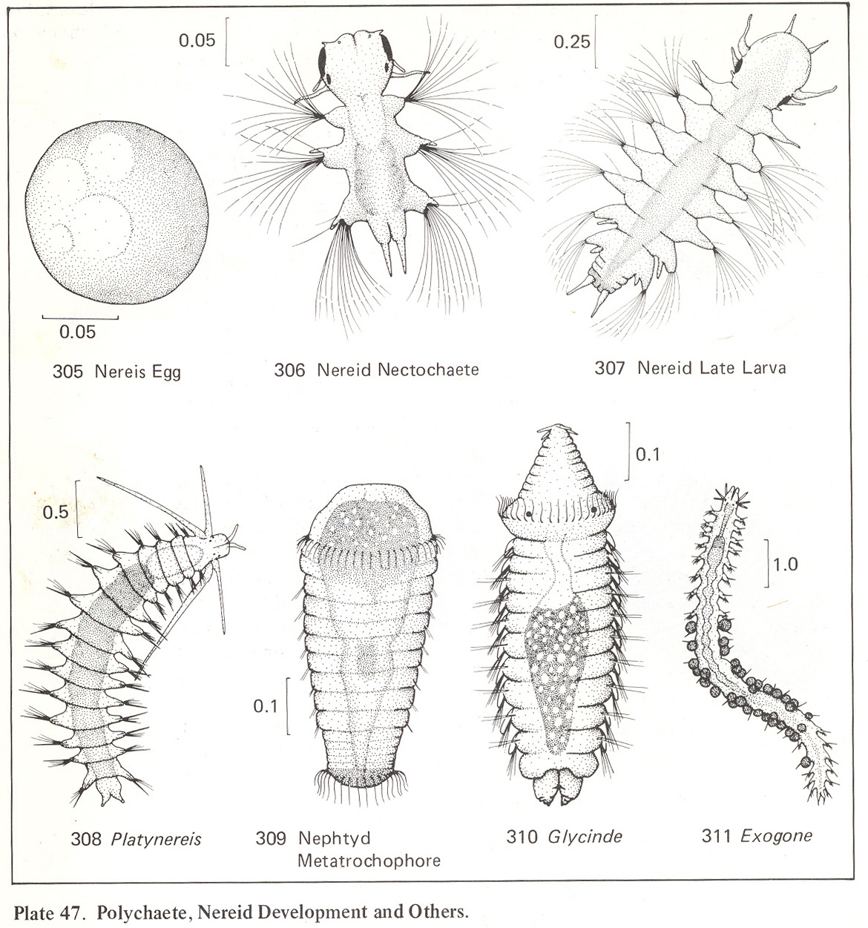
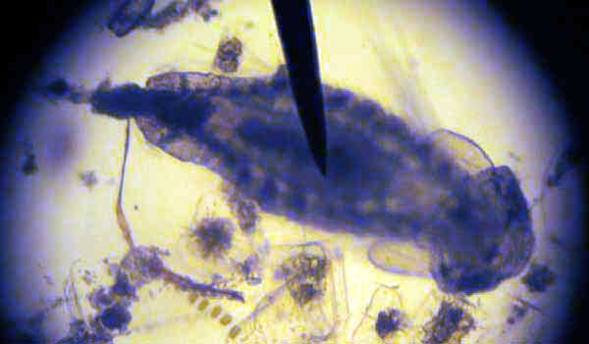
Siponid Annelid Polychaete larvae

CRUSTACEAN (ARTHROPODS)
Domain Eukarya: Kingdom Animalia: Phylum Arthropoda: Segmented. Body of two or three parts. Three or more pairs of legs. Jointed appendages (pincers, mouthparts, walking legs, and swimming appendages; and two pairs of sensory antennae). Bilateral symmetry. Exoskeleton. Striated muscles. Head with pair of eyes. Most successful of all animal phyla.
Subphylum Crustacea: Jawlike mandibles (30,000 species). Copepod, barnacles, krill, isopods, amphipods, shrimp, lobsters, crab, euphasiids.
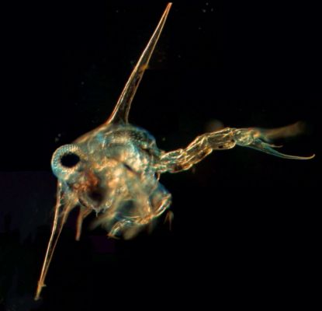  Crab larvae ~1 mm © JM. CAVANIHAC | 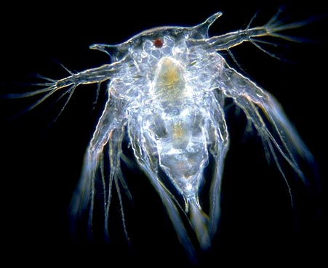  Nauplii Larvae (Barnacle) ~ 1 mm (©Wim van Egmond)
BARNACLES:
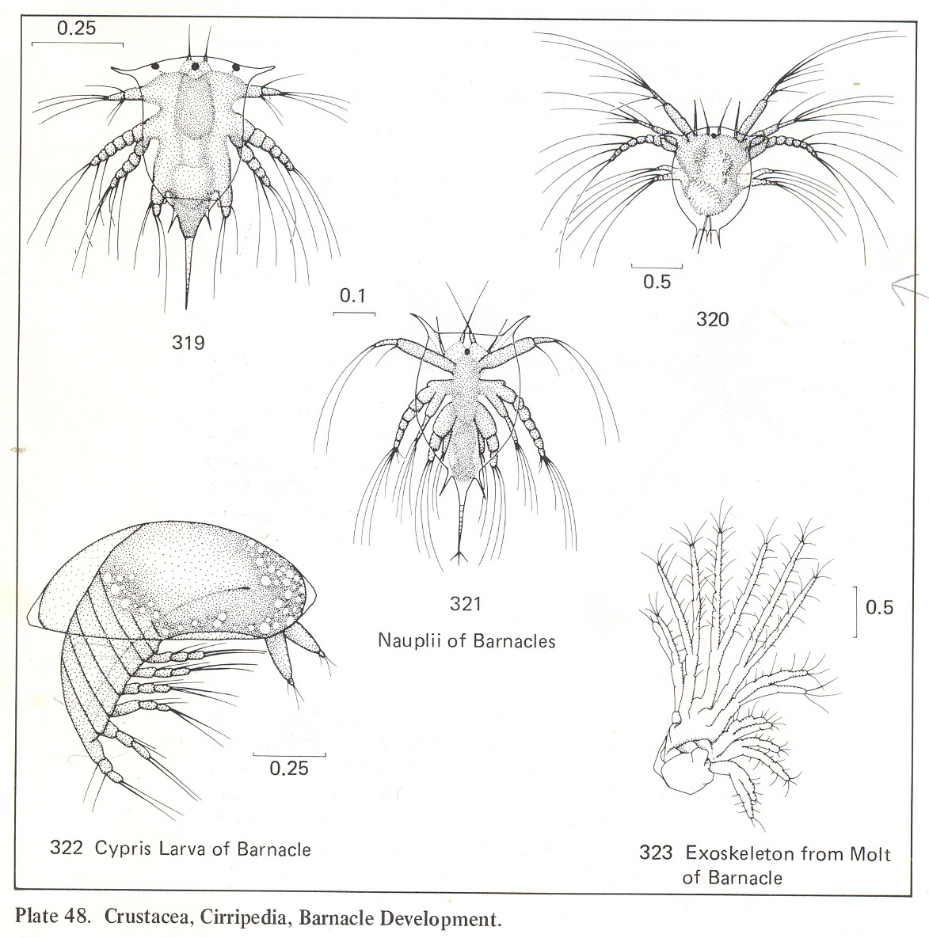
COPEPODS:
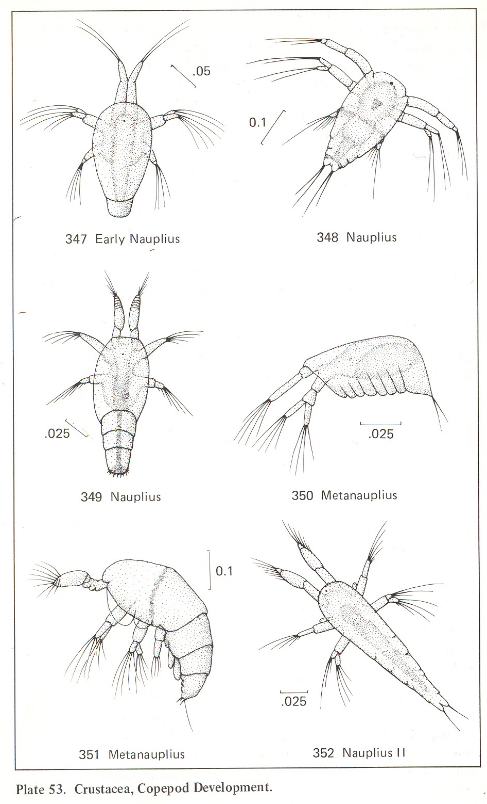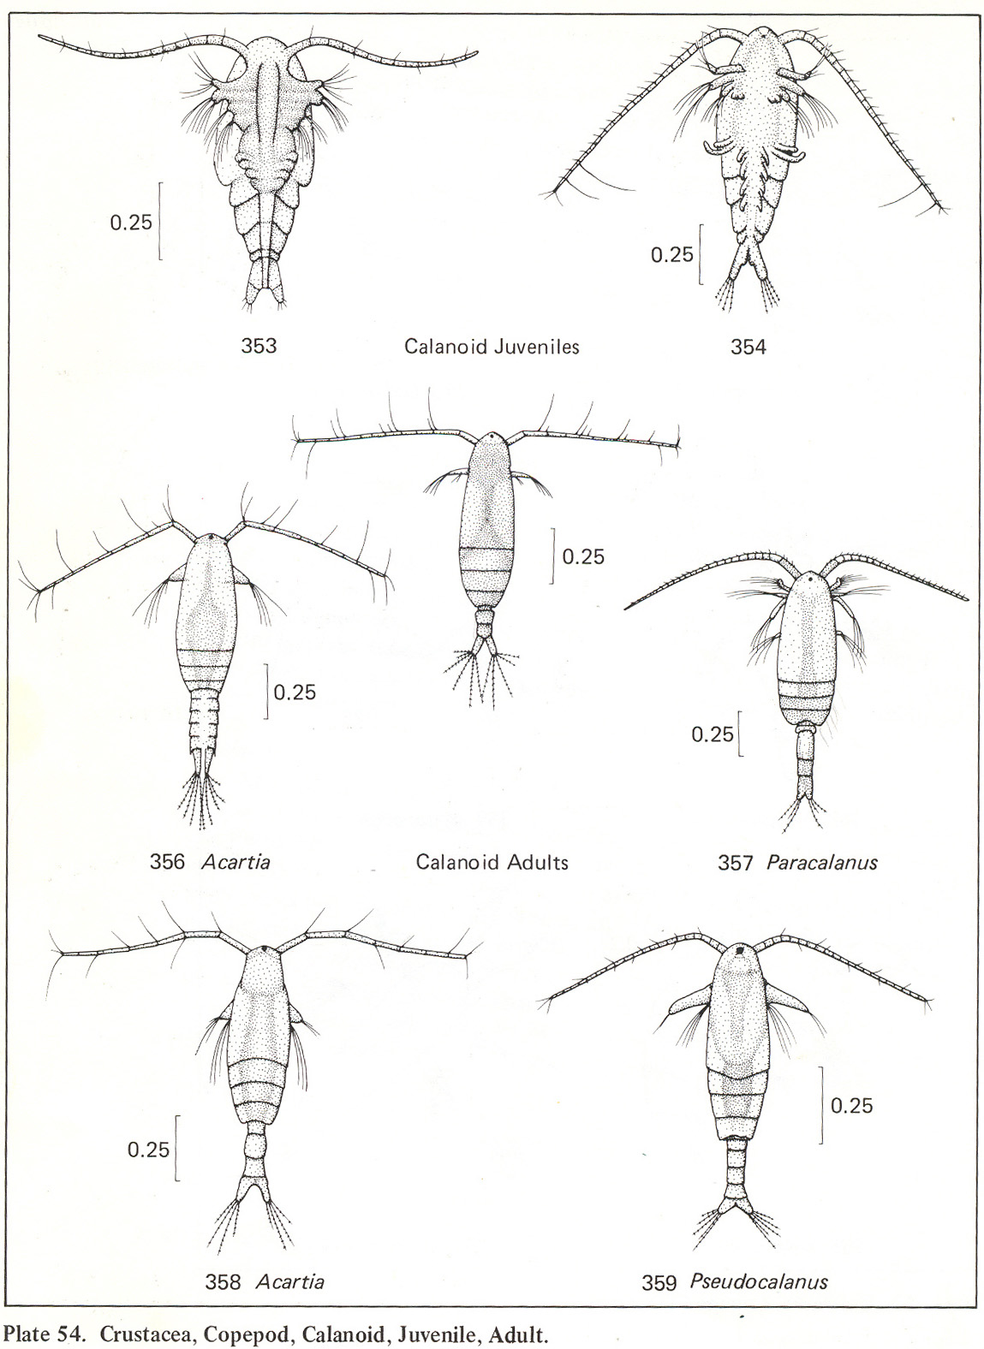
PLANKTON PICTURES TAKEN BY MELISSA DUBOSE, 2010, CHRISSY FIELD SEAWATER SAMPLE

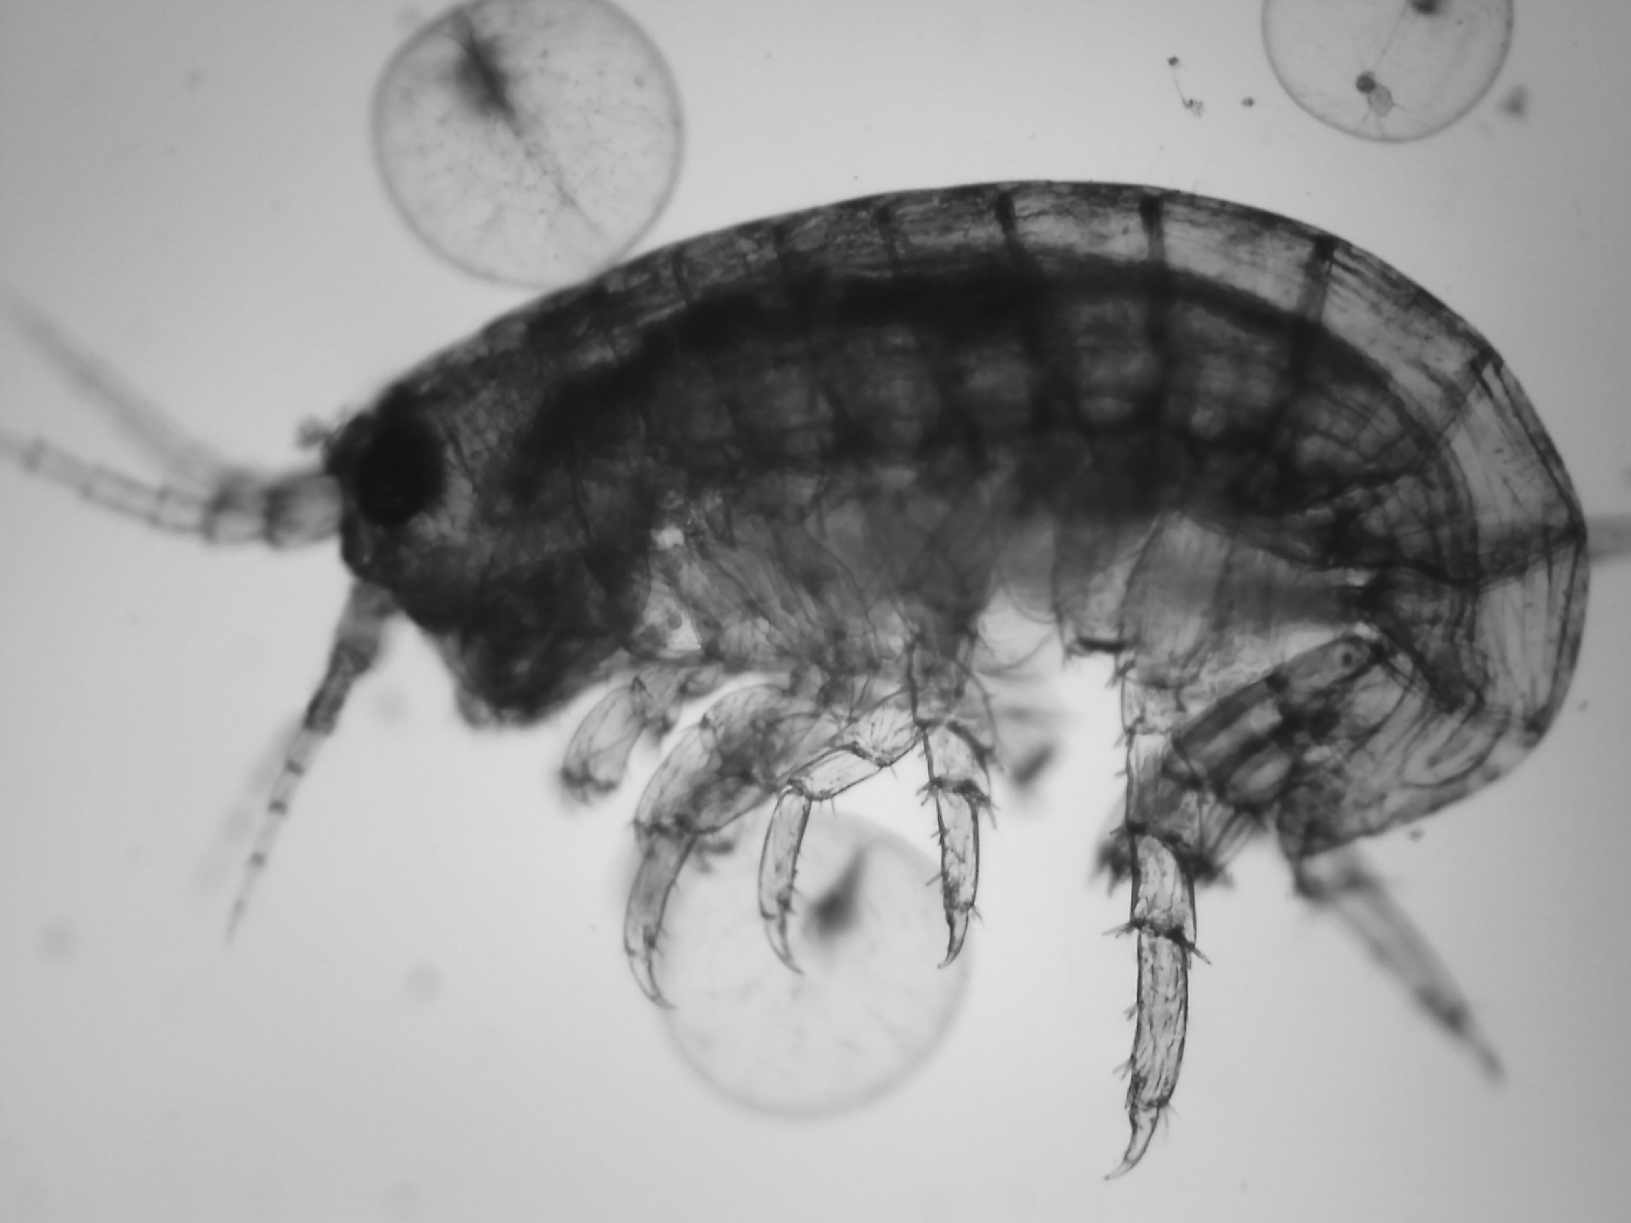  Arthropod, Amphipod, Ampithoe (with Dinoflagellates – Noctiluca in background) | 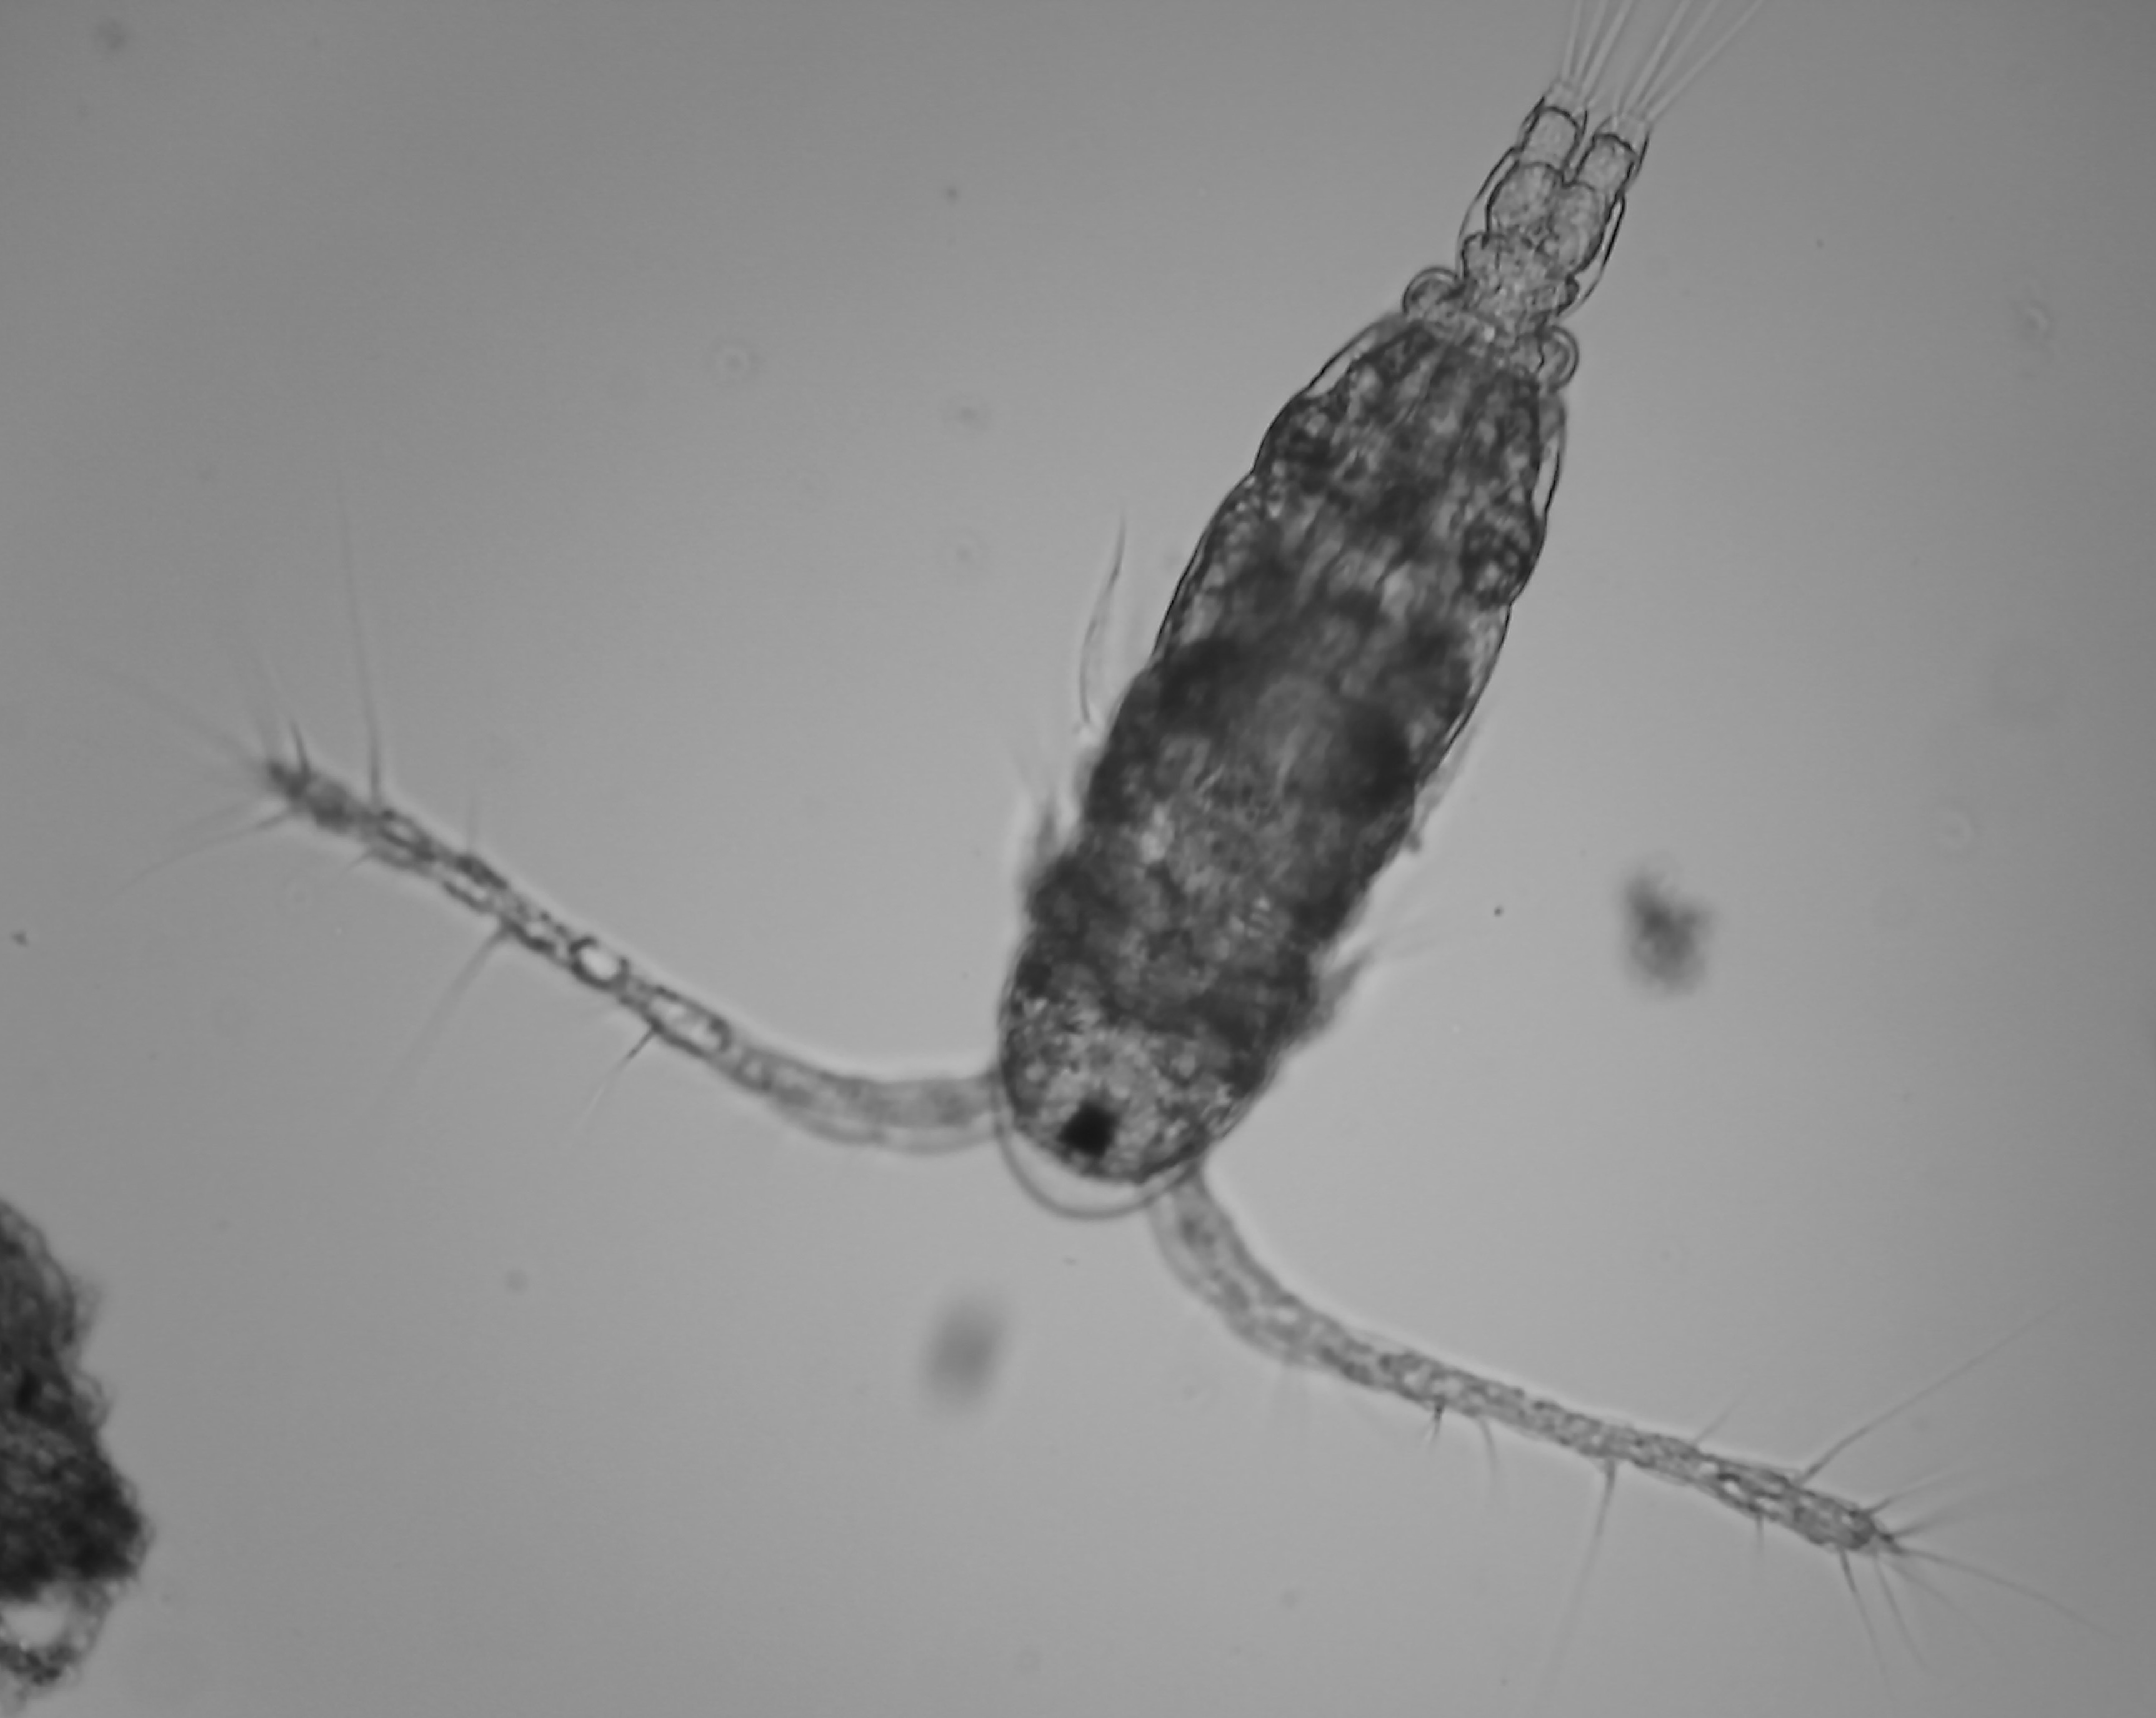  Arthropod, Copepod, Calanoid | 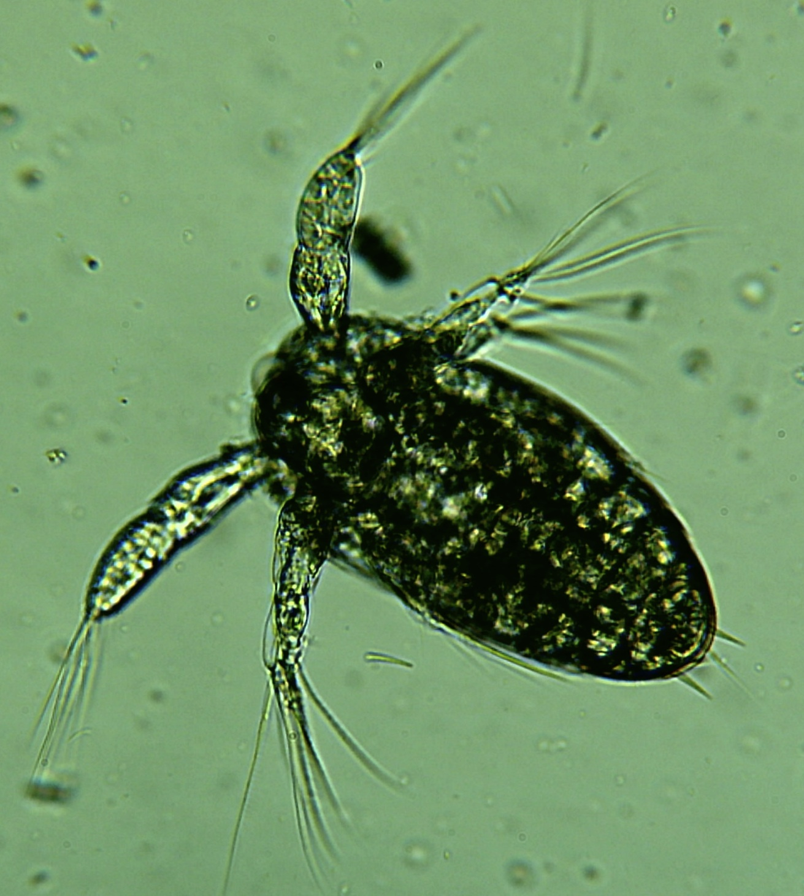  Arthropod, Copepod, Nauplius

MOLLUSCA – GASTROPODS
Phylum Mollusca: (58,000 marine species). Soft bodied, usually protected by a hard CaCO₃ shell. Three parts to body: muscular foot, usually used for movement; visceral mass containing most internal organs; mantle: a fold of tissue that drapes over visceral mass and secretes shell if one present. Many have toothed radula used for digging holes in rocks, removing algae from rocks, etc. Most have gills, anus, and excretory pores. Obvious heads, flow-through digestion, well-developed nervous system. Most have separate sexes with gonads (ovaries or testes).
Class Gastropoda: Asymmetric body plan, usually with coiled shell. Foot cannot attach to sand or mud. Grazers, suspension feeders, predators, some planktonic. Radula rasped across rocks, kelp stipes, or surfaces. 43,000 sp. Snails, limpets, abalones, pteropods, sea slugs (nudibranchs; no shells), sea hares, whelks.

PLANKTON PICTURES TAKEN BY MELISSA DUBOSE, 2010, CHRISSY FIELD SEAWATER SAMPLE

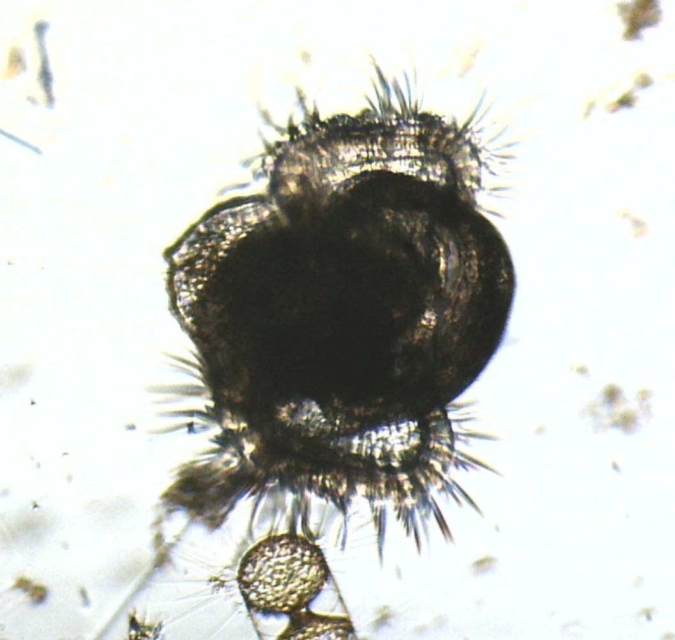  Mollusc, Gastropod veliger | 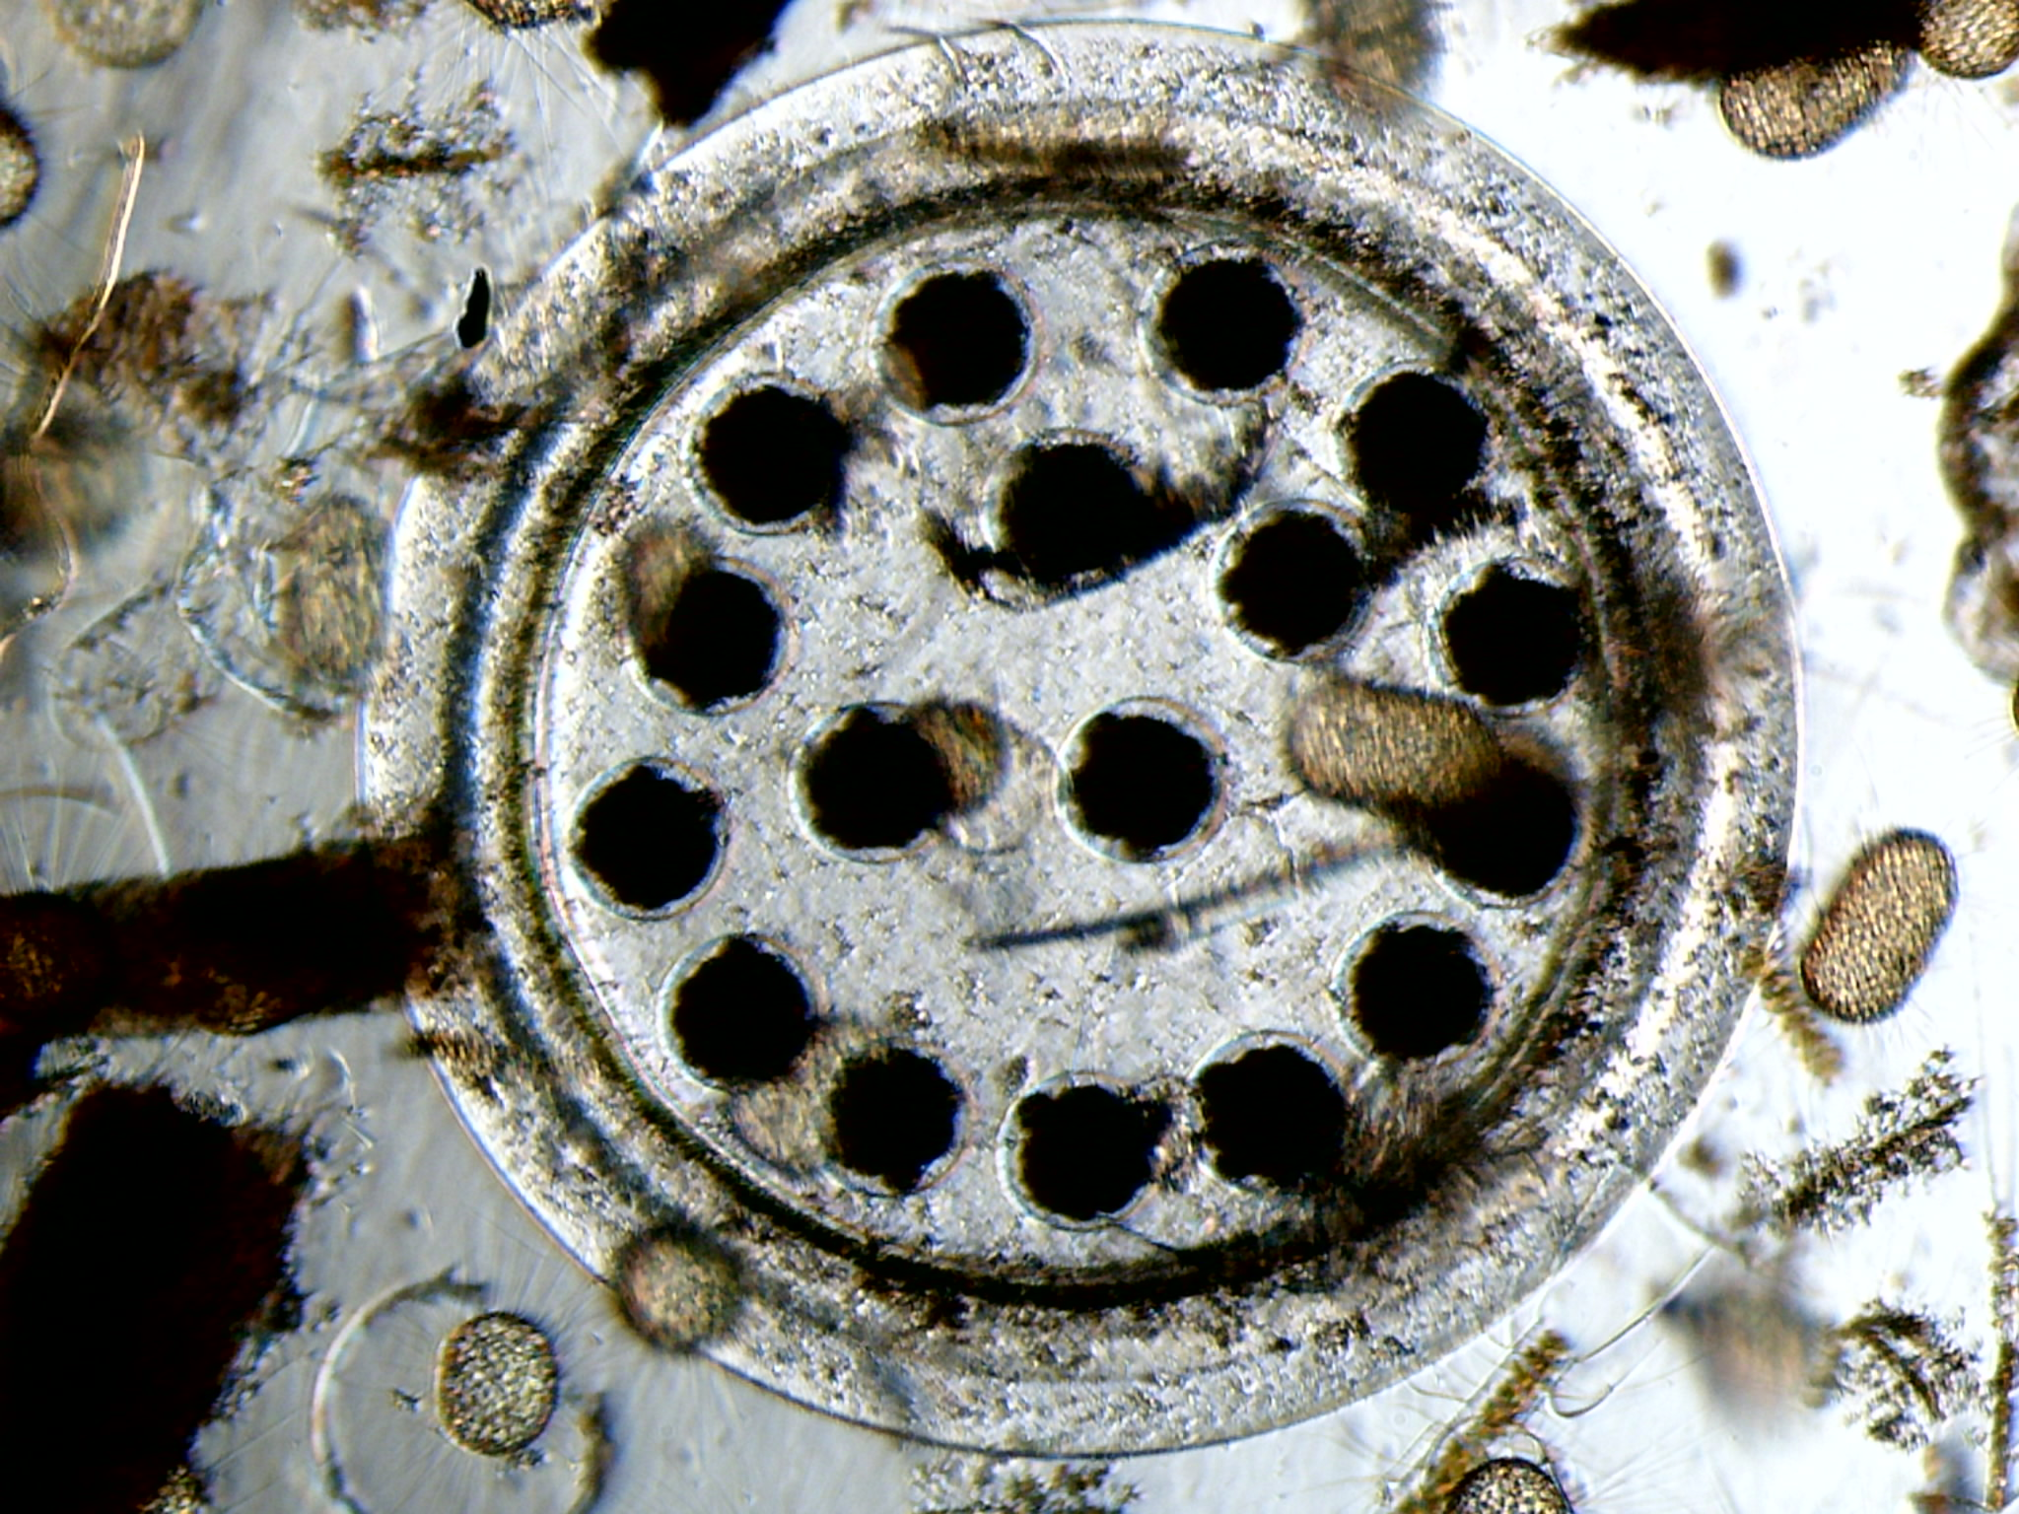  Mollusc, Gastropod (Littorina) Egg Case

Feeding Methods
All organisms can be classified by their Kingdom, Phylum, Class, etc.; by their location (plankton, nekton, benthos) AND further by their feeding methods (see below). You will be providing this information for all organisms in this and all future labs, so be sure to know these definitions and classification schemes!
AUTOTROPHS (make their own food)  Producers | HETEROTROPHS – (eat others to get food)  Deposit feeders – Feed off live or dead organisms that live in or on the seafloor  Filter feeders – Actively move through the water or move water through their bodies, filtering organisms enroute  Suspension feeders – Passive – waits for food to hit it (stingers or spines)  Predators – Actively hunts prey  Grazers – Feeds off autotrophs, at the source, like scraping algae off a rock

Plankton Prereading Homework
Within each box below,
- GIVE DETAILED CLASSIFICATION (KINGDOM, PHYLUM, ETC.)
- List at least FOUR major traits that organisms from that phylum or class all have in common.
- Draw one or more pictures as indicated (see box instructions) showing detail and labelling features. (Review drawing instructions from first lab – spend no more than 5 minutes per drawing).
- Indicate feeding strategy (producer, deposit feeder, filter feeder, suspension feeder, predator, grazer).
Dinoflagellates 1 representative picture

Crustacean larvae: Barnacle, Nauplius Stage 1 representative picture
Tintinnid 1 representative picture

Mollusc Gastropod Larvae 1 representative picture

Copepods 1 representative picture

Polychaete larvae 1 representative picture

Plankton – Lab
SEAWATER PLANKTON IDENTIFICATION
- Use microscopes to observe seawater sample. DO NOT USE ANY BUT 2 SMALLEST OBJECTIVES (≤100X)! DO NOT TRY TO USE THE 400X OR BIGGER OBJECTIVES. The largest objective will hit the large slides.
- INDICATE PHYLUM AND/OR CLASS and NAME of organisms.
(Use lab and class reference material to identify each organism.)
- Draw pictures that show detail and label features.
- Indicate feeding strategy (producer, deposit feeder, filter feeder, suspension feeder, predator, grazer).
- Include SCALE! Use the field of view scales to approximate size for each drawing. Use 100x objective to study smaller phytoplankton or look at finer detail in the larger organisms.

Plankton – Pacifica

Find and identify at least 1 dinoflagellate, 1 diatom, 1 copepod, 1 larval organism
You must locate at least those 4 in each sample. After that, fill your pages with drawings of the other creatures you see.
*DRAWING REMINDER: good drawings can be completed in 5 minutes, but require good observation skills and an understanding of the organisms’ body plans, patterns, and features. Refer to the images in the textbook as a guide.

Plankton – Fort Point

Find and identify at least 1 dinoflagellate, 1 diatom, 1 copepod, 1 larval organism
You must locate at least those 4 in each sample. After that, fill your pages with drawings of the other creatues you see.
*DRAWING REMINDER: good drawings can be completed in 5 minutes, but require good observation skills and an understanding of the organisms’ body plans, patterns, and features. Refer to the images in the textbook as a guide.

Plankton – Oyster Point

Find and identify at least 1 dinoflagellate, 1 diatom, 1 copepod, 1 larval organism
You must locate at least those 4 in each sample. After that, fill your pages with drawings of the other creatues you see.
*DRAWING REMINDER: good drawings can be completed in 5 minutes, but require good observation skills and an understanding of the organisms’ body plans, patterns, and features. Refer to the images in the textbook as a guide.

Plankton – Location Comparison
Carefully review the plankton in the same and complete this table for this location:
Sample Location: | Pacifica | Fort Point |  |  | Oyster Point
Date and time of sample collection:
Refractometer salinity
Tide Level at sample location at that time (from graphs you’ve drawn on preceding pages)
Current type at location at sample time (circle) | Ebb / Flood | Ebb / Flood |  |  | Ebb / Flood
 | Estimated abundance (%) |  | Estimated abundance (%) | Estimated abundance (%)
Dinoflagellates

Diatoms

Tintinnids

Copepod adults

Copepod larvae

Barnacle larvae

Mollusc larvae

Polychate larvae and adults:

Other:

Other:

Other:

Other:

Other:

Other:

Other:

Other:

Other:

Other:

Other:

TOTAL | 100% |  | 100% | 100%

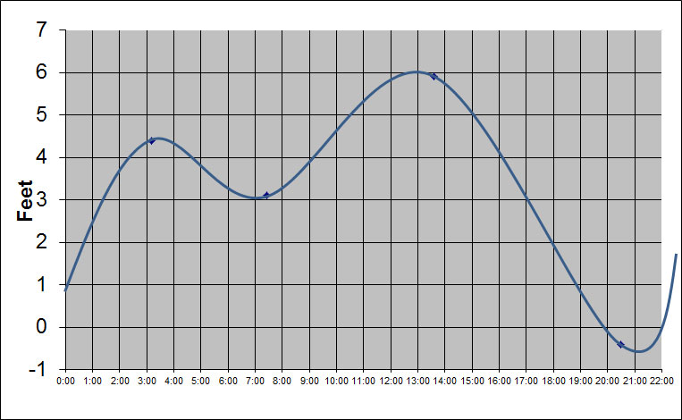
OYSTER POINT TIDES (gather data from web and pu your data on this graph with a colored pencil and label appropriately – existing graph is for guide purposes only and doesn’t represent real data)
DATE: ____________________________________________________________

FORT POINT TIDES (gather data from web and pu your data on this graph with a colored pencil and label appropriately – existing graph is for guide purposes only and doesn’t represent real data)
DATE: ____________________________________________________________

PACIFICA TIDES (gather data from web and pu your data on this graph with a colored pencil and label appropriately – existing graph is for guide purposes only and doesn’t represent real data)
DATE: ____________________________________________________________

