Ocean 101 Name:

**PART A**

**Wave Characteristics**

Goal: The purpose of this exercise is to practice calculating wave characteristics.

**Figure 1**

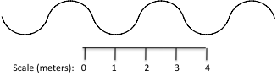

1) In Figure 1, what is the wave height (H) and wavelength (L), in meters? Also, label these on the diagram above.

2) Describe how you could determine the wave period.

3) Calculate the wave steepness (H/L). Be sure to show your work and units. Would this theoretical wave break in the open deep ocean far from land, why or why not?

4) Imagine this wave is stable enough to approach shore. What would happen to the wave height and wavelength at very shallow water depths? Be specific.**PART B Ocean Tides & Sea-level Variation**

Goal: The purpose of this exercise is to help you read tide charts, and understand tides & the forces that generate them.

**Figure 2**

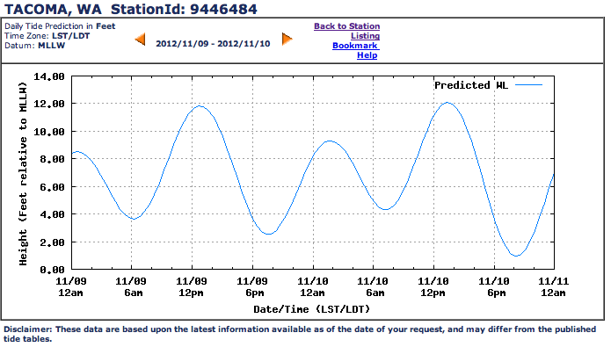

Predicted sea level variations for a monitoring station at the waterfront in Tacoma are shown in the graph above (Figure 2). NOTE: “MLLW” = “Mean Lower Low Water Level,” which is given as a height of 0.0 ft in order to use as a point of reference. [Source = <http://tidesandcurrents.noaa.gov>]

* Looking at the water level, exactly how many high tides and how many low tides are there in each day? – Be precise and notice the date & time as given on the x-axis. You can grab a ruler and draw on the graph if needed.
* What is the maximum height of the tide in Figure 2 (relative to MLLW) and what date & time does it occur?
* At 10 AM on Nov. 9th, is the tide rising, falling, or neither? Does this produce a flood, ebb, or slack current?

Examine a Puget Sound map and the NOAA 2013 Tide Prediction Tables for East Passage in Puget Sound near Des Moines (hand-out or on website on pg. 2), and answer the following questions to practices reading the tide tables:

* You’re planning on going on a low tide beach walk to look at sea life on Wednesday, May 15th. At what time will the lowest tide of the day occur and what is the predicted tidal height?
* Your friends are going for a paddle from Des Moines on Saturday, May 25th and have asked you for help figuring out the general tide. They are planning to leave at 12pm and return by 4pm, and they would like to plan to start paddling against the tidal current, and then “ride the tide” on the way home.

What will be the likely dominant current type during this time and what direction will the current flow towards? What direction (north or south) should your friends travel towards when leaving Des Moines?

Use your lecture notes, textbook, and the website link below to answer the following questions. ***You can answer these questions on a separate sheet of paper if you need more room.*** There are some good animations at this website—try them—they can help you answer the questions.

<http://www.nos.noaa.gov/education/kits/tides/welcome.html>

1) In your own words, what causes the tides? Be complete in your answer.

2) The sun is much more massive than the moon, why does the moon have more of an effect on the tides?

3) Draw the relative position of the sun and the moon during the two “spring tides” in the tidal cycle.

4) Draw the relative position of the sun and the moon during the two “neap tides” in the tidal cycle.

Waxing crescent, 49% of full

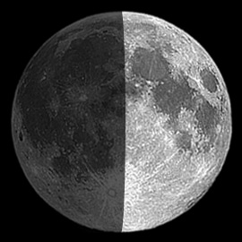

5) On Friday, May 17th, the moon will be in first-quarter phase (waxing). What kind of effect does this have on the tides? Does it produce **neap** or **spring** tides? Why?

6) What is the difference between diurnal, semidiurnal, and mixed semidiurnal tide cycles?

7) Based on Figure 2 and your responses on page 2, what type of tidal cycle is found in Puget Sound (diurnal, semidiurnal, or mixed semidiurnal)? Explain your answer, and make sure to check that you are looking at the tidal variation in one 24-hr day.

Explore the following website to answer the questions below. Use the diagrams on the most recent tidal data for each location:

<http://tidesonline.noaa.gov/geographic.html>

1) What type of tidal cycle is found in San Diego, California? What is the range of tidal height given, from the lowest to the highest tide (use most recent given over the last 2 days)? Be sure to show your units.

2) What type of tidal cycle is found in Pensacola, Florida? What is the range of tidal height?

3) What type of tidal cycle is found in Eastport, Maine? What is the range of tidal height?

4) Now double-check your answers above with Figure 9.16 on pg. 273 in your textbook. What type of tidal cycles would you expect for each location? Note any differences in your observations, and be sure to explain these.

**Extra Credit: Tsunamis** (max. 3 pts) (attach your answers on a separate page)

Use your textbook as a primary reference on tsunamis. To explore some animations and learn more about this event, Go to: <http://serc.carleton.edu/resources/42380.html>

5) In your own words, what causes a tsunami?

6) How does the wavelength and wave height of a tsunami in the deep ocean far from land compare to wind-generated ocean waves in the deep ocean?

7) Could a tsunami happen in the Pacific Northwest? Explain why, and be specific.