Sound and Light in the Ocean

When we think of waves in the ocean we often don’t think about the sound and light waves that allow for communication and visibility underwater. The underwater environment differs from our environment above water in one important way, the two wave types -- sound and light -- reverse roles. When you gaze across a harbor you are able to see the opposite shore, but cannot typically hear noises generated there. Underwater the reverse is true; visibility is limited but sound can travel distances over which light becomes attenuated.

Light is absorbed and scattered, i.e. attenuated, by interaction with water molecules, suspended particles, and dissolved organic substances. Particles can be sediment grains or small organisms. Dissolved organics are very common in coastal waters, due to the high productivity there, and often give the water a yellow-green cast. Because of these differences in the performance of sound and light in water, sound has become the more useful tool for “seeing” in the ocean. Sound is used in depth sounders and side scan sonars to image the sea floor. It is used in fish finders to locate schools of fish. It has even been used to locate shipwrecks, find pockmarks in the sea floor, identify underwater mineral resources, and locate submarines.

Figure 1 was created using sound. It is a sonar image showing both fish and the seafloor. Follow the link to read more on how sonar is being used in coral reef conservation.
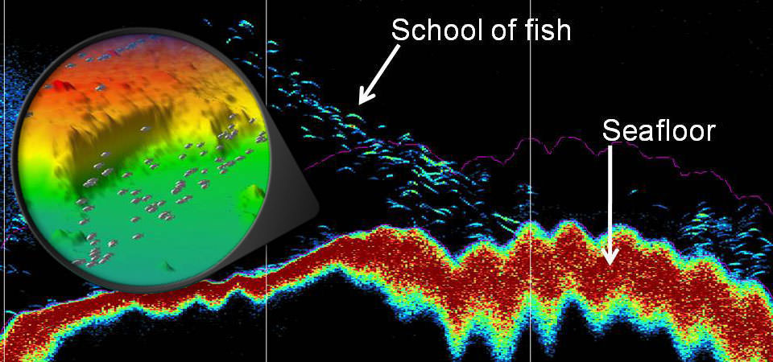
Figure 1. The background image shows fish and the seafloor beneath a sound emitting ship. The insert shows a three dimensional depiction of the same area.
https://oceanservice.noaa.gov/facts/fish-sonar.html
In this lab we examine some sound and light data and see these differences in their behavior for ourselves.
Sound in the Ocean

The speed of sound in the ocean is a function of salinity, temperature and pressure. As each of these properties increases so does the speed of sound. This means that sound travels faster in seawater than in lake water; in warm water than in cold water; and in deep water than in shallow water. By looking at salinity and temperature profiles (Figure 2) we can determine regions of the ocean where one variable dominates the speed of sound. Let’s do that.

Figure 2. Graphs showing the change in temperature and salinity with depth in the deep ocean.

The speed of sound is affected by salinity, temperature and pressure in the following way:

Variable | Effect on sound speed | Notes
Temperature | 5 m/ sec • 1º C | Sound speed drops as temperature drops
Salinity | 3 m/ sec • 1 psu | Sound speed rises as salinity rises
Pressure | 0.018 m/ sec • 1 m | Sound speed increases as depth increases

- Complete the table on the next page. Use Figure 2 to determine ΔT (the change in temperature), ΔS (the change in salinity) and ΔD (the change in depth) from 0 to 500m and from 500m to 3500m. By doing this we will treat the ocean as a two layer system, with the top layer being the thermocline (0 to 500m) and the water below (500-3500m) the deep layer.
Also determine the change in sound speed in each layer due to temperature, salinity and depth (pressure). These will be the ΔC_{T}, ΔC_{S}, and ΔC_{D} columns in the table (C is short for celerity, which is speed). If the speed decreases with depth, the sign of ΔC is negative (and vice versa). For example, since temperature decreases with depth, sound speed decreases from the surface to the bottom and ΔC_{T} will be negative. So, be mindful of the signs when you calculate ΔC with this formula:

ΔC_{T} + ΔC_{S}+ΔC_{D}=ΔC

Determine sound speed at 500m by applying ΔC to the sound speed at 0m (1480 m/sec). Determine sound speed at 3,500m by applying ΔC to the speed at 500 m.
Depth range  (m) | ΔT  (ºC) | ΔC_{T}  (5m/sec•ºC)  (check the sign!) | ΔS  (psu) | ΔC_{S}  (3m/sec•psu) | ΔD  (m) | ΔC_{D}  (0.018m/sec•m) | ΔC  (m/sec) | sound speed  (m/sec)
0 |  |  |  |  |  |  |  | 1480
500
3,500

On the axes below sketch in the sound speed profile.

- Look at your table above. Based on the calculations you made, what causes the greatest change in sound speed in the top layer and in the bottom layer?

Top layer ______________________ Bottom layer ______________________

The characteristics of sound speed in the ocean that you just discovered, and sound’s ability to travel long distances in water (details later), make it possible for whale sounds to carry thousands of miles across the ocean!
Light in the ocean

The source of most light in the ocean is the sun. Where light is strong enough it helps predators to find their prey, and as a result many prey organisms have developed coloration to make them look invisible, for example the silvery bellies on some fish blend in with the sunlight waters above (Figure 3).

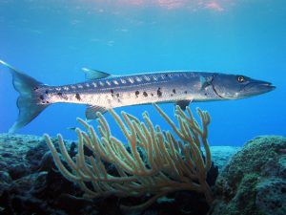
Figure 3. The silvery belly of the barracuda makes it difficult to see when viewed from below. https://commons.wikimedia.org/w/index.php?title=File:Barracuda_laban.jpg&oldid=269831320

Light is also essential for the plants and algae in the ocean. The distribution of light and nutrients controls where phytoplankton (Figure 4) can grow so understanding light is important to understanding ocean productivity.

Figure 4. Marine algae, such as this wagon wheel diatom, live in the sunlight surface waters of the ocean. They are the base of many marine food chains. Image from NOAA Photo Library Image ID: fish2798 | 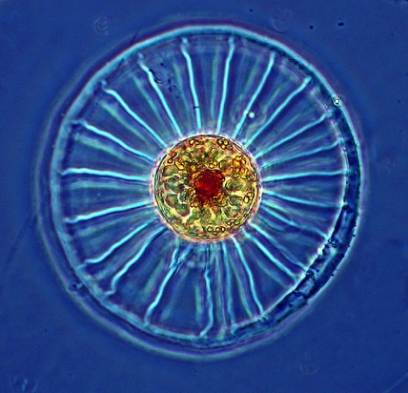

- Below is a plot of light intensity for the clearest ocean water. On the same graph, plot light intensity for average oceanic water, average coastal water, and turbid coastal water, using the data in the table below.

Energy from sunlight (gm cal/cm² hour)
 | Oceanic water |  | Coastal water
Depth (m) | Clearest | Average | Average | Turbid
10 | 16.1 | 9.50 | 1.12 | 0.449
20 | 9.35 | 3.72 | 0.0640 | 0.0120
50 | 2.69 | 0.311
100 | 0.452 | 0.00570
150 | 0.0760

Light intensity decreases differently in the four types of waters shown in the plot above. What might be the differences between oceanic and coastal waters that account for the differences in light absorption?

What could be missing from the clearest oceanic water that enables light to penetrate so deeply in them, compared to average oceanic water?

What could be present in the most turbid coastal waters that make light penetration so difficult? Where would these waters tend to be found?

The plots you made show that light intensity decreases dramatically in the surface waters of the ocean. Although intensity for the clearest ocean water is low at 150 m depth, it is sufficient for human vision. Figure 5 illustrates how sunlight intensity changes at deeper depths. According to that figure, at what depth would the ocean be completely dark?

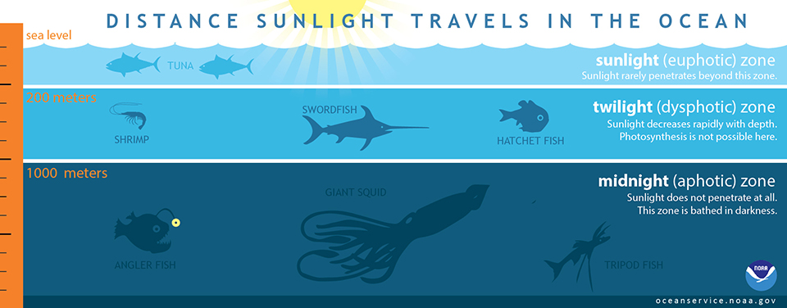
Figure 5. Light fields in the clearest ocean water. https://oceanservice.noaa.gov/facts/light_travel.html

- Some fish, crabs, brittle stars, etc. live at depths where no sunlight penetrates. What senses do they use to find their way around?

Now that you have thought about how creatures navigate in the deep, dark ocean watch these two videos. They show whale falls which occur when whales die and sink to the sea floor and which bring huge pulses of food to the deep ocean. Visit this link to see fish flocking to a whale fall: https://www.youtube.com/watch?v=vQbGk4sHROg

Visit this link to see how the whale fall community changes once the flesh has been consumed: https://www.youtube.com/watch?v=x32PLnBsZsw

These videos are possible because divers have lighted the area. The animals feeding there found the whale fall in pitch black. Does your answer to question 4 still make sense? If not, why not?

How do we “see” in the ocean?

If you have snorkeled or dived in the ocean, or even just gazed down into water from a boat or dock, you know that visibility in water is limited. Although sunlight illuminates the ocean to depths of many 100’s of meters we can’t actually see from the surface down to these depths. Light must travel directly from an object to the eye for one to “see” the object. Water scatters light just as fog does. Both in fog and the deep sea the surroundings may be illuminated but not actually be identifiable. For this reason it isn’t possible to see underwater landscapes in the same way we can see landscapes such as the Grand Canyon. If there were an underwater feature on the scale of the Grand Canyon could we use sound to “see” it? Can sound travel 20 km, the distance across the Grand Canyon, and still be strong enough to be heard? Let’s do a calculation to find out.

- The attenuation rate of sound, which is the amount of sound energy that is absorbed as it travels through a given distance of water, depends on the frequency; the units of frequency are hertz (abbreviated Hz), one Hz is one vibration per second. The table below gives the frequency and intensity of some ocean sounds. Intensity is measured in decibels (abbreviated db and related to sound energy). Complete the table by calculating the intensity of each sound at a distance of 20 km from the source, and the percent of the original sound intensity still present at that distance.

Example calculations
To calculate the intensity of a 20,000 Hz sound with an intensity of 100 db sound, at a distance of 20 km from its source, first look up its attenuation rate in the table (a 20,000 Hz sound has an attenuation rate of 3 db/km). Next, multiply the attenuation rate by the sound’s distance from its source:

3 db/km x 20 km = 60 db.

The answer, 60 db, is the sound intensity lost over 20 km. Subtract this from the original intensity to get the sound’s intensity at 20 km:

100 db – 60 db = 40 db.

Lastly, to find the percent of sound intensity remaining at 20 km from the source, divide the distant intensity by the original intensity and multiply by 100%:

$$\frac{40 \text{db}}{100 \text{db}}×100\% =40\%$$

Sound  Type | Frequency  (Hz) | Intensity  at source  (db) | Attenuation rate  (db/km) | Intensity  at 20 km  (db) | % of original intensity present at 20 km
Tug and barge,  18 km/hour | 100 | 161 | 1.2 x 10⁻³
Seismic survey air guns | 100 | 210 | 1.2 x 10⁻³
Long range sonar | 20,000 | 160 | 3.0
Humpback  Whale song | 20 | 160 | 3.0 x 10⁻⁴

6. Examine the long range sonar data in the table above. The receiving transponder on a long range sonar can detect sounds with a minimum intensity of 90 db. Would a transponder on one side of a submerged Grand Canyon, 20 km from a 160 db sound source, be able to detect the sound?

7. Examine the table in question 5. Notice that the attenuation rate changes as the frequency of the sound changes. Which is attenuated more quickly, high or low frequency sound?

8. Your calculations show that whale sounds can travel great distances. Why do you think this is important for whales?

9. Perhaps no one cares more about being able to see in the ocean than do divers. The Cayman Islands, Bonaire and the Bahamas are all popular dive destinations due to both submarine features, such as coral reefs, and water clarity. Under the best of circumstances, visibility in these locations is between 50 ft (15 m) to 150 ft (45 m). Based on this, and what you have learned about sound, write a paragraph describing those ways in which humans and marine organisms use sound for some underwater tasks and light for others.

10. Using the data, calculations, and graphs in this exercise describe which wave type (sound or light) travels more effectively in water, using numbers to support your reasoning. You could do this by determining the distances over which sound and light decrease by the same percent. For example select one sound out of the table in Question 5. You calculated the percent of the original sound intensity that would be audible at 20 km. Now look at the light intensity graph in Question 3 and choose one of the curves that you drew. If the original light intensity is that measured at the surface at what depth would the intensity be the same percent as sound at 20 km? Use these two distances, the one for sound and the other for light, to make your argument about which travels more effectively.

11. Read the article below. Based on your answer to question 8, explain why broader band noise is likely to affect whales differently even if it is at the same intensity as natural noise.

Whale Racket: Sounding out How Loud the Oceans Were from Whale Vocalizing Prior to Industrial Whaling From Science Daily.
Oct. 23, 2012 — Concern is growing that human-generated noise in the ocean disrupts marine animals that rely on sound for communication and navigation. In the modern ocean, the background noise can be ten times louder than it was just 50 years ago. But new modeling based on recently published data suggests that 200 years ago -- prior to the industrial whaling era -- the ocean was even louder than today due to the various sounds whales make.
California researchers Michael Stocker and Tom Reuterdahl of Ocean Conservation Research in Lagunitas, Calif., present their findings at the 164th meeting of the Acoustical Society of America (ASA), held Oct. 22 -- 26 in Kansas City, Missouri. Using historic population estimates, the researchers assigned "sound generation values" to the species for which they had good vocalization data. "In one example, 350,000 fin whales in the North Atlantic may have contributed 126 decibels -- about as loud as a rock concert -- to the ocean ambient sound level in the early 19th century," Stocker notes. This noise would have been emitted at a frequency from 18 -- 22 hertz.
According to the researchers, use of whaling records to determine just how many whales were harvested from the ocean over the course of industrialized whaling is difficult because the captains were taxed on their catch and therefore had an incentive to "fudge" the numbers. Some captains kept two sets of books. After the collapse of the Soviet Union, some of the real reports began surfacing. In one example the Soviets initially reported taking approximately 2,710 humpback whales from the late 1950s to the mid-1960s. The newer data reveal the actual number was closer to 48,000.
This more accurate data was supported by population estimates using mitochondrial DNA, which does not change through female lines of a species. Thus the current diversity in DNA can serve as a proxy for historic population numbers.
While their estimates suggest there was a whole lot of whale racket a couple centuries ago, Stocker says "we can assume that animals have adapted to biological noise over the eons, which may not be the case with anthropogenic noise. Anthropogenic noise is often broader band and differently textured than natural noise, so the impacts are likely different as well. Investigating these differences and their impact on marine life is the topic of intense research."

Scoring rubric
Question/task | Possible  points | Points  earned | Comments
Question 1.  •Complete table (1 pt/ entry) | 15
•Sound speed profile sketch. | 4
Question 2.  Three points each for top and bottom layers. | 6
Question 3.  •Three profiles of light intensity (5 pts each) | 15
•Correct depth | 3
Question 4. At least one plausible sense mentioned | 5
Question 5. One pt per entry | 8
Question 6. | 8
Question 7. | 8
Question 8. | 8
Question 9. Four pts each:  •Well-written paragraph.  •Describes human uses of sound and light  •Describes organisms’ uses of sound and light | 12
Question 10. Four pts each:  •Includes attenuation data  •Identifies which wave travels more effectively | 8
Question 11. | 2
TOTAL | 100

