OCEAN100 – Ocean Planet Investigation: Isostasy and Global Elevation

**Learning Outcomes:**

• Quantify the relationships between mass, volume, and density

• Calculate the density of basalt and granite hand-samples from measurements of their mass and volume

• Calculate the mean and standard deviation of density for granite and basalt hand-sample populations

• Generalize basalt and granite hand-samples as representative of typical oceanic and continental crust

• Visualize Archimedes’ principle that a floating object displaces a volume of liquid equal to the object’s mass

• Explain the bimodal distribution of global elevations as result of isostatic equilibrium among oceanic and continental crust

##### Introduction

Consider the following observations: *Massive metal ships float, but small rocks sink. Over 90% of an iceberg sits beneath the ocean surface. Continental crust is consistently higher in its elevation than oceanic crust.* All of these observations reflect **Archimedes’ Principle**, which states that a floating object displaces a volume of fluid whose mass will be equal to that of the object. To illustrate this concept, imagine a simple rectangular boat measuring ten meters long by two meters wide with a hull extending two meters below the ocean surface. Using these three dimensions, the volume of seawater displaced by the boat would be 40 m3 (i.e., 10 m x 2 m x 2 m). Assuming a seawater density of ~1,025 kg/m3, the volume of seawater displaced by the boat would have a mass of ~41,000 kg (i.e., 40 ~~m~~~~3~~ x ~1,025 kg/~~m~~~~3~~). Archimedes’ Principle states that the mass of this displaced seawater would be equal to the mass of the entire boat.

The above example was already at equilibrium (i.e., a stable or balanced state), so let’s step back to take a more dynamic approach to Archimedes’ Principle and the involved forces as the boat is lowered by a crane onto the ocean surface. As the Earth’s gravitational force (g; 9.8 m/s2) pulls downward on the boat, its hull progressively sinks and displaces seawater outward in all directions. At the same time, the Earth’s gravitational force also pulls downward on the surrounding seawater and, as with all fluids, this force produces higher hydrostatic pressure in all directions at deeper depths. The net result of this hydrostatic pressure in all directions is a buoyant force upward against the hull of the boat. When the boat’s gravitational force downward and the seawater’s buoyant force upward are equal, then the boat’s vertical position will be stable since it is displacing a volume of seawater equal to the mass of the entire boat . . . again Archimedes’ Principle!

Now, exactly how high or low our boat will float depends on the density of the boat and the density of the seawater – recall that **density** has the dimensions of mass per unit volume (M/V), and is generally reported in units of grams per cubic centimeter (g/cm3) or kilograms per cubic meter (kg/m3). To explore the role of density, imagine boarding the boat, which would displace lower-density air from within the hull’s volume and thereby increase its average or “bulk” density. This increase in bulk density would re-balance the downward gravitational and upward buoyant forces, causing the boat to float lower into the surrounding seawater. As more people boarded and entered the hull, its effective bulk density would progressively increase and the boat would float lower and lower in the seawater. Conversely, as people exited the hull and left the boat, its bulk density would progressively decrease and the boat would float higher and higher in the seawater. At every moment as people came and went, the floating boat would be displacing a volume of seawater equal to the mass of the entire boat.

Where does the displaced water go and why? An expansion of Archimedes’ Principle is the concept of **isostasy**, which is derived from the greek roots *iso* (same) and *statis* (standing). If you measured the hydrostatic pressure (i.e., force per square meter in every direction) at the seafloor directly beneath your boat (i.e., PBoat+Seawater) and at the seafloor adjacent to the boat (i.e., PSeawater), these two pressures, PBoat+Seawater and PSeawater, would be equal or in **isostatic equilibrium**. These relationships can be stated mathematically as:

PBoat+Seawater = boathboatg + seawaterhseawaterg,

PSeawater = seawaterhseawaterg,

PBoat+Seawater = PSeawater,

where P = pressure (kg/m s2 – a combination of units termed Pascals and abbreviated Pa),  = density (kg/m3), h = height (m), and g = force of gravity (9.80 m/s2). For our purposes, we will assume that atmospheric pressure is the same on the boat and ocean surface, and therefore can ignore this component. Any change that would promote PBoat+Seawater ≠ PSeawater will be instantly compensated by some redistribution of the fluid seawater between the two columns. For example, your entering the boat hull would increase its bulk density and one would therefore predict that the pressure on the seafloor under the boat would become greater than the pressure on the adjacent seafloor (i.e., PBoat+Seawater > PSeawater). However, this predicted difference in pressure isn’t realized since the fluid seawater spontaneously flows from higher to lower pressure until the pressure across the seafloor is again equal. Thus, although we can’t perceive any global rise in sea level when we step into a boat, our increased displacement of seawater dictates that this must happen to a minuscule degree! This concept of fluid flow in response to uneven pressure applies to all sorts of phenomenon including the circulation of the atmosphere and ocean on larger spatial scales . . . we will revisit it later in the semester.

In this investigation, we will use the concepts of Archimedes’ Principle and isostasy to explore how the existence to the two basic types of crust, oceanic and continental, within the uppermost lithosphere produce a “bimodal” distribution of global elevations on our planet. As we will see, oceanic crust is typically slightly denser and often much thinner than continental crust. These differences causes oceanic regions to float consistently lower within the underlying plastic asthenosphere than continental regions . . . low enough to produce extensive relatively stable basins that contain our global volume of seawater! As in the boat-and-seawater example, we would predict a common depth within the underlying plastic asthenosphere where pressures exerted by the overlying material are equal. Regions where this prediction is observed are said to be in “isostatic equilibrium”; regions where this prediction is not observed often contain related stresses and are often moving, literally, towards isostatic equilibrium through regional uplift or subsidence.

In Part A, the densities of representative rock samples of granite and basalt are determined experimentally and compared to typical crustal values. In Part B, the concept of isostasy is examined through a continent-to-ocean transect by determining if the hydrostatic pressure at a common asthenosphere depth is approximately equal under four different “columns” of overlying material. In Part C, a dynamic web-based isostasy model is used to predict elevations for lithospheric columns of different crustal thickness and density. In Part D, the bimodal distribution of global elevations is explicitly explored and connected to the fundamental components of isostasy as explored in Parts A, B, and C.

OCEAN100 Investigation: Isostasy and Global Elevation Name: _____________________

##### Part A. Comparing Densities of Oceanic and Continental Crust

Basalt and granite are two distinctive rock types that account for the majority of oceanic and continental crust, respectively, within the uppermost lithosphere. Locate and examine the hand-specimens of the dark-colored basalt and light-colored granite. These specimens, like all rocks, are comprised of a mixture of minerals that reflect the physical and chemical environment of their formation and subsequent history. Basalt is predominantly composed of crystals of grayish plagioclase feldspar, blackish pyroxene, and greenish olivine minerals and largely forms from magma extruded along divergent plate boundaries. Granite is predominantly composed of whitish to pinkish plagioclase and potassium feldspars and clear to whitish quartz minerals (along with minor amounts of biotite, muscovite, and horneblende minerals), and commonly forms from magma produced by the MASH* process along convergent plate boundaries (*MASH = Mixing, Assimulation, Storage, Homogenization; recall Plate Tectonics section of course). Here we determine the density of these hand-specimens of basalt and granite as a first step in exploring the role of crustal density in isostasy and global elevation patterns.

To determine the density of each specimen:

• Record the rock type (i.e., basalt or granite) and hand-specimen number (i.e., 1, 2, 3, 4, 5, 6, 7, or 8).

• Determine and record the dry mass (g) of the hand-specimen using the balance as instructed.

• Record the current water volume in the volumetric flask in milliliters (ml).

• Securely tie a string or thin wire around the hand-specimen.

• Carefully lower the hand-specimen into the volumetric flask until it is completely covered by water.

• Record the new water volume in the volumetric flask in milliliters (ml).

• Calculate and record the hand-specimen volume by subtraction (note: 1 ml = 1 cubic centimeter or cm3).

• Calculate and record the hand-specimen density from its mass and volume.

• Report the density for each hand-specimen to your instructor – be sure to include rock type and specimen number.

|  |  |  |  |  |  |
| --- | --- | --- | --- | --- | --- |
| Rock Type and Hand-Specimen Number | Dry Mass (g) of Hand-Specimen | Volume without Specimen (ml) | Volume with  Specimen (ml) | Specimen Volume (cm3) | Specimen Density (g/cm3) |
|  |  |  |  |  |  |
|  |  |  |  |  |  |
|  |  |  |  |  |  |
|  |  |  |  |  |  |
|  |  |  |  |  |  |
|  |  |  |  |  |  |

1. Your instructor will compile the calculated densities for each basalt and granite hand-specimen on the board or LCD projector. As directed by your instructor and outlined on the next page, use a calculator or spreadsheet to determine the mean (and standard deviation for the basalt density and the granite density. (4 points)

Basalt density (x̅ ± 1 ): _________ Granite density (x̅ ± 1 ): _________

2. How do the density values for your basalt hand-specimens compare to the mean and standard deviation for **all** basalt hand-specimens? (e.g., More or less dense than the mean? Within one standard deviation of the mean?) (5 points)

3. How do the density values for your granite jand-specimen compare to the mean and standard deviation for **all** granite specimens? (e.g., More or less dense than the mean? Within one standard deviation of the mean?) (5 points)

4. Inspect the projected graph of compiled densities for all of the granite and basalt hand-specimens in your class. Based on the data, do the densities of the basalt and granite specimens show pronounced and consistent differences? If so, describe these differences. (5 points)

5. Other than real variations in density among the specimens, describe two other factors that might contribute to the observed variations in the graph. (5 points)

An Overview of Mean and Standard Deviation

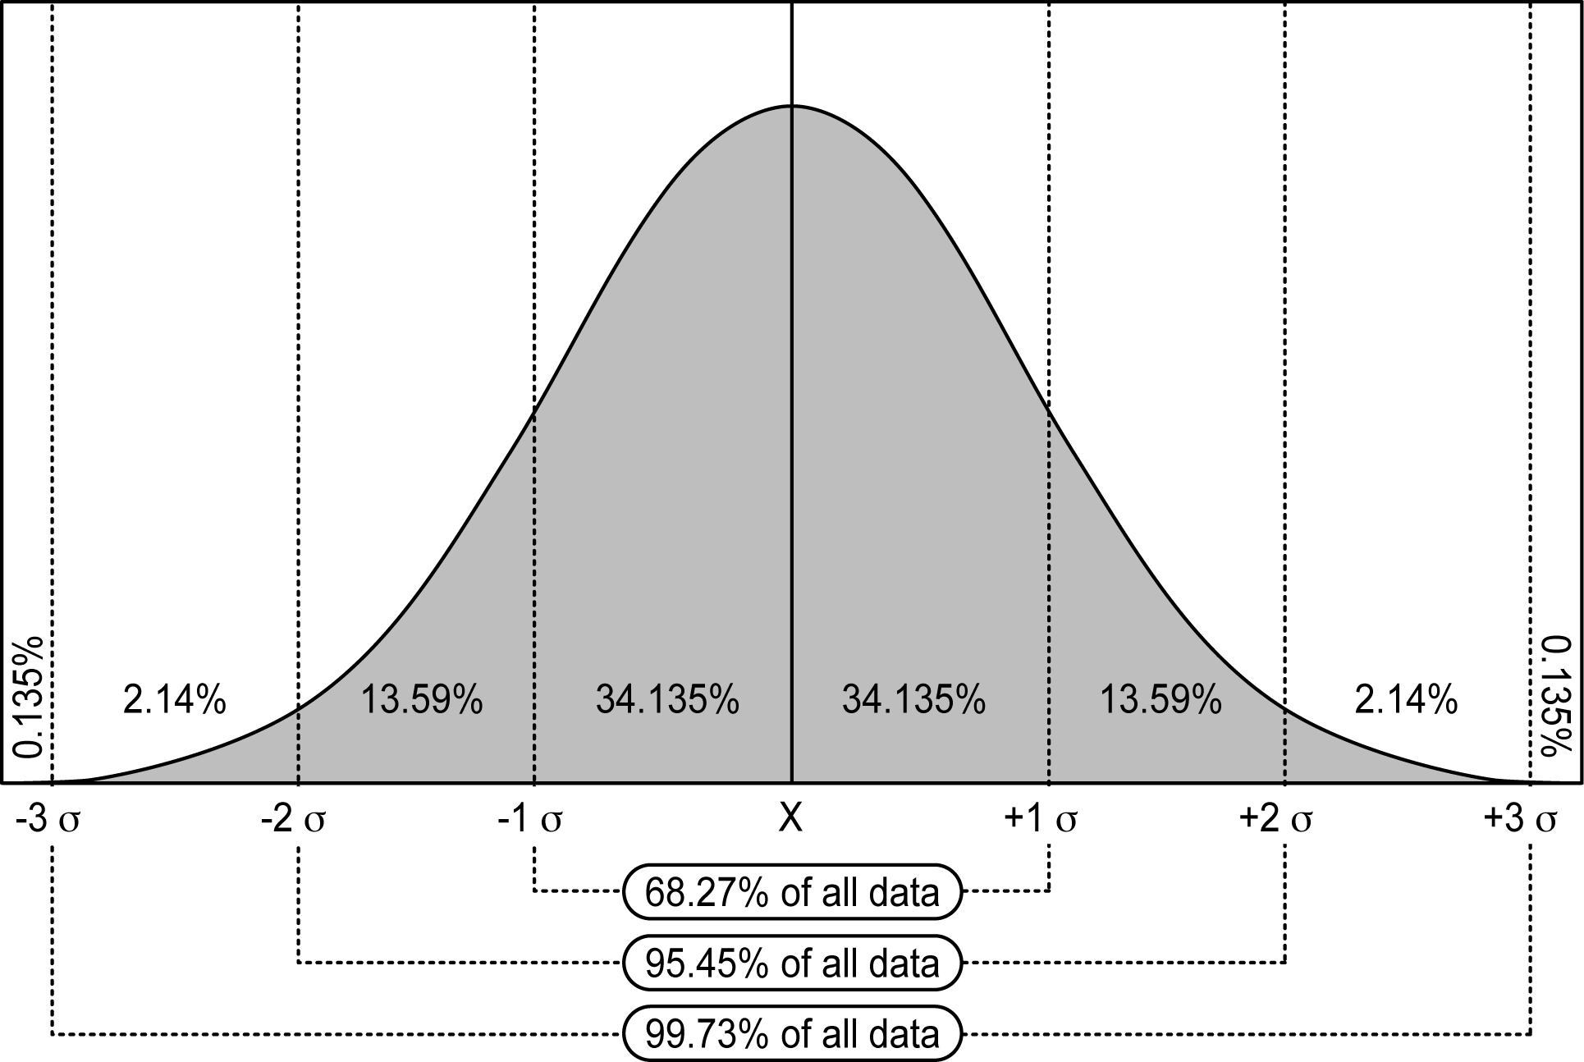The mean and standard deviation are two statistical measures that describe how some variable varies within some population (e.g., the body length of 327 adult female leopard sharks). They are particularly appropriate when the resulting data show a “normal” distribution, where the majority of values are close to the mean and progressively fewer values fall farther from the mean, producing a bell-shaped curve centered on the mean. In such normal distributions, the mean (x̅) is taken to represent the typical value for the measured population and the standard deviation () represents the relative spread or dispersion of values around this mean. In any data set showing such a normal distribution, roughly 68% of all of values will fall with one standard deviation of the mean (i.e., the interval between -1  and +1  in the graph). Thus, if the body lengths of 327 adult female leopard sharks showed a normal distribution, the calculated mean and standard deviation of 163 ± 22 cm would indicate that roughly 68% of all the specimens were between 141 and 185 cm long.

*Calculating the mean by hand*: The equation is: 

In both forms of the equation, the numerator can be translated as the “sum of all individual measurements.” This summed value is then divided by the denominator, which is the total number of individual measurements.

*Calculating the mean by spreadsheet*: Enter all of the individual measurements into the rows of a single column (e.g., Rows 2 through 328 in Column A to the right; note that only rows 1 through 7 are shown). Then, in an adjacent cell (e.g., B2), enter the formula “=AVERAGE(A2:A328)”, where the values in parentheses indicate which cells should be included in the calculation (i.e., Column A, Row 2 through Column A, Row 328). Upon pressing return, the calculated mean will appear in the cell.

*Calculating the standard deviation by hand*: The equation is: 

While this equation looks complex, it can, like all equations, be decomposed into a series of logical steps:

• Find the mean (x̅) for all the measurements.

• For each measurement (xi), calculate its deviation from the mean and square this deviation (i.e., (xi – x̅)2).

• Sum these calculated squared deviations for all the individual measurements.

• Divide this summed value by the total number of individual measurements (n); resulting value is the variance.

• Take the square root of this variance; resulting value is the standard deviation.



*Calculating the standard deviation by spreadsheet*: Calculating the standard deviation by hand can be laborious, especially if you have many individual measurements. Fortunately, the standard deviation can be quickly calculated in a spreadsheet by following the steps above for the mean, but replacing the “AVERAGE” function with the “STDEV” functionas shown in cell B3. Upon pressing return, the calculated standard deviation will appear in the cell.

Part B. Testing a prediction of Isostasy Using a Lithosphere-Asthenosphere Cross-Section

Based on seismic studies of the Earth’s interior, oceanic crust averages ~7.9 km thick and has an average density of ~2.99 g/cm3 (range: ~2.4–3.4 g/cm3). In contrast, continental crust averages ~28 km thick and has an average density of ~2.67 g/cm3 (range: ~2.2–2.8 g/cm3). These two types of crust are underlain by the denser mantle, largely composed of the rock peridotite, with an average density of ~3.3 g/cm3. As temperature and pressure increase with depth, this mantle material transitions in its physical behavior from rigid lithosphere to plastic asthenosphere with little change in density.

6. How do the average densities calculated for the basalt and granite specimens from Part A compare, respectively, to these average density values for oceanic and continental crust? (5 points)

Recall the simple “boat and seawater" example of isostatic equilibrium, which explored how the “boat+seawater” and “seawater” columns exerted the same hydrostatic pressure on the underlying seafloor. This same principle can be applied lithospheric “columns” of differing crustal thickness and density that “float” on the underlying plastic asthenosphere. Thus, if the hydrostatic pressures is equal at some common depth, then the region can be considered to be in isostatic equilibrium.

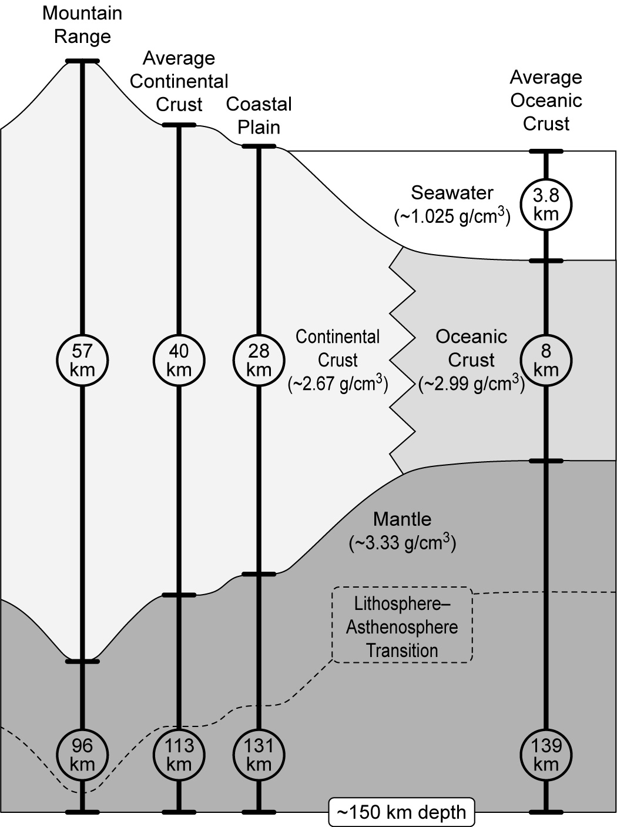 In this part of the investigation, you will test this isostatic prediction of equal hydrostatic pressure at a common depth using the simplified, but realistic, cross-section of a continental margin shown to the right. In this cross-section, four “columns” of lithosphere (*Mountain Range*, *Average Continental Crust*, *Coastal Plain*, *Average Oceanic Crust*) extend downward from the land or ocean surface to a common depth of ~150 km within the asthenosphere. Each column comprises a typical thickness and density for seawater, oceanic crust, continental crust, and mantle as appropriate. Note that the thicknesses of the ocean and crust are highly vertically exaggerated to allow you to see some very subtle (on a global scale) but important (on a human scale) elevation patterns! With respect to the mantle material, note that (1) it physical behavior transitions from rigid lithosphere to plastic asthenosphere (dashed line) at different depths through the cross-section due to local differences in temperature and pressure, and (2) this change in physical behavior is accompanied by very little change in mantle density.

To test the isostatic prediction that the hydrostatic pressure at the bottom of each column is approximately equal, you will use the thickness and density data for each layer in each column to calculate the hydrostatic pressure each column exerts at the common depth of ~150 km. To simplify your calculations, assume that the sides of the columns are 1 m by 1 m (i.e., a horizontal area of 1 m2) and that gravitation acceleration is constant across the cross-section (i.e., g =9.8 m/s2). Finally, two relevant notes on units: (1) Density units are reported in g/cm3, but must be converted to kg/m3 units in order to calculate pressure in standard Pascal (Pa; kg/m s2). (2) Thicknesses in the columns are reported in km, but must be converted to m for your calculation (i.e., 1 km = 1,000 m).

As an example, the calculation of the hydrostatic pressure at the base of the *Average Oceanic Crust Column* is shown below. Recall from the investigation reading that the hydrostatic pressure from each component within each column is calculated by multiplying the component’s density (kg/m3) by its height (m) by the acceleration of gravity (9.8 m/s2). These individual components of hydrostatic pressure are then summed to get the total hydrostatic pressure at the base of the column (PTotal).

Also note that pressure is reported in units of Pascals (Pa) or kg/m s2, so one must convert the density and height data from the figure into values where the mass unit is kg and length unit is m. Stated in terms of typical unit conversion:

**Have**: Density in units of g/cm3 **Want**: Density in units of kg/m3

Density = 1.025 g/cm3 = 1.025 ~~g~~/~~cm~~~~3~~ x 1 kg/1~~000~~ ~~g~~ x 1000~~000~~ ~~cm~~~~3~~/1 m3 = 1025 kg/m3

**Have**: Height in units of kilometers **Want**: Height in units of meters

Height = 3.8 km = 3.8 ~~km~~ x 1000 m/1 ~~km~~ = 3800 m

PSeawater = 1025 kg/m~~3~~ x 3800 ~~m~~ x 9.8 ~~m~~/s2 = 38,171,000 kg/m s2 = 0.38 x 108 Pa

POceanic Crust = 2900 kg/m~~3~~ x 8000 ~~m~~ x 9.8 ~~m~~/s2 = 234,416,000 kg/m s2 = 2.34 x 108 Pa

PMantle = 3330 kg/m~~3~~ x 139000 ~~m~~ x 9.8 ~~m~~/s2 = 4,495,260,000 kg/m s2 = 45.36 x 108 Pa

PTotal = PSeawater + POceanic Crust + PMantle = 0.38 x 108 Pa + 2.34 x 108 Pa + 44.95 x 108 Pa = 48.08 x 108 Pa

7. Calculate PTotal for the base of the *Mountain Range Column:* (5 points)

PContinental Crust =

PMantle =

PTotal =

8. Calculate PTotal for the base of the *Average Continental Crust Column:* (5 points)

PContinental Crust =

PMantle =

PTotal =

9. Calculate PTotal for the base of the *Coastal Plain Column* (5 points)

PContinental Crust

PMantle =

PTotal =

10. To assess the relative differences among the bases of the four columns, calculate the “percent difference“ for the two columns with the highest and lowest hydrostatic pressure using the following equation: (5 points)

Percent Difference = ((Highest Pressure – Lowest Pressure) / Highest Pressure)*100

11. Based on the above percent difference, are the hydrostatic pressures among the bases of the four columns approximately equal (i.e., within 10% of one another)? (5 points)

12. Based on this estimate and assuming no major changes to the system, why would you expect the heights of the four columns to be relatively stable relative to one another on short time-scales (e.g., hundreds to thousands of years)? Explain your reasoning. (5 points)

Part C. Predicting Relative Elevation Differences at the "Tops" of Oceanic and Continental Crust

In Part B, you determined whether four different columns of lithospheric and asthenospheric material contained a similar amount of mass and therefore exerted a similar hydrostatic pressure at their base. If the hydrostatic pressures were roughly equal, then one would predict these columns to be in isostatic equilibrium and therefore relatively stable on short time-scales (e.g., thousands of years). In this part of the investigation, you will take a slightly different, more dynamic, approach to understanding isostasy using an on-line program developed by Dr. Gary Girty (SDSU Geological Sciences) and available by pointing your browser to: <http://www.geology.sdsu.edu/visualstructure/experiments/isostasy1_02.html>. Your instructor will walk through the basics of the on-line program using the LCD projector. The key points to remember are:

• “Live” variables that you control for each lithospheric block are *Density of Crust*, *Density of Mantle*, and *Total Thickness Crust*.

• Resulting information based on these variables include the *Thickness of crust riding above mantle* and the visual depiction of each block in the diagram. Note that you will need to roll your mouse over each block to reveal the elevation of the top of the block relative to sea level.

• After changing **any** variable for a block, you **must** click *Calculate* to update the block results and graph!

For each model below, input the given values, record or calculate the resulting information, and then answer the associated questions.

Model 1: Variable thickness of continental crust (1 point for each table entry)

|  |  |  |  |  |  |  |  |
| --- | --- | --- | --- | --- | --- | --- | --- |
| Block | Crust | Input:  Total Thickness Crust  (km) | Input:  Density  of Crust  (g/cm3) | Input:  Density  of Mantle  (g/cm3) | Output:  Thickness of Crust Riding Above Mantle (km) | Calculate:  % of Crust Riding  Above  Mantle* | Calculate: Block Top Elevation Relative to Sea Level (km)** |
| 5 | Continental | 19 km | 2.67 g/cm3 | 3.3 g/cm3 |  |  |  |
| 4 | Continental | 28 km | 2.67 g/cm3 | 3.3 g/cm3 |  |  |  |
| 3 | Continental | 40 km | 2.67 g/cm3 | 3.3 g/cm3 |  |  |  |
| 2 | Continental | 45 km | 2.67 g/cm3 | 3.3 g/cm3 |  |  |  |
| 1 | Continental | 57 km | 2.67 g/cm3 | 3.3 g/cm3 |  |  |  |

* To calculate, divide *Thickness of Crust Riding Above Mantle* by *Total Thickness of Crust*.

** Roll your mouse over the block for a box showing the elevation of the top of the block relative to sea level.

13. How does *Thickness of Crust Riding Above Mantle* change as continental crust thickens? (5 points)

14. How does the *% of Crust Riding Above Mantle* change as the continental crust thickens? (5 points)

15. Explain your observations in Questions 13 and 14 in terms of isostasy, including the concepts of mass, volume, density, and thickness as appropriate. (5 points)

16. Some regions of the Himalayas have an elevation of ~7.8 km above sea level. Using one of the blocks, vary the *Total Thickness of Crust* to estimate what the thickness of the regional crust would have to be in order to produce this elevation. (5 points)

Part D. Connecting Global Elevation Patterns to Differences in Oceanic and Continental Crust

17. In Part C, *Block 4* in *Model 1* represented average continental crust (i.e., 2.67 g/cm3 and 28 km thick), whereas *Block 2* in *Model 2* representedaverage oceanic crust (i.e., 2.99 g/cm3 and 7.8 km thick. Using your *Block Elevation Above/Below Sea Level* for these two blocks, calculate the model-predicted difference in elevation between average continental crust and average oceanic crust. (5 points)

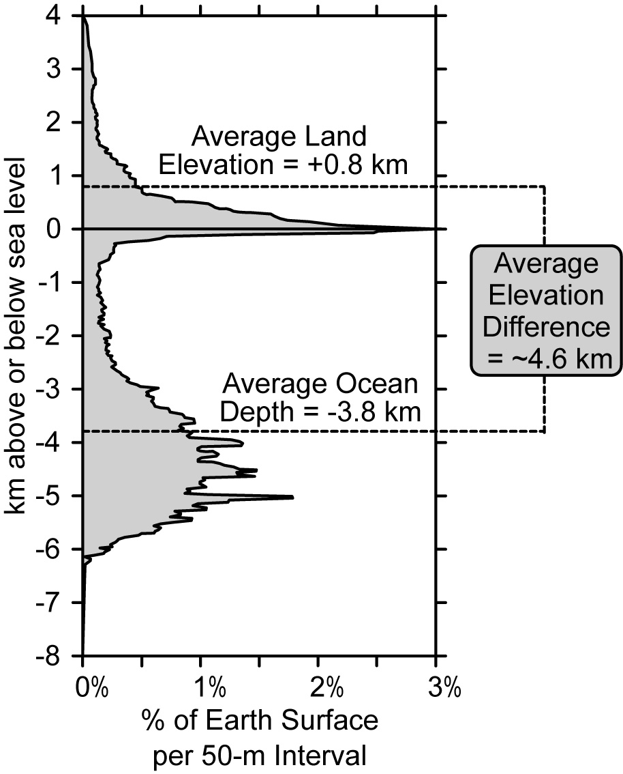18. If you were to go to every location on the Earth's surface, measure its elevation relative to sea level, and construct a graph showing the percent distribution of these elevations in 50-m interval “bins,” you would get the histogram to the right. This histogram shows a “bimodal” distribution of two distinct concentrations of elevations. Note that the average elevation of land is 0.8 km above sea level and the average depth of the ocean is 3.8 km below sea level. Compare the observed difference of 4.6 km between these two average elevations to your calculated difference between the two model blocks in Question 22. Calculate the “percent difference” between these two values using the methods outlined in Question 10. (5 points)

19. The Himalayas and Andes are two major mountain chains on Earth. Based on isostatic principles, what would you predict about the relative thickness of the continental crust in these regions compared to lower elevation regions? Explain your reasoning behind your prediction. (5 points)

20. One question that you may have pondered is how the thickness of continental crust can vary so widely over the Earth. The Himalayas and Andes are examples of two different ways that plate tectonic processes can “thicken” continental crust over time. Concisely explain the cause of the “thickening” of each mountain chain over time in the space below using plate tectonic terms. (5 points)

Himalayas:

Andes:

21. Take a deep breath and look over the “static” example of isostasy in Part B and the “dynamic” examples of isostasy in Part C. Based on your examination of these examples, summarize the basic concepts of isostasy in your own words on the back of this sheet, including and referring to sketches as appropriate (10 points).

22. Now that you have summarized the basic concepts of isostasy, use these concepts and the characteristics of the two basic types of crust to explain the bimodal distribution of elevations on Earth. Again, use your own words and the remainder of the back of this sheet (and additional sheets) if necessary. (10 points)

Part E. Out of this world: Using isostatic principles to make predictions for Mars

Installed on the Mars Global Surveyor (MGS), the Mars Orbiter Laser Altimeter (MOLA) is an instrument that mapped the topography of the red planet over a 4 1/2 year interval. The resulting hypsographic curve for Mars is presented to the right, with elevations reported relative to a surface of a corrected-ellipsoid that best fit the overall shape of the planet.

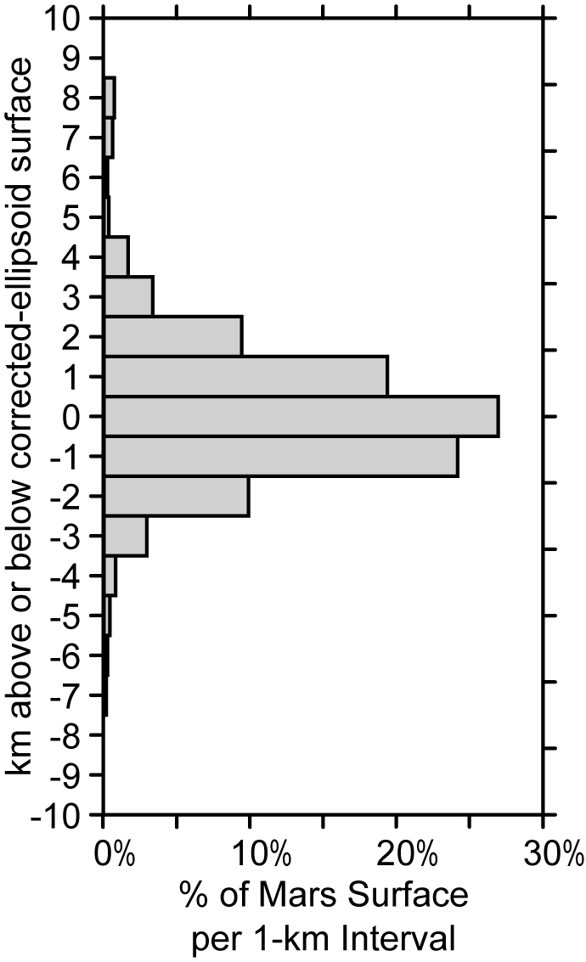

23. Which planet’s histogram shows a finer resolution in terms of elevation? Explain your reasoning. (2 points)

24. Compare and contrast the shapes of the hypsographic curves for the two planets. (3 points)

25. Based on the shape of Mars’ hypsographic curve, propose a hypothesis to explain the presence of only one major mode of elevation on Mars. (5 points)

26. NASA calls you up and asks you to outline some specific ways that they could go about testing your above hypothesis during an upcoming manned mission to Mars. Based on lecture and laboratory explorations of Earth’s plate tectonics, propose two ways that you might go about testing your hypothesis – no budget limit, so go nuts. (6 points).