Coastal Stabilization Structures: Whose idea is best…and where exactly IS this case study?
Note that all of the ideas expressed by students in the case study have drawbacks. For example:
Amy’s idea of a hole in the middle of the breakwater won’t adequately protect the boats. It’s a misconception that the hole will allow sand to be transported through it. Out where the breakwater exists, there is no sand movement (it only occurs in the surf zone due to longshore drift). The hole does, however, allow wave energy to go through the breakwater, which does keep at least some sand moving along the beach.
Bridgette’s idea of a floating breakwater will be expensive. In addition, the breakwater tethered to the ocean floor might have its moorings damaged during a big storm, thus becoming an object that destroys all the boats.
Charles’ idea of adding groins might work if it was properly designed, but it would be expensive.
Damien’s idea of building a boat harbor is really expensive, but it would protect the boats. The jetties that would be built would cause sand accumulation and deposition, potentially making the situation worse or just making problems elsewhere.
Eva’s idea of moving the sand on the beach from the deposition to the erosion is expensive, but it would work.
Fred’s idea of moving the breakwater offshore is expensive (the water is way deeper out there), and it may not protect the boats well if there is an offshore wind and then the waves hit the boats on the other side of the breakwater.
Gracie’s idea of a different design of the breakwater would also create a bulge of sand in the beach, and may even enlarge the bulge. Plus, it would be expensive.

As to where the case study occurred, check out Figure 10.23 on page 306 in the text (I flipped the beach around in the case study to make it more difficult to match up). It’s in Santa Monica, California. Just ignore the pier because it’s up on stilts and has no effect on the distribution of sand on the beach. North is to the right.
Breakwater
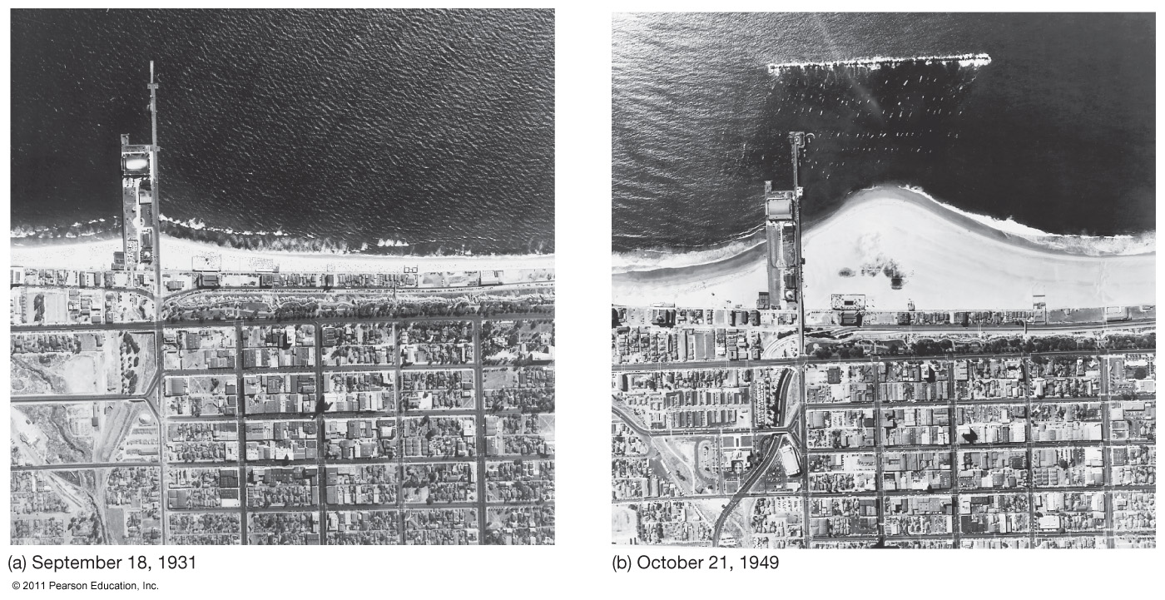
Boat anchorage
Before
After
Bulge of sand
Pier
(has no effect)
So, what did Santa Monica do to eliminate the bulge of sand on the beach? Surprisingly, the city tried Eva’s idea, although they did not use prison inmates (now THAT’s an interesting way to save money!). Instead, they moved the sand from the deposition to the erosion with a suction dredge powered by an electric pump, which moved the sand downcoast through a long pipe (see, for example, Figure 10.26 on page 308 in the text).
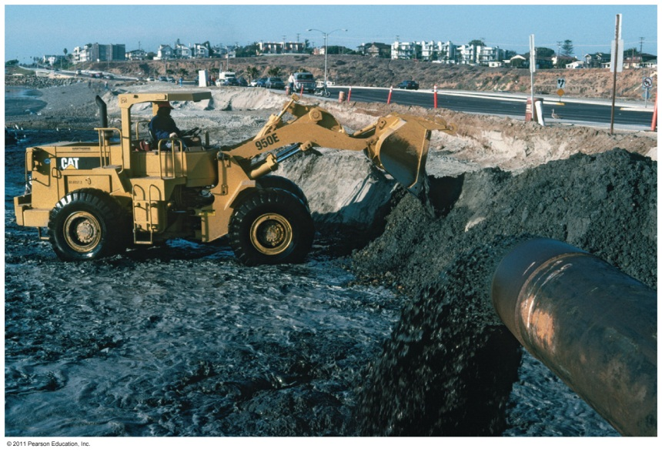
Pumped sand exiting pipe
This makes sense when you consider the situation from an energy standpoint. What keeps the sand moving along the beach and in the surf zone is wave energy; when the offshore breakwater stops that wave energy, new energy is needed to move the sand along the beach. This new energy was in the form of electrical energy, which runs the pump that moved the sand downcoast. One drawback of Eva’s idea is that the suction dredge must work 24/7 to move the enormous amount of sand.
I’m not sure if what Santa Monica did was the best approach, but it’s a moot point now because the breakwater at Santa Monica was destroyed by big waves in 1983. Soon thereafter, the unimpeded wave energy moved the accumulated sand downcoast and the beach returned to a straight coastline.
What are some other ideas? I think a potential solution could be reached by experimenting with various configurations in a wave tank, which simulates the coastal conditions (like what is shown in the video “The Beach: A River of Sand”). Scripps and other institutions have similar wave tanks.
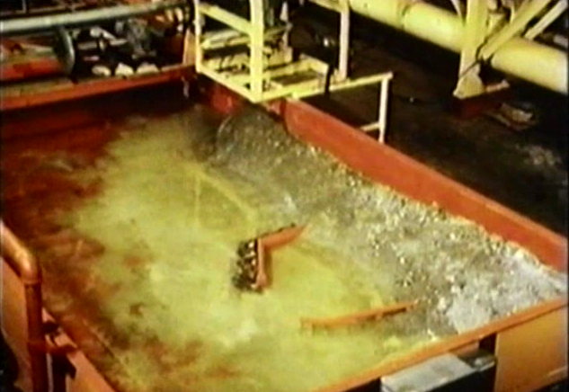
Wave tank
―Mr. T

