Gestures for Mineralogy: Miller Indices
By Barb Dutrow, Kinnari Atit, and Carol Ormand

Goal: At the conclusion of this exercise, you should be comfortable using gesture to convey Miller indices.

Exercise: In this exercise, you are going to use your left hand to represent the three crystallographic axes. Point up with your thumb and forward with your pointer finger. Make your middle finger point to your right, perpendicular to your thumb and pointer finger. Your thumb represents the c axis, your pointer represents the b axis, and your middle finger represents the a axis. They are all pointing the positive direction. You can use your knuckles (and fingertips) to represent coordinates, or intercepts, as shown in the figure on the left, below.

Recall that when we use Miller indices to represent a plane, the numbers are the inverses of the intercepts. So, for example, the (112) plane intersects the a axis at 1, the b axis at 1, and the c axis at ½, as in the image on the right, below.
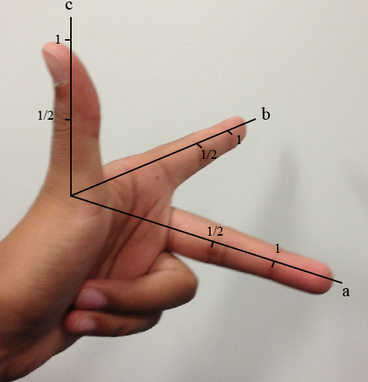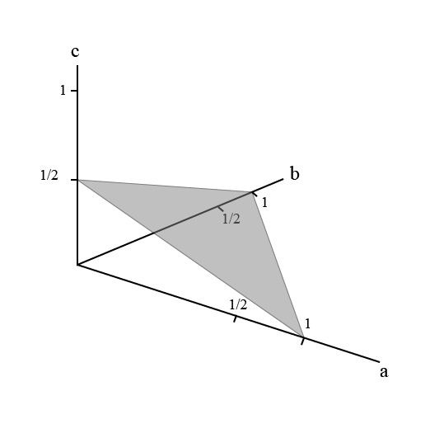

Complete the following exercises with a partner. Assume orthorhombic crystal systems.

Part 1: Use your left hand to gesture the crystallographic axes as shown above. Then use your right hand, held open and flat (to represent a plane) to gesture the location of plane (100). Have your partner confirm that you are gesturing the correct plane. Trade roles. Have your partner gesture the location of plane (010). Confirm that he or she is gesturing the correct plane. Taking turns, gesture planes (001), (110), (011), and (111).

Part 2: Take turns gesturing additional planes and identifying them. (That is, one person gestures, the other identifies the plane.) Have each person gesture and identify at least three additional planes, until you both are comfortable using gestures to convey Miller indices. See if you can find ways to gesture planes such as (201), (132), (331), and planes with negative intercepts.

