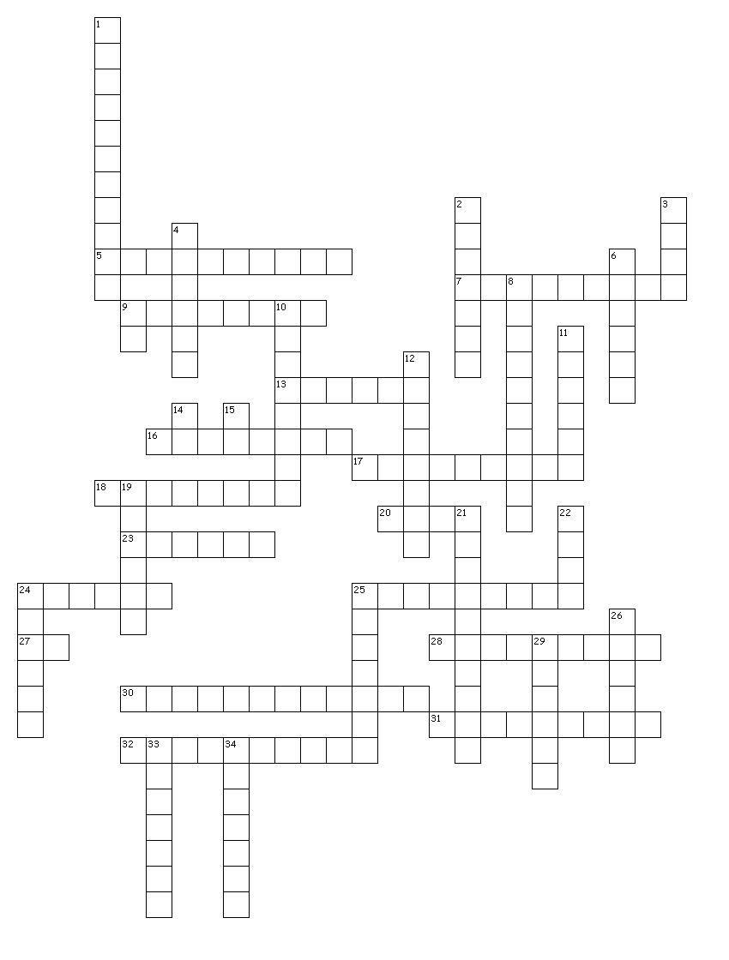Word Bank
Mineral Basics
All of these words for minerals and abbreviations for elements are used in the crossword puzzle:

Augite
Biotite
Calcite
Carbonate
Chalcopyrite
Cleavage
Conchoidal
Cu
Fe
Feldspar
Fluorite
Galena
Garnet
Graphite
Gypsum
Halite
Hematite
Hornblende
Luster
Magnetite
Mohs
Muscovite
Na
Olivine
Pb
Plagioclase
Potassium
Pyrite
Quartz
Refraction
Rose
Silicates
Sphalerite
Streak
Sulfide
Sulfur
Talc

Across
5. 6 planes of cleavage, ZnS
7. mineral group including calcite and dolomite
9. planes of weakness in a mineral
13. cubic crystals; “fool’s gold”
16. reddish streak; iron oxide
17. colorless mica; one direction of cleavage
18. halide with cubic habit and octahedral cleavage
20. hardness of 1; one direction of cleavage
23. yellow native element
24. dodecahedral habit; red gemstone
25. largest group of minerals on Earth
27. chemical abbreviation for lead
28. chemical abbreviation is K
30. copper iron sulfide with a brassy luster
31. magnetic mineral
32. dark green amphibole; two cleavages not at 90°

Down
1. two directions of cleavage at 90°; twinning striations
2. effervesces easily in dilute HCl
3. pink variety of quartz
4. lead sulfide with three directions of cleavage at 90°
6. cubic habit and cleavage; salty taste
8. double __________; calcite makes this optical effect
9. chemical abbreviation for copper
10. hardness of 1; same chemical composition as diamond
11. dark green pyroxene; two cleavages at 90°
12. varies of K-_________ include microcline and orthoclase
14. chemical abbreviation for iron
15. chemical abbreviation for sodium
19. reflection of light from a mineral; includes metallic and non-metallic
21. fracture seen in quartz
22. hardness scale for minerals
24. varieties include alabaster, satin spar, and selenite; hardness of 2
25. mineral group consisting of a metal and sulfur; includes pyrite and galena
26. hexagonal crystals; hardness of 6; SiO₂
29. color of a mineral when powdered
33. sugary, granular appearance; always green
34. brown mica; one direction of cleavage
Key

Using http://puzzlemaker.discoveryeducation.com/code/BuildCrissCross.asp

Title: Mineral Basics
Input: word then space then clue

Augite dark green pyroxene; two cleavages at 90°
Biotite brown mica; one direction of cleavage
Calcite effervesces easily in dilute HCl
Carbonate mineral group including calcite and dolomite
Chalcopyrite copper iron sulfide with a brassy luster
Cleavage planes of weakness in a mineral
Conchoidal fracture seen in quartz
Cu chemical abbreviation for copper
Fe chemical abbreviation for iron
Feldspar varies of K-_________ include microcline and orthoclase
Fluorite halide with cubic habit and octahedral cleavage
Galena lead sulfide with three directions of cleavage at 90°
Garnet dodecahedral habit; red gemstone
Graphite hardness of 1; same chemical composition as diamond
Gypsum varieties include alabaster, satin spar, and selenite; hardness of 2
Halite cubic habit and cleavage; salty taste
Hematite reddish streak; iron oxide
Hornblende dark green amphibole; two cleavages not at 90°
Luster reflection of light from a mineral; includes metallic and non-metallic
Magnetite magnetic mineral
Mohs hardness scale for minerals
Muscovite colorless mica; one direction of cleavage
Na chemical abbreviation for sodium
Olivine sugary, granular appearance; always green
Pb chemical abbreviation for lead
Plagioclase two directions of cleavage at 90°; twinning striations
Potassium chemical abbreviation is K
Pyrite cubic crystals; “fool’s gold”
Quartz hexagonal crystals; hardness of 6; SiO₂
Refraction double __________; calcite makes this optical effect
Rose pink variety of quartz
Silicates largest group of minerals on Earth
Sphalerite 6 planes of cleavage, ZnS
Streak color of a mineral when powdered
Sulfide mineral group consisting of a metal and sulfur; includes pyrite and galena
Sulfur yellow native element
Talc hardness of 1; one direction of cleavage

Created by Prof. Laura Reiser Wetzel, Eckerd College, St. Petersburg, FL, wetzellr@eckerd.edu.

