GLY 3202C: Mineralogy and Petrology Name: ____________________________
Feldspar mineral formula calculation
Today in lab we will use excel to calculate the mineral formula of our feldspar analysis and plot the compositions on a ternary diagram and identify the Feldspar type.
Feldspar can have the general formula of A₁T₂Si₂O₈.
A = Na, K, Ca, Sr, Ba, Rb, Pb, and Eu
T = Si, Al, and Fe³⁺
We did not analyze for Rb, Pb, or Eu, so we will not include these in our analyses. We will work in steps:
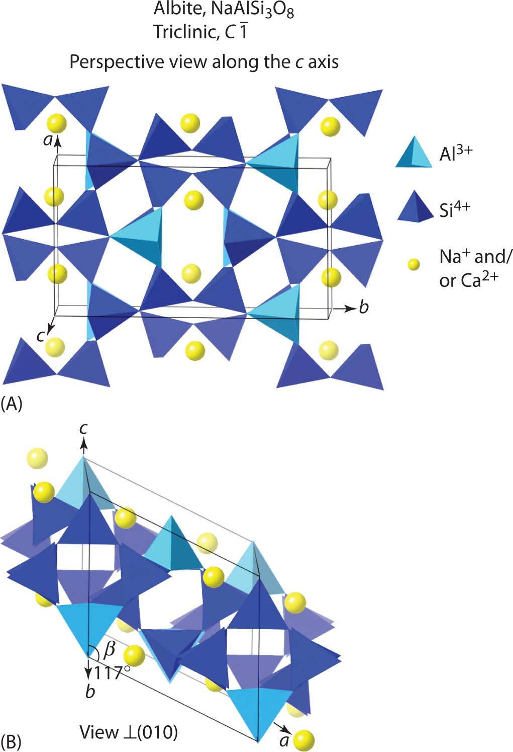
Step 1: convert FeO to Fe₂O₃:
The EPMA cannot differentiate between Fe²⁺or Fe³⁺. So, all Fe is reported as Fe²⁺ and expressed as FeO. This is because Fe²⁺ is more abundant in geological setting. Well, feldspar has Fe in the 3+ state substituting in the C.N. =4 tetrahedral coordination polyhedron site. We will just assume that all of our Fe is 3+, and convert our FeO to Fe₂O₃ by multiplying FeO by its conversion factor 1.11134.

Step 2: calculating moles of oxide:
This is done by dividing the oxide value for each element by the molecular weight for each oxide formula. The molecular weights are in the table below:
SiO₂ | 60.08
TiO₂ | 79.87
Al₂O₃ | 101.96
Fe₂O₃ | 159.69
MnO | 70.94
MgO | 40.30
CaO | 56.08
BaO | 153.33
Na₂O | 61.98
K₂O | 94.20
SrO | 103.62
Example: SiO₂ = 51.56; moles of oxide for Si = 51.56/60.08 = 0.85816

Step 3: calculating moles of oxygen:
This is done by multiplying your moles of oxide by how many O are in the oxide formula. For example, SiO₂ has 2 O in its oxide formula. So the Si from the moles of oxide is multiplied by 2:
0.85816 * 2 = 1.71632.
A second example for CaO:
0.26671 * 1 = 0.26671 (note, the moles of oxide and moles of oxygen are equal because the oxide formula only has one oxygen).

Step 4: Sum the moles of oxygen:
Pretty self-explanatory. Take the moles of oxygen for Si, Ti, Al, Fe3+, Mn, Mg, Ca, Ba, Na, K, and Sr and total them. This will create a number that we will use to covert our data to 8 oxygen, because feldspar has 8 oxygen in its ideal formula.

Step 5: calculating moles of cation:
This is done by multiplying your moles of oxide by the number I of cations in the oxide formula. For example, SiO₂ has one cation, Si, so the moles of cation are: 0.85816 * 1 = 0.85816.
Al₂O₃ has two cations of Al in the oxide formula. So the moles of cation are:
0.29972 * 2 = 0.59944.

Step 6: calculating the cation conversion factor:
This is done to “correct” the cations for 8 oxygen. Feldspar has 8 oxygen in its ideal chemical formula, so your divide 8 by the sum of the moles of oxygen. For example, if the total moles of oxygen is 2.92834,
8 / 2.92834 = 2.73192

Step 7: calculate the cations based on 8 oxygen:
This is done by multiplying the moles of cation for each element by the cation conversion factor. For example, for Si,
0.85816 * 2.73192 = 2.344
The values calculated here can be put into the chemical formula! Example:
(Ca_{0.729}Na_{0.227}Sr_{0.006}K_{0.001})(Si_{2.344}Al_{1.638}Fe_{0.003})O₈

Step 8: end members calculation:
An = Ca / (Ca+Na+K)*100%
Ab = Na / (Ca+Na+K)*100%
Or = K / (Ca+Na+K)*100%
Use your values from the cations based on 8 oxygen to calculate the end members.

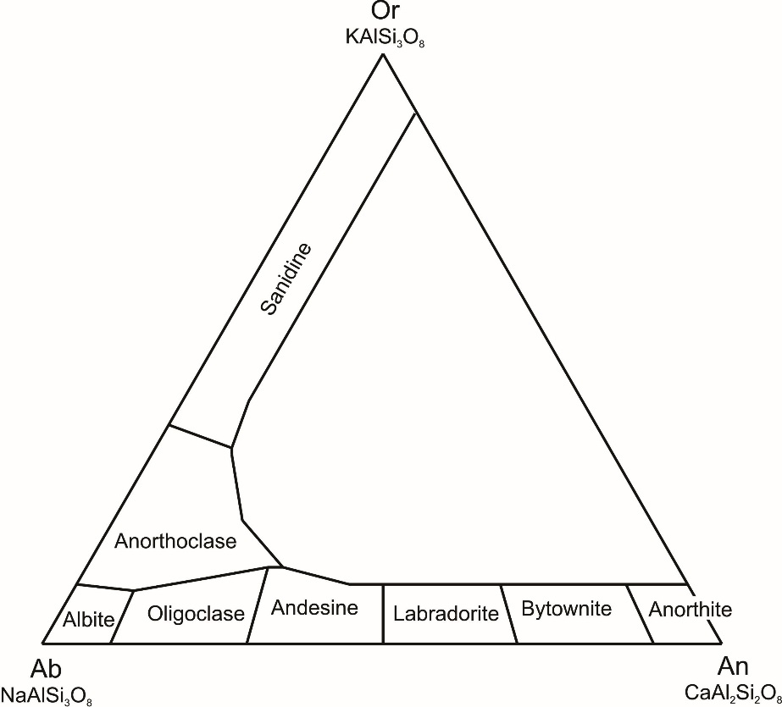
Step 9: Ternary Plotting. Now that you have calculated your end member compositions, plot your normalized data into the attached ternary data sheet (Excel file) or manually plot your ternary data into the provided ternary grid graph paper. Use the figure below to identify your Feldspar class. You can draw (approximate) the area locations on your ternary diagrams based on the image below.

GLY 3202C: Mineralogy and Petrology Name: ____________________________
Averaging and Normalizing EPMA data

The elements that we analyzed on the electron probe micro analyzer (EPMA) are expressed as oxides (e.g., silicon is reported as SiO₂). Also, the EPMA cannot discern Fe²⁺ from Fe³⁺; so, all iron is reported as FeO (Fe²⁺). Now that we have analyzed our minerals, we need to average the multiple analyses from each samples, and then normalize this average. We analyzed 3 points on each minerals so that we could identify any compositional zoning that might exist, and to have a more representative geochemical analysis.
- Using excel, open your raw data file and make sure that your data is organized in a way that is similar to the example below. The order and number of oxides will be different. This is just an example, the oxide order does not matter right now:
No. | SiO2 | Al2O3 | TiO2 | FeO | CaO | NaO | MgO | K2O | Comment
1 | 67.84 | 19.65 | 0.00 | 0.02 | 5.01 | 6.00 | 0.04 | 0.29 | HB1W-7A
2 | 67.23 | 19.56 | 0.01 | 0.03 | 5.06 | 5.97 | 0.03 | 0.31 | HB1W-7B
3 | 67.75 | 19.60 | 0.00 | 0.02 | 5.04 | 6.01 | 0.04 | 0.32 | HB1W-7C

- Add a new row under the 3 data points for each mineral analyzed. Under “Comment”, write “average” after the sample name.
No. | SiO2 | Al2O3 | TiO2 | FeO | CaO | NaO | MgO | K2O | Comment
1 | 67.84 | 19.65 | 0.00 | 0.02 | 5.01 | 6.00 | 0.04 | 0.29 | HB1W-7A
2 | 67.23 | 19.56 | 0.01 | 0.03 | 5.06 | 5.97 | 0.03 | 0.31 | HB1W-7B
3 | 67.75 | 19.60 | 0.00 | 0.02 | 5.04 | 6.01 | 0.04 | 0.32 | HB1W-7C
 |  |  |  |  |  |  |  |  | HB1W-7 average

- Click on the new cell under the SiO2 values. Then click on the Inset Function icon and select AVERAGE. For the “Function Arguments” use the mouse and select the 3 SiO2 cells. Then click “OK”.
No. | SiO2 | Al2O3 | TiO2 | FeO | CaO | NaO | MgO | K2O | Comment
1 | 67.84 | 19.65 | 0.00 | 0.02 | 5.01 | 6.00 | 0.04 | 0.29 | HB1W-7A
2 | 67.23 | 19.56 | 0.01 | 0.03 | 5.06 | 5.97 | 0.03 | 0.31 | HB1W-7B
3 | 67.75 | 19.60 | 0.00 | 0.02 | 5.04 | 6.01 | 0.04 | 0.32 | HB1W-7C
 | 67.61 |  |  |  |  |  |  |  | HB1W-7 average

- Now repeat this for all of your other oxides.
We will now normalize our mineral data so that it adds up to 100%. This is done before plotting or calculating our mineral formula:
- First, add a “Total” column to the data set.
No. | SiO2 | Al2O3 | TiO2 | FeO | CaO | NaO | MgO | K2O | Comment | Total
1 | 67.84 | 19.65 | 0.00 | 0.02 | 5.01 | 6.00 | 0.04 | 0.29 | HB1W-7A
2 | 67.23 | 19.56 | 0.01 | 0.03 | 5.06 | 5.97 | 0.03 | 0.31 | HB1W-7B
3 | 67.75 | 19.60 | 0.00 | 0.02 | 5.04 | 6.01 | 0.04 | 0.32 | HB1W-7C
 | 67.61 | 19.60 | 0.00 | 0.02 | 5.04 | 5.99 | 0.04 | 0.31 | HB1W-7 average

- Then click on the cell to the right of the HB1W-7 average and click on the Inset Function icon, select “SUM”, and click OK.

- Select all of your oxides from the sample average row as your Function Arguments. Then click OK:
- Now, add a “Normalizing value” column to your table. Then insert the following function by: a) clicking on the Normalizing value cell next to the Total for the average of the data; b) type the function =100/(here click on the Total or just type in the value of the total); then, c) press “enter”.
- You will now have the normalizing value you need to make your data equal 100%.
- You will now normalize your data be multiplying each “average” cell for every oxide by the “normalizing value”. First, copy your “Normalizing value” and paste it special as a value.
- Then click on the SiO2 average value cell, and then typing an “=” in front of the value. You would then type the multiply symbol “*” after the value; and then click on the “Normalizing value”.
- Now repeat this for all of your other oxides. You total should change to 100 when you are done.

