ACTIVITY NAME: Tracking sea level and Paleoenvironments with Fossils

AUTHOR AND INSTITUTION: Pete Berquist, Thomas Nelson Community College

EMAIL: berquistp@tncc.edu

SUMMARY
Students will interpret changes in sea level of coastal states within North America by observing the distribution of various fossils. This exercise will use organisms with well-known habitats and will rely on the Paleobiology Database to show the distribution of these organisms over distance and time.

GOALS
After completing this activity, students will be able to:
- Identify coastal/near-shore depositional environments.
- Determine suitable and desirable characteristics of organisms that determine lead to understanding water-depth of their habitat.
- Create maps showing the spatial and temporal distribution of specific fossils.
- Create paleogeographic reconstructions for the Cretaceous, Paleogene, and Neogene Periods of southeastern North America.
- Interpret environmental changes for an area based on the spatial and temporal change of its fossils.
- Describe the extent and rate of sea level change within an area over a specific time frame, based on observation of changes in the fossil record.
- Predict causal mechanisms for sea level change within a specified time and area.
- Predict additional organisms that could be used to identify sea level change in other areas and use the PBDB Navigator to test these predictions.

CONTEXT FOR USE
Educational level:
To be used in an introductory or intermediate undergraduate course, including (but not limited to) physical geology, historical geology, and paleontology.

Class size:
Students can work as individuals or in small groups of four or less. Appropriate class size can range from a small seminar (< 10 students) to a large lecture (> 100), as long as computer resources are available.

Institution type:
Can be used with non-majors or majors from two or four year institutions. Each student or student group will need access to the internet and Microsoft Word (or other word-processing program). We do not recommend using smartphones for the internet and word-processing portions of these activities: laptops, tablets, or desktop computers are more appropriate and useful tools for these activities.

Is it lab, lecture, or field exercise?
This activity can be used in a lecture, lab, or as a homework activity.

How much time is needed:
45-60 minutes.

Skills or concepts that students should have already mastered before encountering this activity.
Student should be able to:
- Interpret a diagram of the geologic time scale and distinguish eons, eras, and periods.
- Generally associate sedimentary rocks with depositional environments. For instance, shale is deposited in low energy environments like the deep ocean and extremely poorly sorted and angular clasts are associated with glacial environments. For more detail, see:
https://www.geol.umd.edu/~jmerck/geol100/lectures/14.html

- Recognize that some organisms require specific habitats, so by seeing the spatial distribution of these organisms at a specific time, we can interpret the environmental conditions at that time. Changes in the spatial distribution of these organisms show changes in environmental conditions.
- Calculate rate of change (specifically sea level rise) and convert common units of length. For additional help with these types of calculations, see:
http://serc.carleton.edu/mathyouneed/index.html

How is this activity situated in the course?
This activity could support a variety of topics, including: sea level change, depositional environments, geologic time, mapping, and paleogeography.

How easy (or hard) would it be to adapt the activity for use in other settings?
This activity can be easily used in face-to-face and online courses with little to no modification. Questions can be omitted or revised to streamline the activity or to tailor to instructor’s preferences.

Grade level:
College (13-14)
College (15-16)

ACTIVITY DESCRIPTION AND TEACHING MATERIALS
Students will need computer access to the Paleobiology Database Navigator to show how the distribution of three groups of organisms change throughout eastern North America during the Cretaceous, Paleogene, and Neogene Periods. Based on the observed trends, students will describe how sea level changed in this area during these time frames.

In addition to computer access, students will need handouts of blank maps for each group of organisms (three total, provided in the activity) and colored pencils.

TEACHING NOTES AND TIPS
Students will need to access the internet, and may need access to other class resources, or require more direction to define specific depositional environments and causal mechanisms for eustatic sea level change.

The questions geared for measuring the rate of sea level change can be converted from English units (feet) into metric units (meters, centimeters, millimeters) to provide practice converting and reporting in more typical scientific units.

ASSESSMENT
Formative assessment: If conducted in class, the instructor should walk around and mix troubleshooting advice with informal observations of whether the relevant time periods and taxa are being investigated.

Summative assessment: the numbered questions, sketches, and three maps are key summative assessment points. In particular, question 3 can be used on an test/quiz/exam for students to demonstrate their spatial understanding of depositional environments. Additionally, question 10 could be modified with different values on a problem set, homework, or test/quiz to assess students’ quantitative reasoning ability.

RESOURCES
Relevant web sites that students will need:
https://paleobiodb.org/navigator/

Potentially useful links for depositional environments:
http://paleodb.org/public/tips/environtips.html
https://www.geol.umd.edu/~jmerck/geol100/lectures/14.html

Help with math/quantitative reasoning skills:
http://serc.carleton.edu/mathyouneed/index.html

SHORT DESCRIPTION

---------------------------------------------------------------------------------------------------------------------

Tracking sea level and Paleoenvironments with Fossils

Name ______________________________

Introduction
During the Cenozoic, sea level of the world ocean (including the Atlantic) changed by hundreds of feet. As this change occurred, areas that were once covered with seawater were now exposed on land, and the location of the shoreline along eastern North America changed dramatically. Along with this change, habitats for organisms were impacted, resulting in both the creation and destruction of environments that certain organisms occupied. We know that this change occurred because of changes seen in the rock and fossil record throughout eastern North America and the Gulf of Mexico. Your task is to use fossils to compile more detailed information about this significant change. For instance:
- did sea level rise or fall, and by how much?
- where could you find the shoreline over time?
- where were the deeper parts of the oceans?
It’s time to use the Paleobiology Database to find out!

Before Digging In
Let’s think broadly about how to use fossils as indicators of sea level change. Not all organisms are well-suited to document this change. Brainstorm on your own and then with a partner about what characteristics or attributes of an organism would be helpful and not-so-helpful in determining ancient sea levels. “Characteristics” could be morphological, behavioral, taxonomic, or ecological. Think broadly! For each characteristic, provide a brief summary justifying your ideas in the chart below:

Characteristic  of organism | Helpful for determining  sea level | Not useful in determining sea level
1) Building on the criteria listed above, list at least two specific organisms that could be useful to study as indicators of specific water depths. Provide a justification for each organism.

2) What are least two organisms that would not be useful as indicators of specific water depths. Why did you choose these organisms?

Delving into the Database
Open the PBDB Navigator and spend some time getting comfortable with how it works:
https://paleobiodb.org/navigator/

The Navigator consists of three parts:
- Map (CENTER) showing continents with dots representing fossil occurrences. The color of these dots represents their geologic age. If you click on the dots, you can see all of the information on each site and the species that occur there.
- Geologic time scale (BOTTOM) showing the major eras, periods, and stages. If you click on the timescale, the map will show you the location of fossil occurrences from a time interval.
- Tool bar (LEFT) showing the tools you can use to explore the database. These include:
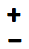 | zoom in/out on the map
 | reconstructs plate tectonic configurations for time interval (era or smaller) you are exploring
 | select which taxonomic group is plotted on map
 | create a diversity curve for the occurrences currently plotted on map
 | download the data (lat/long, geologic age, etc.) for the occurrences plotted on map
Need help? Here’s a YouTube video to help you get started: https://www.youtube.com/watch?v=db2He3p-Jco
Naticidae, Muricidae, and Scleractinia, Oh My!
We are going to focus on three large groupings of marine organisms for this activity: the Naticidae (a family of marine snails), Muricidae (another family of marine snails), and Scleractinia (a type of coral). We’ll use the PBDB Navigator to show the location of these organisms change during the Cretaceous, Paleogene, and Neogene Periods throughout eastern North America. Although they are different critters, they all live in rather specific settings along the coast, namely in shallow subtidal areas within the photic zone.

3) Before we go any further, define and sketch a shallow subtidal environment and the photic zone. Include both the sketch below.

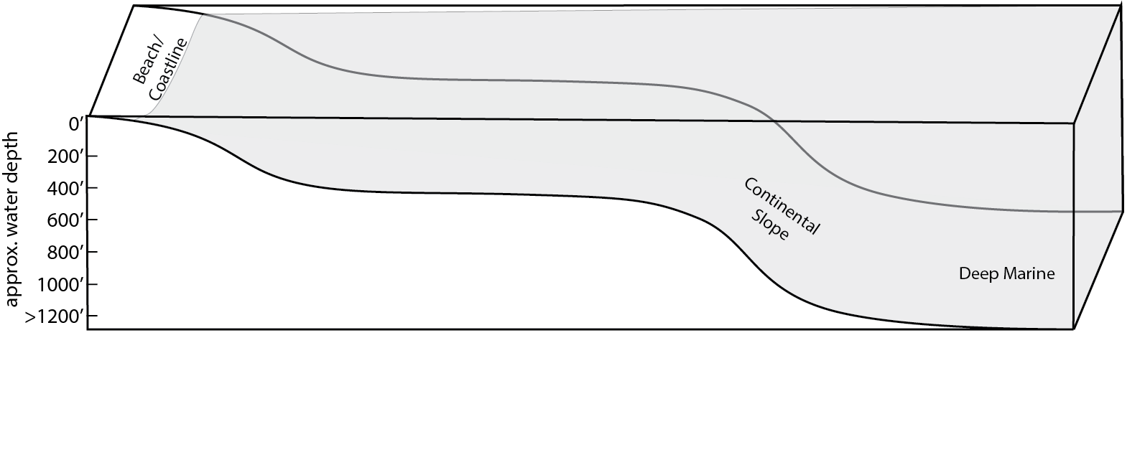
4) Why do you think you are using the Scleractinia corals in this exercise? In other words, what makes these corals useful in tracking changes in sea level?

On to Navigator!

You will need to return to the PBDB “navigator” view and filter your results to show occurrences of the family Naticidae. Zoom in to North America to see the southeastern and Gulf of Mexico states.
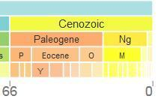 | Use the time scale at the bottom of the screen to filter the fossils by period, starting with the Cretaceous, then Paleogene, and lastly Neogene.
5) Plot the approximate distribution of the Naticidae fossil sites throughout the southern and Gulf of Mexico states of America (see maps at end of this handout). Use a separate color for each period and include a small key or legend on the map of the colors you used.

Repeat this process, following the same time scales, for the family Muricidae and order Scleractinia. Plot each family on a separate map.

6) Briefly describe below how the geographic distribution of each family changes over time.

7) Go back to your maps and for each period, sketch where you think the shoreline existed. Be sure to include labels or add the color used for the shoreline in your map explanation.

In the space below, explain the rationale you used to sketch the shoreline.

8) Now label on each map areas that were inland (land above sea level).

9) Based on these observations, describe how sea level changed throughout this region (e.g. did sea level rise or fall? In what compass directions did the shoreline change?).

10) The oldest fossils from these families are approximately 84 million years old (84 Ma) and are exposed on the surface of the Earth in northeastern Mississippi, at an elevation of approximately 400’ (400 feet). Based on these data, how much has sea level dropped since the Cretaceous?

What is the rate of sea level change, in feet per million years?

In feet per year?

In inches per year?

11) What might be some causes, or mechanisms, that could change sea level by this scale?

12) Think about a few other organisms that live in very specific settings. These could be from any location and any timeframe. Go back to the PBDB Navigator and observe the distribution of these organisms over some timeframe, just like you did earlier in this activity. Be sure to try a few different organisms and several different timeframes.

Which organisms did you use?

What time frames did you try?

What did you find? Summarize your observations about the distribution of organisms

Based on these observations, what can you say about how sea level changed?

13) Reflection:
- Have you used the PBDB before this activity? (Check one) __ No __ Yes
If yes…:
How many times have you used it before? _______
When did you use it? (Circle one)
- previous lab/class activity

- other: ________________________________________

b) Now that you've used the database for this activity, how could you use this database
to create your own research project?

c) Would you want to use this database to create/conduct your own research project?
Why or why not?

Naticidae

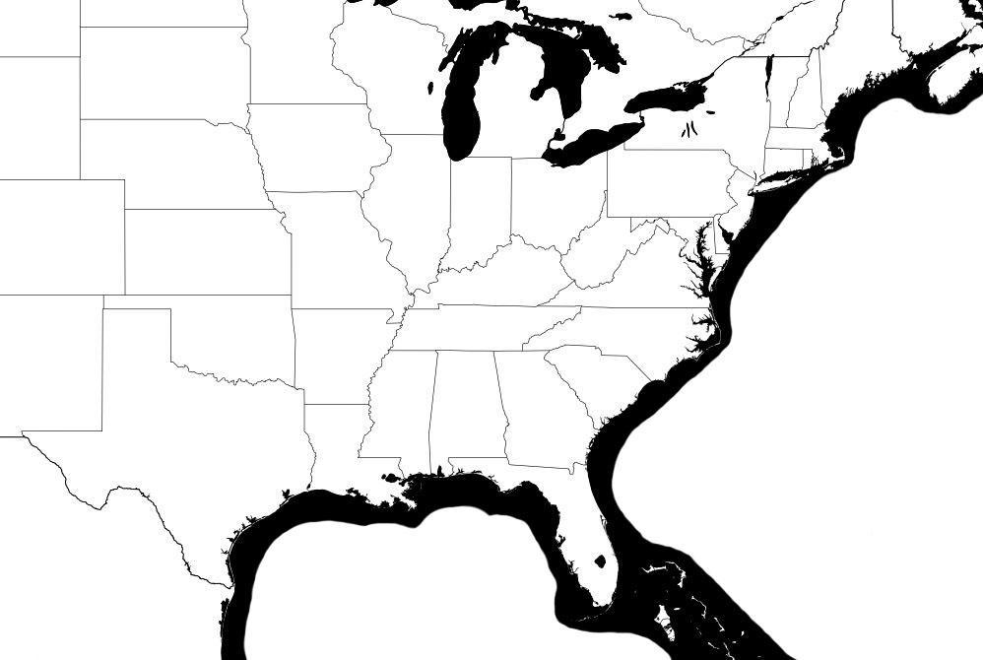
Muricidae

Scleractinia

